12345 Knox Drive Cell: (862) 555-1212
Bradley H. Jensen
Jensen_55@mac.com

Rosharon, TX 77583 Home: (281) 555-1212

SENIOR EXECUTIVE PROFILE: OPERATIONS / GENERAL MANAGEMENT

Guiding Strategic Planning, Operational Controls, and Change Management
to Build Profitable Organizations in Challenging Markets

Versatile, holistic leader with 20+ years of experience driving sustainable growth in finance, technology enablement, and professional services business units serving Fortune 500 clients.

Repeatedly achieved double-digit profitability improvements, paring expenses while improving customer satisfaction, quality, and employee engagement/retention. Areas of impact include:

- Strategic Planning & Leadership  - Marketing & Business Development  - Finance, Accounting, & Budgeting | - Human Resources/Team Building  - Revenue & Profit Growth  - New Product/Service Development | - Information Systems  Strategy  - Mergers & Acquisitions  - Lean Operations

PROFESSIONAL EXPERIENCE:

Jackson Associates – Palatine, IL 2006 to 2009
Leading provider of HR benefits, outsourcing, and consulting services in the U.S. and U.K. 25,000 employees. 30 countries. $3B sales.

SENIOR DIVISION OPERATIONS EXECUTIVE
Doubled sales performance and profitability by establishing robust, systematic business development tools. Owned P&L accountability for U.S. and India operations. Implemented delivery model, call center, and quality programs. Steered product strategy for core benefits platform. Directed $250M in M&A activity and headed 3,000-member organization with 12 direct reports and $150M budget.

$20M Global Sourcing Delivery Model: Absence of critical tools—implementation methodology, cost tracking, supply/demand metrics, PMO practices, pipeline reporting—was resulting in poor quality, inefficient operations and compromised profitability.
Delivery Model Savings
- Strengthened business decisions with real-time dashboards and long-range strategies.  - Achieved critical organizational restructuring, hiring 150 new resources in record time to support increased demand. Achievement was noted in the New York Times Magazine.  - Generated record $147M in new revenue while increasing margins. | 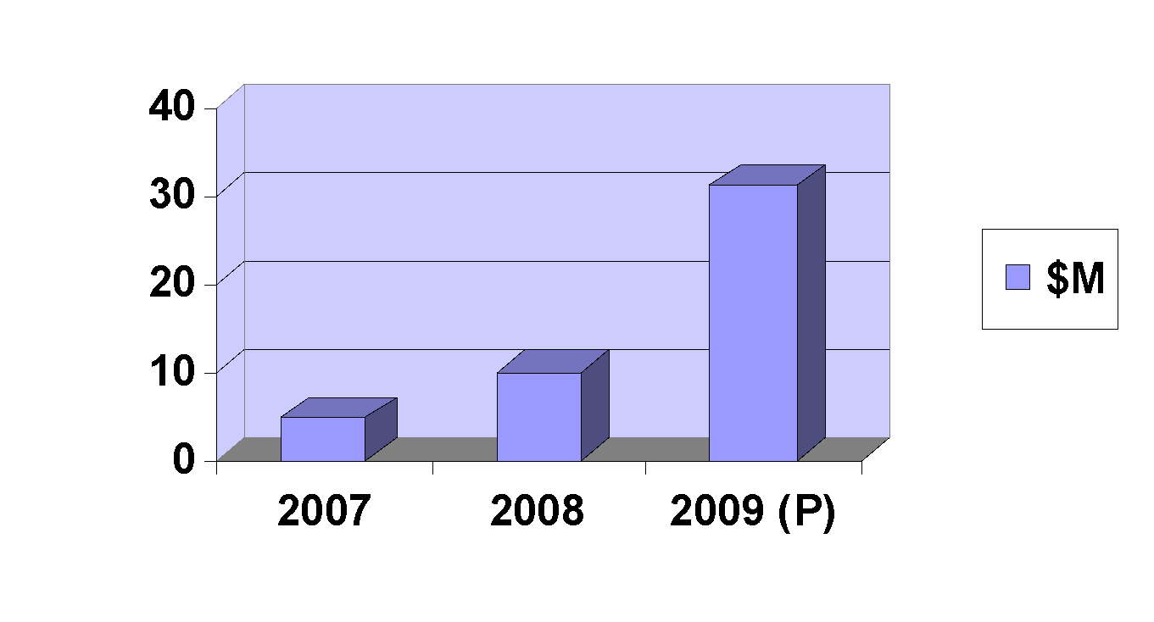
$20M Call Center Turnaround: High call volume (18M annually), stagnant productivity metrics, and high FT-to-PT ratio was fueling significant costs.

- Improved handle time by 15%, from 7.53 minutes to 6.43 minutes with efficiency training program.

- Achieved labor expense savings by relocating call center to Charlotte, NC.

- Increased span of control from 13:1 to 19:1.

- Realized $3.3M in 1st-year savings, $7M to-date.

Jackson Associates, continued

Human Capital Development: Enterprise faced low engagement and employee retention rate. Success was dependent upon acquiring and keeping top talent while conserving payroll expenditure.

- Improved engagement 22% and raised retention to 91% by implementing diversity programs and talent development initiatives.
- Built 98% key-talent retention rate, highest in the division.

Automatic Data Processing, Inc. – Roseland, NJ 1993 to 2006
Global provider of integrated computing and business outsourcing services. 47,000 employees. $8.7B in sales.

DIVISION VICE PRESIDENT/GENERAL MANAGER (2003 to 2007)
Enabled double-digit recurring revenue growth and set stage for continued, sustainable improvement. Owned P&L for $225M global organization. Responsible for multi-year strategy for Time and Labor business. 8 direct reports. $125M budget.

Product Portfolio Planning and Execution: Company growth rate of 8% was lagging market growth rate of 10%. There were ineffective operations and service channels, company lacked pro-active sales channel development, and absence of long-range business and product strategies were hindering progress.

- Grew revenue 34% in 2 years, powering leap from $225M to $340M.

- Reached 11% year-over-year growth, gaining market share instead of losing ground.

- Improved sales productivity 25% from $450K to $563K per FTE.

- Enhanced client retention 3 bps and strengthened communications with top-25 customers.

- Added $10M in liquidity and stretched margins, shortening delivery time from 1 year to 1 quarter.

VICE PRESIDENT/GENERAL MANAGER, MAJOR ACCOUNTS DIVISION (2001 to 2003)
Generated $3M in recurring revenue, 3X expected, during 10-month pilot program.

VICE PRESIDENT/GENERAL MANAGER, SANTA CLARA REGION (1999 to 2001)
Powered explosive 40% revenue leap from $54M to $88M in 24 months while improving profitability, client retention, employee retention, and overall customer satisfaction.

VICE PRESIDENT/GENERAL MANAGER, BUSINESS SERVICES DIVISION (1993 to 1999)
Realized $800K in bottom-line growth. Exceeded all EBIT goals, and led Western Division in QA every year.

Early Career

Held progressively challenging positions in Operations, General Management, and technology, including VP/OPERATIONS EXECUTIVE for Citibank’s Southern California Region. Highlights include:

- Grew sales channel from $17M to $31M in 1 year.
- Facilitated double-digit growth by rebuilding IT infrastructure to accommodate expansion.
- Increased peak transaction capacity 30%.

EDUCATION

MBA, Technology Management, University of Phoenix, 2002
BS, Business Management, University of Phoenix, 1999

Bradley H. Jensen Project Justification

Looking at Bradley’s achievements, it’s hard to believe his phone wasn’t ringing off the hook. But his original résumé was a five-page data dump that made the reader really work to figure how what he’d done.

Part of his “problem” was that he was good at just about every aspect of senior management, so defining a brand and honing in on the most relevant achievements was a challenge. I embraced his multiple talents as assets and positioned him a leader who delivers bottom-line growth by improving every aspect of business from Sales to Operations to HR. I built a branding statement and brief introductory profile to set the expectations of the reader accordingly.

Rather than trying to include all of his accomplishments, I honed in on representative projects from each of his areas of strength, creating mini case studies that provide insight into Bradley’s management style and proof of his effectiveness. One of his accomplishments, saving $30M per year in delivery model operations, became a simple graph that tells an immediate story to the reader.

I wanted to take advantage of Bradley’s stellar early career performance as an executive at a major bank without risking age discrimination. So I created an Early Career Summary without dates.

Bradley’s new resume generated a lot of interest. He landed a General Manager position within three months at a premier HR services firm.

