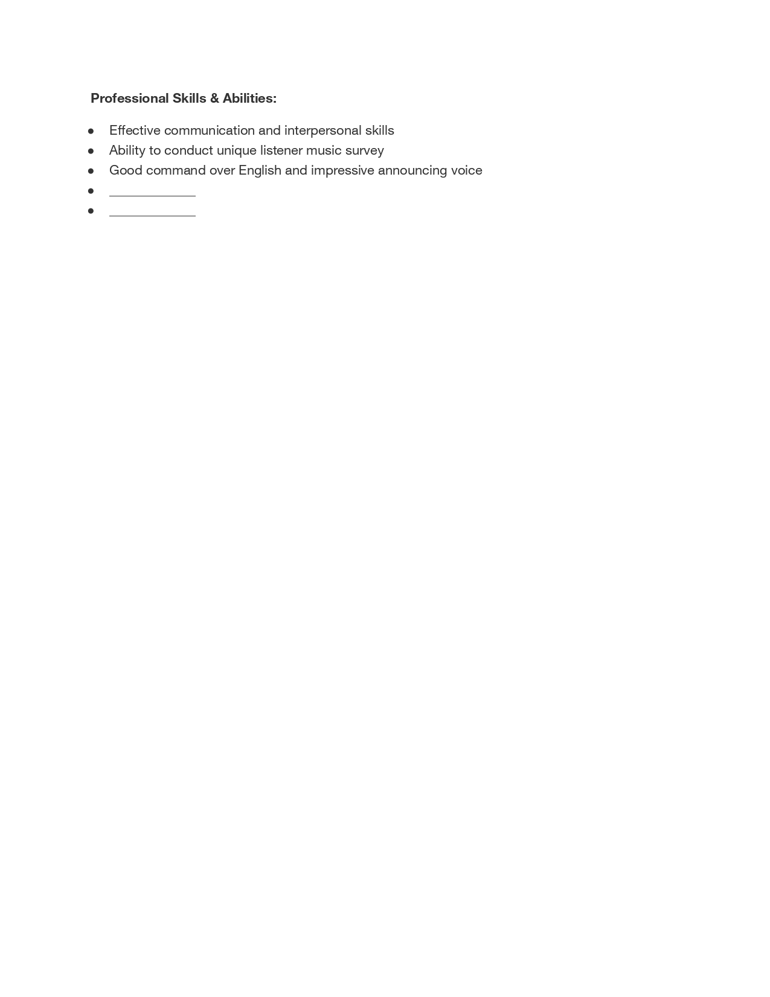
Professional Skills & Abilities:
Effective communication and interpersonal skills Ability to conduct unique listener music survey Good command over English and impressive announcing voice

