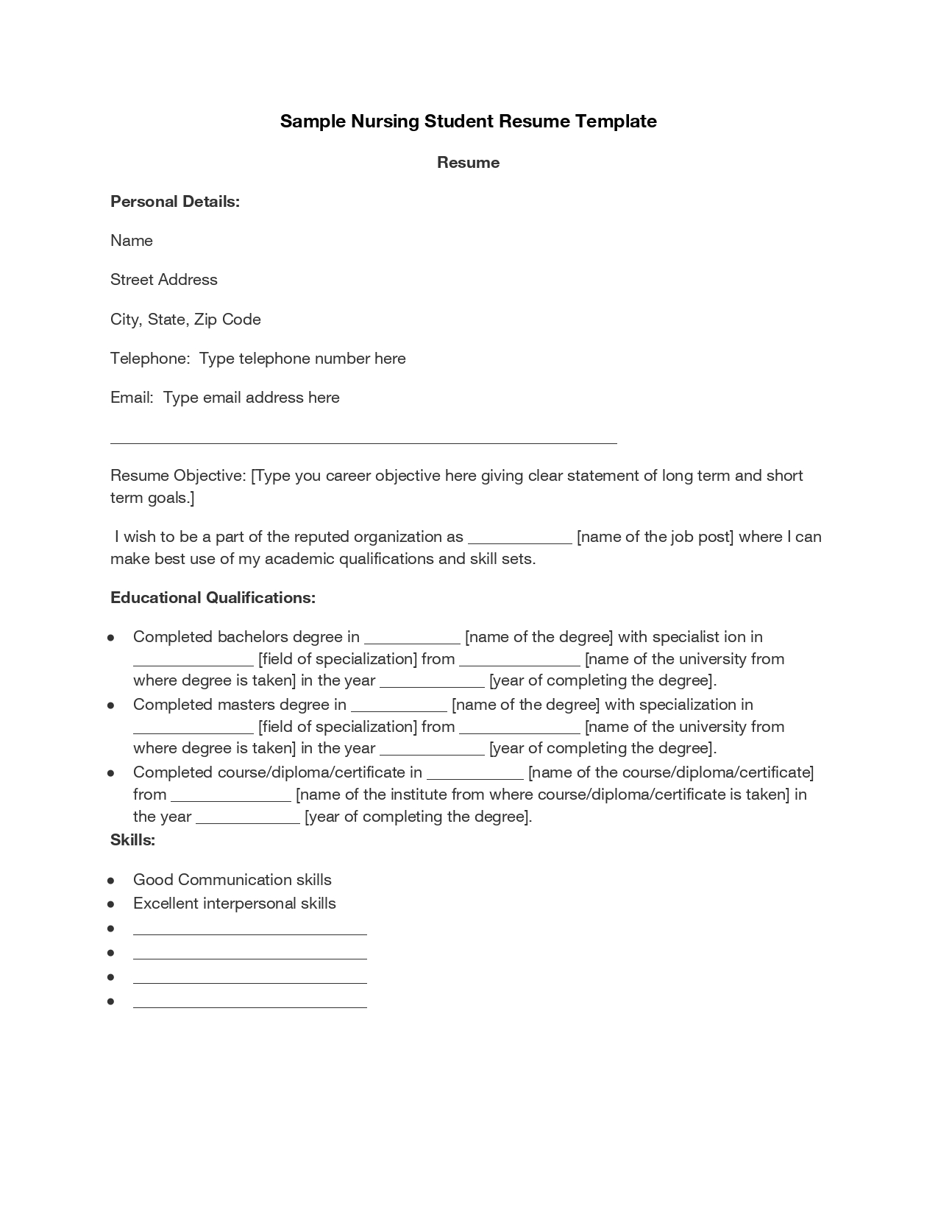
Sample Nursing Student Resume Template
Resume
Personal Details:
Name
Street Address
City, State, Zip Code
Telephone: Type telephone number here
Email: Type email address here
Resume Objective: [Type you career objective here giving clear statement of long term and short term goals.]
- [name of the job post] where I can
I wish to be a part of the reputed organization as make best use of my academic qualifications and skill sets.
Educational Qualifications:
Completed bachelors degree in
[name of the degree) with specialist ion in [field of specialization] from
__[name of the university from where degree is taken] in the year
_ [year of completing the degree). Completed masters degree in
[name of the degree) with specialization in [field of specialization) from
[name of the university from where degree is taken] in the year
[year of completing the degree). Completed course/diploma/certificate in
[name of the course/diploma/certificate] from
[name of the institute from where course/diploma/certificate is taken) in the year
[year of completing the degree). Skills:
Good Communication skills Excellent interpersonal skills
•

