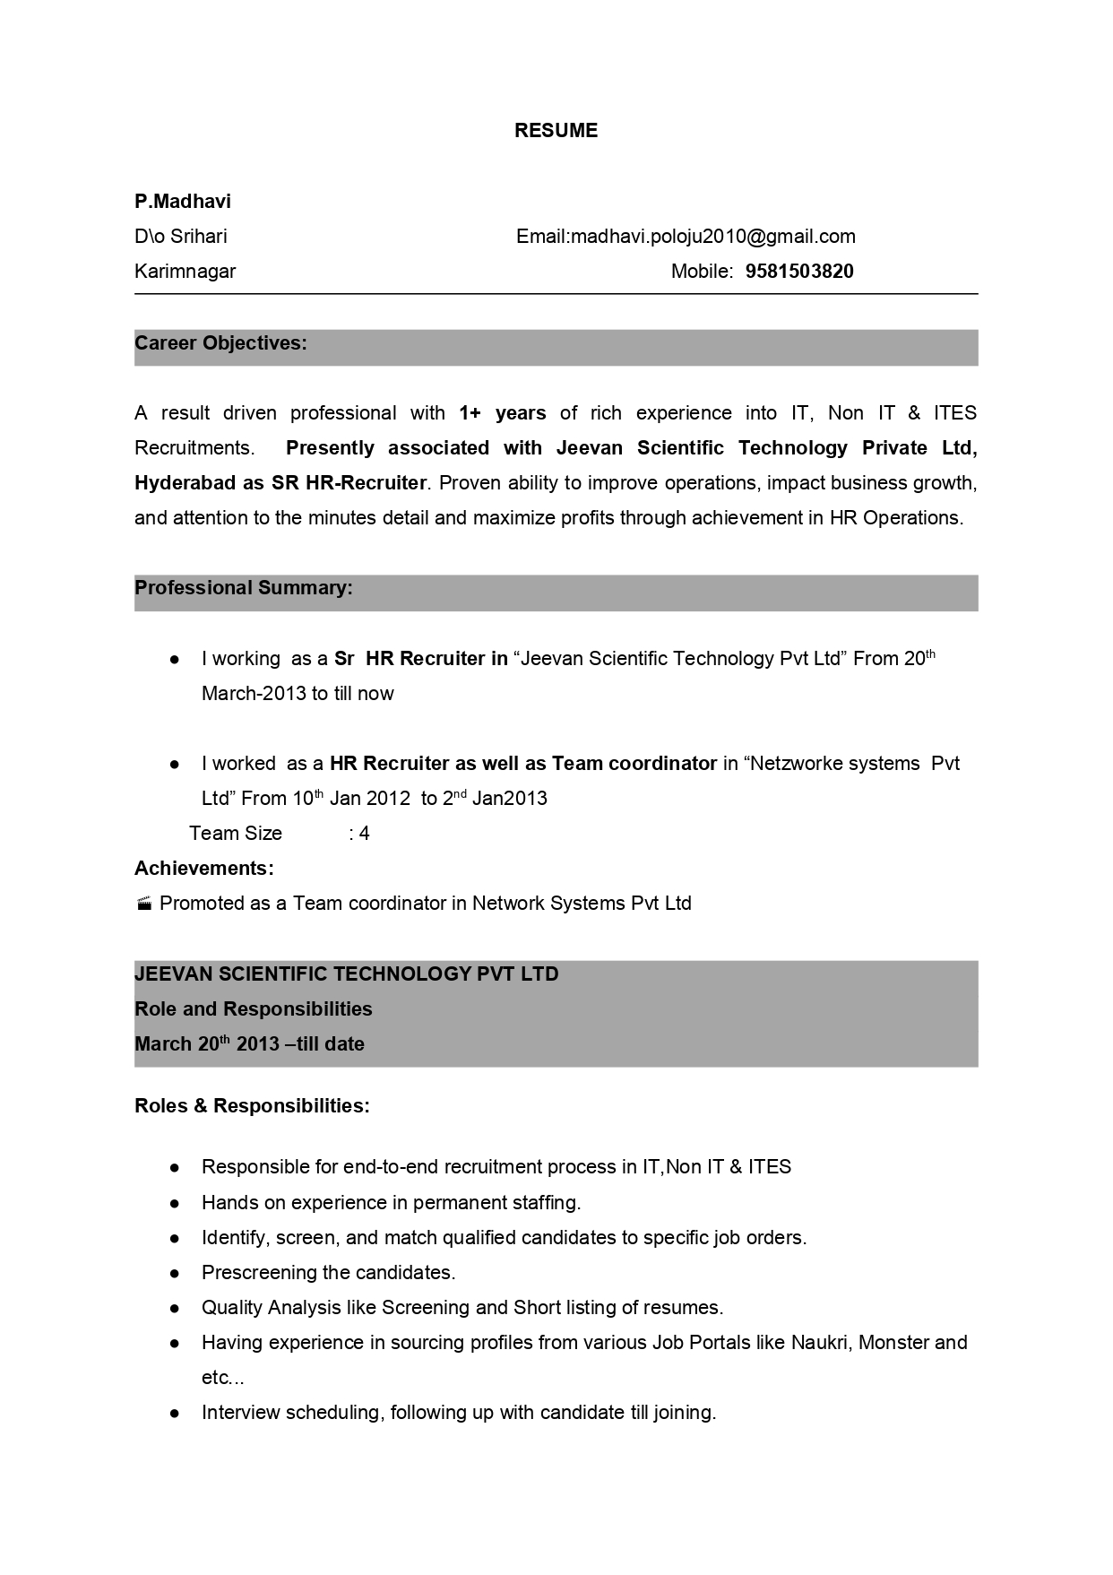
RESUME
P.Madhavi
Dlo Srihari
Email:madhavi.poloju2010@gmail.com
Mobile: 9581503820
Karimnagar
Career Objectives:
A result driven professional with 1+ years of rich experience into IT, Non IT & ITES Recruitments. Presently associated with Jeevan Scientific Technology Private Ltd, Hyderabad as SR HR-Recruiter. Proven ability to improve operations, impact business growth, and attention to the minutes detail and maximize profits through achievement in HR Operations.
Professional Summary:
I working as a Sr HR Recruiter in "Jeevan Scientific Technology Pvt Ltd” From 20th March-2013 to till now
• I worked as a HR Recruiter as well as Team coordinator in "Netzworke systems Pvt
Ltd” From 10th Jan 2012 to 2nd Jan2013
Team Size :4 Achievements: - Promoted as a Team coordinator in Network Systems Pvt Ltd
JEEVAN SCIENTIFIC TECHNOLOGY PVT LTD
Role and Responsibilities March 20th 2013 -till date
Roles & Responsibilities:
Responsible for end-to-end recruitment process in IT,Non IT & ITES
Hands on experience in permanent staffing. Identify, screen, and match qualified candidates to specific job orders. Prescreening the candidates. Quality Analysis like Screening and Short listing of resumes. Having experience in sourcing profiles from various Job Portals like Naukri, Monster and etc... Interview scheduling, following up with candidate till joining.

