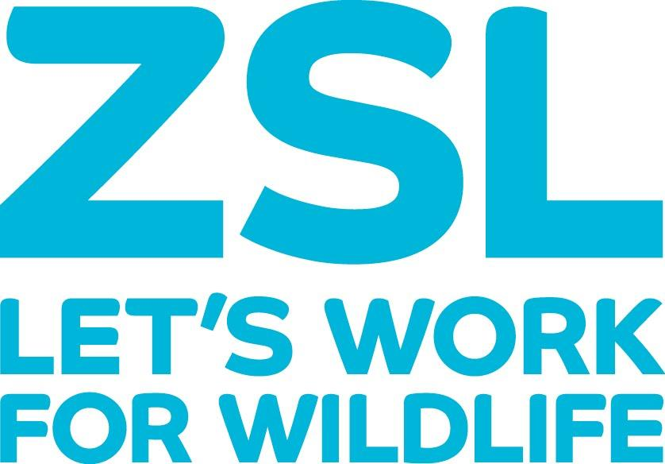

Job Description

Job Title: Senior Animal Keeper

Section: Mammal’s (North/South)

Department: Animal Department

Directorate: Zoological

Responsible to:

Current job holder:

Approved by:

Head of Department/ Director:

Job Evaluation Committee Reference Number:

Grade Allocated:

Date Allocated:

Key Purpose of the Job

The main purpose of the qualified keeper position is to manage the day to day operational duties relating to animal husbandry and visitor interaction within the section. This is directed day to day by the section Team Leader or other key, senior animal management staff within the section.

Main Duties and Responsibilities

- Observing the behaviour, health and security of animals and reporting any problems to the Team Leader or Senior staff
- Ensuring that conditions for animals are suitable and reporting any problems, including defects or repairs required to enclosures the senior managers on section and relevant departments required to support work needed.
- Assisting with the preparation of approved diets and carrying out the correct feeding procedures.
- Cleaning and maintaining exhibits and other designated areas
- Ensuring that safety and emergency procedures are followed at all times.
- Assisting with the movement and/or training of animals.
- Supporting in the training and mentoring of less experienced staff.
- Maintaining courteous and helpful relations with visitors and media.
- Supporting broader ZSL lead events such as late evening s and specialist functions

Expectations of job holder

- To ensure that the policy for equality of opportunity is adhered to and promoted in all aspects of the post holder’s work.
- To ensure effective quality control and continuous improvement in all aspects of the work and responsibilities attached to this post.
- Demonstrate professionalism towards sensitive and confidential information.
- To comply with and promote Health and Safety policies and procedures and to undertake recommended Health and Safety training as and when necessary.
- To be committed to professional self-development, through participation in specific training opportunities aimed at supporting and developing the post
- To undertake such other duties as are commensurate with the grade of the post.
- In consultation with the Team Leader the job holder plans his/her own work and may plan the work of others. Most decisions are made using the job holder’s personal experience but discussions with the Team Leader usually take place before a decision is made. There are general guidelines for the job.
- Most problems relate to animal care or staff. Some are resolved independently often after investigation. Less frequent, more complex, problems are referred to the Team Leader and/or Zoological Manager. Some involvement in exhibit planning.
- A flexible approach is required in order to support the broader zoological collection as well as the post holder’s specific section. Animal work frequently requires individuals to work outside of normal working hours if for example specific levels of care are required. During other events, keeper staff are likely to be required to help out other sections or be present for events managed by other departments (Evening functions, animal talks etc)
- Working with animals requires detailed levels of concentration on both noting animal behaviour and changes to behaviour, as well as security and health and safety elements required to manage Category 1 species. This will include the locking up and checking of locks for category 1 animals or restraint and control of animals for movement or veterinary procedures.
- An ability to work as part of a team, to communicate clearly, effectively and fairly to colleagues.
- Effective communication across all levels of the society. An ability to engage with junior staff as well as senior colleagues across all departments.
- Capable of supporting and mentoring less experienced team members and volunteers in order to develop them within their specific roles. Beyond this, senior keepers should be looking to assist with the continual development of junior staff to enable them to progress within their careers.
- A willingness and ability to present work to various peer groups both externally and internally to the organisation.
- A supportive and engaging approach to visitors.
- A presentable appearance through following uniform and clothing policy.

NB: This job description is designed to outline a range of main duties that may be encountered. It is not designed to be an exhaustive list of tasks and can be varied in consultation with the post holder in order to reflect changes in the job or the organisation.

Person Specification

Qualifications & Experience

- Specific vocational and technical skills pertaining to the husbandry and management of the managed species.
- DMZAA qualification or suitable, recognised equivalent.
- Experience of visitor interactions in an organisation. An understanding of how to engage and support visitors to the collection.
- Be able to mentor, train and enthuse junior members of a team. Instruct and oversee best practice within the section. To support the Team Leader and Deputy Team Leader in ensuring agreed standards of work are met.
- To be able to effectively and respectfully communicate to staff of all levels regardless of their position.
- Maintain high standards of hygiene, equipment care and house-keeping as routine part of daily duties.
- Familiarity with other ZSL departments and an ability to contact key people in emergencies e.g. duty electrician out of hours.
- Effective supervision of volunteers and students providing clear tasks, adequate supervision and a relevant experience.
- Ability to manage and prioritise a diverse workload.

Knowledge

- Familiarity and compliance with all Health and Safety protocols and documentation. This includes emergency procedures, risk assessment and safe working practices. Ability to instruct others in the above and monitor compliance.
- Broad taxonomic knowledge on a range of species managed within zoological collections.
- Understanding of evolving husbandry management within zoological collections to include positive re-enforcement training for behavioural management and varied methods of enrichment for a range of species.
- Knowledge of life support systems, temperature ranges and UV requirements for specific species.
- Knowledge of restraint techniques for specific animals should catch ups or veterinary procedures require this.
- Produce written documentation such as Health and safety information, including Risk Assessments, dietary records and any other relevant material.
- Ability to research a specialist topic using library and internet resources effectively and apply findings to practical operation.
- Effectively input relevant date onto the Daily Report Sheet and zoological Recording programs such as ZIMS.
- Competency in Microsoft Office packages.

Skills & Abilities

- Familiarity with the operation, maintenance and trouble-shooting of all equipment in regular use.
- Excellent observational skills and the ability to identify animal health problems quickly.
- An ability to carry out agreed veterinary treatments accurately as determined by vet team/team leader/curator. Good record keeping and follow up observations on treatments and conditions.
- Demonstrate a thorough and evolving knowledge of husbandry, exhibition, diet and reproduction.
- Have a wider knowledge of specific animal groups, outside of the immediate collection. Have a working knowledge of behavioural enrichment and conditioning and training programs.
- Demonstrate a knowledge of the role of modern zoo’s in terms of conservation and education.
- A clear awareness and understanding of the conservation issues relating to species within the zoological collection and conservation on the whole.
- Public Relations - An ability to interact with stakeholders and represent ZSL where required, to include VIP and media based situations.
- Presentation Skills – An ability and willingness to present papers, research or Society based material at conferences, or select groups.
- An understanding and supportive approach to the commercial nature of the Zoological collection whilst maintaining the highest standards of husbandry and welfare to the living collection.
- An understanding and support of ZSL’s sustainability program. Overseeing and implementing best practice in terms of sustainability within the department.

Other Requirements

- Flexible approach in terms of working hours and an awareness that the post requires weekend working.
- Ability to travel and attend conferences or other zoo’s as the position requires, in order to share knowledge, beneficial to the collection
- An ability to present work in a conference or lecture based environment would be an advantage.

