Research proposal for the degree of
Doctor of Philosophy (PhD) in Management
at the University of Stellenbosch

Table of contents
List of tables iv
List of figures v
List of acronyms and abbreviations vi
1. INTRODUCTION 1
2. OVERVIEW OR BACKGROUND 1
3. RESEARCH FOCUS 1
3.1 RESEARCH PROBLEM 2
3.2 RESEARCH QUESTION 2
3.3 RESEARCH AIM 2
4. RESEARCH METHODOLOGY 2
4.1 QUALITATIVE RESEARCH 3
4.2 QUANTITATIVE RESEARCH 3
4.3 DATA COLLECTION 3
4.4 DATA ANALYSIS 3
5. MERIT OF THE RESEARCH AND PROPOSED CONTRIBUTION TO SCIENCE 3
6. LITERATURE REVIEW 4
7. RESEARCH PROTOCOL 4
8. REFERENCES 4
APPENDIX A TECHNICAL SPECIFICATIONS 5
A.1 INTRODUCTION 5
A.2 PAGE LAYOUT 5
A.3 HEADINGS AND LISTS 5
A.3.1 Headings 5
A.3.1.1 Numbering of headings 6
A.3.1.2 Type of headings 6
A.3.2 Lists 6
A.4 FORMATTING OF TABLES AND FIGURES 7
A.4.1 Tables 7
A.4.2 Figures 8
A.4.3 Numbering of tables and figures 9
A.5 FORMULAS 10
APPENDIX B USB STYLE SHEETS 11
APPENDIX C REFERENCES 13
C.1 INTRODUCTION 13
C.2 EXAMPLES OF REFERENCES TO BOOKS 14
C.3 EXAMPLES OF REFERENCES TO JOURNALS, NEWSPAPERS, ETC. 14
C.4 EXAMPLES OF REFERENCES TO PAPERS AND SPEECHES AT CONFERENCES 15
C.5 EXAMPLES OF REFERENCES TO THESES AND DISSERTATIONS 15
C.6 REFERENCES TO RESEARCH REPORTS 15
C.7 EXAMPLES OF REFERENCES TO MORE THAN ONE PUBLICATION WITH THE SAME AUTHOR(S) OR TITLE IN THE SAME YEAR 16
C.8 EXAMPLES OF REFERENCES TO SOURCES CONSISTING OF CONTRIBUTIONS BY VARIOUS AUTHORS EDITED BY AN EDITOR 16
C.9 EXAMPLES OF REFERENCES TO PERSONAL AND TELEPHONE INTERVIEWS 16
C.10 EXAMPLES OF REFERENCES TO GOVERNMENT PUBLICATIONS 16
C.11 EXAMPLES OF REFERENCES TO INFORMATION DOCUMENTS OF ORGANISATIONS 16
C.12 ELECTRONIC SOURCES 17

List of tables
Table A.1: Definitions of concepts 8
Table A.2: Numbering of tables 9
Table A.3: Tables containing percentages 9
Table B.1: USB research proposal style sheets 12

List of figures
Figure A.1: Technical layout of a dissertation 8
Figure B.1: Styles in this template 11

List of acronyms and abbreviations
A total assets
CD-ROM compact disk with read-only memory
E total equity
FTP file transfer protocol
IT information technology
JSE Johannesburg Stock Exchange
L total leverage
PhD Doctor of Philosophy
USB University of Stellenbosch Business School
WWW world-wide web or internet

- INTRODUCTION
In our experience, many students experience difficulties with the formatting of their research proposals. Although some of the editors listed by the University of Stellenbosch Business School (USB) can do technical editing for you, it will save you time and money if your document is in the correct format from the beginning. This template is designed to assist you in writing a research proposal in the correct technical format as required by the USB. This template should serve as a starting point for any student writing a research proposal. The headings and styles give an indication of the sections required in the research proposal.
The initial research proposal should be typed, using double-line spacing, and be between 2 000 and 3 000 words in length. Refer to the information supplied in Appendix A and Appendix B and style sheets used in this template.
You need to save this template under a personalised file name and start by providing a preliminary title on the cover page. This preliminary title should clearly convey the key words associated with the proposed research. It is the responsibility of the applicant, not of the University of Stellenbosch Business School (USB) or provisional promoter, to find a suitable topic.
- OVERVIEW OR BACKGROUND
Give an overview of the subject area. By way of introduction, this reading section of the existing literature should take the form of an abstract of the general subject or study area and identify the discipline(s) within which it falls. From this analysis the problem or disorder you wish to research will emerge and constitutes the reason or condition which necessitates the research.
You should also indicate here the way in which your background gives you competencies in the chosen area.
- RESEARCH FOCUS
This is where you explain the research problem, question and aim. If you use subheadings, this is the way to format them.
3.1 RESEARCH PROBLEM
From the overview of the subject area follows the research problem, i.e. you have to identify the possible cause(s) of the disorder. This section states the problem that you are exploring.
3.2 RESEARCH QUESTION
The research question is specific, concise, and clear. The research question can be expanded upon by stating sub-questions.
Note: The difference between the research problem and research question is that the problem is broader, while the research question represents the “one question that you will answer at the end of your dissertation”.
3.3 RESEARCH AIM
Next, you have to describe the research aim as it relates to solving the uncertainty or burning question you are interested in. It should explicitly hint towards the contribution you want to make with the intended study. You will in a later section (Section 5) elaborate on the scientific contribution made.
- RESEARCH METHODOLOGY
Outline the methodology to be used. In its most widely-used description, research methodology relates to the nature of the scientific method used.
You need to display an awareness of the available methodologies for data collection and show a clear understanding of the methodologies that would be most suitable for your research. It may be that qualitative methods are appropriate, e.g. case studies and group discussions. Alternatively, your research may involve quantitative aspects relating to statistics and finance. In many instances you will be combining methodologies.
You are expected to outline the design you consider to be most appropriate, i.e. how the research would be conducted. Typically, reference is made here to the type of data you will need, the nature of data collection (questionnaire development, sampling, type of survey, etc.), processing and interpretation.
4.1 QUALITATIVE RESEARCH

4.2 QUANTITATIVE RESEARCH

You need to select the appropriate proposed methodology. Since most studies are multi-disciplinary, they employ a combination of qualitative and quantitative research methodologies, which is called a hybrid approach.
4.3 DATA COLLECTION
Describe the data collection methods you will use.
4.4 DATA ANALYSIS
Describe your proposed data analysis approach and techniques.
- MERIT OF THE RESEARCH AND PROPOSED CONTRIBUTION TO SCIENCE
A convincing statement is required as to why your topic merits scientific research, i.e. how it will contribute to and enrich the academic knowledge and understanding of management theory and professional management practice. This contribution results from the systematic investigation of your research activities, which are conducted to discover new information, as well as to expand and verify existing knowledge.
This contribution does not simply imply the gathering of new data and a description thereof, i.e. the What? questions. There are many things we do not know and that we could find out. This is data-gathering. The contribution to be made by doctoral research goes beyond this and requires the So what? questions, i.e. explanations, relationships, generalisations and theories.
We refer you to a working paper by Dr John Morrison, entitled A contribution to scientific knowledge, which we highly recommend to PhD registrants. (Find the link to this downloadable document at www.usb.ac.za/phd.)
- LITERATURE REVIEW
In this section you should demonstrate that you are au fait with the debates and issues raised in related literature. You should furnish a description of recent academic and empirical research in your chosen area.
References to key texts and recently published articles should be made to convince that you appreciate their integrative relevance to your research area. A PhD is original research and you should be able to demonstrate that your proposed area has not been studied before. As such, you need to identify how your own research might make a useful contribution to the particular management-related area.
- RESEARCH PROTOCOL
You need to include a preliminary time and work schedule outlining the main phases in your research project. This is referred to as the research protocol.
- REFERENCES
A full list of references to key texts and articles must be included. Appendix C has examples of how referencing should be done.
The USB’s website has comprehensive details on the PhD programme. The brochure can be downloaded at http://www.usb.ac.za/Degrees/Phd/Default.aspx
The most important thing regarding references is that you should start recording all details of your references from the first day you start your research. It is impossible to try and find details, such as page numbers and volume numbers, when you compile your final reference list months later. Rather keep more details than you think you will need.

APPENDIX A
TECHNICAL SPECIFICATIONS
A.1 INTRODUCTION
This is how an appendix is given. Whenever it is referred to in the main body of the proposal or dissertation, it is referred to as Appendix A.
If you have any figures or tables here, number the according to the appendix, e.g. Figure A.1 would be the first figure in Appendix A.
A.2 PAGE LAYOUT
The general page layout of your research proposal should be an A4-size page with 20 mm margins on all sides. This means that the text width is 17 cm. Arial is the preferred font. The title and chapter headings are in 14 point Arial Bold. The other headings and body text are in 11 point Arial.
A.3 HEADINGS AND LISTS
New headings or lists should not start at the bottom of a page with less than two lines. Rather insert a page break and start the heading on a new page. In general, the best way to force a page break is to press [control-enter] or click Insert Page Break.
A.3.1 Headings
Note that headings like the one above should be in upper case. Leave no space under the heading, as the formatting already provides for a space. Use the format painter tool () to paint parts of texts in the same way. Note that you should refrain from using too many capitals in a heading. Rather write ‘Demographic profile of respondents’ and not ‘Demographic Profile of Respondents’.
A.3.1.1 Numbering of headings
The numbering of headings in this document was done manually, rather than using the ‘auto-numbering’ function. This was done due to the problems that students often experience with this tool.
A.3.1.2 Type of headings
The above is an example of a Heading 4 in the document. The USB guidelines limit you to four numbers in the heading.
The headings in this document are formatted in accordance with the USB guidelines. Use the tool to paint headings of the same level or select the same type of heading from the list of Styles.
Here are the names of the headings:
- USB PHD PROPOSAL HEADING 1 (left aligned, bold, upper case 1. heading);
- USB PHD PROPOSAL HEADING 2 (left aligned, bold, upper case 1.1 heading);
- USB PhD proposal heading 3 (left aligned, bold, upper and lower case 1.1.1 heading); and
- USB PhD proposal heading 4 (left aligned, bold, italic, upper and lower case, 1.1.1.1 heading).
A.3.2 Lists
The list above was formatted using the ‘USB Bullet’ style. There is also a ‘Bullet last’ style. This style has a slightly bigger space below the bullet. Note that the Bullet style is used where a list of a few items is given as above and where each bullet is only a few words or a line long. All bullets should start with a capital letter and end with a semi-colon or a full-stop.
For longer lists especially those referred to as a numbered list, use the style called ‘USB list to follow’ for this line and then the following style called ‘USB i ii iii’ for the numbered items:
- This is the first item.
- This is the second item.
- This is the third item.
A.4 FORMATTING OF TABLES AND FIGURES
A.4.1 Tables
Table 2.1 is an example of what a table should look like in a USB document. Tables should be centred and preferably 17 cm wide, as your text width is also 17 cm. Also, note that there is a style designed specifically for text in tables. You may choose to centre some text in tables, but start out with USB Table text and then change the alignment ‘manually’. The table text is slightly smaller at 10 point Arial and has some ‘breathing space’ of three points around it. Each column should have a heading in bold. The headings on the left-hand side should be left aligned. The other headings/columns can be either left aligned or centred depending on their content. If the column contains text, as in Table 2.1, it will be left aligned. If numerical data is given, the heading will be centred and the numbers within the column will be right aligned with the decimal points lining up. Refer example Table 2.2. Also, show only a relevant number of decimal places (not 534.785623, but 534.8 – if you show a large number of decimal places you infer accuracy!). Be consistent and stay with one or two decimal places throughout.
Where the information is too little to put into a table that is 17 cm wide, make the table 8 cm wide or whatever works for the information, but try to be consistent in the sizes so that your report has only one or two sizes and all the tables or figures are not different sizes.
Tables are always blocked. Figures also seem neater when blocked. Consistency is key.
Note that the reference should include a page number as you are referring to a table on a specific page in the source. The style used for the reference is called USB Table and figure source. This is always centred so that it works with any size table or figure.
Table A.1: Definitions of concepts
Concepts | Definition
Table text | Table text = 10 pt and not justified, but left aligned to avoid text stretching over the width of the table cell
Formatting | Please format all the text in the table (under paragraph formatting as keep to next to avoid the table to split over pages. The last row in the table must pull the source info with it (The heading is already pre-formatted to stick to the table)
Number of lines | If your table runs over two pages, repeat the heading with (continued) in brackets and repeat the headings of the columns
Source: Thompson, Strickland and Gamble, 2007: 20.
A.4.2 Figures
Figures are numbered and the title is given below the figure. When referring to a specific table or figure, write the word with a capital letter, as you would for Figure A.1 below.
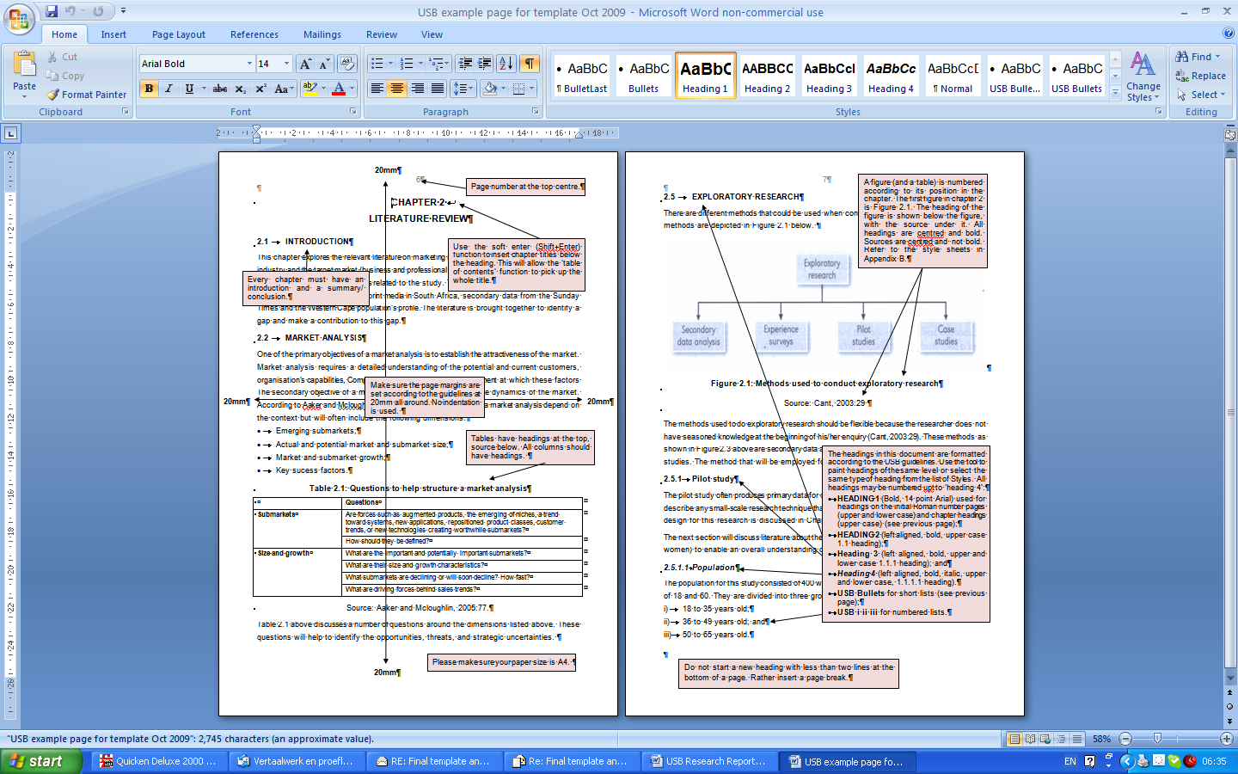
Figure A.1: Technical layout of a dissertation
Source: USB, 2008: 20.
A.4.3 Numbering of tables and figures
The number of a table reflects its position in the document. Table A.2 below, for instance, indicates that this is the second table in Appendix A. This table is 8 cm wide and shows the decimals lining up in the column on the right-hand side which is formatted in USB Table text decimals. The cells were formatted using Paragraph, format Tabs, Decimal so that the decimal points line up automatically.
Note that when you refer to numbers smaller than ten, rather use the words, e.g. “Five respondents indicated ...”. If you refer to larger numbers, you can use 25, 33 and 82. Also note that the USB prefers the use of the words per cent to the use of the % symbol when used in body text. If you refer to numbers in brackets or in figures, the % symbol is acceptable. Refer Table A.3.
Table A.2: Numbering of tables
Month | Sales | Growth
January | 2 488 | 1.45
February | 1 009 | 12.50

Table A.3: Tables containing percentages
Month | 2007 | 2008 | Improvement
June | 14 | 20 | 43%
July | 12 | 27 | 125%
August | 13 | 21 | 62%
September | 15 | 20 | 33%
Total | 54 | 88 | 63%
Source: Thompson, Strickland and Gamble, 2007: 20.
A.5 FORMULAS
Using the balance sheet identity: A = L + E ...(4.1)
Where (A) = total assets, (L) = total leverage and (E) = total equity. It can be demonstrated that growth in (L) or (E) drives growth in (A) and must be financed from one of the two sources.
Note that formulas have to be numbered per section or chapter as well, i.e. this is the first formula used in Section Four. When you refer to it in the text, you would explain Formula 4.1.

APPENDIX B
USB STYLE SHEETS
Most of the formatting of this document was done with ‘styles’ in MS Word. Figure B.1 shows most of the styles as it would appear in Word 2007, the software used by the USB. (You can obtain a copy of the software at a discount from the USB information technology (IT) support team.) We will refer to some of these styles throughout the document. For instance, the text you are reading is formatted as ‘normal’, while the heading below Figure B.1 is formatted as ‘USB Figure heading’. The body of the report is typed in ‘normal’ which is justified Arial 11 point with a built-in space after each paragraph. Refer Table B.1 a complete list of styles to be used.
If you only obtain this template after you have typed your document, the template can be used to format paint the text into the correct styles of formatting using this tool:
Use the styles to format text in the correct format. This will make you life a great deal easier and assure that you comply with the USB technical specifications.
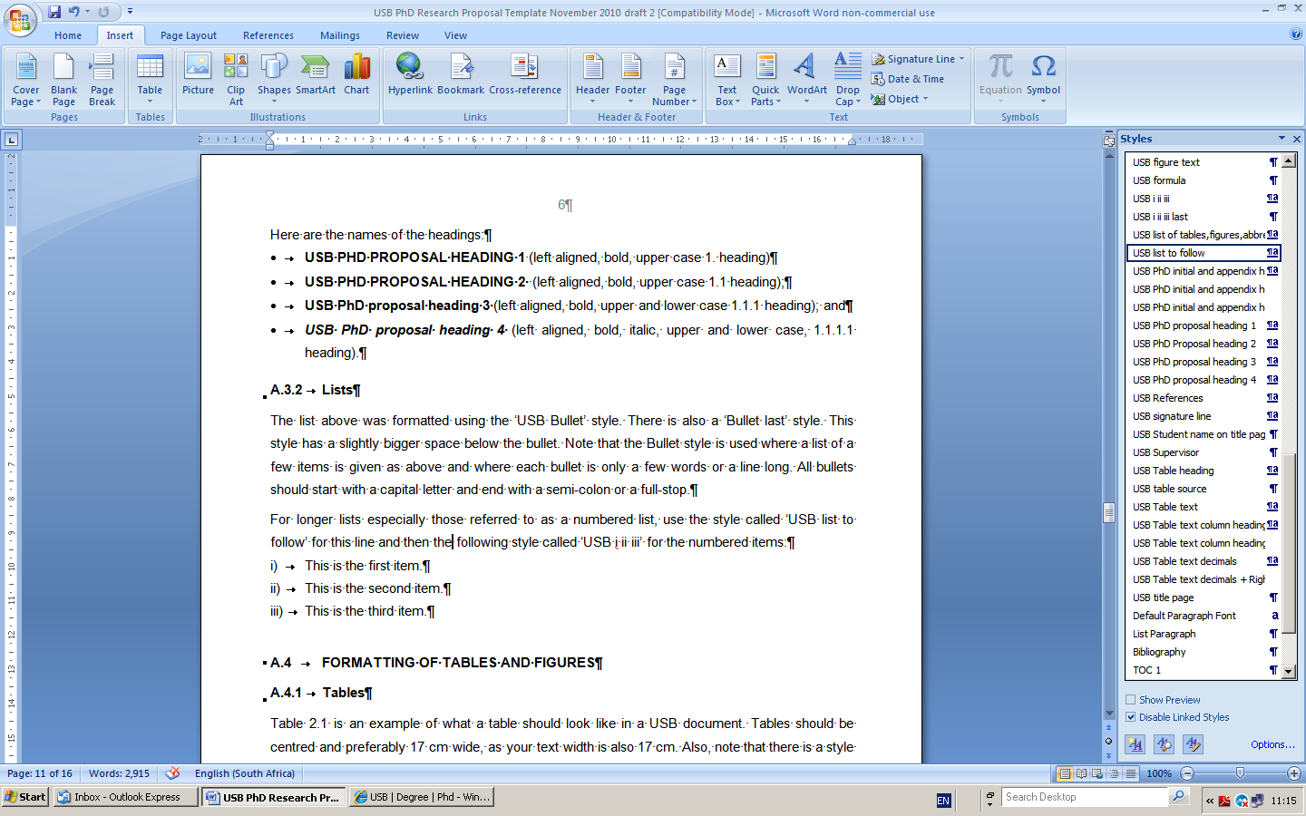
Figure B.1: Styles in this template
Table B.1: USB research proposal style sheets
Name of style sheet | Where the style sheet should be used
Normal | Body text in 11pt Arial, 1.5 spacing, 6 pt after paragraph
Title | Centred title in upper and lower case on first page in 16pt Arial
USB Bullets | Bulleted lists with indent of 1cm
USB Bullet last | Last bullet of list with space after
USB Figure heading | Heading of a figure, centred below
USB Figure itself | Figure in line with text, centred
USB Figure source | Source centred below a figure
USB Figure text | Single spaced paragraph in 10 point Arial used in figures
USB Formula | Formula with number right aligned in brackets
USB i ii iii | Numbered list
USB i ii iii last | Last line of a numbered list with space after
USB list of tables, figures, abbreviations | List of tables, figures, abbreviations
USB list to follow | The last paragraph of body text before a bulleted or numbered list is given. It has no space after so that the list is ‘tied’ to the paragraph preceding it.
USB PhD initial and appendix headings | Centred headings in 14pt Arial with a page break before
USB PhD proposal heading 1 | Left aligned, bold, upper case 1. heading
USB PhD proposal heading 2 | Left aligned, bold, upper case 1.1 heading
USB PhD proposal heading 3 | Left aligned, bold, upper and lower case 1.1.1 heading
USB PhD proposal heading 4 | Left aligned, bold, italic, upper and lower case, 1.1.1.1 heading
USB References | List of sources are left aligned, 16pt spacing with 12pt after
USB Student name on title page | In 12 point Arial, centred
USB Table source | Source centred below a table
USB Table heading | Heading of a table, above centred
USB Table text | Word text within a table in 10pt Arial
USB Table text column heading | Headings of the columns within a table
USB Table text decimals | Numbers within a table with decimal points aligned
USB Title page | Text on title page, centred in 12pt Arial

APPENDIX C
REFERENCES
C.1 INTRODUCTION
The references (from Andersen below) are formatted in 16 pt spacing which is between single and one-and-a-half spacing, with 12 pt space after to define each source. It is left aligned to keep electronic references from stretching too wide across the width of the page. Refer to the style sheet named ‘USB References’. Start with formatting all your resources in this style and then format the words required in italics or bold according to the examples in the guide.
The entire References is arranged alphabetically according to the surname of the first author if this is available (not subdivided in different categories). If the author is unknown, the title of the source is listed alphabetically among the authors of other sources. Although the main body of the dissertation is written in justified text, the References may be left aligned to avoid stretching over the page width, especially where electronic references are given. Refer to the style ‘USB References’.
The aim of the References is to make it easy to trace a source that is referred to. For this purpose all information on the source should be correct. This information includes the authors' names, the year of publication, the title of the source, place of publication and the name of the publisher. When referring to journal articles the title of the article and that of the journal must be supplied, as well as the volume and issue numbers and the first and last page numbers of the article in the journal. The format in which the information should be given is indicated in the examples. If a source is a journal article, the journal's volume number is printed in bold, followed by the issue number in parentheses.
To prevent confusion and to facilitate the tracing of a source, the information on a source is given in the language of the source, provided that it is either in English or Afrikaans. If the source is written in any other language, any description of the source, for example "Unpublished PhD dissertation" is given in the language in which the dissertation itself is written.
Be consistent in the way in which the References is prepared. If only the initials of the authors are given in some cases, do this consistently, and do not give the full names of the authors for other sources. If the ampersand (&) is used between the names of authors, do not replace it elsewhere by ‘and’. Use the abbreviated name of a publisher consistently, for instance Irwin, and not Richard D. Irwin, or even Richard D. Irwin, Inc.
Electronic sources are becoming more and more popular. The reference to electronic sources takes on the following general format:
Surname of author, Initials. Year. Title of work. Title of complete work [Type of medium]. Available: protocol and address Directory: Directory and file particulars Date of message or visit.
Walker. 1996. Electronic Style: A guide to Electronic Information. [Online] Available: http://www.cas.usf.edu/english/walker/mla.html Accessed: 17 October 2009.
Note that it is important that the information regarding protocol, address and directories is not followed by full stops, since the full stop may be an important character. The information is usually given in lower case, but a computer could be sensitive to the difference in lower and upper case. In those cases the correct format must be supplied. It is also possible that not all of the information is available. In that case only the available information is displayed.
C.2 EXAMPLES OF REFERENCES TO BOOKS
Covey, S. 2004. The 8th habit. London: Simon & Schuster.
Pocket world in figures: 2007 edition. 2006. London: Profile Books.
Simpson, J. & Dore, B. 2004. Marketing in South Africa: Cases and concepts. Pretoria: Van Schaik.
Thompson, A.A., Strickland, A.J. & Gamble, J.E. 2007. Crafting and executing strategy: The quest for competitive advantage. 15th edition. New York: McGraw-Hill Irwin.
C.3 EXAMPLES OF REFERENCES TO JOURNALS, NEWSPAPERS, ETC.
- Author(s) known
Caelers, D. 2004. Tik, the mother city’s devastating teen time bomb. Cape Argus, 27 October, 10.
Clark, L. 2004. Do the knowledge. Caterer and Hotelkeeper, 193(4329), 34-35.
Cooper, C., Schindler, J., McCaul, C., Potter, F. & Cullum, M. 1985. Race relations survey. Johannesburg: SAIRR.
Nel, C. 1986. Sanctions threaten millions. Sunday Times, 7 July, 1.
Northedge, R. 1986. Barclays is not off the hook. Sunday Times, 30 November, 34.
Indyk, M. 2009. Obama’s options: How the new president can push for a quick truce in Gaza and a larger Palestinian solution. Time, 19 January, 17.
Robinson, R.B., Pearce, J.A. & Littlejohn, W.F. 1983. The impact of formalized strategic planning on financial performance in small organizations. Strategic Management Journal, 4(3), July-September, 197-207.
- Author(s) unknown
Johannesburg Stock Exchange Handbook. 2006. Johannesburg.
Sunday Times. 2009. New poise and energy needed. Editorial, 11 January, 14.
The Economist. 2009. Plenty more fish in the sea? 390(8612), 3-9 January, 10-11.
SABMiller Sustainability Report. 2009. Cape Town.
- Interview
Sullivan, L. 1986. Quoted in The Star. 17 June, 13.
C.4 EXAMPLES OF REFERENCES TO PAPERS AND SPEECHES AT CONFERENCES
Cromie, S. 1986. Some similarities and differences between men and women who choose business proprietorship as a career. Paper delivered at the International Congress on Women in Organizations, Chicago, 10 August.
C.5 EXAMPLES OF REFERENCES TO THESES AND DISSERTATIONS
Du Plessis D.P. 1984. The incremental information content of AC 201 inflation-adjusted data. Unpublished D.B.A.-dissertation. Bellville: University of Stellenbosch.
C.6 REFERENCES TO RESEARCH REPORTS
Erwee, R. 1987. Profiel van die Suid-Afrikaanse vroue-entrepreneur. Unpublished research report. University of Pretoria, January.
Lomberg, R. & Greig, F. 1984. The fishing industry. Johannesburg: Davis Borkum Hare.
Schneier, S. 1983. Occupational mobility among blacks in South Africa. Working paper no. 58. Cape Town: University of Cape Town, SALDRU.
C.7 EXAMPLES OF REFERENCES TO MORE THAN ONE PUBLICATION WITH THE SAME AUTHOR(S) OR TITLE IN THE SAME YEAR
The Economist. 2009a. Saline solutions. 390(8612), 3-9 January, 17-18.
The Economist. 2009b. The aid workers who really help. 393(8649), 10-16 October, 60.
C.8 EXAMPLES OF REFERENCES TO SOURCES CONSISTING OF CONTRIBUTIONS BY VARIOUS AUTHORS EDITED BY AN EDITOR
Thomas, W. 2008. The developmental state in a social market economy. In Turok, B., (ed.) Wealth doesn’t trickle down: The case for a developmental state in South Africa. Cape Town: New Agenda: South African Journal of Social and Economic Policy (publisher), 223-230.
C.9 EXAMPLES OF REFERENCES TO PERSONAL AND TELEPHONE INTERVIEWS
Booysen, G. 1987. General Manager, Motorcycle Division, Honda. Johannesburg: Personal interview, 4 January.
Nortjé, M. 2010. Language editor. Langebaan: Telephone interview, 22 November.
C.10 EXAMPLES OF REFERENCES TO GOVERNMENT PUBLICATIONS
Republic of South Africa. Companies Act, no. 61 of 1973.
Republic of South Africa. 1982. Forestry guide plan for South Africa. Pretoria: Department of Environmental Affairs, Directorate Forestry.
C.11 EXAMPLES OF REFERENCES TO INFORMATION DOCUMENTS OF ORGANISATIONS
- Author(s) unknown
Energy and Development Research Centre (EDRC). 2007. Clean Energy and Development for South Africa: Results. EDRC, University of Cape Town.
Organisation for Economic Co-operation and Development. 2004. OECD Principles of Corporate Governance, 1-69.
Unifruco. 1988. General circular. Bellville, 27 January.
- Author(s) known
Cross, H.P. 1986. Personnel Manual. Cape Town: ABC Stores.
C.12 ELECTRONIC SOURCES
The use of electronic sources has increased dramatically over the last few years and the following points give some guidelines. Therefore in this rapidly changing environment, it is advisable to request advice from the library services if there is any doubt about how to document an electronic source.
- CD-ROM
Green, P.S. 1989. Fashion colonialism: French export "Marie Claire" makes in-roads [CDROM]. Advertising Age. Abstract from: ABI/INFORM Item: 89-41770.
International Trade Administration. 1992. Hungary - Foreign Labour Trend 1981-92 - FLT9207. Foreign labour trend report: Hungary 1981-1992 [CDROM]. Available: National Trade Data Bank – The Export Connection (R) Program: Market Research Reports
- FTP Site
Bruckman, A. 1994. Approaches to managing deviant behaviour in virtual communities. [Online] Available: ftp.media.mit.edu Directory: pub/asb/papers/deviance-chi94 Accessed: 4 December 2009.
- WWW Site
When referring to websites it is very important to verify the quality of the information referred to. Anybody can start a website and post any idea on that site. That does not make it a good source. Hence the reputation of the author or owner of the website is important in determining the quality of the information. Preferably articles referred to should have an author, and the article should have a date when it was published. If the author cannot be identified nor can a date of publication be identified, it could well be an indication of the lack of quality of the source. If the document referred to does not have a date, the copyright date of the website can be used in lieu of the article date. If the author of the article is not identified, the owner of the website (company or association, for instance “The Economist”) should be identified as the author or owner and referenced accordingly.
Always reference the author and date of publication where possible.
If no date is available for the publication, rather say “no date”...but still show the date you accessed the information in your references (the list at the back).
Examples of referencing in text:
(Smith & Wesson, 2008) where author and date is available.
(Smith & Wesson, no date) where only the author is available, but no date is given. Sometimes you can find a date-stamp at the bottom of the web-page...use it if available.
(The Economist, 2010) Where author is not given, but the owner of the web-page is known. Date is known. As with the date stamp, the owner of the web-page is also often shown at the bottom of the web-page.
(Peak Oil, no date) Where author is not given and no date is available.
A word of caution: You are probably aware that the authority of a source is important. For instance, at the top end you have references out of peer reviewed papers, and at the bottom you have websites such as the one I used in this reference (Peak Oil, a site dedicated to a particular pressure group). Anyone can say anything on the web, so in academic writing you need to take note of how trustworthy the opinion is that you are quoting from.
Examples listed in References:
Engineering News. 2008a. Eskom may revise DSM project evaluation, funding. 16 April. [Online] Available: http://www.engineeringnews.co.za/article/eskom-may-revise-dsm-project-evaluation-funding-2008-04-16 Accessed: 20 June 2009.
Engineering News. 2008b. Eskom suspends new DSM projects – official. 5 May. [Online] [Online] Available: http://www.engineeringnews.co.za/article/eskom-suspends-new-dsm-projects-ndash-official-2008-05-05 Accessed: 20 June 2009.
Eskom. 2005a. DSM Project Approval Process. Eskom Holdings Ltd. Sandton. [Online] Available: www.eskomdsm.co.za/sites/default/ files/u1/DSMPrjApprProcessg.pdf Accessed: 16 April 2009.
Eskom. 2005b. ESCO Evaluation Criteria. Eskom Holdings Ltd. Sandton. [Online] Available: www.eskomdsm.co.za/sites/default/files/u1/ESCO_ EvaluationCriteria1_g.pdf Accessed: 15 June 2008.
Financial Services Board. 2005. FSB almost there with FAIS registrations. 25 October. [Online] Available: http://www.fsb.co.za Accessed: 12 November 2005.
Hope, J. 2006. Using a rolling forecast to spot trends. Harvard Business School Working Knowledge, 13 March. [Online] Available: http://hbswk.hbs.edu/pubitem.jhtml?id=5250&t=finance Accessed: 14 March 2006.
World Energy Council (WEC). 2007. The Energy Industry unveils its blueprint for tackling Climate Change. [Online] Available: www.worldenergy.org/publications/125.asp Accessed: 10 March 2009.

