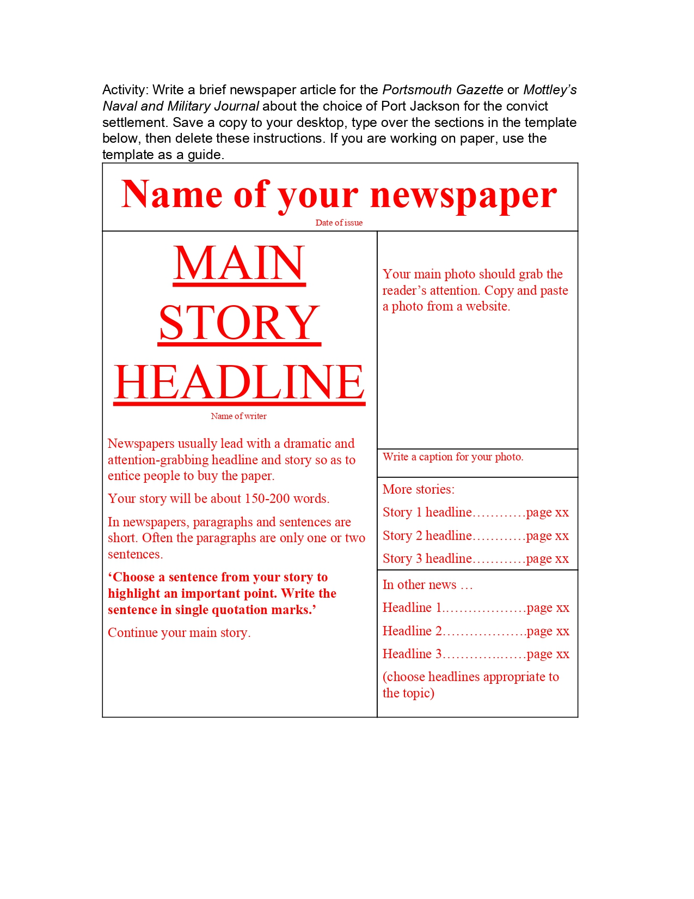
Activity: Write a brief newspaper article for the Portsmouth Gazette or Mottley's Naval and Military Journal about the choice of Port Jackson for the convict settlement. Save a copy to your desktop, type over the sections in the template below, then delete these instructions. If you are working on paper, use the template as a guide.
Date of issue
Name of your newspaper
MAIN STORY HEADLINE
Your main photo should grab the reader's attention. Copy and paste a photo from a website.
Name of writer
Write a caption for your photo.
Newspapers usually lead with a dramatic and attention-grabbing headline and story so as to entice people to buy the paper. Your story will be about 150-200 words.
More stories:
Story 1 headline............page xx
In newspapers, paragraphs and sentences are short. Often the paragraphs are only one or two sentences.
Story 2 headline ..page xx Story 3 headline............page xx
'Choose a sentence from your story to highlight an important point. Write the sentence in single quotation marks.'
Continue your main story.
In other news ... Headline 1. ........page XX Headline 2
..page xx Headline 3.......... ..page xx (choose headlines appropriate to the topic)

