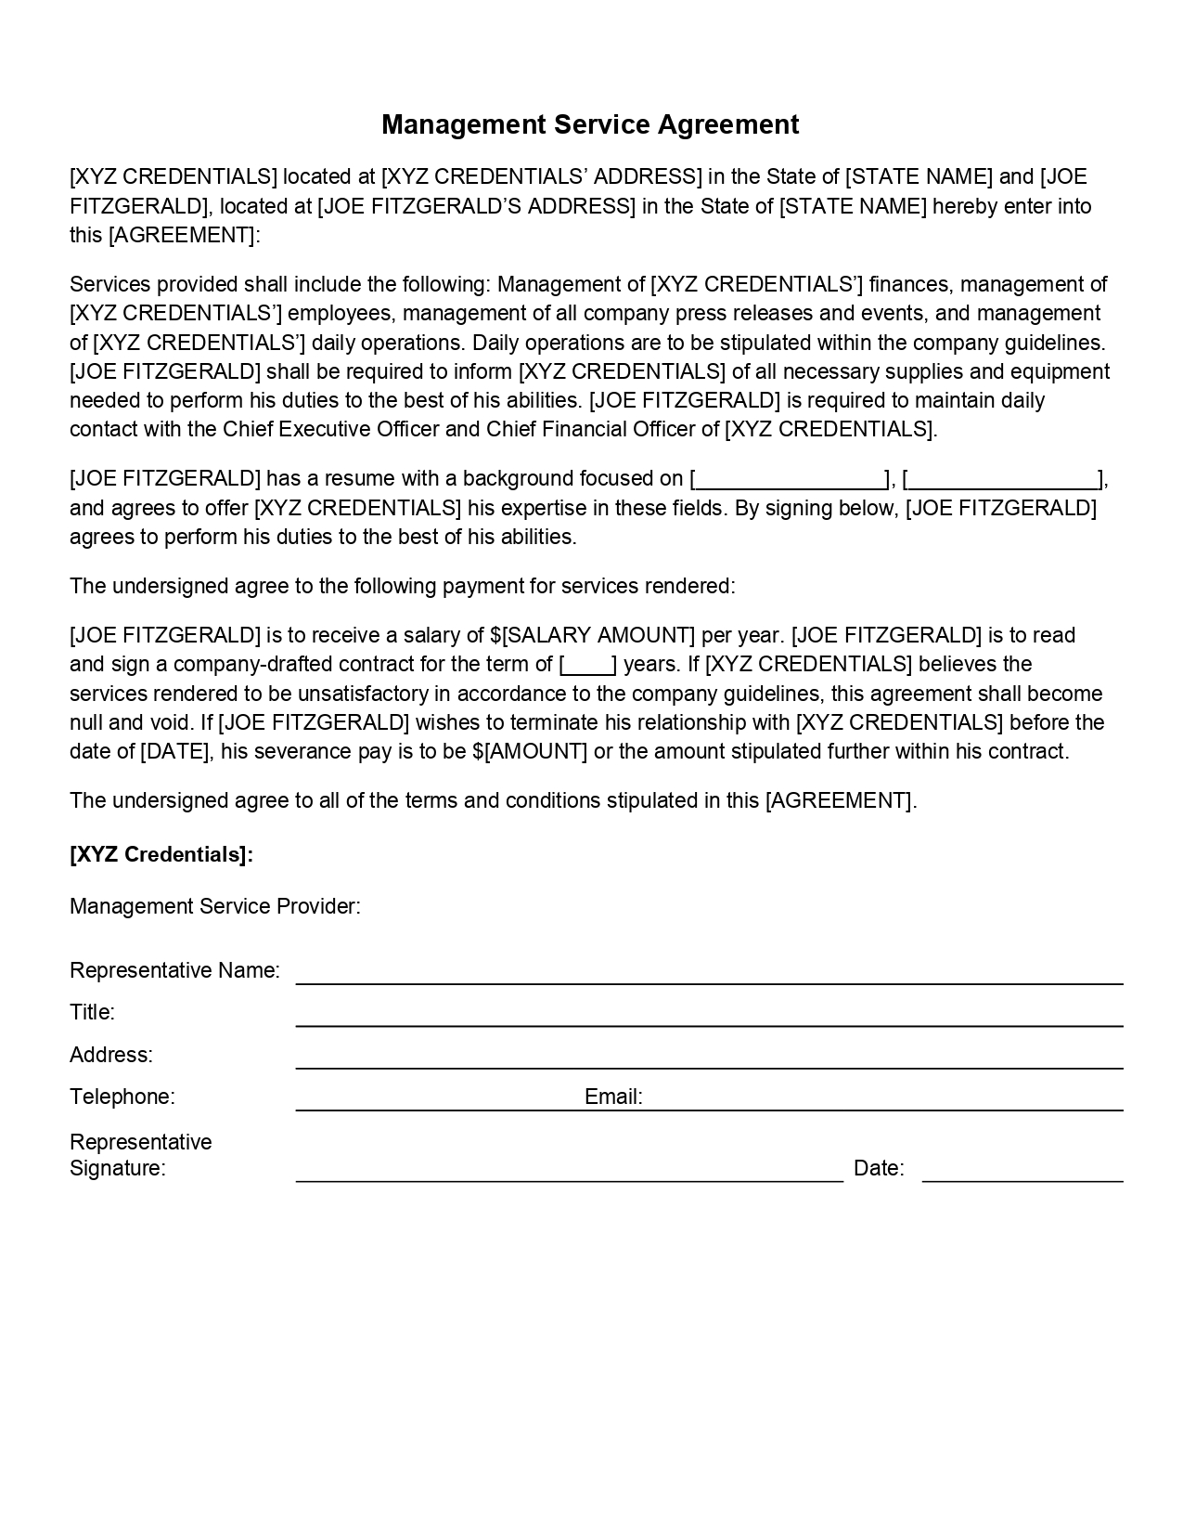
Management Service Agreement
[XYZ CREDENTIALS] located at [XYZ CREDENTIALS' ADDRESS] in the State of [STATE NAME] and [JOE FITZGERALD], located at JOE FITZGERALD'S ADDRESS) in the State of STATE NAME] hereby enter into this [AGREEMENT]:
Services provided shall include the following: Management of [XYZ CREDENTIALS'] finances, management of [XYZ CREDENTIALS'] employees, management of all company press releases and events, and management of [XYZ CREDENTIALS'] daily operations. Daily operations are to be stipulated within the company guidelines. [JOE FITZGERALD] shall be required to inform (XYZ CREDENTIALS] of all necessary supplies and equipment needed to perform his duties to the best of his abilities. (JOE FITZGERALD] is required to maintain daily contact with the Chief Executive Officer and Chief Financial Officer of [XYZ CREDENTIALS].
[JOE FITZGERALD] has a resume with a background focused on L and agrees to offer [XYZ CREDENTIALS] his expertise in these fields. By signing below, (JOE FITZGERALD] agrees to perform his duties to the best of his abilities.
The undersigned agree to the following payment for services rendered:
[JOE FITZGERALD] is to receive a salary of $[SALARY AMOUNT] per year. [JOE FITZGERALD) is to read and sign a company-drafted contract for the term of years. If [XYZ CREDENTIALS] believes the services rendered to be unsatisfactory in accordance to the company guidelines, this agreement shall become null and void. If [JOE FITZGERALD] wishes to terminate his relationship with [XYZ CREDENTIALS] before the date of [DATE], his severance pay is to be $[AMOUNT] or the amount stipulated further within his contract.
The undersigned agree to all of the terms and conditions stipulated in this [AGREEMENT].
[XYZ Credentials]:
Management Service Provider:
Representative Name:
Title:
Address:
Telephone:
Email:
Representative Signature:
Date:

