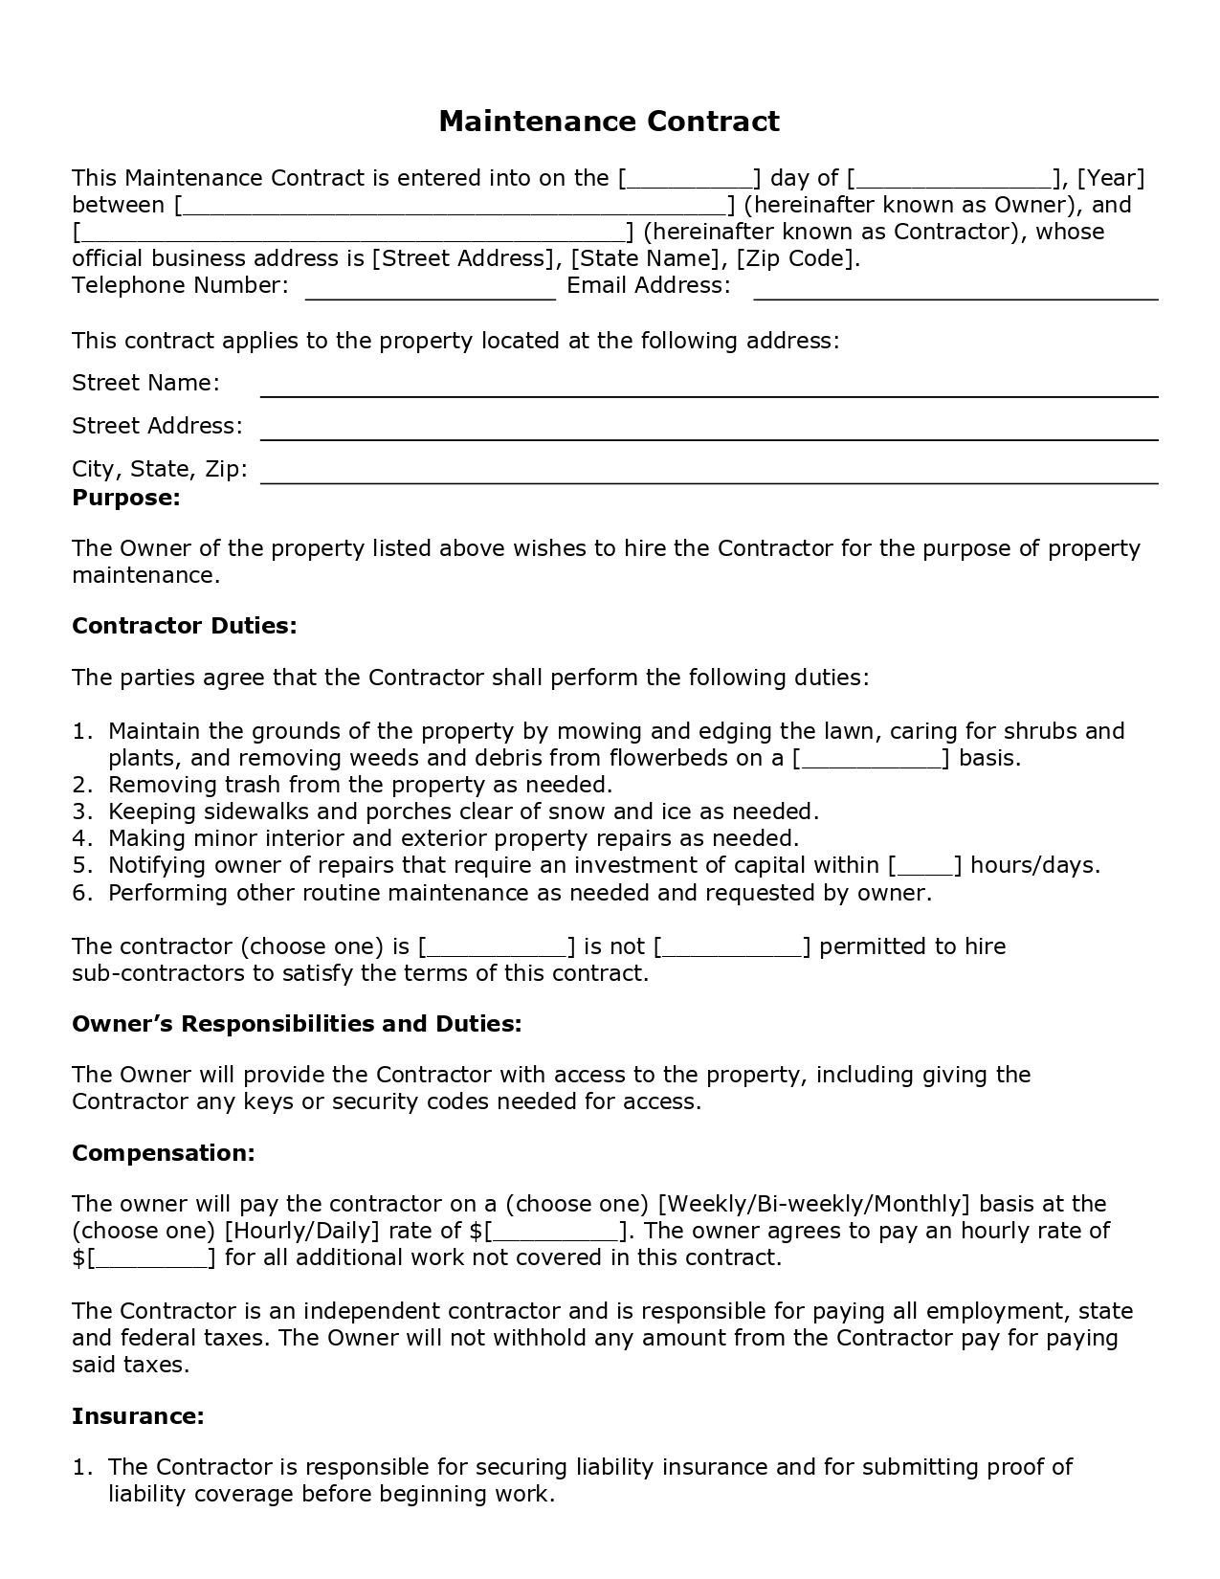
Maintenance Contract
This Maintenance Contract is entered into on the [_
] day of [.
_], [Year] between
L] (hereinafter known as Owner), and
_) (hereinafter known as Contractor), whose official business address is [Street Address], [State Name], [Zip Code]. Telephone Number:
Email Address:
This contract applies to the property located at the following address: Street Name: Street Address: City, State, Zip: Purpose:
The owner of the property listed above wishes to hire the Contractor for the purpose of property maintenance.
Contractor Duties:
The parties agree that the Contractor shall perform the following duties:
1. Maintain the grounds of the property by mowing and edging the lawn, caring for shrubs and plants, and removing weeds and debris from flowerbeds on a [_
] basis. 2. Removing trash from the property as needed. 3. Keeping sidewalks and porches clear of snow and ice as needed. 4. Making minor interior and exterior property repairs as needed. 5. Notifying owner of repairs that require an investment of capital within [. ] hours/days. 6. Performing other routine maintenance as needed and requested by owner.
The contractor (choose one) is [
] is not [. sub-contractors to satisfy the terms of this contract.
_] permitted to hire
Owner's Responsibilities and Duties:
The Owner will provide the Contractor with access to the property, including giving the Contractor any keys or security codes needed for access.
Compensation:
The owner will pay the contractor on a (choose one) [Weekly/Bi-weekly/Monthly] basis at the (choose one) [Hourly/Daily] rate of $[.
]. The owner agrees to pay an hourly rate of $[.
] for all additional work not covered in this contract.
The Contractor is an independent contractor and is responsible for paying all employment, state and federal taxes. The Owner will not withhold any amount from the Contractor pay for paying said taxes.
Insurance:
1. The Contractor is responsible for securing liability insurance and for submitting proof of
liability coverage before beginning work.

