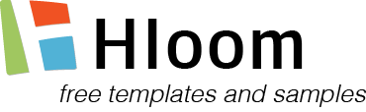 | Hotel Name  123 Park Avenue, Michigan 69789 MI  Phone: 123-456-7899, Fax: 123-123-4567

Credit Card Authorization Form

I, _____________________________________ hereby authorize the use of my credit card as the method of payment to cover the following charges as stated below:

❑ Guest room and taxes for each night.

❑ All charges including guest room, applicable taxes, meals, phone charges, and any other incidental charges for each night.

❑ All banquet room charges including food & beverage charges, where applicable, for each day.

For the reservation of Confirmation Number

Arriving on Number of Nights

Type of Credit Card: ❑ Visa ❑ MasterCard ❑ American Express

- Discover ❑ JCB ❑ Diners Club

Credit Card Number Expiration Date

Name of Cardholder E-mail Address and Phone

Cardholder Signature Date

This Authorization Form is not valid without a photocopy of the front and back of the credit card.

front of the credit card | back of the credit card

