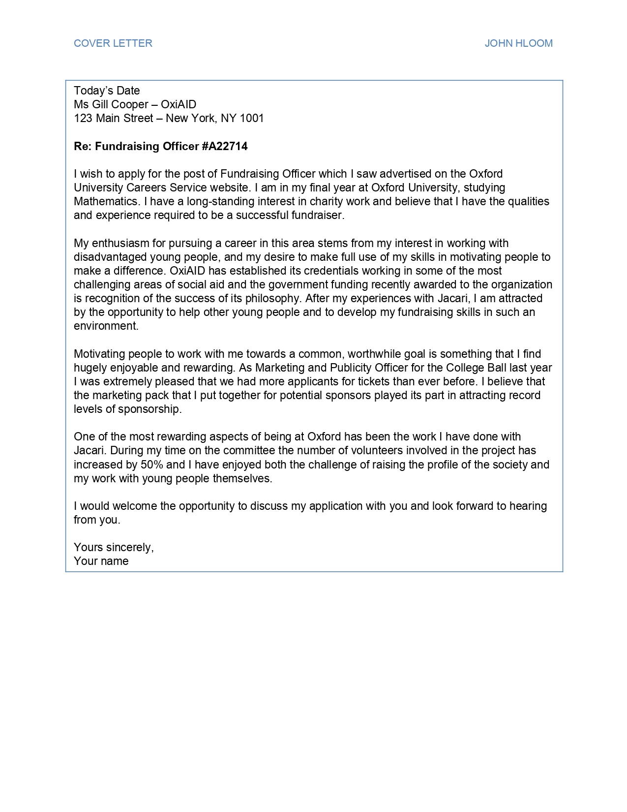
COVER LETTER
JOHN HLOOM
Today's Date Ms Gill Cooper - OxiAID 123 Main Street - New York, NY 1001
Re: Fundraising Officer #A22714
I wish to apply for the post of Fundraising Officer which I saw advertised on the Oxford University Careers Service website. I am in my final year at Oxford University, studying Mathematics. I have a long-standing interest in charity work and believe that I have the qualities and experience required to be a successful fundraiser.
My enthusiasm for pursuing a career in this area stems from my interest in working with disadvantaged young people, and my desire to make full use of my skills in motivating people to make a difference. OxiAID has established its credentials working in some of the most challenging areas of social aid and the government funding recently awarded to the organization is recognition of the success of its philosophy. After my experiences with Jacari, I am attracted by the opportunity to help other young people and to develop my fundraising skills in such an environment.
Motivating people to work with me towards a common, worthwhile goal is something that I find hugely enjoyable and rewarding. As Marketing and Publicity Officer for the College Ball last year I was extremely pleased that we had more applicants for tickets than ever before. I believe that the marketing pack that I put together for potential sponsors played its part in attracting record levels of sponsorship.
One of the most rewarding aspects of being at Oxford has been the work I have done with Jacari. During my time on the committee the number of volunteers involved in the project has increased by 50% and I have enjoyed both the challenge of raising the profile of the society and my work with young people themselves.
I would welcome the opportunity to discuss my application with you and look forward to hearing from you.
Yours sincerely, Your name

