[COMPANY’S NAME]

ACCIDENT
REPORT

[COMPLETE ADDRESS]
[CONTACT NUMBER]
[WEBSITE] / [EMAIL] ADDRESS]

An accident within the company is something that cannot be predicted easily. It is important that an office practices safety protocols within the premises. [COMPANY’S NAME] is a [SPECIFY] company that takes the employees’ overall health and safety seriously. We ensure and guarantee to make the office into a safe space for all of our workers. We aim to make sure that our workers have the proper awareness of what to do and what not to do whilst inside the office. We want our employees to exercise proper posture and we want to make our office as accident free as possible.

[COMPANY’S NAME] is known for its [SPECIFY] and [SPECIFY], while it may not require much physical activities, we cannot deny that accidents can still happen while at work. We are a company that cares about our employees’ well-being. Not only do we want to have a safe environment, we also want the best for our employees; in all mental and physical state of mind.

OFFICE INJURIES - HOW TO PREVENT IT

The office is believed to be one of the least accident prone areas in terms of occupational hazard, it’s actually quite the opposite. The office has one of the highest rates of accidents per year. This mindset of safety, is one of the reasons why the rate is so high. Many office employees tend to be less alert of their surroundings and be more laidback.

Preventing these injuries is very vital to your employees. It can save a lot of other hassles that may occur when an employee gets injured. Injuries comes with necessary expenses for the recuperation of the injured employee. Even if the injury is minor, it will still affect the employee’s performance. It may be a hindrance to both the employee and the company. An employee who suffered a major injury may not be able to work for long periods of time. A replacement is harder than it sounds.

An injury, whether minor or major, will affect the performance of your employees. It’s not just the injured employee who will be affected too, it will also affect the performance of your other employees. If the other employees rely heavily on the performance of the injured employee then the productivity of the whole team will also be affected. It will also affect the work hours of the employees; should an employee suffer a major injury and be advised to rest at home then the non-injured employee will have to take their place. They may have to double their workload and even work for more hours until a suitable replacement is found or until the injured work is given the go signal to get back to work.

One of the most effective ways of preventing office injuries is just being aware of your surroundings in general. Avoid areas that may look dangerous to you or tell your superiors about it. If you notice something (tangled wires or broken office supplies) that you think may cause an injury to someone, inform your manager about it. Make sure that you also warn your fellow workers about the areas to increase awareness.

The practice of regular inspection is also recommended. It makes the awareness linger with the employees. Keep practicing and practicing until the employees make it a habit into maintaining alertness and keeping the office clean of possible accident-inducing disorganization. It will also help your employees learn about the importance of being aware of your surroundings even if it’s just inside the office. The overall health of your employees; both physically and mentally, are sure to improve. The practice of inspection will also make you aware of anything that needs fixing inside the office; such as a broken chair or if the cubby holes are placed too high for your employees. You begin to notice things that may need some improvement.

As an employer, you have an obligation to keep your employees safe and sound during office hours. You may not be able to prevent accidents all the time but you can definitely help prevent it. Employees look up to you; you must be able to set an example on the importance of safety and self-awareness whilst inside the office.

There are many different ways of preventing injuries in the office. In the end, it’s all up to you in choosing which techniques to practice. If it’s effective and safe, go and do it. You must keep in mind that employees are not robots; they are humans who can also get injured.

POSSIBLE INJURIES YOU CAN ACQUIRE FROM THE OFFICE

INJURY | CAUSES | HOW TO PREVENT
Back injuries - This injury comes from sitting for long hours a day and not having a proper posture. This injury may result to permanent back injury. A back injury may cause you life long pain and discomfort. An office-based work doesn’t offer an employee much room for movement so this can be a problem in the long run. | - Improper posture during working  - Sitting on a chair for long periods of time  - Broken or disabled chairs  - Tripping or slipping | - Investing in ergonomic chairs that are adjustable.  - Encourage your employees to walk from time to time to stretch their back.  - Promote proper posture while working in the office.
INJURIES FROM FALLING OBJECTS - Some offices have cubby holes or cabinets placed in high places. This may become a problem for those who are on the shorter side. They may try and reach the said objects but end up with more than what they bargain for. Injuries from falling objects include excessive bleeding, fractures or a cracked skull. | - Commonly used office supplies that are placed too high  - Not having a proper place for your belongings  - Bumping into desk or tables resulting in the whole area to be disturbed and the things placed in higher areas can fall | - Make sure to have a proper storage space for objects that are too heavy to be placed in a high place or store them on a lower place  - Avoid stacking objects and piling them up too high
SLIDING/SLIPPING/FALLING - This is one of the most common physical office-related injuries according to statistics. An employee can easily fall or slip due to many reasons. The injuries that can be obtained with slipping or falling are sprains, fractures, wounds, broken bones and sometimes it may even cause death. | - Tangled wires all around the office  - Wet floors without any warning signs  - Slippery tiles  - Tripping on improperly placed objects in the office  - Unstable chairs or tables in the office | - Tidying up the tangled wires  - Providing warning signs when the floor is wet or if the floor is naturally slippery  - Inspecting the chairs and tables regularly to see if it needs fixing or replacing  - Making sure your employees watch their belongings
EYESIGHT PROBLEMS - This is also another common injury that you can obtain when working in the office. An office usually involves sitting in front of the desktop monitor for many hours in a day. These can cause serious eye problems in the future; such as computer vision syndrome and even blindness. | - Screens that are too bright  - Monitors that are not placed at a proper distance or angle  - Working with a computer for excessive hours | - Make sure that your screen is placed at a proper angle  - Make that your screen isn’t too bright  - Make sure that the font size of your monitor is just right for you
STRESS - Whilst stress may not be a physical injury, it can also lead to more injuries when an employee is not at their best. An employee tends to be zombie-like when they’re stressed and may be less alert and aware of their surroundings. This can cause for them to get involved in accidents. | - Overworked employees  - Possible office conflicts  - Problems with management  - Giving your employees more work than they can handle | - Only provide workload that your employees can handle  - Do not overwork your employees  - Resolve conflicts as soon as possible
[SPECIFY] | [SPECIFY] | [SPECIFY]

PERCENTAGE RATE OF THE OFFICE ACCIDENTS IN YEAR [YEAR]

TYPE OF ACCIDENT | PERCENTAGE
[SPECIFY] | [SPECIFY PERCENTAGE] %
[SPECIFY] | [SPECIFY PERCENTAGE] %
[SPECIFY] | [SPECIFY PERCENTAGE] %
[SPECIFY] | [SPECIFY PERCENTAGE] %
[SPECIFY] | [SPECIFY PERCENTAGE] %
[SPECIFY] | [SPECIFY PERCENTAGE] %

OCCUPATIONAL HAZARD CHART IN YEAR [YEAR]

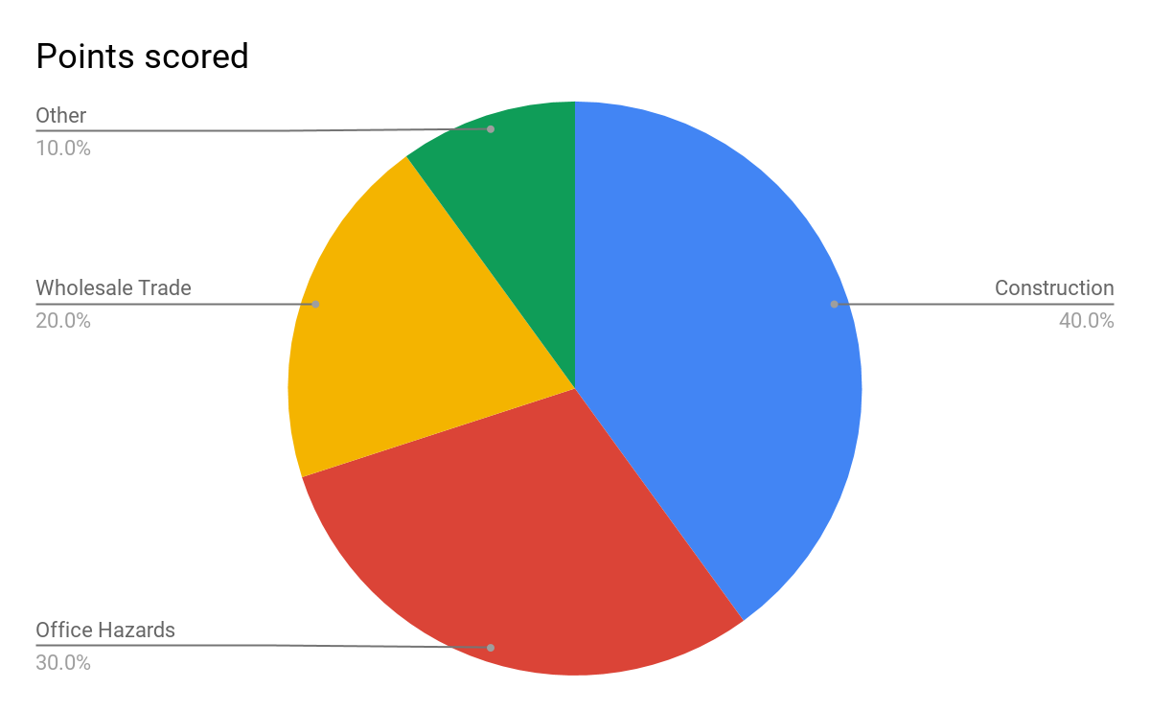

ERGONOMIC TIPS FOR AN ACCIDENT FREE OFFICE

- Making sure your computers are user friendly. Changing the settings of your computer for better lighting and less glare is surely helpful to the employees. Make sure the monitor is directly in front of you and that it is placed at a proper angle. Ensure that the resolution of your laptop screen or monitor, if the resolution of your laptop is poor, have it upgraded. Adjust the font size of your monitor to better suit your eyesight. Work with a proper external keyboard and an external mouse, especially if you are using the said devices in your primary workstation.

- Investing in Ergonomic chairs. An ergonomic chair is usually the most advisable and safest chair that an office-based company can use. A proper chair combined with the proper posture can make all the difference when working in an office. The use of a proper ergonomic chair that supports the lower back and promotes good posture. Investing in Ergonomic chairs will lessen life long injuries for your employees. When getting an ergonomic chair, your must consider the following:

- Arm rests should be easily adjustable for the benefit of the employee
- Seat height should also be easily adjustable to fit the employee
- An ergonomic chair should be able to rotate easily
- The chair should be able to fully support the lower back of anyone who is sitting on it
- Ergonomic chairs must be efficient and high quality

- Proper placement of belongings. Make sure that your office has spaces for the belongings of each employee. This will prevent your employees from knocking down the things or tripping on them.

- Body Alignment. A proper posture is good for the body in the long run. As an office employee, you sit for long hours in the day in front of your screen. It is important that you are aware of the proper body posture that one must practice while working in the office. Make sure that you move around from time to time; a single position, despite its comfort, will get tiring if you sit long enough.

- Promoting self-care in the office. The health of your employees, both physical and mental health are important for the overall function of the performance of your employees.

WHAT TO DO WHEN YOU GET INTO AN ACCIDENT?

- All injuries, major or minor, must be written into an accident book. An accident book is a must for every company.
- You must immediately inform your supervisor about the said injury if you can
- An employee is entitled to a sick leave upon the orders of the doctor.
- The employee who was injured has to make sure that the accident has been reported by the employer to the health and safety department.
- An office is obliged to have a first aid kit in case of accidents.
- You are entitled to a compensation if you think it is the fault of the employer that you got into an accident (e.g. if the accident was caused by a problem that has been repeatedly reported in the past)

ACCIDENT REPORT FORM - [COMPANY’S NAME]

Date: [DATE]
Name: [NAME]
Position: [JOB POSITION]
Department: [SPECIFY]

ACCIDENT REPORT FORM - [COMPANY’S NAME]
Filed by: [NAME] | Position of the person who filed: [SPECIFY]
Injured person: [NAME]
Sex: ☐ MALE ☐ FEMALE
Age: [SPECIFY AGE]
Civil status of the injured person:

☐ Single ☐ Married ☐ Widowed ☐ Divorced
With children: ☐ YES ☐ NO

If yes, how many?
Emergency Contact Details:

[EMERGENCY CONTACT’S NAME]
[CONTACT NUMBER]
[EMAIL ADDRESS]
[COMPLETE ADDRESS]
This is a report of: ☐ ACCIDENT ☐ DEATH ☐ [SPECIFY] ☐ [SPECIFY]
Part Of The Body Affected: (check all that apply)  ☐ [SPECIFY]  ☐ [SPECIFY]  ☐ [SPECIFY]  ☐ [SPECIFY] | Date of injury: [DATE]  Time of injury: [TIME]  Witnesses during injury: [NAME]
Describe what you were doing during the time of injury:  [SPECIFY]  Example:  I, John Smith, was busy unloading some boxes for inventory purposes around 7 am, Thursday morning when I accidentally tripped due to the tangled wires. I hit my head on the table and immediately cried out in pain, my cries were heard and my co-worker, Jon Snow, saw my head bleeding. He immediately responded to aid me and informed our supervisor about the injury. | Type of injury: (check all that apply)  ☐ [SPECIFY]  ☐ [SPECIFY]  ☐ [SPECIFY]  ☐ [SPECIFY]  ☐ [SPECIFY]  ☐ [SPECIFY]  ☐ [SPECIFY]  ☐ [SPECIFY]
Why did the incident happen?  ☐ [SPECIFY]  ☐ [SPECIFY]  ☐ [SPECIFY]  ☐ [SPECIFY] | Unsafe practices that caused the accident:  ☐ [SPECIFY]  ☐ [SPECIFY]  ☐ [SPECIFY]  ☐ [SPECIFY]
Was this the first time that such accident in the office occurred?

☐ YES ☐ NO
Medical history of the injured person

Does the injured person have any pre-existing medical conditions?

☐ YES ☐ NO

If so, please specify: [SPECIFY]

Have you told your supervisor?  ☐ YES ☐ NO | Supervisor’s statement:  [SPECIFY]
Did you see a doctor?  ☐ YES ☐ NO | Name of Doctor: [DOCTOR’S NAME]
If yes, when did you see the doctor?  [DATE] | Supervisor’s name and signature:  [AUTHORIZED SIGNATURE]  [SUPERVISOR’S NAME]
Your Signature:  [AUTHORIZED SIGNATURE] | [COMPANY’S NAME]  [COMPANY’S SEAL]

Preventive measures you can advise the company in order to prevent any related accidents.

