WEBSITE BUSINESS PLAN

[INSERT NAME OF THE BUSINESS/COMPANY]
[INSERT THE COMPLETE BUSINESS/COMPANY ADDRESS]
[INSERT THE BUSINESS/COMPANY CONTACT NUMBERS]
[INSERT THE BUSINESS/COMPANY EMAIL ADDRESS]
[INSERT THE BUSINESS/COMPANY WEBSITE ADDRESS]

PREPARED BY:

[INSERT FULL NAME/S OF THE
PEOPLE WHO PREPARED THIS PLAN]

[INSERT DATE]

Index

Executive Summary [PAGE NUMBER]
Company Overview [PAGE NUMBER]
Products and Services [PAGE NUMBER]
Execution [PAGE NUMBER]
Operational Plan [PAGE NUMBER]
Financial Plan [PAGE NUMBER]

EXECUTIVE SUMMARY

[IEX Technologies LLC] is a web design and development company specializing in full-stack website development. It mainly serves companies within the Research Triangle in Durham, North Carolina and plans to extend its services to restaurants and retail stores. The company sees profitable growth over the next three years as e-commerce drives considerable increases in the number of online businesses.

COMPANY OVERVIEW

Mission Statement: [IEX Technologies LLC] is committed to helping clients market their businesses professionally through expert web design and development services tailored to their specific needs.

Philosophy: [IEX Technologies LLC] integrates simplicity, creativity, and professionalism in serving its clients.

Vision: [IEX Technologies LLC] aims to be a productive and innovative web design company catering to the various technical needs of its clients. The company envisions to become one of the top website developers recognized for its creative approach to digital marketing.

Outlook: The fast growth of e-commerce in the [US] will be the main driver of the web development industry. Experts predict that a [15%] industry growth is expected [2016-2026] as companies have completely embraced digital marketing for business sustainability. The increased use of mobile applications has also contributed to the increase in demand for web development services specializing in mobile website design and development.

Type of Industry: [Web Development and Design]

Business Structure: Limited Liability Company

Ownership: [LLC, Joseph Honne, Kelly Ayres, Amy Hung, Veeshun Reddy, James Peters, and Honey Finn].

Start-Up Summary: The total start-up cost is [$50,000.00], covering operational expenses, rent, equipment, and etc.

Start-Up Funding
Start-Up Expenses | $27,000.00
Start-Up Assets | $23,000.00
Total Funding Required | $50,000.00
Assets
Non-Cash Assets from Start-Up | $6,000.00
Cash Requirements from Start-up | $5,000.00
Additional Cash Raised | $5,000.00
Cash Balance on Starting Date | $7,000.00
Total Assets | $23,000.00
Capital
Planned Investment
Owners | $35,000.00
Additional Investment Requirement | $15,000.00
Total Planned Investment | $50,000.00
Loss at Start-Up (Start-Up Expenses) | -$27,000.00
Total Capital | $23,000.00
Total Capital and Liabilities | $23,000.00
Start-Up
Requirements
Start-Up Expenses
Rent | $4,000.00
Utilities | $3,500.00
Equipment & Tools | $3,500.00
Operations | $15,000.00
Marketing & Promotion | $1,000.00
Total Start-Up Expenses | $27,000.00
Start-Up Assets
Cash Required | $17,000.00
Other Current Assets | $2,500.00
Long-Term Assets | $3,500.00
Total Assets | $23,000.00
Total Requirements (Total Start-Up Expenses + Total Assets) | $50,000.00

MANAGEMENT TEAM:

Management Team | Role/Function | Skills
Joseph Honne | General/Operations Manager | Leadership, organization, delegation
Kelly Ayres | Front-End Development Manager | Technical and analytical, problem-solving, time management
Amy Hung | Back-End Development Manager

SHORT- AND LONG-TERM GOALS AND MILESTONES:

Short-Term Goals | Milestones
Hire employees | - Interviewed 10 candidates (November 10-15, 2018)  - Hired 5 new designers, IT specialists, and content writers (November 20, 2018)
Find office space | - Assessed prospective office location (September 7, 2018)  - Signed lease contract with property landlord (November 10, 2018)
Long-Term Goals | Milestones
Build a client base | - Created a marketing plan (November 2, 2018)  - Sent business proposals to companies in the Research Triangle (November 2018)
Break-even by Q2 of 2019 | - Created a financial plan (October 10, 2018)

PRODUCTS AND SERVICES

Product/Service Description: [IEX Technologies LLC’s] services include full-stack web development, content and document management, e-commerce solutions, and mobile-optimized website design.

Value Proposition: [IEX Technologies LLC] ensures that the clients understand what the developers will do to optimize their website according to their business needs. [IEX Technologies LLC] is efficient in presenting technical details to its clients without boring them.

Pricing Strategy: Pricing strategies will be project-based. Cost-plus pricing is used in projects that require additional materials and paraphernalia. Bundled pricing is applied to projects that require more than one service category.

EXECUTION

Marketing Plan: The target market for [IEX Technologies LLC] consists of startups based in the Research Triangle located in Durham. Networking is a priority to reach potential clients. Creative marketing strategies will also be used to attract startups owned by young entrepreneurs.

Market Research: The company will focus on marketing efforts targeted at e-commerce businesses mainly operating on mobile website capacities. The [12%] increase in the number of tech startups in the Research Triangle also denotes a huge potential customer base for the company and compels a marketing plan based on interpersonal networking.

SWOT Analysis | Strengths | Weaknesses | Opportunities | Threats
IEX Technologies LLC | - Excellent client communication | - Lacks resources | - State government support for emerging markets | - Established competitors with a strong client base
Studio 57 | - Fast fulfillment | - Overworked employees | - Brand recognition in other parts of the country | - Competitors making better offers for compensation and benefits
Box Digital Creatives | - Proficient workforce | - Understaffed | - Positive customer feedback

MARKETING STRATEGY

Enhancing user experience is a priority in ensuring that the company effectively sells its brand of service quality. Networking is also a crucial move for new securing clients.

Marketing Strategy | Activities | Timeline | Success Criteria
Enhancing user experience | - Develop a mobile website design | - November 2018 | - Increase in users' visit duration
Networking | - Join Facebook and other social media groups | - October 2018 to present | - More online interactions
 | - Attend industry events | - October 2018 to present | - Gained additional contact list
Search Engine Optimization | - Hire SEO specialist | - November 2018 | - SEO specialist commences work on December 2018.
 | - Revamp web strategy | - December 2018 to present | - Increase in website visits

ORGANIZATIONAL STRUCTURE:

GENERAL/
OPERATIONS MANAGER
FRONT-END DEV'T MANAGER
BACK-END DEV'T MANAGER
HUMAN RESOURCE MANAGER
SALES & MARKETING MANAGER
BUSINESS & FINANCE MANAGER
DESIGN & DEVELOPMENT SPECIALISTS
IT & SEO SPECIALISTS
CREATIVE CONTENT TEAM
ACCOUNTING STAFF
ADMIN STAFF

OPERATIONAL PLAN

Location and Facilities: The company operates at a rented office space in [Griffin Street, Durham]. Covering [2,376 sq.ft.] of floor space, the interior is complete with a reception area, workstations, comfort rooms, a pantry, and a private conference room.

Tools and Equipment Checklist:

Software | Quantity
Adobe Dreamweaver CC | 5
Adobe Photoshop | 5
Hardware | Quantity
PC units | 15
Projector | 5

IT Infrastructure

Infrastructure | Existing (Y/N) | Description
Data Storage and Backup | Y | - With disaster recovery capability
Network Security | Y | - Secure confidential data

FINANCIAL PLAN

Assumptions: The financial plan for this business is based on the following assumptions:

1. Monthly expenses will remain at the same level until [Q3 of 2019].

2. Revenue will increase beginning [Q3 of 2019].

Monthly Expense

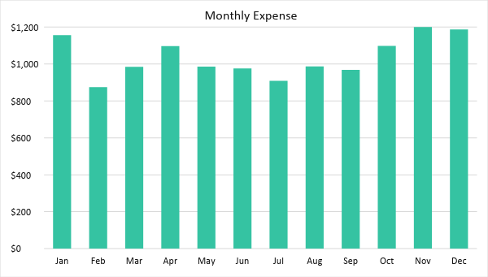

Monthly Revenue

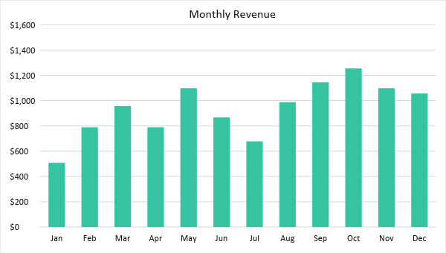

BUSINESS FINANCING

The member-managers contribute a total of [$35,000.00]. The remaining [$15,000.00] capital requirement will be acquired through a business loan payable within the next [5 years].

STATEMENTS

Profit and Loss Projection
 | FY2019 | FY2020 | FY2021
Sales | $11,226.00 | $36,457.00 | $51,284.46
Direct Cost of Sale | $2,375.00 | $2,174.00 | $3,165.00
Other Cost of Sale | $450.00 | $450.00 | $450.00
Total Cost of Goods Sold or COGS (Sales - Direct Cost of Sale - Other Cost of Sale) | $2,825.00 | $2,624.00 | $3,615.00
Gross Profit (Sales-Total Cost of Goods Sold) | $8,401.00 | $33,833.00 | $47,669.46
Gross Margin % (Gross Profit/Sales) | 74.84% | 92.80% | 92.95%
Operating Expenses
Rent | $4,000.00 | $4,000.00 | $4,000.00
Insurance | $3,500.00 | $3,500.00 | $3,500.00
Utilities | $3,500.00 | $3,000.00 | $2,500.00
Salary (Including Tax) | $15,000.00 | $17,000.00 | $20,000.00
Maintenance & Supplies | $1,000.00 | $1,000.00 | $1,000.00
Total Operating Expenses | $27,000.00 | $28,500.00 | $31,000.00
EBITDA (Total Cost of Sale-Total Operating Expenses) | -$24,175.00 | -$25,876.00 | -$27,385.00
Depreciation | $0.00 | $500.00 | $500.00
Interest Expense | $0.00 | $0.00 | $0.00
Taxes Paid | $0.00 | $100.00 | $100.00
Net Profit (Gross Profit - Operating Expenses - Taxes - Interest) | -$18,599.00 | $5,233.00 | $16,569.46

Balance Sheet Projection
 | FY2019 | FY2020 | FY2021
Cash | $30,000.00 | $30,000.00 | $30,000.00
Accounts Receivable | $0.00 | $1,000.00 | $1,750.00
Inventory | $850.00 | $1,000.00 | $1,350.00
Other Current Assets | $2,500.00 | $3,500.00 | $4,000.00
Total Current Assets | $33,350.00 | $35,500.00 | $37,100.00
Long-Term Assets | $3,500.00 | $3,000.00 | $4,000.00
Accumulated Depreciation | $500.00 | $500.00 | $500.00
Total Long-Term Assets (Long-Term Assets-Accumulated Depreciation) | $3,000.00 | $2,500.00 | $3,500.00
Total Assets (Total Current Assets + Total Long-Term Assets) | $36,350.00 | $38,000.00 | $40,600.00
Accounts Payable | $3,000.00 | $3,500.00 | $3,500.00
Notes Payable | $1,000.00 | $1,540.00 | $2,000.00
Other | $1,500.00 | $2,000.00 | $1,750.00
Total Liabilities | $5,500.00 | $7,040.00 | $7,250.00
Paid-in Capital | $10,000.00 | $15,000.00 | $20,000.00
Retained Earnings | $3,745.00 | $7,438.00 | $11,454.00
Total Owner's Equity (Total Assets - Total Liabilities) | $30,850.00 | $30,960.00 | $33,350.00
Total Liabilities & Equity (Total Liabilities/Total Owner's Equity) | 17.83% | 22.74% | 21.74%

Cash Flow Projection
 | FY2019 | FY2020 | FY2022
Operating Cash Beginning | $30,000.00 | $30,000.00 | $30,000.00
Sources of Cash
Receivables | $0.00 | $1,000.00 | $1,750.00
Sales | $11,226.00 | $36,457.00 | $51,284.46
Others | $2,500.00 | $3,500.00 | $4,000.00
Total Cash | $43,726.00 | $70,957.00 | $87,034.46
Expenditures
Rent | $4,000.00 | $4,000.00 | $4,000.00
Utilities | $3,500.00 | $3,500.00 | $3,500.00
Equipment & Tools | $3,500.00 | $3,000.00 | $2,500.00
Operations | $15,000.00 | $17,000.00 | $20,000.00
Marketing & Promotion | $1,000.00 | $1,000.00 | $1,000.00
Total Expenditures | $27,000.00 | $28,500.00 | $31,000.00
Net Income/Loss (Total Cash - Total Expenditures) | $16,726.00 | $42,457.00 | $56,034.46

