[Frank's Farm Warehouse]
Business Plan For Fiscal Year 2020
[December 10, 2019]
[Frank D. Moreland]

WAREHOUSE BUSINESS PLAN

[frankmoreland@gmail.com]
[660-683-8167 | 573-979-5772]
[3078 Oak Lane
Craig, MO 64437 USA]

Index

Executive Summary [PAGE NUMBER]
Company Overview [PAGE NUMBER]

Products and Services [PAGE NUMBER]

Execution [PAGE NUMBER]

Operational Plan [PAGE NUMBER]

Financial Plan [PAGE NUMBER]

Executive Summary

[Frank's Farm Warehouse] is a warehousing company based in [Craig, MO]. The company targets grain farmers and producers based in [Missouri, Iowa, and Nebraska] as well as grain importers in the Midwest region. As the demand for warehouses increases due to excessive yields in the past year, [Frank's Farm Warehouse] is hopeful that the company will see profitable growth in the next two years.

COMPANY OVERVIEW

Mission Statement

[Frank's Farm Warehouse] aims to provide clean, safe, and secure off-farm storage solutions for farmers and producers in the Midwest.

Philosophy

[Frank's Farm Warehouse] values service consistency, systematic planning and management, and customer focus.

Vision

[Frank's Farm Warehouse] envisions to be a leading off-farm product storage solutions provider for farmers based in [Missouri, Iowa, and Nebraska].

Outlook

Current volatile prices of grains such as corn, soybean, and wheat continue to encourage farmers to store their products for future sales. In [2017], the average grain storage capacity in the US grew by a mere [1]%, indicating a need for more off-farm storage providers to service farmers and producers whose crop yields are in excess. The increase of imported grains also signifies a need to increase grain storage capacity.

Type of Industry: Storage and Warehousing Industry

Business Structure: General Partnership

Ownership

The business will be owned and operated by partners [Frank Moreland, Roberto Plando, and William Hurst]. Each owns [33.33]% shares of the business.

Start-Up Summary

The $[60,000.00] start-up cost will cover the purchase of land and equipment, payments for utilities and other operational expenses.

Start-Up Funding
Start-Up Expenses | $30,000.00
Start-Up Assets | $30,000.00
Total Funding Required | $60,000.00
Assets
Non-Cash Assets from Start-Up | $5,000.00
Cash Requirements from Start-up | $10,000.00
Additional Cash Raised | $5,000.00
Cash Balance on Starting Date | $10,000.00
Total Assets | $30,000.00
Capital
Planned Investment
Owners | $30,000.00
Additional Investment Requirement | $30,000.00
Total Planned Investment | $60,000.00
Loss at Start-Up (Start-Up Expenses) | -$30,000.00
Total Capital | $30,000.00
Total Capital and Liabilities | $30,000.00
Start-Up
Requirements
Start-Up Expenses
Land | $10,000.00
Utilities | $4,000.00
Equipment | $10,000.00
Operations | $5,000.00
Marketing and Promotion | $1,000.00
Total Start-Up Expenses | $30,000.00
Start-Up Assets
Cash Required | $25,000.00
Other Current Assets | $1,000.00
Long-Term Assets | $4,000.00
Total Assets | $30,000.00
Total Requirements (Total Start-Up Expenses + Total Assets) | $60,000.00

Management Team:

Management Team | Role/Function | Skills
Frank Moreland | Business & Finance | Conflict management, accounting
Roberto Plando | Operations | Organization, resource management
William Hurst | Sales & Marketing | Negotiation, marketing

Short- and Long-Term Goals and Milestones:

Short-Term Goals | Milestones
Purchase land | Met with the land vendor [June 2, 2018]  Signed purchase agreement [June 17, 2018]
Build a storage facility | Commissioned a contractor for design and planning [July 30, 2018]  Commenced construction [August 7, 2018]
Long-Term Goals | Milestones
Integrate order fulfillment services | Conducted research on requirements and costing [October 13, 2018]
Achieve $[50,000.00] sales goal by Q2 of [2020] | Created sales and marketing plan [September 2018]

PRODUCTS AND SERVICES

Product/Service Description

[Frank's Farm Warehouse] stores grains such as corn, soybeans, wheat, oats, and barley. The company uses both metal and wooden storage bins, depending on the grade and type of grain delivered for storage.

Value Proposition

[Frank's Farm Warehouse] ensures that the right kind of storage system is used to store each customer's product. The company is mindful about the duration of storage, indoor temperature, elevation, and other aspects that directly affect the quality of the grain when in storage.

Pricing Strategy

The business utilizes cost-plus pricing. Price bundling is effective for clients who have more than one type of grain for storage.

EXECUTION

Marketing Plan

The target market of [Frank's Farm Warehouse] consists of middle-aged farmers. In order to attract this demographic, the business will focus on a people-to-people approach.

Market Research

[Frank's Farm Warehouse] targets grain farmers based in [Missouri, Iowa, and Nebraska]. More than 300 farmers in Iowa produce a surplus of corn and are in need of off-farm facilities to store and preserve their products. The company also aims to provide storage services for rice and grain importers located in the [Midwest].

SWOT Analysis | Strengths | Weaknesses | Opportunities | Threats
Frank's Farm Warehouse | Strategic location | No trucking service | Increase in imports | Continued decrease in grain prices
DV Logistics | Huge customer base | Internal management issues | Expansion | State regulations
Big Lake Storage and Delivery | Low prices | Unmotivated workforce | Approval into federal storage facility | Volatile market

Marketing Strategy: [Frank's Farm Warehouse] will directly market its services to target customers.

Marketing Strategy | Activities | Timeline | Success Criteria
Online marketing | Set up Facebook page  Make a website that features useful information about the company | December 17, 2018  November 2018 to present | 1000 likes within Q1 of 2019  Increased site visits between Q1 and Q2 of 2019
Print advertising | Distribute/display brochures, posters | November 2018 to present | Increased personal and phone inquiries
Networking | Attend farm industry conventions/events | September 2018 to present | Increased contact list

Organizational Structure

BUSINESS & FINANCE
OPERATIONS
SALES & MARKETING
WORKFORCE

OPERATIONAL PLAN

Location and Facilities

[Frank's Farm Warehouse] is located at a [7-acre property in Craig, Missouri]. Facilities include silos, metal and wooden bins, and covered courts where bagged grains are stored.

Tools and Equipment Checklist

Software | Quantity
Excalibur WMS | 1
Office 360 | 1
Hardware | Quantity
Metal bin | 15
Grain spreader | 15

IT Infrastructure

Infrastructure | Existing (Y/N) | Description
Social media | Y | Facebook is only for communication with target market
Website | N | Currently under development
Data storage | Y | Through Excalibur WMS  For client inventory tracking

FINANCIAL PLAN

Assumptions

The financial plan for [Frank's Farm Warehouse] is based on the following assumptions:

- The total expenses for each month in FY [2019] will not be higher than $[1,500.00].

- The monthly revenue will increase by [1.7]%.

Monthly Expense

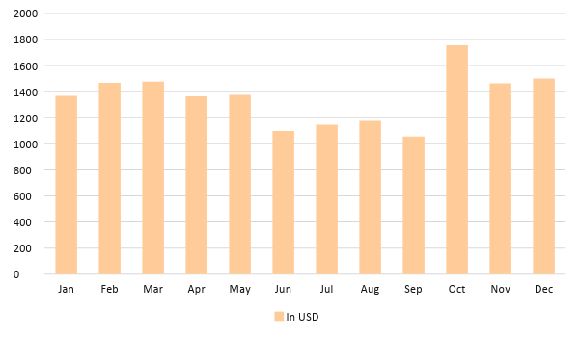

Monthly Revenue

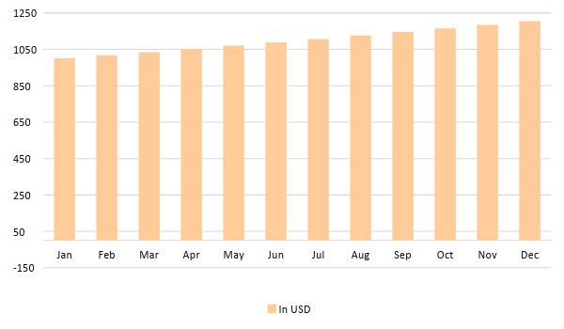

Business Financing

The partners contribute a total of $[30,000.00]. A business loan will be acquired to finance the business if it does not reach its sales goals by the end of FY [2019].

Statements

Profit and Loss Projection
 | FY2019 | FY2020
Sales | $13,201.18 | $47,653.98
Direct Cost of Sale | $1,650.87 | $11,650.87
Other Cost of Sale | $0.00 | $0.00
Total Cost of Goods Sold or COGS (Sales - Direct Cost of Sale - Other Cost of Sale) | $1,650.87 | $11,650.87
Gross Profit (Sales-Total Cost of Goods Sold) | $11,550.31 | $36,003.11
Gross Margin % (Gross Profit/Sales) | 87.49% | 75.55%
Operating Expenses
Land | $10,000.00 | $5,000.00
Utilities | $4,000.00 | $4,000.00
Equipment | $10,000.00 | $10,000.00
Operations | $5,000.00 | $5,000.00
Marketing and Promotion | $1,000.00 | $1,000.00
Total Operating Expenses | $30,000.00 | $25,000.00
EBITDA (Total Cost of Sale-Total Operating Expenses) | -$28,349.13 | -$13,349.13
Depreciation | $0.00 | $5,000.00
Interest Expense | $0.00 | $0.00
Taxes Paid | $0.00 | $0.00
Net Profit (Gross Profit - Operating Expenses - Taxes - Interest) | -$18,449.69 | $11,003.11

Balance Sheet Projection
 | FY2019 | FY2020
Cash | $25,000.00 | $30,000.00
Accounts Receivable | $0.00 | $0.00
Inventory | $0.00 | $0.00
Other Current Assets | $1,000.00 | $1,000.00
Total Current Assets | $26,000.00 | $31,000.00
Long-Term Assets | $4,000.00 | $5,000.00
Accumulated Depreciation | $0.00 | $5,000.00
Total Long-Term Assets (Long-Term Assets-Accumulated Depreciation) | $4,000.00 | $1,000.00
Total Assets (Total Current Assets + Total Long-Term Assets) | $30,000.00 | $32,000.00
Accounts Payable | $2,000.00 | $2,000.00
Notes Payable | $0.00 | $0.00
Other | $18,000.00 | $1,000.00
Total Liabilities | $20,000.00 | $3,000.00
Paid-in Capital | $30,000.00 | $40,000.00
Retained Earnings | $10,000.00 | $2,000.00
Total Owner's Equity (Total Assets - Total Liabilities) | $10,000.00 | $29,000.00
Total Liabilities & Equity (Total Liabilities/Total Owner's Equity) | 200.00% | 10.34%

Cash Flow Projection
 | FY2019 | FY2020
Operating Cash Beginning | $25,000.00 | $30,000.00
Sources of Cash
Receivables | $0.00 | $0.00
Sales | $13,201.18 | $47,653.98
Others | $5,000.00 | $5,000.00
Total Cash | $43,201.18 | $82,653.98
Expenditures
Land | $10,000.00 | $5,000.00
Utilities | $4,000.00 | $4,000.00
Equipment | $10,000.00 | $10,000.00
Operations | $5,000.00 | $5,000.00
Marketing and Promotion | $1,000.00 | $1,000.00
Total Expenditures | $30,000.00 | $25,000.00
Net Income/Loss (Total Cash - Total Expenditures) | $13,201.18 | $57,653.98

