VACATION RENTAL BUSINESS PLAN

[January 31, 2019]

[Peggy Fuller]
[peggyfuller@gmail.com]
[912-580-2855] [www.savannahholidayhome.com]
[331-333 E Broad St, Savannah, GA 31401]

Index
[Page Number]
[Page Number]
[Page Number]
[Page Number]
[Page Number]
[Page Number]

Executive Summary……..…………………………………………..........................
Company Overview..……………………………………………….……………………….
Products and Services..…………………………………………………………………....
Execution………...……...…………………….…………...….……............................
Operational Plan…..………………….………………………………………………………
Financial Plan...……………………………………………............……………………….

Executive Summary:

[Savannah Holiday Home] will offer affordable and cozy vacation homes for rent in Savannah to guests and tourists from all over the world. Today, there is an increasing demand among tourists to avail of vacation home rentals instead of expensive hotels. It is in this view that the business seeks to provide its guests relaxing and comfortable home away from their homes. The owner, Peggy Fuller, and her staff always make sure that the guests enjoy their vacation from the moment they enter the vacation home up until they go back to sleep after traversing the scenic spots of Savannah.

[Savannah Holiday Home] intends to have a wider market reach as it plans to expand its business by adding more vacation homes for rent. It will enlist on popular booking websites and make use of social media to strengthen its presence online. With the increasing number of tourists visiting Savannah every year, the business aims to improve its sales during its second year of operations.

Company Overview:

Mission Statement: [Savannah Holiday Home] provides the best quality and affordable vacation rental homes for tourists who want to relax and enjoy the beauty of the city of Savannah in Georgia.

Philosophy: [Savannah Holiday Home] always considers the comfort and the luxury of vacation living as the top priority for the guests of Savannah, Georgia. The company makes sure that the guests are pampered with everything they need to make their stay in Savannah more meaningful.

Vision: [Savannah Holiday Home] aims to become the top provider of vacation home rentals to tourists who choose to visit Savannah, Georgia.

Outlook: With the continuous growth of tourism in Savannah, more people are venturing into various businesses like restaurants, travel agencies, and vacation rentals. This makes the competition tight among players in the hospitality industry especially between hotels and vacation rentals. There are 14 million tourists projected to visit the historic and beautiful city this year. The company plans to stand out as a go-to vacation home provider for tourists who prefer a decent home for their holiday instead of a hotel room or a condominium unit. The business aims to receive 102 bookings within six months from the start of its operations.

Type of Industry: Vacation Rental Industry

Business Structure: Sole Proprietorship

Ownership: Sole Proprietorship, Peggy Fuller

Start-Up Summary: [Savannah Holiday Home] has a start-up cost amounting to 200K USD which will be shouldered by the owner, Ms. Peggy Fuller. This initial funding will cover expenses such as rent, staff training, legal fees, advertising, and maintenance.

Start-Up Funding
Start-Up Expenses | $79,700
Start-Up Assets | $120,300
Total Funding Required | $200,000
Assets
Non-Cash Assets from Start-Up | $72,300
Cash Requirements from Start-up | $10,000
Additional Cash Raised | $28,000
Cash Balance on Starting Date | $10,000
Total Assets | $120,300
Capital
Planned Investment
Owners | $200,000
Other | $0
Additional Investment Requirement | $0
Total Planned Investment | $200,000
Loss at Start-Up (Start-Up Expenses) | -$79,700
Total Capital | $120,300
Liabilities | $0
Total Capital and Liabilities | $120,300
Start-Up
Requirements
Start-Up Expenses
Rent - 6 Months | $17,700
Advertising | $3,500
Legal Fees | $2,500
Staff Training | $3,000
Insurance | $3,000
Other | $50,000
Total Start-Up Expenses | $79,700
Start-Up Assets
Cash Required | $20,000
Start-Up Inventory | $27,500
Other Current Assets | $32,500
Long-Term Assets | $40,300
Total Assets | $120,300
Total Requirements (Total Start-Up Expenses + Total Assets) | $200,000

Management Team:

Management Team | Role/Function | Skills
Peggy Fuller | Managing Executive | Leadership, Communication, Decision-Making, Team Management, Problem-Solving
Jennifer Kerr | Marketing Associate | Market Awareness, Use of Digital Marketing Tools and Techniques, Communication

Short- and Long-Term Goals and Milestones:

Short-Term Goals | Milestones
Hire a few housekeeping staff to manage daily cleaning and maintenance of the vacation home | 6 qualified candidates are scheduled for an interview during the last week of February 2019.
Secure the services of digital media partners to have a wider reach of the target market | A few renowned booking websites have been contacted and a discussion on the service details is underway.
Long-Term Goals | Milestones
Establish a steady number of bookings annually | The website will be linked to popular booking websites once a deal with the selected sites is established.
Purchase additional vacation homes within the vicinity of the historic district of Savannah | The owner has scouted for a few houses for sale that fits the business’ concept and unique selling point.

Products and Services

Product/Service Description: [Savannah Holiday Home] provides its guests with [2] duplex homes accredited and licensed as vacation home rentals in Savannah, Georgia. Guests can use the amenities of these homes for a night or more but not more than a month during their vacation.

Value Proposition: Your Home in Historic Savannah. The business offers a relaxing and cozy home away from home. After a day of exploring the scenic and tourist spots in Savannah, the company provides its guests a place where they can unwind and recharge to be ready for another day’s tour and activities.

Pricing Strategy: [Savannah Holiday Home] uses the competitive pricing approach and prices its vacation homes for [$180] per night. Each vacation home accommodates a maximum of [6] guests. There is a charge of [$10] for every additional person per night.

Execution

Marketing Plan: [Savannah Holiday Home] plans to have a wider market reach and a steady increase in the number of bookings annually. It will work on including the company in the listing of vacation home rentals on popular booking websites as well as on the official website of Savannah. The company will also use various social media platforms to strengthen its presence online.

Market Research: After being hailed as one of the best places for travelers to visit, Savannah has attracted more people to invest and convert their homes into vacation rentals, particularly, those near tourist destinations. There is a gradual increase in tourists who book vacation home rentals over hotels. As seen on the chart below, more families and couples are inclined to availing the services of vacation home rentals.

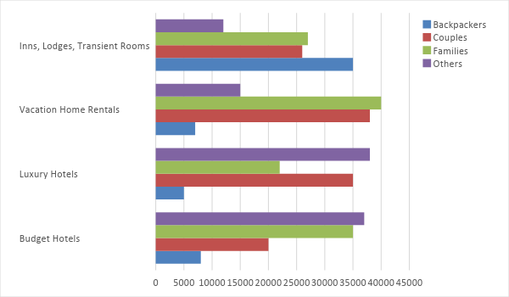

SWOT Analysis | Strengths | Weaknesses | Opportunities | Threats
Savannah Holiday Home | - Located within downtown Savannah  - Affordable rent rates for a luxurious and cozy stay | - Only a few vacation homes available  - Poor marketing/ promotional activity | - Increasing demand for vacation home rentals over hotels | - More homes near tourist destinations are opened for rent
Holiday Den Vacation Homes | - Top contender for the most booked vacation home rental in Savannah | - Highly expensive rates and service charges | - Increase in number of vacation homes in other areas of Savannah | - Growing interest in affordable vacation home rentals with similar amenities as the luxurious ones
TinyHouse Rentals | - Provides cozy and affordable place for tourists to live in during their vacation | - Location of vacation homes is far from the tourist destinations | - Houses in the historic district and downtown Savannah can be converted into vacation home rentals | - More vacation home rentals in downtown Savannah

Marketing Strategy: [Savannah Holiday Home] plans to widen its target market and consequently receive more bookings. Towards this end, marketing associate, Jennifer Kerr, will oversee the following marketing strategies:

- Enlisting of the company on popular booking websites;
- Use of social media advertising to reach out to potential customers from as far as Europe; and
- Making use of promos including giving discounts for early bookings

The following table shows the various tasks that the marketing associate has been accomplished and will still be completed in the days to come.

Marketing Strategy | Activities | Timeline | Success Criteria
Enlist on popular booking websites | Contact the companies handling booking websites and mobile applications | February 20, 2019 | A discussion on the payment details is underway with renowned booking websites. Mobile application developers are yet to be contacted.
Social media advertising | Post video advertisements and other info about the company | February 28, 2019 | The first draft for the video advertisement and posts to be inserted on various social media platforms will be completed by February 10, 2018.
Consistent update on the website | - Hire a web designer to create a user-friendly website  -Organize website content and portfolio that customers can peruse and review | ASAP | A web designer is already hired and is currently reorganizing the website’s interface.

Organizational Structure:

The table below shows the roles and functions of the officers and employees of the company:

Name | Role/Function | Responsibilities | Reports to
Peggy Fuller | Owner/Manager | Handles the decision-making process and oversees the operations of the business | N/A
Jennifer Kerr | Marketing and Customer Associate | Implements the marketing strategies and caters to guest bookings | Manager
No  Names Yet | Housekeeping and Maintenance | Maintains the safety and cleanliness of the rental homes | Manager

Operational Plan:

Location and Facilities

[Savannah Holiday Home] is a provider of duplex house licensed as vacation rentals located at [331-333] E Broad St, Savannah, [GA 31401]. These vacation homes are fully furnished and are ready to be occupied anytime. The property has a mini-swimming pool perfect for bonding with family, relatives, and friends.

Tools and Equipment Checklist

Software | Quantity
Property Management System | 1
Reservation System | 1
Hardware | Quantity
Desktop Computer | 1
Telephone line | 2

IT Infrastructure

Infrastructure | Existing (Y/N) | Description
Social Media | N | The company has no accounts on popular social media platforms.
Website | Y | The company owns a website and is eligible for an upgrade.
Latency proof | Y | The business experiences quick and efficient response and processing times from network connections.
Downtime | N | The business records no disruptions caused by the network.

Financial Plan

Assumptions

[Savannah Holiday Home] uses the financial information derived from both market trends and market research regarding vacation home rentals to create its projected financial forecasts. The company’s financial assumptions are as follows:

- The business expects a [25%] increase in sales starting the second year of its operations.
- There is expected inflation during the second half of [2020] until the first quarter of [2021].
- The prevailing market interest rate is [4.5%]. Taxes equal to [30%] of the gross compensation amount.
- Depreciation expense amounts to [$2,000] every year.
- The standard check-in time is [2:00 pm] and check-out time is [12:00] noon the following day.

Monthly Expense

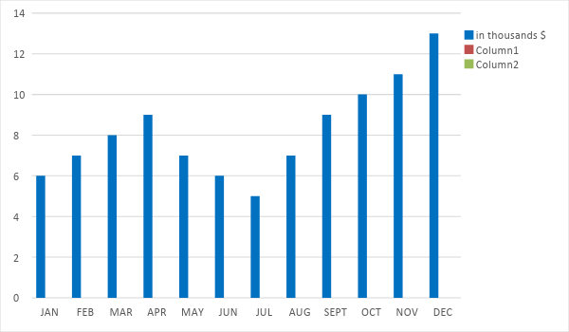

Monthly Revenue
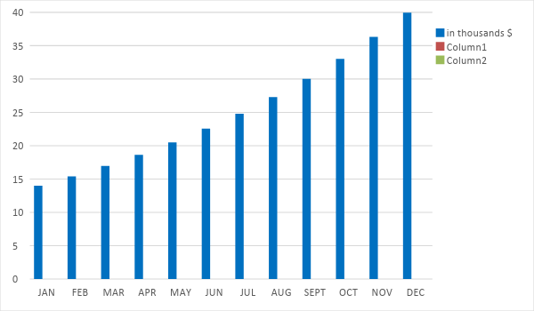

Business Financing

The owner of Savannah Holiday Home, Peggy Fuller, initially funded the business with a total amount of [200K] USD. The fund was acquired through the owner’s cash contribution of [50K] and a business loan amounting to [150K] payable in [6 years].

Statements

Profit and Loss Projection
 | FY2019 | FY2020 | FY2021
Sales | $340,000.00 | $425,000.00 | $531,250.00
Direct Cost of Sale | $102,000.00 | $212,500.00 | $265,625.00
Other Cost of Sale | $2,000.00 | $2,040.00 | $2,080.80
Total Cost of Goods Sold or COGS (Sales - Direct Cost of Sale - Other Cost of Sale) | $236,000.00 | $210,460.00 | $263,544.20
Gross Profit (Sales-Total Cost of Goods Sold) | $104,000.00 | $214,540.00 | $267,705.80
Gross Margin % (Gross Profit/Sales) | 30.59% | 50.48% | 50.39%
Operating Expenses
Rent | $35,400.00 | $35,400.00 | $35,400.00
Insurance | $6,000.00 | $6,000.00 | $6,000.00
Utilities | $7,000.00 | $7,000.00 | $7,000.00
Salary (Including Tax) | $40,000.00 | $40,000.00 | $40,000.00
Maintenance & Supplies | $3,000.00 | $4,000.00 | $5,000.00
Total Operating Expenses | $91,400.00 | $92,400.00 | $93,400.00
EBITDA (Total Cost of Sale-Total Operating Expenses) | $144,600.00 | $118,060.00 | $170,144.20
Depreciation | $2,000.00 | $2,000.00 | $2,000.00
Interest Expense | $924.00 | $924.00 | $924.00
Taxes Paid | $12,000.00 | $12,000.00 | $12,000.00
Net Profit (Gross Profit - Operating Expenses - Taxes - Interest) | -$324.00 | $109,216.00 | $161,381.80

Balance Sheet Projection
 | FY2019 | FY2020 | FY2021
Cash | $28,600.00 | $77,200.00 | $151,000.00
Accounts Receivable | $25,000.00 | $35,000.00 | $40,000.00
Inventory | $27,500.00 | $34,100.00 | $42,284.00
Other Current Assets | $32,500.00 | $32,500.00 | $32,500.00
Total Current Assets | $113,600.00 | $178,800.00 | $265,784.00
Long-Term Assets | $40,300.00 | $40,300.00 | $40,300.00
Accumulated Depreciation | $2,000.00 | $4,000.00 | $6,000.00
Total Long-Term Assets (Long-Term Assets-Accumulated Depreciation) | $38,300.00 | $36,300.00 | $34,300.00
Total Assets (Total Current Assets + Total Long-Term Assets) | $151,900.00 | $215,100.00 | $300,084.00
Accounts Payable | $130,000.00 | $123,610.00 | $117,220.00
Notes Payable | $2,500.00 | $3,000.00 | $3,600.00
Other | $2,000.00 | $1,500.00 | $2,000.00
Total Liabilities | $134,500.00 | $128,110.00 | $122,820.00
Paid-in Capital | $200,000.00 | $200,000.00 | $200,000.00
Retained Earnings | -$324.00 | $108,892.00 | $270,273.80
Total Owner's Equity (Total Assets - Total Liabilities) | $17,400.00 | $86,990.00 | $177,264.00
Total Liabilities & Equity (Total Liabilities/Total Owner's Equity) | 772.99% | 147.27% | 69.29%

Cash Flow Projection
 | FY2019 | FY2020 | FY2021
Operating Cash Beginning | $20,000.00 | $28,600.00 | $77,200.00
Sources of Cash | $20,000.00 | $20,000.00 | $20,000.00
Receivables | $25,000.00 | $35,000.00 | $40,000.00
Sales | $50,000.00 | $80,000.00 | $100,000.00
Others | $5,000.00 | $6,000.00 | $7,200.00
Total Cash | $120,000.00 | $169,600.00 | $244,400.00
Expenditures
Rent | $35,400.00 | $35,400.00 | $35,400.00
Insurance | $6,000.00 | $6,000.00 | $6,000.00
Utilities | $7,000.00 | $7,000.00 | $7,000.00
Salary (Including Tax) | $40,000.00 | $40,000.00 | $40,000.00
Maintenance & Supplies | $3,000.00 | $4,000.00 | $5,000.00
Total Expenditures | $91,400.00 | $92,400.00 | $93,400.00
Net Income/Loss (Total Cash - Total Expenditures) | $28,600.00 | $77,200.00 | $151,000.00

