[Escapades Travel Agency]
[2018 – 2019]

Travel
Agency Sales Plan

Index

Executive Summary [PAGE NUMBER]
Company Overview [PAGE NUMBER]
Products and Services [PAGE NUMBER]
Marketing Analysis [PAGE NUMBER]
Strategy and Implementation [PAGE NUMBER]
Management and Personnel [PAGE NUMBER]

Sales Action Plan [PAGE NUMBER]

EXECUTIVE SUMMARY

[Escapades Travel Agency] wants to provide affordable and well-organized travel packages for students and budget travelers. With a physical office as well as online presence, the company will take advantage of the growing tourism industry and low plane ticket prices to expand its target market.

By utilizing print advertising, online platforms, and social media marketing strategies, the company hopes to break even within its first year of operation.

COMPANY OVERVIEW

Mission Statement:

[Escapades Travel Agency] aims to be a leading travel agency that caters to the travel needs of students and budget travelers alike.

Philosophy:

[Escapades Travel Agency] offers travel experience without the need for high expenses. The company focuses on affordable and enriching tours.

Vision:

[Escapades Travel Agency] wants to become the leading budget travel company that promotes positive tourism at affordable costs.

Outlook:

Factors such as economic growth, consumer income, and airline ticket affordability all affect the demand for travel agencies in the US. In the past five years, the industry has grown by [5.2 percent], with a [$43 billion] revenue in [2018]. With expected steady growth in the economy, the industry foresees an increase in revenue in the next [five years].

Type of Industry: Travel and Tourism Industry

Business Structure: Sole Proprietorship

Ownership: Sole Proprietorship, Alison Cowell

Start-Up Summary:

The owner will provide the start-up capital of [$50,000]. This amount will be used for rent, hardware and software acquisition, and payroll.

Start-Up Funding
Expenses | $25,000
Assets | $25,000
Total Funding Required | $50,000
Assets
Non-Cash Assets | $12,000
Cash Requirements | $5,000
Additional Cash Raised | $3,000
Cash Balance on Starting Date | $5,000
Total Assets | $25,000
Capital
Planned Investment
Owner | $50,000
Other | $0
Additional Investment Requirement | $0
Total Planned Investment | $50,000
Loss | -$25,000
Total Capital | $25,000
Total Capital and Liabilities | $25,000
Start-Up
Requirements
Start-Up Expenses
Rent | $3,000
Advertising | $4,000
Legal Fees | $1,000
Software and Equipment | $6,000
Insurance | $1,000
Other | $10,000
Total Start-Up Expenses | $25,000
Start-Up Assets
Cash Required | $12,000
Inventory | $2,500
Other Current Assets | $4,500
Long-Term Assets | $6,000
Total Assets | $25,000
Total Requirements (Total Start-Up Expenses + Total Assets) | $50,000

PRODUCTS AND SERVICES

Product/Service Description:

[Escapades Travel Agency] caters to student and budget travelers and offers the following services in its physical office and online:

- Air Travel Booking
- Hotel and Accommodation
- Car for Hire and Rentals
- Local Tours
- Tour Arrangements and Packages

Value Proposition:

[Escapades Travel Agency] sets itself apart from other travel agencies in the area through its highly affordable travel packages.

Pricing Strategy:

[Escapades Travel Agency] utilizes competitive pricing strategies.

Marketing Analysis

The outlook for travel agencies remains positive in the following years. The company itself sees positive growth in its first year as travel becomes even more affordable for students. To reach its target market, the company will utilize online marketing and offer promotional features in travel magazines and the lifestyle sections of the local newspapers.

Market Segmentation

[Escapades Travel Agency] will focus its sales efforts on student and budget travelers. The following chart shows the projected market segmentation:

Target Market Segmentation Strategy

- The company will focus on targeted social media advertisements, emphasizing solo tours, safe environment, and budget-friendly accommodations.
- Print and broadcast advertising will be the focus of this target market to effectively show fun and affordable adventures that are perfect for student and budget travelers.

STRATEGY AND IMPLEMENTATION

Target Market Strategy

[Escapades Travel Agency] aims to increase its clientele by [15%] every month in its first year of operation. This can be achieved through its advertising efforts and customer service.

Competitive Edge

The company focuses on student and budget travelers, providing its clients with itineraries based on their travel expectations, at affordable prices.

SWOT Analysis | Strengths | Weaknesses | Opportunities | Threats
Escapades Travel Agency | Has an excellent understanding of its niche market | New in the business and still needs to establish customer trust | Low airline cost encourages travel | Rising costs of operations may cut revenue
Fox Tours | Experienced travel and tour operator | Outdated website | Changes in travel trends help create better travel experiences for the clients | Market saturation
Simpkins Travels | Go-to travel agency in the area | Lack of strategic partners and suppliers | Sustainable local and international travel demands | Partnership establishments are not a hundred percent reliable

Sales Strategy and Forecast

By emphasizing that the company caters to student and budget travelers, it aims to see a continued increase in sales in the following year.

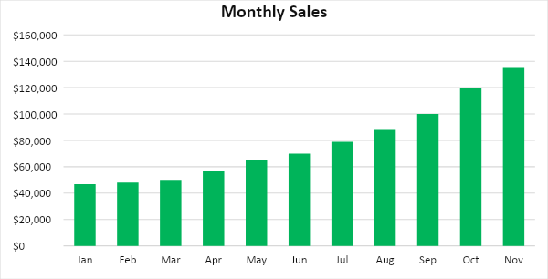

By creating effective sales strategies, student and budget travelers will be more inclined to book their travels with the company. The following chart shows the projected sales growth of Escapades Travel Agency in the next two years:

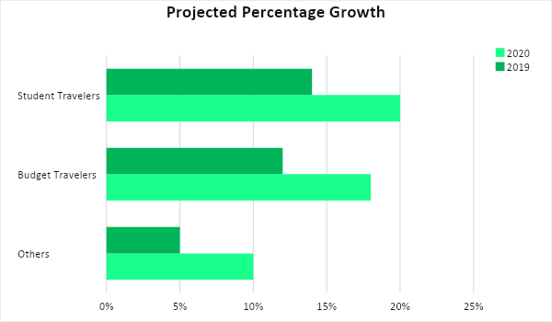

Emphasis is placed on effective customer service to meet the company’s sales goals. The following strategies shall be utilized:

Sales Strategy | Activities | Timeline | Success Criteria
Sales promotions | - Online and offline sales strategies will be utilized to promote the company’s services. The website, social media accounts, and other print ads and features shall specifically target students and budget travelers. | April 1, 2019 | - Promotional materials are designed, produced, and scheduled for social media posting
Customer excellence | - The company will ensure that customers are satisfied with the services offered. Customer relationships shall also be established for repeat business. | ASAP | - Positive customer reviews on the website and on social media

Marketing Strategy

[Escapades Travel Agency] will make use of different marketing strategies to increase sales. This will include website development and targeted social media advertising. The company will also place more effort on customer support to retain clients and encourage repeat business.

Milestones

Marketing Strategy | Activities | Timeline | Success Criteria
Online Sales Strategies | Develop a user-friendly website for effective bookings and tour selections | ASAP | - Increased website hits by fifteen percent every month  - Increased sales and bookings by twenty percent every month
 | Create and manage social media pages and adverts that specifically target students and budget travelers | ASAP | - Increasing likes and follows, as well as high customer engagement.  - At least sixty-five percent advertisement clicks leading to sales and bookings
Customer Service and Support | Hire front desk helpers who are trained in customer relations | April 10, 2019 | - Positive customer reviews. Get a hundred percent customer satisfaction rating.

MANAGEMENT AND PERSONNEL

As a start-up business, [Escapades Travel Agency] operates at bare minimum staffing where all employees report directly to the owner. The company’s organizational structure will be limited to store operations, marketing, and finance.

The company’s organizational structure is seen below:

Owner
Store Operations
Marketing and Sales
Finance
Accounts
Payroll
Online Marketing Manager
Sales
Staff

SALES ACTION PLAN

The table below summarizes the sales goals and their corresponding activities with details on the target dates, resources, person-in-charge, and key performance indicators (KPIs).

Sales Goals | Action Items | Start Date | End Date | KPIs | Owner
Increase sales by fifteen percent in the next six months by | Meet with the team every week for updates on sales efforts and deliverables | April 1, 2019 | None, ongoing effort | Achieve sales targets with a fifteen percent increase each month | Marketing and Sales
Increase the number of business partners by twenty percent by the end of the year | Contact at least three businesses to partner with the agency, e.g. hotels, restaurants, and etc. | April 1, 2019 | October 30, 2019 | At least 55% positive response from targeted businesses | Acquisitions

