ROOFING
COMPANY BUSINESS PLAN

[Top Raise United]

Business Plan For Fiscal Year 2019

[January 1, 2019]

[Ann M. Keith]
[AnnMKeith@dayrep.com]
[805-486-3487]
[www.TRUcompany.com]
[1459 Diane Street
Oxnard, CA 93032]

Index

Executive Summary [PAGE NUMBER]

Company Overview [PAGE NUMBER]

Products and Services [PAGE NUMBER]

Execution [PAGE NUMBER]

Operational Plan [PAGE NUMBER]

Financial Plan [PAGE NUMBER]

EXECUTIVE SUMMARY

[Top Raise United] is a roofing company that provides manpower — professionally trained roofers — in [California, USA]. With economic stability, there are more businesses and real estate owners demanding roofing services. The company expects an increase in profit margins for years to come. Social media and word-of-mouth marketing are the main focus of the company’s marketing endeavors.

COMPANY OVERVIEW

Mission Statement

Top Raise United builds quality roofs for the commercial and residential community of [California].

Philosophy

It is [Top Raise United] philosophy to always provide excellent workmanship and service to its clients.

Vision: Top Raise United aims to provide roofs that protect and shelter its clients through decades.

Outlook

As the number of real-estate owners steadily incline, the company aims to fill the increasing demand as well. Top Raise United looks to expand to [California’s] neighboring states. In the state of [California] alone, there is a [10]% monthly increase in the number of real-estate owners and the typical age group is getting younger.

Type of Industry: Roofing Industry

Business Structure: Sole Proprietorship

Ownership: Sole Proprietorship, [Ann M. Keith]

Start-Up Summary

The start-up cost is [300K] USD to be provided by the owner and to be used mainly for insurance, supplies, tools, and payroll.

Start-Up Funding
Start-Up Expenses | $250,000
Start-Up Assets | $50,000
Total Funding Required | $300,000
Assets
Non-Cash Assets from Start-Up | $10,000
Cash Requirements from Start-up | $10,000
Additional Cash Raised | $10,000
Cash Balance on Starting Date | $20,000
Total Assets | $50,000
Capital
Planned Investment
Owner | $300,000
Other | $0
Additional Investment Requirement | $0
Total Planned Investment | $300,000
Loss at Start-Up (Start-Up Expenses) | -$250,000
Total Capital | $50,000
Liabilities | $0
Total Capital and Liabilities | $50,000
Start-Up
Requirements
Start-Up Expenses
Rent - 5 Months | $30,000
Advertising | $150,000
Legal Fees | $10,000
Staff Training | $10,000
Insurance | $50,000
Other | $0
Total Start-Up Expenses | $250,000
Start-Up Assets
Cash Required | $10,000
Start-Up Inventory | $15,000
Other Current Assets | $8,000
Long-Term Assets | $17,000
Total Assets | $50,000
Total Requirements (Total Start-Up Expenses + Total Assets) | $300,000

Management Team

Management Team | Role/Function | Skills
[Linda O’Shane] | Marketing Specialist | Communication and Marketing Strategies Implementation
[Shane Creakly] | Human Resource | Onboarding, Performance Management, and PR

Short- and Long-Term Goals and Milestones

Short-Term Goals | Milestones
Elect a lead roofer among the employees by the end of [February 2019]. | Two candidates have been selected and are currently training for the position.
Create a dedicated training department by the start of the 2nd quarter of [2019] to accept junior roofers or interns/volunteers for possible employment | The company is ramping up its efforts to realize this goal by training team leaders to potentially become future trainers.
Long-Term Goals | Milestones
Expand to Oregon by the end of [2020]. | By capitalizing on word-of-mouth and social media, the company aims to generate an [11.5]% increase in quarterly sales and grow its profit margins enough to make the expansion to Oregon possible by the end of the third quarter of [2021].

PRODUCTS AND SERVICES

Product/Service Description

Top Raise United deploys professional roofers who specialize in installation, and accurate measuring, maintenance, and repair of roofing projects.

Value Proposition

Top Raise United operates on all seven days of the week (day shift) to be able to cater to customers as fast as possible. In contrast to other competitors, Top Raise United also offers after-sale support and a natural calamity insurance package.

Pricing Strategy

Top Raise United utilizes cost-plus pricing and price bundling; depending on whether the client wants to avail of an insurance package.

Formula:
Profit Margin = 1- (Expenses/Net Sales)

[Top Raise United]
Profit Margin = 1 - ($43,000/$130,000)
= 1-0.33
= 0.69 or 69%

EXECUTION

Marketing Plan

[Top Raise United] aims to expand its reach to Oregon using word-of-mouth and social media marketing.

Market Research

A study conducted by the National Association of Home Builders (NAHB) revealed that the demands for better roofing have been increasing since [2016]. With this, different trends in roof design and construction have emerged. This has called for technological advancement in the way roofs, shingles, and various other materials are being manufactured.

Although costs to manufacture, avail, and install these new materials have increased, demand has not dwindled in [California]. Thus, the company is guaranteed to earn back the costs and even improve its profit and revenue margins at least for the first three years.

SWOT Analysis | Strengths | Weaknesses | Opportunities | Threats
[Top Raise United] | Offers insurance packages | The company is new to the industry | Technological advances allow for safer roof installations
[Power Incorporated] | Has the largest workforce in the industry | Materials used are of poor quality |  | There are many competitors whose respective brand names are already well-known
[True Blue Roofers] | Offers the lowest price point | Has yet to expand beyond California | Demand is increasing due to government programs that create housing and shelter for the homeless

Marketing Strategy

[Top Raise United] is planning to capitalize on its existing website by adding SEO-optimized posts, blogs, and articles. Also, the company’s roofers are encouraged to promote the brand to their respective clients and organically generate word-of-mouth advertising through good customer relationships.

[Top Raise United] will soon acquire a dedicated writing and SEO team, as well as a manager, to oversee the said team.

Marketing updates are as follows:

Marketing Strategy | Activities | Timeline | Success Criteria
Articles and blog posts | The writing team has started work on the marketing articles and blogs | February 21, 2018 | The articles will be posted on the company website in the first week of [March 2019].
Word-of-mouth marketing | Roofers are encouraged to build good customer relationships | Daily | The company has received new clients from the recommendations of past satisfied customers.

Organizational Structure

Ann M. Keith owns the company. She and five board members drive the company’s direction. Top Raise United has also employed three managers, a marketing specialist, and dedicated HR personnel. The company is also hiring a team of five writers and an editor.

OPERATIONAL PLAN

Location and Facilities

Provide a sketch or blueprint of the facility.

Provide photos or images of the location/facility.

Tools and Equipment Checklist

Software | Quantity
AutoCAD, Solidworks, and LibreCAD | 25
Hardware | Quantity
Harness | 60
Carpentry tools (Shingles, wood) | 60

IT Infrastructure

The following table reflects [Top Raise United’s] IT infrastructure.

Infrastructure | Existing (Y/N) | Description
Storage Subsystem | Y | The company has a storage subsystem where data of old and new clients are backed-up.
Wi-Fi and Ethernet Routers | Y | Internet and network connection
Biometrics Scanner | N | Employee attendance monitoring

FINANCIAL PLAN

Assumptions

The financial forecast is based mainly on the state of the real estate industry and government housing projects. Apart from the day-to-day operational costs, most of Top Raise United’s expenses will go to the payroll, equipment maintenance, supplies, various insurance packages, and legal fees.

Monthly Expense

The chart shows the projected monthly expense for [2019].

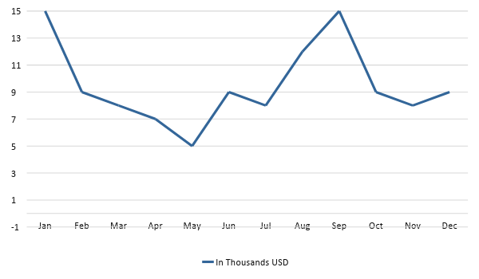

Monthly Revenue

The chart depicts the projected monthly revenue for [2019].
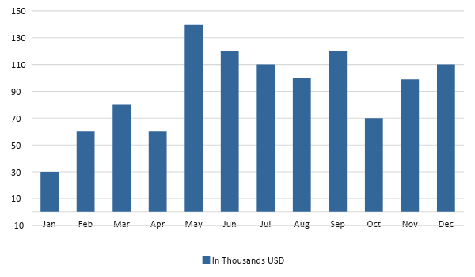

Business Financing

Half of the business’ funding comes from the owner and the other half comes from a bank loan.

Statements

Profit and Loss Projection
 | FY2019 | FY2020 | FY2021
Sales | $400,000.00 | $400,000.00 | $450,000.00
Direct Cost of Sale | $0.00 | $174,000.00 | $0.00
Other Cost of Sale | $130,000.00 | $0.00 | $130,000.00
Total Cost of Goods Sold or COGS (Sales - Direct Cost of Sale - Other Cost of Sale) | $270,000.00 | $226,000.00 | $320,000.00
Gross Profit (Sales-Total Cost of Goods Sold) | $130,000.00 | $174,000.00 | $130,000.00
Gross Margin % (Gross Profit/Sales) | 32.50% | 43.50% | 28.89%
Operating Expenses
Rent | $0.00 | $0.00 | $0.00
Insurance | $0.00 | $10,000.00 | $0.00
Utilities | $20,000.00 | $0.00 | $26,000.00
Salary (Including Tax) | $20,000.00 | $20,000.00 | $20,000.00
Maintenance & Supplies | $3,000.00 | $3,000.00 | $3,000.00
Total Operating Expenses | $43,000.00 | $33,000.00 | $49,000.00
EBITDA (Total Cost of Sale-Total Operating Expenses) | $227,000.00 | $193,000.00 | $271,000.00
Depreciation | $0.00 | $0.00 | $0.00
Interest Expense | $0.00 | $0.00 | $0.00
Taxes Paid | $4,000.00 | $5,000.00 | $6,000.00
Net Profit (Gross Profit - Operating Expenses - Taxes - Interest) | $83,000.00 | $136,000.00 | $75,000.00

Balance Sheet Projection
 | FY2019 | FY2020 | FY2021
Cash | $90,000.00 | $165,000.00 | $165,000.00
Accounts Receivable | $0.00 | $15,000.00 | $11,000.00
Inventory | $3,000.00 | $0.00 | $0.00
Other Current Assets | $5,000.00 | $6,000.00 | $0.00
Total Current Assets | $98,000.00 | $186,000.00 | $176,000.00
Long-Term Assets | $8,000.00 | $7,000.00 | $6,000.00
Accumulated Depreciation | $3,000.00 | $8,000.00 | $8,000.00
Total Long-Term Assets (Long-Term Assets-Accumulated Depreciation) | $5,000.00 | -$1,000.00 | -$2,000.00
Total Assets (Total Current Assets + Total Long-Term Assets) | $103,000.00 | $185,000.00 | $174,000.00
Accounts Payable | $20,000.00 | $30,000.00 | $15,000.00
Notes Payable | $8,000.00 | $8,000.00 | $8,000.00
Other | $3,500.00 | $8,000.00 | $5,000.00
Total Liabilities | $31,500.00 | $46,000.00 | $28,000.00
Paid-in Capital | $10,000.00 | $10,000.00 | $120,000.00
Retained Earnings | $115,000.00 | $120,000.00 | $130,000.00
Total Owner's Equity (Total Assets - Total Liabilities) | $71,500.00 | $139,000.00 | $146,000.00
Total Liabilities & Equity (Total Liabilities/Total Owner's Equity) | 44.06% | 33.09% | 19.18%

Cash Flow Projection
 | FY2019 | FY2020 | FY2021
Operating Cash Beginning | $100,000.00 | $150,000.00 | $160,000.00
Sources of Cash | $0.00 | $18,000.00 | $30,000.00
Receivables | $30,000.00 | $0.00 | $30,000.00
Sales | $30,000.00 | $25,000.00 | $0.00
Others | $0.00 | $0.00 | $8,000.00
Total Cash | $160,000.00 | $193,000.00 | $228,000.00
Expenditures
Rent | $30,000.00 | $30,000.00 | $30,000.00
Insurance | $30,000.00 | $10,000.00 | $15,000.00
Utilities | $20,000.00 | $30,000.00 | $26,000.00
Salary (Including Tax) | $70,000.00 | $30,000.00 | $90,000.00
Maintenance & Supplies | $3,000.00 | $30,000.00 | $4,500.00
Total Expenditures | $153,000.00 | $130,000.00 | $165,500.00
Net Income/Loss (Total Cash - Total Expenditures) | $7,000.00 | $63,000.00 | $62,500.00

