2019 – 2020

REAL ESTATE SALES PLAN

Index

Executive Summary [PAGE NUMBER]

Company Overview [PAGE NUMBER]
Products and Services [PAGE NUMBER]

Marketing Analysis [PAGE NUMBER]
Strategy and Implementation [PAGE NUMBER]

Management and Personnel [PAGE NUMBER]

Sales Action Plan [PAGE NUMBER]

EXECUTIVE SUMMARY

[Lafayette Real Estate], Ltd. is a startup company in the state of [Ohio] offering real estate property services. Buying a house has become more expensive as home prices have increased significantly since the 1960s. Today, the median home listing price in the US is nearly $[280,000], but that varies by state. The company chose to start a real estate company in Ohio as its current sales and price statistics show a positive change in the number of houses sold and average sale price for the year [2018].

[Lafayette] will seek affordable real estate property and offer them to its clients. Additionally, the company is a member of [Ohio’s Real Estate Trade Organization] which will guarantee the buyers of the legality of the sale.

COMPANY OVERVIEW

Mission Statement

It is the mission of [Lafayette] to provide the best holistic real estate services in the state of [Ohio].

Philosophy: [Lafayette] will always focus on continuous adaptation to changes in the real estate market. [Lafayette] strives to be innovative and ambitious in its techniques and strategies.

Vision

The vision of [Lafayette] is to achieve the highest possible standards in the real estate market while establishing the company as the premier and preferred real estate company in the state of [Ohio].

Outlook

In today’s market, where people may have to save as long as ten years to afford a down payment for a real estate property, buying one is a big deal. In the US, the cost of purchasing a real estate property has increased significantly. Today, the median home listing price is $[280,000]. However, Ohio is listed as one with the most affordable places to purchase a property with a median listing price of $[110] per square feet.

Type of Industry: Real Estate Industry

Business Structure: Limited Liability Partnership

Ownership: Limited Liability Partnership
General Partners: [Patricia Stephens and Charles Alexander]
Limited Partners: [Kathleen Williams and Elizabeth Smith]
Managing Partner: [Savannah Lee]

Start-Up Summary

The start-up cost is [100K] USD to be provided by the owners equally and to be used mainly for the rent, insurance, supplies, and payroll.

Start-Up Funding
Start-Up Expenses to Fund | $50,000
Start-Up Assets to Fund | $50,000
Total Funding Required | $100,000
Assets
Non-Cash Assets from Start-Up | $20,000
Cash Requirements from Start-Up | $20,000
Additional Cash Raised | $5,000
Cash Balance on Starting Date | $5,000
Total Assets | $50,000
Capital
Planned Investment
Owner | $100,000
Other | $0
Additional Investment Requirement | $0
Total Planned Investment | $100,000
Loss at Start-Up (Start-Up Expenses) | -$50,000
Total Capital | $50,000
Total Capital and Liabilities | $50,000
Total Funding | $50,000
Start-Up
Requirements
Start-Up Expenses | $25,000
Rent - 1 year | $12,000
Advertising | $1,000
Legal Fees | $10,000
Staff Training | $1,000
Insurance | $1,000
Total Start-Up Expenses | $50,000
Start-Up Assets
Cash Required | $30,000
Start-Up Inventory | $10,000
Other Current Assets | $5,000
Long-Term Assets | $5,000
Total Assets | $50,000
Total Requirements (Total Start-Up Expenses + Total Assets) | $100,000

PRODUCTS AND SERVICES

Description

The primary business of [Lafayette] is to assist home buyers and homeowners with the purchasing and selling of property. [Lafayette] will receive commissions of up to [6]% of the transaction value for each home sold by the business. The company will also provide property management services to residential property owners.

Value Proposition

[Lafayette] serves home buyers and homeowners in [Ohio] in the purchasing and selling of property. The company, being a member of [Ohio’s Real Estate Trade Organization], will be able to sell homes faster than the clients could if they tried to market their home without the assistance of a licensed real estate company.

Pricing Strategy

[Lafayette’s] pricing strategies are the following:

- Competitive pricing. Lafayette will compare similar sales within the area no further back than three months.

- Setting a realistic price with the homeowner. Communicate with the homeowner as to the lowest price that the homeowner is willing to sell the property for.

- Understanding the seller. If there are a lot of interested buyers, the highest offer will dictate the final selling price.

- Not setting a price. One of the best pricing strategy with respect to prestige properties is to allow the buyer to set the price based on their target.

MARKETING ANALYSIS

The real estate industry has continued to grow over the last ten years. Currently, the economic marketing condition in the US is moderate. The growth of the industry has been tremendous and this trend is expected to continue. The advent of the Internet and the use of social media has allowed even startup companies to engage in the business of real estate by maintaining a presence on the Internet.

Market Segmentation

[Lafayette] will focus its market and sales strategy on the following demographics:

- Renters
- Families
- First time home buyers

In connection with this, Lafayette is focused on assisting its clients throughout the whole legal process. [Lafayette] will always put the needs of the customers first and believes that by doing so, it will benefit marketing and sales.

The table below shows which types of real estate houses are more popular and at what demographics.

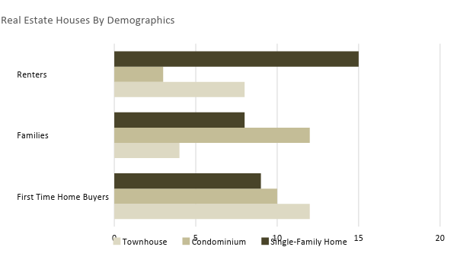

Target Market Segmentation Strategy

Renters

- [Lafayette] will be developing their company website and create a social media account to establish an Internet presence.
Families

- [Lafayette] will be implementing a local campaign through the use of local newspaper advertisements and flyers.
First time home buyers

- [Lafayette] will establish strong relationships with other real estate agents and companies within the area.

STRATEGY AND IMPLEMENTATION

Target Market Strategy

[Lafayette] aims to achieve a break-even in its sales by the second year of business operations. This will be accomplished by developing an online presence, implementing a local campaign, and establishing relationships with other real estate agents and companies.

Competitive Edge

[Lafayette] is adopting several pricing strategies in order to establish its brand in the state. The table below provides a quick look at how it compares with two of its biggest competitors.

SWOT Analysis | Strengths | Weaknesses | Opportunities | Threats
[Lafayette Real Estate, Ltd.] | - The company is a member of Ohio’s Real Estate Trade Organization  - The team is composed of professional real estate agents  - Adaptable to changes | - Still new in the business  - Has not yet established a strong relationship with financial institutions so legal procedures will take time | - There is still a big opportunity to increase Internet presence, which will increase brand recognition | - More companies are getting into the real estate business  - There is a higher level of financial and legal risks
[L.L. Berger] | - The company has a higher level of available resources  - Offers real estate properties that are located in the center of the state and is highly accessible | - Low brand recognition | - Use of new technologies  - Opportunity to implement strategic real estate visibility | - Changes in the real estate market  - Rapid changes in the real estate positioning environment
[Handy City, Inc.] | - The company has been in the real estate business for 20 years and has established goodwill and a proven track record  - The goodwill of the company among financial institutions benefits the customers in a smooth flow of work and legal procedures | - High level of resistance and adaptability to changes | - Opportunities to implement innovations in communication | - Changes in potential buyers’ preferences

Sales Strategy and Forecast

Lafayette will be developing its own online website and cultivate its online presence by acquiring accounts from major online real estate portals. Generally, the company will be using an Internet-based sales strategy.

With an improved online presence, the company targets the following monthly sales for [2019]:

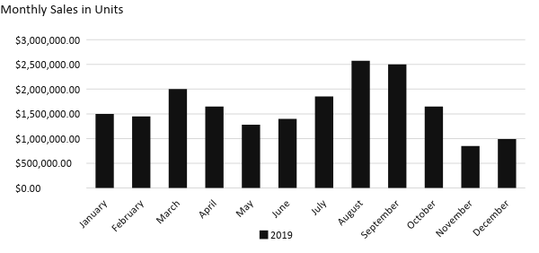
With an increased online presence, the table provided below depicts the company’s projected percentage growth in 2 years.

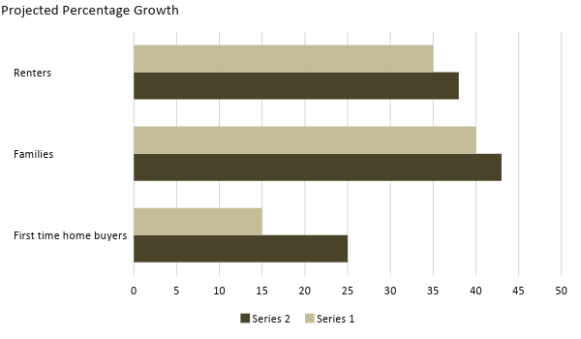

Emphasis is placed on the company’s online presence to meet the forecasted sales goals.

Sales Strategy | Activities | Timeline | Success Criteria
Company website | - The company will outsource its IT services. The website must contain all the necessary information about the company and must contain all the real estate property listings. | - Estimated date of development of the company website: January 15, 2019  - Estimated date of finalizing the information placed on the website: January 25, 2019 | - Outsource IT services by [January 2, 2019]  - The website is fully operational by the end of [January 2019].
Social media accounts | - The trend in sales and marketing calls for the need to establish social media accounts. The sales and marketing team will have sessions on how to improve its social media presence and on how to attract clients and customers. | - Target date of finalizing the social media accounts: January 2, 2019  - Training and sessions: second and third week of January 2019 | - The social media accounts are fully operational and updated by the end of [January 2019].  - Outsource speakers for the training sessions by [January 3, 2019].

MARKETING STRATEGY

[Lafayette] plans to use an Internet-based marketing strategy. This is very important because most people who are seeking to purchase real estate property use the Internet to conduct their preliminary searches. [Lafayette] will be developing its own website and will be establishing social media accounts so that potential buyers can easily reach [Lafayette]. Lafayette will also maintain a sizable amount of print and traditional advertising methods for the local market.

[Lafayette] has already established its marketing team and a part of its duties is to manage the company website and social media accounts. The marketing manager will be the head of the marketing team and shall be working closely with the sales manager who, in turn, will provide all the information necessary for the company’s website and social media accounts.

The team has kicked-off various activities to move the marketing strategy forward. Here are some of the updates:

Milestones

Marketing Strategy | Activities | Timeline | Success Criteria
Company Website Development | HR will outsource the IT services for the development of the company website  HR will hire a new front-end developer who will report to the content marketing team | January 2, 2019 | The developer will fully develop the website by the end of [January 2019].
Social Media Accounts | The marketing team will create accounts for the following social media platforms: Facebook, Twitter, Instagram, LinkedIn | January 2, 2019 | The social media accounts are already operational by [January 14, 2019].
Printing of advertisements on newspapers and flyers | The first draft is currently in review with management.  The marketing team is currently in contact with newspaper companies to discuss the advertisement rates. | Flyers: January 7, 2019.  Newspapers: January 10, 2019 | Final draft for the flyers on or before [January 10, 2019].  The rates for the advertisement is finalized on or before [January 14, 2019].

MANAGEMENT AND PERSONNEL

The managing partner will be the head of the company. The staff shall be divided into two departments: Operations Department and Administrative Department.

The head of each team under the Operations Department reports to the managing partner. Under this department are:

- Agent management team - manages all the real estate agents

- Listing procurement team - procures all the list of houses and the corresponding prices

- Commission disbursement team - disburses all the necessary commissions to the real estate agents

The head of each team under the Administrative Department reports to the managing partner. Under this department are the:

- Sales team - manages all sales-related transactions

- Marketing team - manages all marketing-related transactions (company website development, the establishment of social media accounts, and the advertisements on newspapers and the printing of flyers)

- Accounting team - manages all accounting-related transactions

Below is the organizational structure of the company:

General Partners
Limited Partners
Managing Partner
Operations Department
Administrative Department
Agent Management
Listing Procurement
Commission Disbursement
Sales
Marketing
Accounting

SALES ACTION PLAN

The table below provides the sales goals and their corresponding activities with details on the target dates, resources, person-in-charge, and key performance indicators (KPIs) to measure their success.

Sales Goals | Action Items | Start Date | End Date | KPIs | Owner
Obtain [3]% increase in customer listings for the 2nd until the 4th quarter of 2019 | Assign real estate agents in the field to conduct a preliminary search on real estate properties | January 2, 2019 | No end dates | Obtained a list of properties for sale which are not in the state listing and communicated with the owner to offer the services of the company | Sales, agent management, and list procurement teams
Align the sales goals with the marketing team’s strategy | Assign real estate agents for desk work to conduct an Internet search on websites and social media groups for prospective customers | January 2, 2019 | No end dates | Aligned goals and objectives, saving time and resources for the company | Sales and marketing teams

