RADIO STATION BUSINESS PLAN

[June 1, 2019]
[Lucas Kelly] [kellyllradio@bing.com]
[501-341-1186] [www.lrradio923.com]
[3030 Mulberry Avenue Little Rock, AR 72211, USA]

INDEX
[Page Number]
[Page Number]
[Page Number]
[Page Number]
[Page Number]
[Page Number]

Executive Summary
Company Overview
Products and Services
Execution
Operational Plan
Financial Plan

Executive Summary:

Little Rock [(LR) Radio] is a new radio station in Little Rock, Arkansas that targets audiences aged [12] and above. It regularly plays music genres that are not commonly played in the city such as electronic, alternative, pop rock, and hard rock. The station covers the whole city of Little Rock and parts of Benton and Jacksonville. It will also set up its own website which will be made accessible to a wide range of audiences all over the country.

Company Overview:

Mission Statement: [LR Radio] aims to bring a new range of music genres to the younger population of Little Rock.

Philosophy: [LR Radio] thrives on the value of adaptability in the ever-changing world of music.

Vision: [LR Radio] aims to take the radio station business into the digital world.

Outlook: Digital technology has disrupted many industries, including the radio broadcasting industry, since its evolution. There has been a struggle among traditional radio operators on how to best integrate digital technology into their businesses. Spending on radio is decreasing and will continue to decline in the coming years. In light of this trend, [LR Radio] will adopt new ways to integrate digital technology into its process and leverage its marketing power to attract more clients.

Type of Industry: Radio Broadcasting Industry

Business Structure: Sole Proprietorship

Ownership: Sole Proprietorship, Lucas Kelly

Start-Up Summary: The overall cost for the start-up is [$80,000,] which is provided solely by the owner. The funds will be used for rent, initial supplies, maintenance, insurances, and payroll.

Start-Up Funding
Start-Up Expenses | $25,000
Start-Up Assets | $55,000
Total Funding Required | $80,000
Assets
Non-Cash Assets from Start-Up | $20,000
Cash Requirements from Start-up | $12,000
Additional Cash Raised | $11,000
Cash Balance on Starting Date | $12,000
Total Assets | $55,000
Capital
Planned Investment
Owner | $80,000
Other | $0
Additional Investment Requirement | $0
Total Planned Investment | $80,000
Loss at Start-Up (Start-Up Expenses) | -$25,000
Total Capital | $55,000
Liabilities | $0
Total Capital and Liabilities | $55,000
Start-Up
Requirements
Start-Up Expenses
Advertising | $2,000
Staff Training | $2,500
Insurance | $1,100
Other | $4,500
Total Start-Up Expenses | $25,000
Start-Up Assets
Cash Required | $12,000
Start-Up Inventory | $20,000
Other Current Assets | $11,000
Long-Term Assets | $12,000
Total Assets | $55,000
Total Requirements (Total Start-Up Expenses + Total Assets) | $80,000

Management Team:

Management Team | Role/Function | Skills
Ricky D. Rourke | Station Manager | Business Management, Personnel Management, Radio Operation, and Critical-thinking
Jack L. McDonald | Sales and Marketing Manager | Commercial Awareness, Promotional, Client Relation, and Creativity

Short- and Long-Term Goals and Milestones:

Short-Term Goals | Milestones
Start selling digital marketing services by the end of the year | The managers have already discussed this matter last May 4, 2019
Launch digital marketing campaign by the end of the second quarter | Hired a sales and marketing manager last February 14, 2019 to lead the campaign
Long-Term Goals | Milestones
Increase monthly listeners by 12% in the next two years | The marketing team will discuss its latest campaign this week
Increase annual revenue by 35% in the next four years | The CEO and the sales and marketing manager have discussed this matter last May 3, 2019

Products and Services

Product/Service Description: [LR Radio] provides a new set of genres of music to young adult and adult listeners in Little Rock City. The company recognizes that there is a need for electronic, alternative, pop rock, and hard rock genres in the city for the identified market segments.

Value Proposition: [LR Radio] provides a new set of music genres that are seldom played in the city. It specificaly targets young adults and older generations.

Pricing Strategy: [LR Radio] currently generates its income by selling radio spots to advertisers using this pricing formula: Number of People Listening x Cost to Reach [1,000] listeners (CPM) = Cost of Advertising Per Spot. [LR Radio’s] CPM rate is [$11-$15].

Formula:
Profit Margin = 1- (Expenses/Net Sales)

[LR Radio]
Profit Margin = 1 - ($170,000/$173,000)
= 1-0.982
= 0.018 or 1.8%

Execution

Marketing Plan: [LR Radio’s] marketing plan follows the traditional methods of marketing. However, with the advent of the internet, it will utilize several online approaches, such as social media marketing and website optimization, in order to keep up and stay relevant in the digital world.
Market Research: Little Rock has [197,640] people, and more than [40%] of these are adults and young adults who regularly listen to radio broadcasts. Many of these listeners enjoy their music inside their cars while driving, although some prefer using the digital media platforms where they have more freedom to choose what type of music they’d like to listen to.

In other words, the company is currently competing for audiences against emerging digital media platforms. One way to overcome this is to integrate digital technology into the company’s operations and start leveraging its marketing capacity to attract more clients and advertisers.

SWOT Analysis | Strengths | Weaknesses | Opportunities | Threats
[LR Radio] | - Flexible to the current demands of the market  - Currently has a low cost of operations | Difficulty in attracting new audiences | - Getting into the digital space can broaden the audience of the station  - Strengthening and optimizing the company’s website can improve brand presence | The emergence of digital media platforms
RadioDotComm | - Has a specific target audience  - Has good-performing radio jockeys | Limited range of music being broadcasted | Opportunity to gain new audiences in the digital space | Tight competition within the industry along with the emergence of the digital media platforms
CBTN LoveRadio | A popular radio station in Little Rock | Is not able to convert its audience to follow their music online | Still has strong advertising gains due to its popularity | The shift of consumer behavior; from radio broadcasts to digital media platforms

Marketing Strategy: [LR Radio] will focus its marketing efforts on creating effective online marketing strategies. The station will start optimizing its website to improve traffic and increase its visibility. Then, the company will start hiring content creators to start creating content that is relevant to the station’s main audience. The station will also be active on several social media platforms such as Facebook, Twitter, and Instagram. Marketing lists will also be built to further increase the station’s contacts and leads.

The rest of the efforts will be on the promotions outdoor such as sponsorships of live events and community involvement. In a year, the station will also start selling services such as online radio commercials, web design, print design, digital advertising, and other marketing services, slowly turning it into a full-service marketing agency to increase its relevance in the media industry.

The team has started executing some of the activities to move the marketing strategy forward. Here is their progress so far:

Marketing Strategy | Activities | Timeline | Success Criteria
Website optimization | The team has hired an SEO specialist and the project is already in progress | June 25, 2019 | Increase company website visibility and ranking
Blogging and content creation | The team has hired a copywriter and has started researching for contents | June 4, 2019 | Blogs and other relevant contents will be posted regularly
Organizational Structure:

CEO
STATION MANAGER
SALES AND MARKETING MANAGER
RADIO JOCKEY 1
RADIO JOCKEY 2
SALES ASSISTANT
MARKETING ASSISTANT

Operational Plan:
Location and Facilities

Provide a sketch or blueprint of the facility.

Provide photos or images of the location/facility.

Tools and Equipment Checklist

Software | Quantity
Mixxx | 2
LadioCast | 2
Hardware | Quantity
Audio Console | 2
Microphone | 2
Microphone Arm | 4
Cue Speakers | 4
Headphones | 3

IT Infrastructure
The following table reflects [LR Radio] IT infrastructure.

Infrastructure | Existing (Y/N) | Description
Radio Broadcasting Software | Y | The station uses Mixxx and LadioCast to enhance its broadcasting operations.
Broadcast Audio Processor | Y | Improves the sound that the station produces

Financial Plan
Assumptions

[LR Radio’s] financial forecast is based on the current status of the industry, the trends in the digital advertising industry, and the performance of its competitors. Most of the company’s expenses will be on rent, payroll, supplies, maintenance, and insurances.

Monthly Expense
The chart shows [LR Radio’s] projected monthly expenses for [2019].

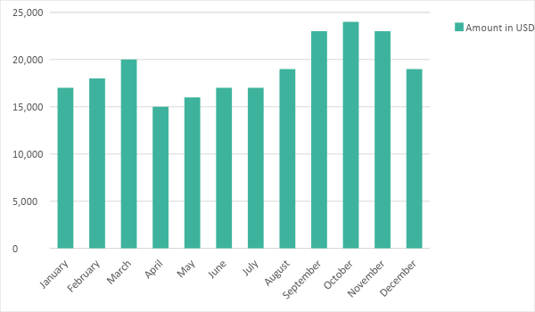

Monthly Revenue
The chart depicts [LR Radio’s] projected monthly revenues for [2019].

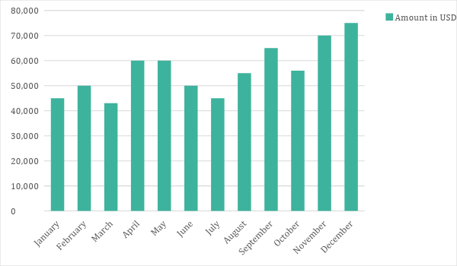

Business Financing
The business is solely funded by the owner worth [$80,000]. The majority of the expenses will be on rent, initial supplies, maintenance, permits, business insurances, and payroll.

Statements

Profit and Loss Projection
 | FY2019 | FY2020 | FY2021
Sales | $670,000.00 | $750,000.00 | $890,000.00
Direct Cost of Sale | $160,000.00 | $170,000.00 | $185,000.00
Other Cost of Sale | $13,000.00 | $13,000.00 | $15,000.00
Total Cost of Goods Sold or COGS (Sales - Direct Cost of Sale - Other Cost of Sale) | $497,000.00 | $567,000.00 | $690,000.00
Gross Profit (Sales-Total Cost of Goods Sold) | $173,000.00 | $183,000.00 | $200,000.00
Gross Margin % (Gross Profit/Sales) | 25.82% | 24.40% | 22.47%
Operating Expenses
Rent | $40,000.00 | $45,000.00 | $45,000.00
Insurance | $15,000.00 | $15,000.00 | $15,000.00
Utilities | $25,000.00 | $26,000.00 | $27,000.00
Salary (Including Tax) | $80,000.00 | $80,000.00 | $90,000.00
Maintenance & Supplies | $10,000.00 | $10,000.00 | $12,000.00
Total Operating Expenses | $170,000.00 | $176,000.00 | $189,000.00
EBITDA (Total Cost of Sale-Total Operating Expenses) | $327,000.00 | $391,000.00 | $501,000.00
Depreciation | $2,000.00 | $3,000.00 | $4,000.00
Interest Expense | $0.00 | $0.00 | $0.00
Taxes Paid | $3,000.00 | $4,000.00 | $5,000.00
Net Profit (Gross Profit - Operating Expenses - Taxes - Interest) | $0.00 | $3,000.00 | $6,000.00

Balance Sheet Projection
 | FY2019 | FY2020 | FY2021
Cash | $160,000.00 | $170,000.00 | $185,000.00
Accounts Receivable | $30,000.00 | $40,000.00 | $50,000.00
Inventory | $6,000.00 | $8,000.00 | $9,000.00
Other Current Assets | $10,000.00 | $10,000.00 | $10,000.00
Total Current Assets | $206,000.00 | $228,000.00 | $254,000.00
Long-Term Assets | $20,000.00 | $20,000.00 | $25,000.00
Accumulated Depreciation | $5,000.00 | $5,000.00 | $5,000.00
Total Long-Term Assets (Long-Term Assets-Accumulated Depreciation) | $15,000.00 | $15,000.00 | $20,000.00
Total Assets (Total Current Assets + Total Long-Term Assets) | $221,000.00 | $243,000.00 | $274,000.00
Accounts Payable | $15,000.00 | $20,000.00 | $25,000.00
Notes Payable | $12,000.00 | $14,000.00 | $15,000.00
Other | $5,000.00 | $5,000.00 | $6,000.00
Total Liabilities | $32,000.00 | $39,000.00 | $46,000.00
Paid-in Capital | $55,000.00 | $60,000.00 | $80,000.00
Retained Earnings | $200,000.00 | $260,000.00 | $300,000.00
Total Owner's Equity (Total Assets - Total Liabilities) | $189,000.00 | $204,000.00 | $228,000.00
Total Liabilities & Equity (Total Liabilities/Total Owner's Equity) | 16.93% | 19.12% | 20.18%

Cash Flow Projection
 | FY2019 | FY2020 | FY2021
Operating Cash Beginning | $160,000.00 | $170,000.00 | $185,000.00
Sources of Cash | $24,000.00 | $25,000.00 | $30,000.00
Receivables | $20,000.00 | $20,000.00 | $20,000.00
Sales | $50,000.00 | $50,000.00 | $56,000.00
Others | $12,000.00 | $14,000.00 | $16,000.00
Total Cash | $266,000.00 | $279,000.00 | $307,000.00
Expenditures
Rent | $40,000.00 | $45,000.00 | $45,000.00
Insurance | $15,000.00 | $15,000.00 | $15,000.00
Utilities | $25,000.00 | $26,000.00 | $27,000.00
Salary (Including Tax) | $80,000.00 | $80,000.00 | $90,000.00
Maintenance & Supplies | $10,000.00 | $10,000.00 | $12,000.00
Total Expenditures | $170,000.00 | $176,000.00 | $189,000.00
Net Income/Loss (Total Cash - Total Expenditures) | $96,000.00 | $103,000.00 | $118,000.00

