Business Plan For Fiscal Year 2019

[March 10, 2018]

[Charles Rhodes]
[crhodes@victrola.com]
[206 301 2656]
[http://victrolaclub.com]
[2957 Owagner Lane
Seattle, WA 98119]

NIGHTCLUB BUSINESS PLAN

Index

Executive Summary [PAGE NUMBER]

Company Overview [PAGE NUMBER]

Products and Services [PAGE NUMBER]

Execution [PAGE NUMBER]

Operational Plan [PAGE NUMBER]

Financial Plan [PAGE NUMBER]

EXECUTIVE SUMMARY

[Victrola Nightclub] will be the most sought-after, high-energy nightclub in [Seattle, Washington]. A simple, yet unique themed atmosphere creates a sense of magic and belonging for locals and tourists.

[Victrola Nightclub] capitalizes on its excellent location and will launch the venue with a highly-publicized grand opening. With a combination of entertainment, distinctive design, and exceptional service, the company believes that the club appeals to the masses and the upper-classes.

COMPANY OVERVIEW

Mission Statement

[Victrola Nightclub] wants to create a mystifying environment that satisfies the changing tastes of its customers.

Philosophy

[Victrola Nightclub] believes that accessibility and dedication to service are essential in the industry and, thus, puts its employees in the highest regard to ensure that every customer finds his/her experience at the club enjoyable.

Vision

[Victrola Nightclub] sees itself as the leading entertainment establishment that provides its customers with an enjoyable, but safe experience.

Outlook

The bar and nightclub industry has grown a significant [3.4]% in the United States in the past few years, and is expected to reach the $[27 billion] revenue ceiling in [2019]. With over [70,000] nightclubs around the country, this is an industry that is not expected to plateau in its growth soon.

Type of Industry: Nightclub Industry

Business Structure: Sole Proprietorship

Ownership: Sole Proprietorship, [Charles Rhodes]

Start-Up Summary

[Victrola Nightclub] will need renovations and upgrades that will require $[70,000] and a bar and music equipment that will cost around $[65,000]. Together with other expenses for salaries, insurance, and maintenance, the owner will put up an amount of $[200,000].

Start-Up Funding
Start-Up Expenses | $100,000.00
Start-Up Assets | $100,000.00
Total Funding Required | $200,000.00
Assets
Non-Cash Assets from Start-Up | $40,000.00
Cash Requirements from Start-up | $20,000.00
Additional Cash Raised | $10,000.00
Cash Balance on Starting Date | $30,000.00
Total Assets | $100,000.00
Capital
Planned Investment
Owner | $200,000.00
Other | $0.00
Additional Investment Requirement | $0.00
Total Planned Investment | $200,000.00
Loss at Start-Up (Start-Up Expenses) | -$100,000.00
Total Capital | $100,000.00
Liabilities | $0.00
Total Capital and Liabilities | $100,000.00
Start-Up
Requirements
Start-Up Expenses
Rent - 5 Months | $15,000.00
Advertising | $3,000.00
Legal Fees | $5,000.00
Staff Training | $65,000.00
Insurance | $12,000.00
Other | $0.00
Total Start-Up Expenses | $100,000.00
Start-Up Assets
Cash Required | $60,000.00
Start-Up Inventory | $10,000.00
Other Current Assets | $12,000.00
Long-Term Assets | $18,000.00
Total Assets | $100,000.00
Total Requirements (Total Start-Up Expenses + Total Assets) | $200,000.00

Management Team:

Management Team | Role/Function | Skills
[Erik Fisher] | Club Manager | Leadership, Organization, Keen Eye for Detail, Technical
[Jenny Jameson] | Marketing and Sales | Sales Talk, Creativity, Teamwork
[Daniel Goldberg] | Security and Maintenance | Technical Skills, Security Training, Personal Effectiveness

Short- and Long-Term Goals and Milestones

Short-Term Goals | Milestones
Hire 4 DJs with distinctive musical taste and style | Hired 2 excellent DJs  Other applicants still for scheduled for interviews
Gain attention from the target audience | Social media pages have over 5,000 likes and increasing engagement
Long-Term Goals | Milestones
Build a loyal client base that consistently gets the club at [85-100]% capacity on weekends for a year
Ensure improving sales margins at [5]% increase every month in the first year and at [10]% in the second year of operation

PRODUCTS AND SERVICES

Product/Service Description

[Victrola Nightclub] will offer late-night entertainment in the local area with a casual food menu that consists of appetizers and entrees, as well as alcoholic and non-alcoholic beverages.

Value Proposition

To set itself apart from other nightclubs in the area, [Victrola Nightclub] promises nights of safe fun, variety, and mystery, and offerings of menu varieties and distinctive music.

Pricing Strategy

All menu items will be moderately priced. An average guest expenditure is estimated to be at $[35].
EXECUTION

Marketing Plan

[Victrola Nightclub] will utilize both traditional and modern marketing strategies. However, the company firmly believes that client satisfaction will be its best marketing tool and that word-of-mouth is the best type of advertisement. It will also offer discounts and accept referrals to foster better relationships with its clients and expand the business at the same time.

Market Research

Despite the competition, rising consumer spending and alcohol consumption bolster the nightclub industry. The overall growth of the industry is expected to reach a rate of [3]% and revenue of up to $[27 billion]. [Victrola Nightclub] appeals to three major market segments of individuals between [21-35] years old as shown in the chart below.

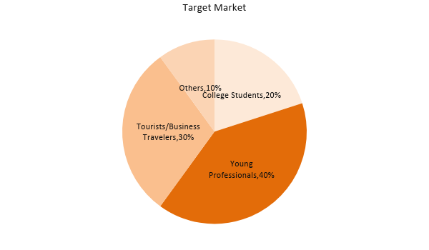
SWOT Analysis | Strengths | Weaknesses | Opportunities | Threats
[Victrola Nightclub] | Prime location | New business with financial limitations |  | Complaints from customers impact revenue
[Tric Bar and Club] | Affordable food and drinks | Inability to keep up with consumer demands |  | Increasing supplier prices may narrow sales margins
[Shadow Play] | Established club with a strong image | Expensive entrance fees |  | An economic downturn can affect sales

Marketing Strategy

[Victrola Nightclub] will start its operation with a grand opening weekend in [March 2019] and a cheaper cover charge for the first [250] customers. Following the grand opening, the club will focus its marketing efforts on online advertising by updating customers on new club events, themes, and promotional drinks.

Marketing Strategy | Activities | Timeline | Success Criteria
Online and Social Media Marketing | Created the club website and social media accounts | ASAP | The club’s social media accounts already have a large audience following.
Grand Opening Weekend Party | Grand opening party | March 23, 2019 | Have at least 400 customers in attendance
Weekly Promotional Food or Drinks | Created a list of food or drink menu items that will serve as promotional products | Every 1st day of the month | Increased the number of customers during nights with promotional activities.

Organizational Structure

CEO
Club Manager
Bar Staff
Kitchen Staff
Security
Maintenance
Marketing
Entertainment

OPERATIONAL PLAN

Location and Facilities

The following shows the layout of the club, with two different bar areas to make them more accessible to the customers.
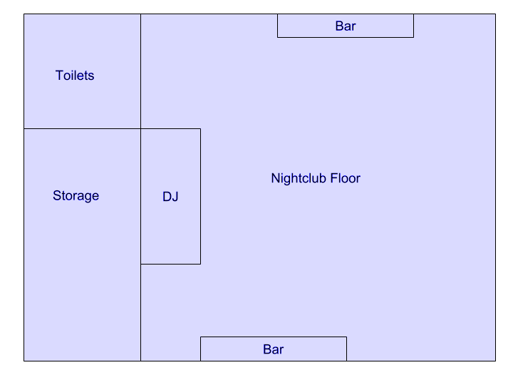

FINANCIAL PLAN

Assumptions

The following assumptions are based on ongoing trends in the nightclub industry.

Monthly Expense

The chart shows the projected monthly expenses for [2019].

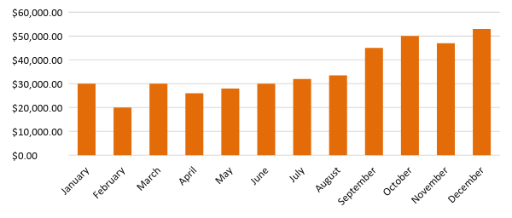
Monthly Revenue

The chart depicts the projected monthly revenue for [2019].

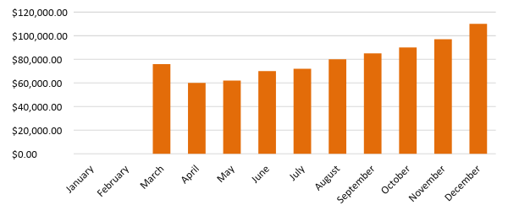

Business Financing

The business shall be funded by the owner and used mainly for renovations, purchase of furniture and supplies, rent, payroll, and utilities.

Statements

Profit and Loss Projection
 | FY2019 | FY2020 | FY2021
Sales | $802,000.00 | $1,200,000.00 | $1,500,000.00
Direct Cost of Sale | $400,000.00 | $700,000.00 | $950,000.00
Other Cost of Sale | $13,000.00 | $25,000.00 | $33,000.00
Total Cost of Goods Sold or COGS (Sales - Direct Cost of Sale - Other Cost of Sale) | $389,000.00 | $475,000.00 | $517,000.00
Gross Profit (Sales-Total Cost of Goods Sold) | $413,000.00 | $725,000.00 | $983,000.00
Gross Margin % (Gross Profit/Sales) | 51.50% | 60.42% | 65.53%
Operating Expenses
Rent | $36,000 | $36,000 | $36,000
Insurance | $12,000 | $12,000 | $12,000
Utilities | $45,000 | $50,000 | $60,000
Salary (Including Tax) | $250,000 | $275,000 | $300,000
Maintenance & Supplies | $20,000 | $23,000 | $25,000
Total Operating Expenses | $363,000.00 | $396,000.00 | $433,000.00
EBITDA (Total Cost of Sale-Total Operating Expenses) | $26,000.00 | $79,000.00 | $84,000.00
Depreciation | $3,000.00 | $4,000.00 | $4,000.00
Interest Expense | $0.00 | $0.00 | $0.00
Taxes Paid | $4,000.00 | $5,000.00 | $6,000.00
Net Profit (Gross Profit - Operating Expenses - Taxes - Interest) | $46,000.00 | $324,000.00 | $544,000.00

Balance Sheet Projection
 | FY2019 | FY2020 | FY2021
Cash | $120,000.00 | $500,000.00 | $700,000.00
Accounts Receivable | $10,000.00 | $15,000.00 | $11,000.00
Inventory | $10,000.00 | $12,000.00 | $15,000.00
Other Current Assets | $55,000.00 | $6,000.00 | $8,000.00
Total Current Assets | $195,000.00 | $533,000.00 | $734,000.00
Long-Term Assets | $50,000.00 | $70,000.00 | $60,000.00
Accumulated Depreciation | $3,000.00 | $2,500.00 | $2,000.00
Total Long-Term Assets (Long-Term Assets-Accumulated Depreciation) | $47,000.00 | $67,500.00 | $58,000.00
Total Assets (Total Current Assets + Total Long-Term Assets) | $242,000.00 | $600,500.00 | $792,000.00
Accounts Payable | $15,000.00 | $17,000.00 | $20,000.00
Notes Payable | $5,000.00 | $6,000.00 | $8,000.00
Other | $3,500.00 | $7,000.00 | $5,000.00
Total Liabilities | $23,500.00 | $30,000.00 | $33,000.00
Paid-in Capital | $5,000.00 | $5,000.00 | $5,000.00
Retained Earnings | $46,000.00 | $324,000.00 | $524,000.00
Total Owner's Equity (Total Assets - Total Liabilities) | $218,500.00 | $570,500.00 | $759,000.00
Total Liabilities & Equity (Total Liabilities/Total Owner's Equity) | 10.76% | 5.26% | 4.35%

Cash Flow Projection
 | FY2019 | FY2020 | FY2021
Operating Cash Beginning | $50,000.00 | $664,000.00 | $1,671,000.00
Sources of Cash | $20,000.00 | $26,000.00 | $40,000.00
Receivables | $150,000.00 | $170,000.00 | $200,000.00
Sales | $802,000.00 | $1,200,000.00 | $1,500,000.00
Others | $5,000.00 | $7,000.00 | $8,000.00
Total Cash | $1,027,000.00 | $2,067,000.00 | $3,419,000.00
Expenditures
Rent | $36,000 | $36,000 | $36,000
Insurance | $12,000 | $12,000 | $12,000
Utilities | $45,000 | $50,000 | $60,000
Salary (Including Tax) | $250,000 | $275,000 | $300,000
Maintenance & Supplies | $20,000 | $23,000 | $25,000
Total Expenditures | $363,000.00 | $396,000.00 | $433,000.00
Net Income/Loss (Total Cash - Total Expenditures) | $664,000.00 | $1,671,000.00 | $2,986,000.00

To Use This Documents
The text inside the brackets which is highlighted is meant to be edited with your text. This is the way you can edit the document as given below:

To Edit Text:
- Point the mouse where you want to edit and delete the sample text and then you can add your text.
- You can change the size, font & color of the text in the Main Tab: Home

To Edit Table:
- Point the mouse in the table where you want to edit and delete the sample text and then you can add your text.
- You can adjust the row & column size of the table in the Main Tab: Layout

To Edit Chart:
- Select the chart which is going to edit and then
- In Main tab: Design -> Edit Data
- It will open the excel sheet where you can edit the values of the chart

