LAUNDRY BUSINESS PLAN
Business Plan For Fiscal Year 2020
July 1, 2020
[Cheryl Downing] [cherdowning@gmail.com]
[303-965-9491] [www.coinwashexpress.com]
[2076 S University Blvd University Park, Denver, CO 80210, USA]

INDEX
Executive Summary
Company Overview
Products and Services
Execution
Operational Plan
Financial Plan
[Page Number]
[Page Number]
[Page Number]
[Page Number]
[Page Number]
[Page Number]

Executive Summary:

[Coin Wash Express] is a laundromat purposely intended for university students and working professionals in Denver, Colorado. The company also employs laundry assistants to aid customers every time they needed help. Providing self-service laundry, the company hopes to attract customers who prefer to use coin-powered washing machines and dryers.

[Coin Wash Express] aims to establish a good brand and reputation as a laundry service provider in Denver, Colorado by utilizing both traditional and online advertising strategies.

Company Overview:

Mission Statement: [Coin Wash Express] delivers cost-efficient laundry services to university students and working professionals by providing high-quality and efficient coin-operated machines and affordable laundry essentials.

Philosophy: [Coin Wash Express] strives to deliver customers’ laundry needs through dedication to service and commitment to provide customer satisfaction.

Vision: [Coin Wash Express] aims to become the most patronized laundromat among university students and working professionals.

Outlook: The laundromat industry is currently declining with the increase in purchasing power among high-income households. However, an opportunity arises with the growing demand for laundry services among university students and working professionals. The company expects a [25-40%] increase in profit during its first years of operation due to its strategic location.

Type of Industry: Laundromat Industry

Business Structure: Sole Proprietorship

Ownership: Sole Proprietorship, Cheryl Downing

Start-Up Summary: [Coin Wash Express]has a total start-up cost of [750K] USD. The owner assumes the responsibility of paying for the company’s initial funds.

Start-Up Funding
Start-Up Expenses | $117,700
Start-Up Assets | $632,300
Total Funding Required | $750,000
Assets
Non-Cash Assets from Start-Up | $509,300
Cash Requirements from Start-up | $15,000
Additional Cash Raised | $98,000
Cash Balance on Starting Date | $10,000
Total Assets | $632,300
Capital
Planned Investment
Owners | $750,000
Other | $0
Additional Investment Requirement | $0
Total Planned Investment | $750,000
Loss at Start-Up (Start-Up Expenses) | -$117,700
Total Capital | $632,300
Liabilities | $0
Total Capital and Liabilities | $632,300
Start-Up
Requirements
Start-Up Expenses
Rent - 6 Months | $11,000
Advertising | $3,500
Legal Fees | $1,000
Staff Training | $4,500
Insurance | $2,700
Other | $95,000
Total Start-Up Expenses | $117,700
Start-Up Assets
Cash Required | $25,000
Start-Up Inventory | $109,300
Other Current Assets | $98,000
Long-Term Assets | $400,000
Total Assets | $632,300
Total Requirements (Total Start-Up Expenses + Total Assets) | $750,000

Management Team:

Management Team | Role/Function | Skills
Cheryl Downing | General Manager | Leadership, Decision-Making, Communication, Conflict Management
Ann Ward | Marketing Associate | Planning and Organization, Market Awareness, Attention to Detail, Time Management

Short- and Long-Term Goals and Milestones:

Short-Term Goals | Milestones
Install washing machines and dryers | Completed installation of laundry equipment last June 1, 2020.
Hire customer assistants and maintenance personnel | Scheduled final interviews for the shortlisted applicants.
Long-Term Goals | Milestones
Establish a good brand and reputation as a laundromat | Secured a strategic location to open the business
Secure a solid customer base | Distributed flyers to people living near the business location

Products and Services

Product/Service Description: [Coin Wash Express] provides coined laundry services to university students and working professionals within the area. The customer may choose to do self-service laundry or to request an assistant to do the laundry in his/her stead for an affordable price.

Value Proposition: [Coin Wash Express] ensures customers of invaluable and cost-efficient laundry services in a well-maintained area.

Pricing Strategy: [Coin Wash Express] uses penetration pricing as its strategy. The company prices its laundry services at [$5] per standard load of laundry. For its self-service coined laundry, the company charges [$2.75] for washing machines and [$ 1.50] for dryers.

Execution

Marketing Plan: [Coin Wash Express] plans to create a good brand and reputation as a laundromat in Denver, Colorado. The company aims to secure a customer base among university students and working professionals using both conventional and online marketing strategies.

Market Research: The demand for laundromats is slightly decreasing among high-income households but is increasing among university students and working professionals in Denver, Colorado. The chart below shows the company’s market survey results.
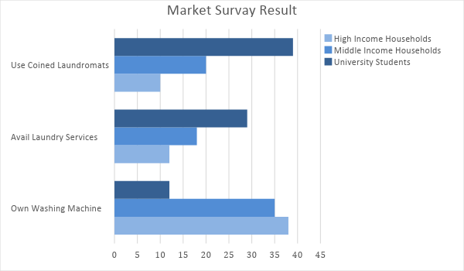

SWOT Analysis | Strengths | Weaknesses | Opportunities | Threats
Coin Wash Express | Inexpensive charge for use of laundry supplies and machines | Lack of presence in the market | Students and professionals are looking for an affordable laundry service provider | The immense influence of established laundry businesses in the market
Denver Express Laundry | Current trusted brand of working professionals for laundry services | Highly expensive charges | There are people who avail of their service despite the high cost | Emerging laundry service businesses that offer lower charges
Coined Laundromat Express | Known coined laundry express among university students | Inefficiency in machine maintenance | The increase in demand for coined laundromats enables such businesses to expand | Tight competition among starting and small laundry businesses

Marketing Strategy: [Coin Wash Express] plans to use conventional and online marketing strategies. The company will distribute flyers near the business location and will use social media platforms to advertise its services.

The following table shows the tasks needed to be accomplished to complete the aforementioned strategies.

Marketing Strategy | Activities | Timeline | Success Criteria
Flyer Distribution | Distribute and post flyers in universities and offices | August 10, 2020 | Print 1,000 flyers by July 20, 2020
Social Media Advertising | Post content about the company’s affordable laundry services | September 1, 2020 | The company’s affordable services are posted on its Facebook and Instagram accounts on July 15, 2020 and onward

Organizational Structure:

The owner, Cheryl Downing, will manage the day-to-day operations of [Coin Wash Express]. Ann Ward, the marketing associate, will assist the owner in entertaining customers and in advertising the company’s services. The assistants and maintenance personnel to be employed will directly report to the owner for their assignments.

Operational Plan:

Location and Facilities

[Coin Wash Express] will operate in a [2,070] square foot commercial space in [2076] S University Blvd, University Park, Denver, CO [80210], USA. About[8] washing machines and [6] dryers will occupy the space aside from the counter where the laundry supplies will be displayed.

Tools and Equipment Checklist

Software | Quantity
Inventory Management | 2
Point of Sale System | 1
Hardware | Quantity
Computer | 2
Washers and Dryers | 14

IT Infrastructure

The following table shows the current condition or status of the company’s IT infrastructure.

Infrastructure | Existing (Y/N) | Description
Social Media | N | The company has yet to open its social media accounts.
Latency | Y | There are delays in the processing and response time of the network.
Downtime | N | There are no connection disruptions encountered.

Financial Plan

Assumptions

[Coin Wash Express] prepared its projected financial statements based on market trends. Its financial assumptions are as follows:
- The company expects a profit of [25%] during its first year of operations and [40%] in the succeeding years.
- The prevailing market interest is [4%] and the tax amount equals [15%] of the total compensation recorded for the year.
- There are no drastic increases in the price of laundry supplies in the market.
Monthly Expense

The chart below shows the projected monthly expenses of [Coin Wash Express] for [2020].
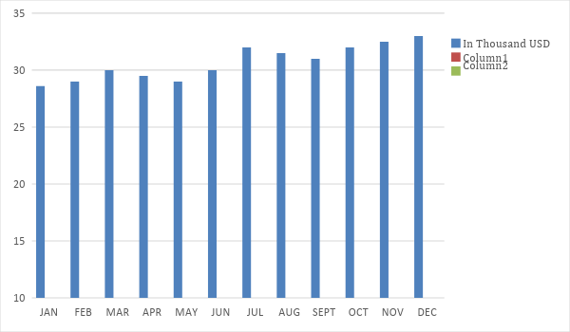

Monthly Revenue

The chart below shows the projected monthly revenues of [Coin Wash Express] for [2020].

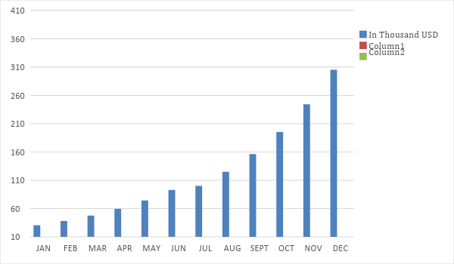

Business Financing

The owner, Cheryl Downing, generated funds for [Coin Wash Express] by acquiring a business loan amounting to [750K] USD payable in [8] years. The initial funds cover disbursements pertaining to equipment, payroll, inventory, supplies, rent, and maintenance.

Statements

Profit and Loss Projection
 | FY2020 | FY2021 | FY2022
Sales | $323,000.00 | $452,200.00 | $633,080.00
Direct Cost of Sale | $145,350.00 | $203,490.00 | $284,886.00
Other Cost of Sale | $1,500.00 | $1,530.00 | $1,560.60
Total Cost of Goods Sold or COGS (Sales - Direct Cost of Sale - Other Cost of Sale) | $176,150.00 | $247,180.00 | $346,633.40
Gross Profit (Sales-Total Cost of Goods Sold) | $146,850.00 | $205,020.00 | $286,446.60
Gross Margin % (Gross Profit/Sales) | 45.46% | 45.34% | 45.25%
Operating Expenses
Rent | $22,000.00 | $22,000.00 | $22,000.00
Insurance | $8,100.00 | $8,100.00 | $8,100.00
Utilities | $5,000.00 | $5,100.00 | $5,202.00
Salary (Including Tax) | $75,000.00 | $75,000.00 | $75,000.00
Maintenance & Supplies | $15,000.00 | $15,300.00 | $15,606.00
Total Operating Expenses | $125,100.00 | $125,500.00 | $125,908.00
EBITDA (Total Cost of Sale-Total Operating Expenses) | $51,050.00 | $121,680.00 | $220,725.40
Depreciation | $1,000.00 | $1,000.00 | $1,000.00
Interest Expense | $10,000.00 | $10,000.00 | $10,000.00
Taxes Paid | $11,250.00 | $11,250.00 | $11,250.00
Net Profit (Gross Profit - Operating Expenses - Taxes - Interest) | $500.00 | $58,270.00 | $139,288.60

Balance Sheet Projection
 | FY2020 | FY2021 | FY2022
Cash | $29,900.00 | $83,150.00 | $203,479.50
Accounts Receivable | $20,000.00 | $27,000.00 | $36,450.00
Inventory | $109,300.00 | $135,532.00 | $168,059.68
Other Current Assets | $98,000.00 | $98,000.00 | $98,000.00
Total Current Assets | $257,200.00 | $343,682.00 | $505,989.18
Long-Term Assets | $400,000.00 | $400,000.00 | $400,000.00
Accumulated Depreciation | $1,000.00 | $2,000.00 | $3,000.00
Total Long-Term Assets (Long-Term Assets-Accumulated Depreciation) | $399,000.00 | $398,000.00 | $397,000.00
Total Assets (Total Current Assets + Total Long-Term Assets) | $656,200.00 | $741,682.00 | $902,989.18
Accounts Payable | $50,000.00 | $45,000.00 | $40,000.00
Notes Payable | $3,000.00 | $3,600.00 | $4,320.00
Other | $1,000.00 | $2,000.00 | $2,500.00
Total Liabilities | $54,000.00 | $50,600.00 | $46,820.00
Paid-in Capital | $750,000.00 | $750,000.00 | $750,000.00
Retained Earnings | $500.00 | $58,770.00 | $198,058.60
Total Owner's Equity (Total Assets - Total Liabilities) | $602,200.00 | $691,082.00 | $856,169.18
Total Liabilities & Equity (Total Liabilities/Total Owner's Equity) | 8.97% | 7.32% | 5.47%

Cash Flow Projection
 | FY2020 | FY2021 | FY2022
Operating Cash Beginning | $25,000.00 | $29,900.00 | $83,150.00
Sources of Cash | $15,000.00 | $18,750.00 | $23,437.50
Receivables | $20,000.00 | $28,000.00 | $39,200.00
Sales | $90,000.00 | $126,000.00 | $176,400.00
Others | $5,000.00 | $6,000.00 | $7,200.00
Total Cash | $155,000.00 | $208,650.00 | $329,387.50
Expenditures
Rent | $22,000.00 | $22,000.00 | $22,000.00
Insurance | $8,100.00 | $8,100.00 | $8,100.00
Utilities | $5,000.00 | $5,100.00 | $5,202.00
Salary (Including Tax) | $75,000.00 | $75,000.00 | $75,000.00
Maintenance & Supplies | $15,000.00 | $15,300.00 | $15,606.00
Total Expenditures | $125,100.00 | $125,500.00 | $125,908.00
Net Income/Loss (Total Cash - Total Expenditures) | $29,900.00 | $83,150.00 | $203,479.50

