KAYAK
BUSINESS PLAN

[Charles Peralta]
[cperalta@thetakayaks.com]
[833-855-6678]
[www.thetakayaks.com]
[Seeley Lake, MT]
[59868, USA]

Index

Executive Summary | [Page Number]
Company Overview | [Page Number]
Products and Services | [Page Number]
Execution | [Page Number]
Operational Plan | [Page Number]
Financial Plan | [Page Number]

Executive Summary:

[Theta Kayaks] is a [kayak] rental business along the calm and relaxing waters of the Clearwater Canoe Trail in Montana. The company wants to provide safe, reliable, and fun kayak services that are for the easy trail, which is particularly attractive to families who want to experience short kayaking trips with beautiful mountain views.

The company ensures that the business grows in the next five years by providing beautiful and well-crafted kayaks to target more tourists.

Company Overview:

Mission Statement:

Theta [Kayaks] is committed to providing customers with high-quality kayaking products and services to ensure that customers have enjoyable kayaking experiences every time.

Philosophy:

Theta [Kayaks] compete fairly and ethically with other businesses in the area to properly serve its customers and make sure that their enjoyment and vacation needs are always prioritized.

Vision:

The vision of Theta [Kayaks] is simple. The company wants to be viewed by its customers as an indispensable establishment for their family vacations.

Outlook:

There are at least [3,500] entertainment equipment rental businesses in the United States, which include outdoor water activities such as kayaking. The aggregate yearly revenue of the business is approximately [$3.5 billion dollars] per year and employing over [30,000] people. The growth of this industry is expected to remain on par with the growth of the tourism industry in general and is expected to remain positive in the following years.

Type of Industry: Rental Industry

Business Structure: Sole Proprietorship

Ownership: Sole Proprietorship, Charles Peralta

Start-Up Summary: The owner of the company is expected to provide [$100,000] for the start-up expenses and will serve as the capital for the business. This amount shall be used for space renovations, rental units, equipment, supplies, and payroll.

Start-Up Funding
Start-Up Expenses | $55,000
Start-Up Assets | $45,000
Total Funding Required | $100,000
Assets
Non-Cash Assets from Start-Up | $20,000
Cash Requirements from Start-up | $5,000
Additional Cash Raised | $5,000
Cash Balance on Starting Date | $15,000
Total Assets | $45,000
Capital
Planned Investment
Owner | $45,000
Other | $0
Additional Investment Requirement | $0
Total Planned Investment | $45,000
Loss at Start-Up (Start-Up Expenses) | $55,000
Total Capital | $100,000
Liabilities | $0
Total Capital and Liabilities | $100,000
Start-Up
Requirements
Start-Up Expenses | $15,000
Renovations | $10,000
Advertising | $5,000
Legal Fees | $5,000
Staff Training | $15,000
Insurance | $5,000
Other | $0
Total Start-Up Expenses | $55,000
Start-Up Assets
Cash Required | $25,000
Start-Up Inventory | $10,000
Other Current Assets | $5,000
Long-Term Assets | $5,000
Total Assets | $45,000
Total Requirements (Total Start-Up Expenses + Total Assets) | $100,000

Management Team:

Management Team | Role/Function | Skills
Terrence Santiago | Store Manager | Communication, People Management, Teamwork, and Resilience
Norman Sudekis | Maintenance | Communication, Technical Skills, Organization

Short- and Long-Term Goals and Milestones:

Short-Term Goals | Milestones
- Create a marketing plan for the summer season | - Increase bookings for the summer season
- Acquire new kayaks for rental | - Additional kayaks acquired
Long-Term Goals | Milestones
- Increase sales by 30% from the previous year
- Become the foremost kayak rental business in the area | - The continuous increase of clients per season.

Products and Services

Product/Service Description:

[Theta Kayaks] will provide kayak rental services for tourists and returning customers along the Clearwater Canoe Trail. The company will provide different kinds of kayaks for water enthusiasts who want to spend time on the lake. Our services will range from hourly to weekly rentals, all of which have GPS tracking devices for the safety of the clients and rental units.

Value Proposition:

[Theta Kayaks] offers great-quality kayaks for enthusiasts. The company also offers a wide range of other services such as instructors and guides for first-time kayakers, who may also take them to see the best views of the lake.

Pricing Strategy:

[Kayaks] offer a variety of prices depending on the kayak model with hourly, daily, and reduced weekly rates for those who intend to spend a long time in the area.

Execution

Marketing Plan:

[Theta Kayaks] shall use different marketing strategies that will allow the company to target individuals. These strategies include traditional print advertisements, with ads placed on strategic areas that make information accessible to the public. It shall also employ digital marketing methods such as social media and email advertising.

Market Research:

The revenue for the kayak rental business is directly proportional to the number of units it rents out on a daily basis. Such business is also seasonal, which is true in Montana.

The upward trend in kayaking sees a younger demographic, which is a significant change compared to the 50-plus crowd in the last decade. With more people getting in touch with nature, sales in kayak rentals are expected to improve in the next few years. As outdoor enthusiast baby boomers retire and millennials looking to get in touch with nature, kayak rental sales are expected to grow by at least 12% every year.

Target Market:

[Theta Kayaks] serves water enthusiasts, tourists, families, couples, and students during the kayaking season.

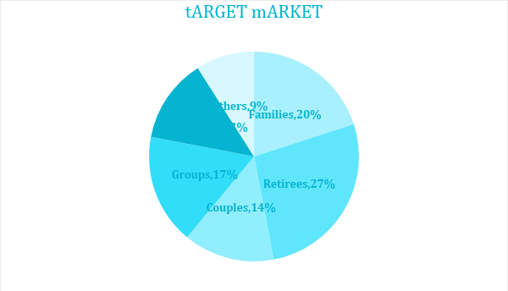

SWOT Analysis | Strengths | Weaknesses | Opportunities | Threats
[Theta Kayaks] | Experienced management team | Lesser-known business compared to others in the area | A surge in kayaking and water adventures in Montana | Getting into the market
Seeley Canoes and Kayaks | Solid knowledge of the Montana Rental Market | Some of the units are old and weathered | Promotion of adventure tourism | Lack of newer technology makes business more prone to theft
Montana Water Adventures | A wide variety of rentals and services | Customer service needs improvement | Tourism season brings more clients due to a wider variety of services | New rental businesses in the area

Marketing Strategy:

[Theta Kayaks] plans to reach out to its customers through traditional marketing channels that will reach tourists from all over the globe. As the Internet serves as an effective means of communication, the company will focus on online marketing and partnership with travel agencies to help improve business.

Marketing Strategy | Activities | Timeline | Success Criteria
Print Marketing | Create print ads for newspapers, magazines, and brochures | February 25, 2019 | - Increase in clientele
Online Marketing | Upgrade website, create social media accounts, and curate posts | ASAP | - Increase in likes and engagement
Business Partnerships | Speak with Concierge relations, Chamber of Commerce, and others regarding partnership possibilities | February 25, 2019 | - Positive responses to partnership possibilities

Organizational Structure:

Owner/ Operator
Financial Officer
Marketing and Sales
Store Manager
Guide and Staff
Maintenance
Security

Operational Plan:

Location and Facilities

Theta Kayaks is located by the waterfront with an expansive display of kayaks and offerings of related activities.

Lockers/Showers
Store and Display
Storage

Financial Plan

Assumptions

The financial forecast is based on taking control of the majority of the tourist share in the area. During the summer months, aggressive marketing will help increase revenue. Growing competition and other business upgrades being made will also have a positive influence regarding market expansion.

Monthly Expense
The chart shows the projected monthly expense for 2019.

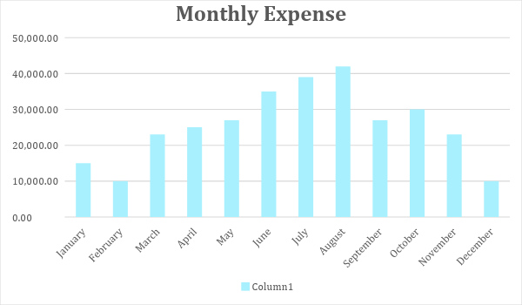

Monthly Revenue

The chart depicts the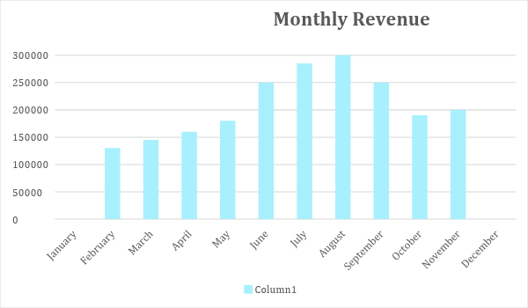

projected monthly revenue for 2019. There are no sales for January and December as this is typically the closing season in the area.

Business Financing

The business will be funded mainly by the owner. The amount will be used for renovations, acquisition of rental units, equipment, supplies, and payroll.

Statements

Profit and Loss Projection
 | FY2019 | FY2020 | FY2021
Sales | $6,090,000.00 | $8,500,000.00 | $9,000,000.00
Direct Cost of Sale | $3,000,000.00 | $4,500,000.00 | $5,000,000.00
Other Cost of Sale | $50,000.00 | $55,000.00 | $60,000.00
Total Cost of Goods Sold or COGS (Sales - Direct Cost of Sale - Other Cost of Sale) | $3,040,000.00 | $3,945,000.00 | $3,940,000.00
Gross Profit (Sales-Total Cost of Goods Sold) | $3,050,000.00 | $4,555,000.00 | $5,060,000.00
Gross Margin % (Gross Profit/Sales) | 50.08% | 53.59% | 56.22%
Operating Expenses
Renovations/Updates | $36,000 | $5,000 | $5,000
Insurance | $5,000 | $5,000 | $5,000
Utilities | $5,000 | $5,000 | $5,000
Salary (Including Tax) | $1,000,000 | $1,000,000 | $1,000,000
Maintenance & Supplies | $24,000 | $24,000 | $24,000
Total Operating Expenses | $1,070,000.00 | $1,039,000.00 | $1,039,000.00
EBITDA (Total Cost of Sale-Total Operating Expenses) | $1,970,000.00 | $2,906,000.00 | $2,901,000.00
Depreciation | $4,000.00 | $4,000.00 | $4,000.00
Interest Expense | $0.00 | $0.00 | $0.00
Taxes Paid | $4,000.00 | $5,000.00 | $6,000.00
Net Profit (Gross Profit - Operating Expenses - Taxes - Interest) | $1,976,000.00 | $3,511,000.00 | $4,015,000.00

Balance Sheet Projection
 | FY2019 | FY2020 | FY2021
Cash | $5,090,000.00 | $5,650,000.00 | $5,000,000.00
Accounts Receivable | $10,000.00 | $15,000.00 | $11,000.00
Inventory | $3,000.00 | $5,000.00 | $6,000.00
Other Current Assets | $5,000.00 | $6,000.00 | $8,000.00
Total Current Assets | $5,108,000.00 | $5,676,000.00 | $5,025,000.00
Long-Term Assets | $50,000.00 | $70,000.00 | $60,000.00
Accumulated Depreciation | $3,000.00 | $2,500.00 | $2,000.00
Total Long-Term Assets (Long-Term Assets-Accumulated Depreciation) | $47,000.00 | $67,500.00 | $58,000.00
Total Assets (Total Current Assets + Total Long-Term Assets) | $5,155,000.00 | $5,743,500.00 | $5,083,000.00
Accounts Payable | $20,000.00 | $30,000.00 | $15,000.00
Notes Payable | $5,000.00 | $6,000.00 | $8,000.00
Other | $3,500.00 | $7,000.00 | $5,000.00
Total Liabilities | $28,500.00 | $43,000.00 | $28,000.00
Paid-in Capital | $5,000.00 | $5,000.00 | $5,000.00
Retained Earnings | $2,090,000.00 | $3,000,000.00 | $3,700,000.00
Total Owner's Equity (Total Assets - Total Liabilities) | $5,126,500.00 | $5,700,500.00 | $5,055,000.00
Total Liabilities & Equity (Total Liabilities/Total Owner's Equity) | 0.56% | 0.75% | 0.55%

Cash Flow Projection
 | FY2019 | FY2020 | FY2021
Operating Cash Beginning | $800,000.00 | $2,135,000.00 | $2,843,000.00
Sources of Cash | $100,000.00 | $120,000.00 | $150,000.00
Receivables | $100,000.00 | $120,000.00 | $300,000.00
Sales | $2,200,000.00 | $1,500,000.00 | $1,700,000.00
Others | $5,000.00 | $7,000.00 | $8,000.00
Total Cash | $3,205,000.00 | $3,882,000.00 | $5,001,000.00
Expenditures
Renovations/Updates | $36,000 | $5,000 | $5,000
Insurance | $5,000 | $5,000 | $5,000
Utilities | $5,000 | $5,000 | $5,000
Salary (Including Tax) | $1,000,000 | $1,000,000 | $1,000,000
Maintenance & Supplies | $24,000 | $24,000 | $24,000
Total Expenditures | $1,070,000.00 | $1,039,000.00 | $1,039,000.00
Net Income/Loss (Total Cash - Total Expenditures) | $2,135,000.00 | $2,843,000.00 | $3,962,000.00

