PREPARED BY:

[INSERT FULL NAME/S OF THE
PEOPLE WHO PREPARED THIS PLAN]

[INSERT DATE]

HEALTH & SAFETY BUSINESS PLAN

[INSERT NAME OF THE BUSINESS/COMPANY]
[INSERT THE COMPLETE BUSINESS/COMPANY ADDRESS]
[INSERT THE BUSINESS/COMPANY CONTACT NUMBERS]
[INSERT THE BUSINESS/COMPANY EMAIL ADDRESS]
[INSERT THE BUSINESS/COMPANY WEBSITE ADDRESS]

Index

Executive Summary [PAGE NUMBER]
Company Overview [PAGE NUMBER]
Products and Services [PAGE NUMBER]
Execution [PAGE NUMBER]
Operational Plan [PAGE NUMBER]
Financial Plan [PAGE NUMBER]

EXECUTIVE SUMMARY:

[Aegis Consultants] is a consulting firm that specializes in assisting small businesses to comply with health and safety measures in the workplace. [Aegis Consultants] is knowledgeable about the safety issues in different work environments and ensures that companies are compliant with [federal safety codes].

With approximately [4.1 million] US workers experiencing workplace injuries, the need for health and safety consulting businesses have become more significant as companies hire consultants to train employees, evaluate business procedures, and reinforce safety programs.

To gain a strong audience, [Aegis Consultants] has turned to lead-generating activities by focusing on targeted paid ads, site rankings, email marketing, as well as creating special events such as seminars and conferences.

COMPANY OVERVIEW:

Mission Statement: It is the mission of [Aegis Consultants] to support small businesses in complying with [federal, state, and local safety codes] for the safety of their employees and customers alike.

Philosophy: [Aegis Consultants] recognizes the importance of health and safety in the different business sectors and, thus, utilizes various strategies to ensure client satisfaction.

Vision: [Aegis Consultants] promises to provide unique approaches for different companies to ensure the quality and compatibility of the health and safety measures put in place.

Outlook: The [health and safety industry] has grown since [2017] and is expected to grow to [$7.3 billion] at a compound annual growth rate of [11.1%] by [2022] due to more stringent government regulations and the growing awareness on environmental health and safety standards for employees.
Type of Industry: [Professional, Scientific, and Technical Services]

Business Structure: Sole Proprietorship

Ownership: Sole Proprietorship, [Beatrice Burch]

Start-Up Summary: [Aegis Consultants] will need [$50,000] to cover for its start-up costs. This amount shall be provided by the owner and will be used to cover operational expenses such as rent, training, and payroll.

Start-Up Funding
Start-Up Expenses | $35,000
Start-Up Assets | $15,000
Total Funding Required | $50,000
Assets
Non-Cash Assets from Start-Up | $8,500
Cash Requirements from Start-up | $2,000
Additional Cash Raised | $3,000
Cash Balance on Starting Date | $1,500
Total Assets | $15,000
Capital
Planned Investment
Owner | $50,000
Other | $0
Additional Investment Requirement | $0
Total Planned Investment | $50,000
Loss at Start-Up (Start-Up Expenses) | -$35,000
Total Capital | $15,000
Liabilities | $0
Total Capital and Liabilities | $15,000
Start-Up
Requirements
Start-Up Expenses
Rent - 3 Months | $6,000
Advertising | $1,000
Legal Fees | $1,000
Staff Training | $15,000
Insurance | $1,000
Other | $11,000
Total Start-Up Expenses | $35,000
Start-Up Assets
Cash Required | $5,000
Start-Up Inventory | $2,000
Other Current Assets | $3,000
Long-Term Assets | $5,000
Total Assets | $15,000
Total Requirements (Total Start-Up Expenses + Total Assets) | $50,000

MANAGEMENT TEAM:

Management Team | Role/Function | Skills
Beatrice Burch | Operations Manager | Leadership, Negotiation, Organization
Melissa Santiago | Marketing Manager | Teamwork, Attention To Detail, Communication

SHORT- AND LONG-TERM GOALS AND MILESTONES:

Short-Term Goals | Milestones
Find a corporate office that will serve as company headquarters by December 15 | Found office space, leased for 6 months with the option to extend
Hire 7 health and safety consultants | Hired 3 consultants, 5 set for interviews
Long-Term Goals | Milestones
Grow company clientele to 150 in 5 years | Increase clientele by at least 15% every year
Expand the number of consultants to 25 within five years | Hire new consultants every year to expand the company and grow the business.

PRODUCTS AND SERVICES

Product/Service Description: [Aegis Consultants] offers consulting services on health and safety for small businesses. These consulting services are customized per client to ensure that issues are addressed accordingly.

Value Proposition: [Aegis Consultants] offers customer-centric, customized services based on the needs of companies at lower prices compared to other firms.

Pricing Strategy: [Aegis Consultants] employs a customized pricing scheme that takes into account the necessary services and company size, among others.

EXECUTION

Marketing Plan: As a new [consulting firm], [Aegis Consultants] plans to penetrate the market by offering package projects at a discount during the first three months of operation and discounted additional services for repeat clients.

Market Research: Consulting firms are hired by companies depending on their needs. Aegis Consultants expects the bulk of its clientele to be made up of small and medium-sized businesses.

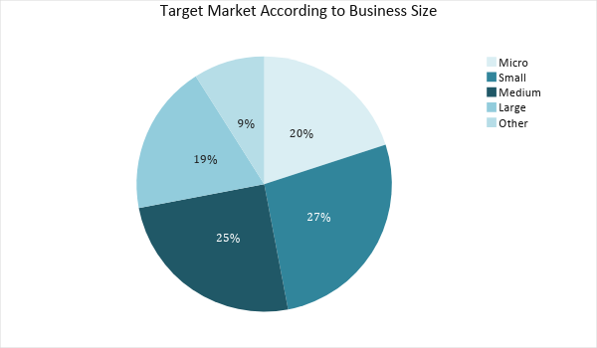

SWOT Analysis | Strengths | Weaknesses | Opportunities | Threats
Aegis Consultants | Strong client communication skills | New in the industry | Expand health and safety campaigns to reach a larger audience | Inflation could negatively affect company funding for EHS consulting services
RT Consulting Firm | Strong relationship with large businesses and corporations | Limited workforce also limits the number of clients that it can accommodate | New technology such as safety analysis software can help make the most of the limited workforce | The increasing number of new health and safety consulting firms
Penn Health and Safety Consulting | Known health and safety consulting firm | Limited budget impedes firm growth | Government policies and sanctions increase the demand for health and safety consulting | Industry saturation dries up market demand

Marketing Strategy: [Aegis Consultants] will utilize social media for its lead-generating activities, and as well as bidding, and special events to reach a wider audience.

Marketing Strategy | Activities | Timeline | Success Criteria
Email Marketing | Lead-generation, with email follow-through | March 30, 2019 | Positive responses from 60% of the leads
Seminars and Conferences | Host seminars or conferences to gain attention from potential businessmen | Every 2nd Saturday of the month | 50 participants during the first seminar, increasing the number every month
Bidding | Participate in bidding activities | TBA | Win at least three bids in the first year of operation

ORGANIZATIONAL STRUCTURE:

CEO
Marketing
Finance
Head Consultant
Consulting Staff

OPERATIONAL PLAN:

Location and Facilities
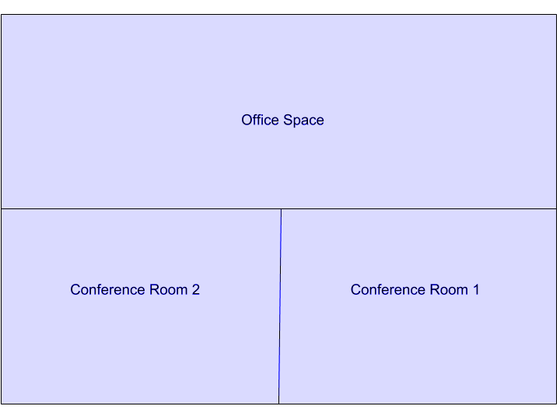

FINANCIAL PLAN

Assumptions

The following financial forecast is based on the growing economy of [Portland, Pennsylvania], taking into account the needs of small and mid-sized companies. The company will focus its efforts on different marketing strategies to further finance its operating expenses, most of which will be spent on payroll, rent, and supplies.

Monthly Expense

The monthly expenses for [2019] are depicted below:

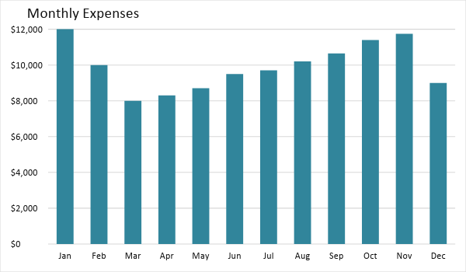

Monthly Revenue

The projected monthly revenue for [2019] is as follows:

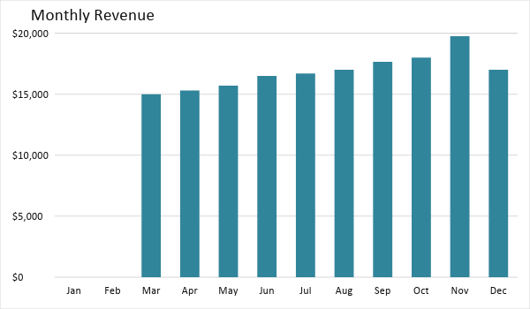

BUSINESS FINANCING

The start-up cost of the business, which totals [$50,000], will be funded in full by the owner. This amount will be used for [rent, marketing, insurance, supplies, and maintenance].

STATEMENTS

Profit and Loss Projection
 | FY2019 | FY2020 | FY2021
Sales | $170,000.00 | $250,000.00 | $325,000.00
Direct Cost of Sale | $150,000.00 | $200,000.00 | $275,000.00
Other Cost of Sale | $15,000.00 | $10,000.00 | $9,000.00
Total Cost of Goods Sold or COGS (Sales - Direct Cost of Sale - Other Cost of Sale) | $5,000.00 | $40,000.00 | $41,000.00
Gross Profit (Sales-Total Cost of Goods Sold) | $165,000.00 | $210,000.00 | $284,000.00
Gross Margin % (Gross Profit/Sales) | 97.06% | 84.00% | 87.38%
Operating Expenses
Rent | $12,000.00 | $12,000.00 | $12,000.00
Insurance | $1,000.00 | $1,000.00 | $1,000.00
Utilities | $6,000.00 | $6,000.00 | $6,000.00
Salary (Including Tax) | $70,000.00 | $75,000.00 | $80,000.00
Maintenance & Supplies | $3,000.00 | $3,500.00 | $3,700.00
Total Operating Expenses | $92,000.00 | $97,500.00 | $102,700.00
EBITDA (Total Cost of Sale-Total Operating Expenses) | -$87,000.00 | -$57,500.00 | -$61,700.00
Depreciation | $4,000.00 | $4,000.00 | $4,000.00
Interest Expense | $0.00 | $0.00 | $0.00
Taxes Paid | $4,000.00 | $5,000.00 | $6,000.00
Net Profit (Gross Profit - Operating Expenses - Taxes - Interest) | $69,000.00 | $107,500.00 | $175,300.00

Balance Sheet Projection
 | FY2019 | FY2020 | FY2021
Cash | $30,000.00 | $125,000.00 | $296,500.00
Accounts Receivable | $7,000.00 | $5,000.00 | $7,500.00
Inventory | $3,000.00 | $5,000.00 | $6,000.00
Other Current Assets | $5,000.00 | $6,000.00 | $8,000.00
Total Current Assets | $45,000.00 | $141,000.00 | $318,000.00
Long-Term Assets | $5,000.00 | $7,000.00 | $6,000.00
Accumulated Depreciation | $3,000.00 | $2,500.00 | $2,000.00
Total Long-Term Assets (Long-Term Assets-Accumulated Depreciation) | $2,000.00 | $4,500.00 | $4,000.00
Total Assets (Total Current Assets + Total Long-Term Assets) | $47,000.00 | $145,500.00 | $322,000.00
Accounts Payable | $10,000.00 | $12,000.00 | $13,000.00
Notes Payable | $5,000.00 | $6,000.00 | $8,000.00
Other | $3,500.00 | $7,000.00 | $5,000.00
Total Liabilities | $18,500.00 | $25,000.00 | $26,000.00
Paid-in Capital | $5,000.00 | $5,000.00 | $5,000.00
Retained Earnings | $170,000.00 | $250,000.00 | $325,000.00
Total Owner's Equity (Total Assets - Total Liabilities) | $28,500.00 | $120,500.00 | $296,000.00
Total Liabilities & Equity (Total Liabilities/Total Owner's Equity) | 64.91% | 20.75% | 8.78%

Cash Flow Projection
 | FY2019 | FY2020 | FY2021
Operating Cash Beginning | $30,000.00 | $125,000.00 | $296,500.00
Sources of Cash | $5,000.00 | $7,000.00 | $10,000.00
Receivables | $7,000.00 | $5,000.00 | $7,500.00
Sales | $170,000.00 | $250,000.00 | $325,000.00
Others | $5,000.00 | $7,000.00 | $8,000.00
Total Cash | $217,000.00 | $394,000.00 | $647,000.00
Expenditures
Rent | $12,000.00 | $12,000.00 | $12,000.00
Insurance | $1,000.00 | $1,000.00 | $1,000.00
Utilities | $6,000.00 | $6,000.00 | $6,000.00
Salary (Including Tax) | $70,000.00 | $75,000.00 | $80,000.00
Maintenance & Supplies | $3,000.00 | $3,500.00 | $3,700.00
Total Expenditures | $92,000.00 | $97,500.00 | $102,700.00
Net Income/Loss (Total Cash - Total Expenditures) | $125,000.00 | $296,500.00 | $544,300.00

