HAIR EXTENSION BUSINESS PLAN

[Audrey Barnard]
[abarnard@perfectlocks.com]
[702-222-416]
[http://perfectlocks.com]
[1018 Hiney Road]
[Las Vegas, NV 89102 USA]

Index

Executive Summary | [Page Number]
Company Overview | [Page Number]
Products and Services | [Page Number]
Execution | [Page Number]
Operational Plan | [Page Number]
Financial Plan | [Page Number]

Executive Summary:

[Perfect Locks] is a brand of [hair extension] products located in [Las Vegas, Nevada]. The company deals with a wide range of customers from commercial establishments, celebrities, and private citizens who want premium grade luxury hair extensions.

The company’s different hair extension products are created to suit the different preferences of its wide range of customers. Each strand is waxed with keratin to ensure that they last as long as possible. To this effect, the company hired experienced professionals to ensure their quality each time.

Company Overview:

Mission Statement:

[Perfect Locks] ensures that we source our hair extensions using reliable suppliers to produce premium grade products.

Philosophy:

[Perfect Locks] is guided by its core value of preserving the premium quality of its brand and execute creativity to ensure customer satisfaction.

Vision:

[Perfect Locks’] vision is to produce quality hair extensions with beautiful textures and designs that will attract salons, distributors, and retailers nationwide.

Outlook:

There is a growing demand for high-end [hair extensions] and quality synthetic wigs in the [US], which will create new opportunities for manufacturers. The global hair wig and extension market is estimated to reach over [$10 billion] in revenue by the end of [2023], making it a good investment in today’s economy.

Type of Industry: [Hair Extension Industry]

Business Structure: Sole Proprietorship

Ownership: Sole Proprietorship, [Audrey Barnard]

Start-Up Summary:

The start-up costs to launch Perfect Locks is [USD 500,000.] The amount is provided by the owner and shall be used for the rent, manufacturing, packaging, and payroll.

Start-Up Funding
Start-Up Expenses | $400,000
Start-Up Assets | $100,000
Total Funding Required | $500,000
Assets
Non-Cash Assets from Start-Up | $25,000
Cash Requirements from Start-up | $10,000
Additional Cash Raised | $50,000
Cash Balance on Starting Date | $15,000
Total Assets | $100,000
Capital
Planned Investment
Owner | $250,000
Bank Loan | $250,000
Additional Investment Requirement | $0
Total Planned Investment | $250,000
Loss at Start-Up (Start-Up Expenses) | $100,000
Total Capital | $350,000
Liabilities | $0
Total Capital and Liabilities | $350,000
Start-Up
Requirements
Start-Up Expenses | $300,000
Rent - 5 Months | $36,000
Advertising | $5,000
Legal Fees | $5,000
Staff Training | $30,000
Insurance | $24,000
Other | $0
Total Start-Up Expenses | $400,000
Start-Up Assets
Cash Required | $75,000
Start-Up Inventory | $5,000
Other Current Assets | $5,000
Long-Term Assets | $15,000
Total Assets | $100,000
Total Requirements (Total Start-Up Expenses + Total Assets) | $500,000

Management Team:

Management Team | Role/Function | Skills
Teresa Franke | Quality Assurance Manager | Technical skills, planning and organization skills, teamwork, product knowledge
Leonard Duncan | Customer Service Executive | Attentiveness, communications, product knowledge, time management

Short- and Long-Term Goals and Milestones:

Short-Term Goals | Milestones
- Pay business loans within one year of operations | - Paid 50% of the business loans
- Expand the existing product line | - Development of new products is in progress
Long-Term Goals | Milestones
- Create an online ordering and delivery system | - Partnership with delivery services in the negotiation stage
- Keep cash flow positive | - Cash flow positive so far

Products and Services

Product/Service Description: Perfect Locks intends to give its customers a variety of hair extension options with customized extensions available upon request. Among the products and services that the company offers include the following:

- Premium-grade and luxury hair extensions - retail
- Premium-grade and luxury hair extensions - commercial
- Premium-grade and luxury wigs
- Customized premium-grade and luxury hair extensions
- Customized premium-grade and luxury wigs

Value Proposition:

The variety and consistency of products manufactured by Perfect Locks are incomparable to other businesses thanks to its premium grade, luxurious quality. Allowing for the customization of products also attracts more clients.

Pricing Strategy:

[Perfect Locks] utilizes a cost plus mark-up strategy in competitive prices, making our products particularly attractive to a wider range of customers.

Execution

Marketing Plan:

[Perfect Locks] will be utilizing multiple marketing strategies to encourage more customers. Among its strategies include online promotions through its company website, social media, influencer campaigns, and traditional print media. In doing so, the company aims to capture at least [35%] of the market within the year.

Market Research:

The global hair extension business has many players in the market. Thus, there remains a need for product innovations to attract more customers and gain a larger market share.

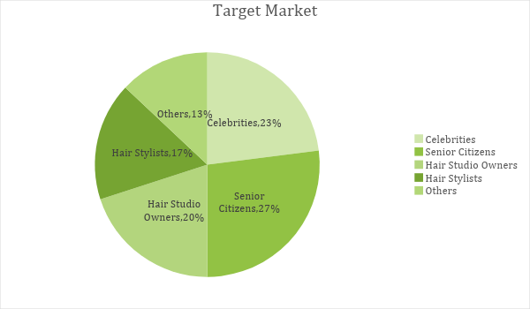

SWOT Analysis | Strengths | Weaknesses | Opportunities | Threats
Perfect Locks | - The company’s location leads to the high demand for products and services | Limited clientele due to unrecognized business presence | Opportunities to partner with influencers and celebrities to endorse the products | An economic downturn may affect the business
Locks and Tresses | Experienced CEO | Problems with customer service | Evolving hair trends and styling methods | Presence of competitors
Luxury Hair and Style | Renowned luxury brand | Limited patronage due to high prices | Introduction of new product lines | Introduction of premium products at lower prices threatens the customer base

Marketing Strategy:

The company intends to take full advantage of the Internet to reach a wider audience. Among the marketing strategies to be adopted by the company include sponsorship of pageants, leveraging social media platforms, and attending trade fairs and local sales events.

Marketing Strategy | Activities | Timeline | Success Criteria
Sponsorship | Find pageants and contests to sponsor | ASAP | Sponsorship of successful events and pageants
Trade fairs and local sales events | Ensure slot in trade fairs and sales events | TBA | Sell at least 1,000 extensions and 250 wigs per event
Social media platforms | Create social media pages and curate posts | March 1, 2019 | Have at least 10,000 followers within 3 months of launching

Organizational Structure:

CEO
Quality Assurance Manager
HR Admin
Operations Manager
Purchasing Manager
HR Assistant
Finance and Payroll
Store Manager
Delivery Driver
Custom Service Executives
Staff
Security and Maintenance

Operational Plan:
Location and Facilities

Display Window

Physical Store
Storage
Factory and Manufacturing

Financial Plan

Assumptions

The United States is among the top five exporters of hair extensions globally, with a total export value of over [USD 2 Billion]. With the hair extension market growing annually at an increasing rate of [25%], the company sees a positive cash flow in the next few years of operations.

Monthly Expense
The chart shows the projected monthly expense for 2019.

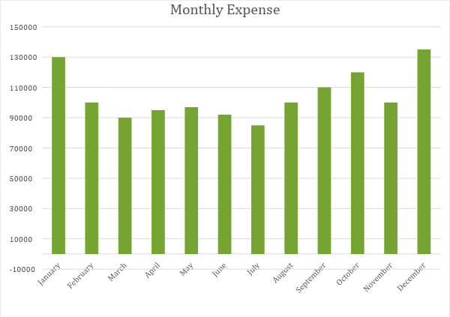

Monthly Revenue
The chart depicts the projected monthly revenue for 2019

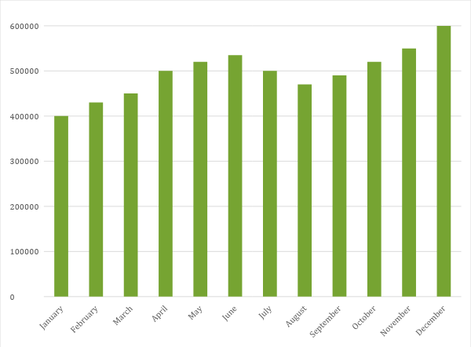

Business Financing

The business shall be funded by personal funds and bank loans made by the owner. Majority of the expenses will cover for the rent, salaries, supplies, production, and maintenance.

Statements

Profit and Loss Projection
 | FY2019 | FY2020 | FY2021
Sales | $6,000,000.00 | $6,500,000.00 | $7,500,000.00
Direct Cost of Sale | $1,200,000.00 | $1,500,000.00 | $2,000,000.00
Other Cost of Sale | $500,000.00 | $550,000.00 | $570,000.00
Total Cost of Goods Sold or COGS (Sales - Direct Cost of Sale - Other Cost of Sale) | $4,300,000.00 | $4,450,000.00 | $4,930,000.00
Gross Profit (Sales-Total Cost of Goods Sold) | $1,700,000.00 | $2,050,000.00 | $2,570,000.00
Gross Margin % (Gross Profit/Sales) | 28.33% | 31.54% | 34.27%
Operating Expenses
Rent | $36,000 | $36,000 | $36,000
Insurance | $5,000 | $5,000 | $5,000
Utilities | $5,000 | $5,000 | $5,000
Salary (Including Tax) | $1,000,000 | $1,000,000 | $1,200,000
Maintenance & Supplies | $24,000 | $24,000 | $24,000
Total Operating Expenses | $1,070,000.00 | $1,070,000.00 | $1,270,000.00
EBITDA (Total Cost of Sale-Total Operating Expenses) | $300,000.00 | $320,000.00 | $350,000.00
Depreciation | $4,000.00 | $4,000.00 | $4,000.00
Interest Expense | $0.00 | $0.00 | $0.00
Taxes Paid | $4,000.00 | $5,000.00 | $6,000.00
Net Profit (Gross Profit - Operating Expenses - Taxes - Interest) | $626,000.00 | $975,000.00 | $1,294,000.00

Balance Sheet Projection
 | FY2019 | FY2020 | FY2021
Cash | $6,000,000.00 | $6,500,000.00 | $7,500,000.00
Accounts Receivable | $1,200,000.00 | $1,500,000.00 | $2,000,000.00
Inventory | $500,000.00 | $550,000.00 | $570,000.00
Other Current Assets | $5,000.00 | $6,000.00 | $8,000.00
Total Current Assets | $7,705,000.00 | $8,556,000.00 | $10,078,000.00
Long-Term Assets | $200,000.00 | $230,000.00 | $250,000.00
Accumulated Depreciation | $3,000.00 | $2,500.00 | $2,000.00
Total Long-Term Assets (Long-Term Assets-Accumulated Depreciation) | $197,000.00 | $227,500.00 | $248,000.00
Total Assets (Total Current Assets + Total Long-Term Assets) | $7,902,000.00 | $8,783,500.00 | $10,326,000.00
Accounts Payable | $20,000.00 | $30,000.00 | $15,000.00
Notes Payable | $5,000.00 | $6,000.00 | $8,000.00
Other | $3,500.00 | $7,000.00 | $5,000.00
Total Liabilities | $28,500.00 | $43,000.00 | $28,000.00
Paid-in Capital | $5,000.00 | $5,000.00 | $5,000.00
Retained Earnings | $3,000,000.00 | $4,500,000.00 | $6,000,000.00
Total Owner's Equity (Total Assets - Total Liabilities) | $7,873,500.00 | $8,740,500.00 | $10,298,000.00
Total Liabilities & Equity (Total Liabilities/Total Owner's Equity) | 0.36% | 0.49% | 0.27%

Cash Flow Projection
 | FY2019 | FY2020 | FY2021
Operating Cash Beginning | $1,000,000.00 | $5,481,000.00 | $9,584,000.00
Sources of Cash | $1,500,000.00 | $1,800,000.00 | $1,500,000.00
Receivables | $100,000.00 | $120,000.00 | $300,000.00
Sales | $2,000,000.00 | $2,200,000.00 | $2,500,000.00
Others | $5,000.00 | $7,000.00 | $8,000.00
Total Cash | $4,605,000.00 | $9,608,000.00 | $13,892,000.00
Expenditures
Rent | $30,000 | $30,000 | $30,000
Insurance | $12,000 | $12,000 | $12,000
Utilities | $5,000 | $5,000 | $5,000
Salary (Including Tax) | $5,000 | $5,000 | $5,000
Maintenance & Supplies | $30,000 | $30,000 | $30,000
Total Expenditures | $24,000 | $24,000 | $24,000
Net Income/Loss (Total Cash - Total Expenditures) | $4,581,000.00 | $9,584,000.00 | $13,868,000.00

