GYM
MARKETING PLAN

[Muscle Blast Gym]
[2019 – 2021]

Index

Executive Summary | [PAGE NUMBER]
Company Overview | [PAGE NUMBER]
Products and Services | [PAGE NUMBER]
Marketing Analysis | [PAGE NUMBER]
Strategy and Implementation | [PAGE NUMBER]
Management and Personnel | [PAGE NUMBER]
Financial Plan | [PAGE NUMBER]

EXECUTIVE SUMMARY

[Muscle Blast Gym] is a Cleveland-based fitness establishment furnished with professional-grade equipment for amateurs and gym buffs alike. The company aims to capitalize on the rise of the public consciousness to get fit and healthy despite the many commitments and busy schedule. It plans to put up billboards to encourage more people to avail of its service. It will also use blogs and articles as promotional content.

With its available funds, [Muscle Blast Gym] is set to begin earning a steady [15]% increase in monthly revenue once everything is in place.

COMPANY OVERVIEW

Mission Statement

[Muscle Blast Gym] empowers individuals to take control of their fitness by providing them with an environment that values and nurtures their physical well-being.

Philosophy

[Muscle Blast Gym] will always focus on the customers and their fitness goals. This focus will allow the company to operate and produce the desired results.

Vision: [Muscle Blast Gym] aspires to be Cleveland’s most popular gym.

Outlook

A study done in [2017] showed that [49]% of Cleveland’s total population go to the gym at least twice a week. With this in mind, the company aims to serve the public while growing its profit margin by [15]% annually.

Type of Industry: Fitness Industry

Business Structure: Sole Proprietorship

Ownership: Sole Proprietorship, [Craig F. Johnson]

Start-Up Summary

The start-up cost worth [30K] USD is to be provided by the owner and to be used mainly for the rent, insurance, supplies, and payroll.

Start-Up Funding
Start-Up Expenses to Fund | $10,000
Start-Up Assets to Fund | $20,000
Total Funding Required | $30,000
Assets
Non-Cash Assets from Start-Up | $15,000
Cash Requirements from Start-up | $1,000
Additional Cash Raised | $3,000
Cash Balance on Starting Date | $1,000
Total Assets | $20,000
Capital
Planned Investment
Owner | $30,000
Other | $0
Additional Investment Requirement | $0
Total Planned Investment | $30,000
Loss at Start-Up (Start-Up Expenses) | -$10,000
Total Capital | $20,000
Total Capital and Liabilities | $20,000
Total Funding | $20,000
Start-Up
Requirements
Start-Up Expenses
Rent - 5 Months | $5,000
Advertising | $1,000
Legal Fees | $1,000
Staff Training | $2,000
Insurance | $1,000
Other | $0
Total Start-Up Expenses | $10,000
Start-Up Assets
Cash Required | $1,000
Start-Up Inventory | $5,000
Other Current Assets | $12,000
Long-Term Assets | $2,000
Total Assets | $20,000
Total Requirements (Total Start-Up Expenses + Total Assets) | $30,000

PRODUCTS AND SERVICES

Product/Service Description

[Muscle Blast Gym] provides a complete set of equipment for all types of workout and a personal trainer for each client. The gym offers weight lifting, free-weight (body) lifting, Crossfit, and H.I.I.T (high-intensity interval training) programs.

Value Proposition

The company provides trainers and subscription packages. Compared to trainers in other gyms, [Muscle Blast Gym] trainers are professional bodybuilders or have been at some point.

Apart from this, [Muscle Blast Gym] also provides packages, where a client can bring in a friend or partner at least three times a month to use the facilities for free. If that companion enrolls in one of the gym’s programs, both parties get a discount in their selected subscription packages.

Pricing Strategy

[Muscle Blast Gym] utilizes price bundling and competitive pricing. The gym stays competitive by making sure its services are cheaper compared to competitor gym’s price points.

MARKETING ANALYSIS

The fitness industry has been growing non-stop for decades. As stated by Forbes magazine: “The [$30 billion] health and fitness industry in the U.S. has been growing by at least [3 – 4]% annually for the last ten years.” More and more people are inspired to keep their fitness level at prime condition. This is mainly due to the influence of social media stars and online videos.

Market Segmentation

[Muscle Blast Gym] focuses its sales and marketing strategies on the customers ages [15-55]. For customers above [55], the gym will need a medical certificate that proves that the client is in a stable condition and is safe to practice heavy exercises.

[Muscle Blast Gym] will always put its customers first by providing them with tutorials, training, and tips on how to do proper exercise, proper posture, and how to operate the heavy equipment properly.

Here is a chart showing a particular age group’s attendance to a particular exercise.

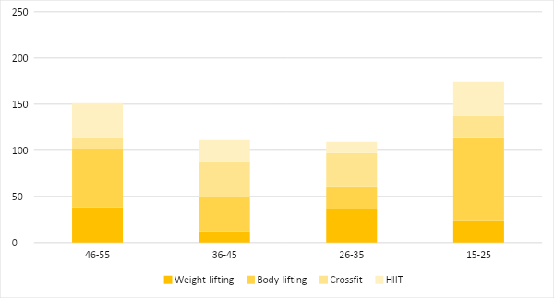

Target Market Segmentation Strategy

Gym enthusiasts

- The company is set to capture this target market by putting up billboards in populous areas.
- More videos and other content will be created and uploaded on the gym’s social media accounts (Facebook and Instagram).

Beginners to amateurs

- For those who are yet to begin their journey towards fitness, [Muscle Blast Gym] hopes to capture their interest by creating free tutorial videos that come with tips. These videos will also come with an invitation (as well as a “first timers” discount) to choose the gym as its fitness partner.

STRATEGY AND IMPLEMENTATION

Target Market Strategy

By heavily prioritizing and executing well the gym’s chosen marketing strategies, [Muscle Blast Gym] should be able to increase its client base by at least [15]% from its inception.

Competitive Edge

The gym is using price bundling and competitive pricing as its pricing strategies.

SWOT Analysis | Strengths | Weaknesses | Opportunities | Threats
[Muscle Blast Gym] | Heavily-experienced trainers  First-class equipment | Only has one facility available |  | The fitness industry is not new; thus, it can be a very saturated market.
[Gymsters] | Very experienced in running a gym | The gym’s equipment is old and worn out | An increase in gym goers means more demand for better facilities | Well-established gyms can be very hard to compete against
[Next Level Fitness] | Very good at marketing its services | Has yet to expand | Growing health concerns (obesity, smoking, lifestyle diseases) encourage people to take part in weight-loss and fitness programs

Sales Strategy and Forecast

With improved content and search engine optimized blogs, the company targets the following monthly sales:

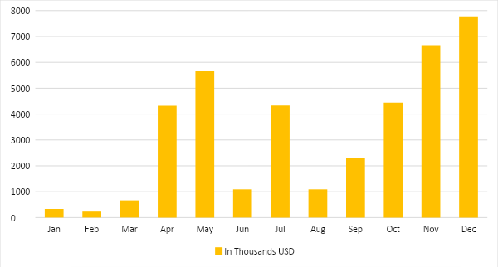

MARKETING STRATEGY

[Muscle Blast Gym] plans to utilize more tutorial and promotional videos and improve its social media exposure by posting content daily. The gym is starting to upload articles and blogs that promote its services.

The team has kicked-off various activities to move the marketing strategies forward. Here are some of the updates:
Milestones

Marketing Strategy | Activities | Timeline | Success Criteria
Billboards | HR will decide to hire either an onboard designer or a freelancer to work on the design | February 25, 2018 | The billboards increase brand awareness.
SEO blogs and articles | Writes blogs and articles about the company’s services and optimize their searchability to stay on top of any search engine page results | ASAP | Significant number of blog and article visits and regular interactive exchange of information with potential clients online.

MANAGEMENT AND PERSONNEL

Currently, the gym is being run by its owner, [Jim Nickel Foster]. He has one HR officer who handles employee concerns, communications, and onboarding. The gym also has one marketing specialist who manages the execution of marketing strategies.

FINANCIAL PLAN

The financial plan includes the projected break-even analysis, profit and loss, balance sheet, and cash flow.

Break-Even Analysis

Fixed Costs | Average Price |  | Variable Costs |  | Contribution Margin | Break-Even Units
$9,000.00 | $45.00 |  | $30.00 |  | $15.00 | 600.00
Fixed Costs |  | Amount |  | Variable Costs |  | Per Unit Amount
Rent |  | 3,000 |  | Advertising |  | 3
Insurance |  | 1,000 |  | Legal Fees |  | 3
Equipment Maintenance |  | 5000 |  | Staff Training |  | 3
Total |  | 9,000 |  | Total |  | 9

Fixed Costs |  | Variable Costs
Business Lease - Rent |  | $2,000
Insurance |  | $1,000
Total Fixed Costs |  | $3,000
Total Units Sold in 1 Month |  | 500
Variable Costs (Unit Sold/Cost per Unit) | Average Price | Variable Costs
Advertising | $500 | $1.00
Legal Fees | $400 | $1.25
Staff Training | $400 | $1.25
Total Variable Cost (Per Unit) |  | $3.50
Break-Even
Selling Price Per Unit |  | $30.00
Break-Even Point Per Unit [Fixed Costs/(Sales Price Per Unit - Variable Cost Per Unit)] |  | 6,000
 |  | 26.50
Break-Even Point in Units |  | 226
Contribution Margin (Selling Price - Total Variable Cost) |  | $26.50

Profit and Loss Projection
 | FY2019 | FY2020 | FY2021
Sales | $30,000.00 | $45,000.00 | $60,000.00
Direct Cost of Sale | $15,000.00 | $15,000.00 | $15,000.00
Other Cost of Sale | $8,000.00 | $1,000.00 | $4,050.00
Total Cost of Goods Sold or COGS (Sales - Direct Cost of Sale - Other Cost of Sale) | $7,000.00 | $29,000.00 | $40,950.00
Gross Profit (Sales-Total Cost of Goods Sold) | $23,000.00 | $16,000.00 | $19,050.00
Gross Margin % (Gross Profit/Sales) | 76.67% | 35.56% | 31.75%
Operating Expenses
Rent | $3,000.00 | $3,000.00 | $3,000.00
Insurance | $1,000.00 | $1,000.00 | $1,000.00
Utilities | $0.00 | $0.00 | $0.00
Salary (Including Tax) | $5,000.00 | $5,000.00 | $5,000.00
Maintenance & Supplies | $1,000.00 | $1,000.00 | $1,000.00
Total Operating Expenses | $10,000.00 | $10,000.00 | $10,000.00
EBITDA (Total Cost of Sale-Total Operating Expenses) | -$3,000.00 | $19,000.00 | $30,950.00
Depreciation | $4,000.00 | $4,000.00 | $4,000.00
Interest Expense | $0.00 | $0.00 | $0.00
Taxes Paid | $4,000.00 | $5,000.00 | $6,000.00
Net Profit (Gross Profit - Operating Expenses - Taxes - Interest) | $9,000.00 | $1,000.00 | $3,050.00

Balance Sheet Projection
 | FY2019 | FY2020 | FY2021
Cash | $45,000.00 | $60,000.00 | $75,000.00
Accounts Receivable | $0.00 | $0.00 | $0.00
Inventory | $0.00 | $0.00 | $0.00
Other Current Assets | $0.00 | $0.00 | $0.00
Total Current Assets | $45,000.00 | $60,000.00 | $75,000.00
Long-Term Assets | $24,000.00 | $24,000.00 | $24,000.00
Accumulated Depreciation | $0.00 | $0.00 | $0.00
Total Long-Term Assets (Long-Term Assets-Accumulated Depreciation) | $24,000.00 | $24,000.00 | $24,000.00
Total Assets (Total Current Assets + Total Long-Term Assets) | $69,000.00 | $84,000.00 | $99,000.00
Accounts Payable | $0.00 | $0.00 | $0.00
Notes Payable | $4,000.00 | $4,000.00 | $4,000.00
Other | $0.00 | $0.00 | $0.00
Total Liabilities | $4,000.00 | $4,000.00 | $4,000.00
Paid-in Capital | $115,000.00 | $130,000.00 | $5,000.00
Retained Earnings | $5,000.00 | $5,000.00 | $130,000.00
Total Owner's Equity (Total Assets - Total Liabilities) | $65,000.00 | $80,000.00 | $95,000.00
Total Liabilities & Equity (Total Liabilities/Total Owner's Equity) | 6.15% | 5.00% | 4.21%

