GENERAL

CONTRACTOR
BUSINESS PLAN

[Bill Gil Construction]
Business Plan For Fiscal Year [2019]
[January 1, 2018]

[Billy M. Gilchrist]
[BillyMGilchrist@teleworm.us]
[970-914-5856]
[www.BMGenCon.com]
[4501 Stark Hollow Road
Houston, TX 80112]

Index

Executive Summary | [PAGE NUMBER]
Company Overview | [PAGE NUMBER]
Products and Services | [PAGE NUMBER]
Execution | [PAGE NUMBER]
Operational Plan | [PAGE NUMBER]
Financial Plan | [PAGE NUMBER]

EXECUTIVE SUMMARY

[Bill Gil Construction] is a general contracting service company based in [Houston, Texas]. The company can complete small or large-scale construction projects for companies from different fields of business.

[Bill Gil Construction] directs its funding and marketing strategies around building a solid portfolio. Since Texas is in a good economic state, the company is looking at an increasing profit margin over the next three years.

COMPANY OVERVIEW

Mission Statement

It is [Bill Gil Construction] mission to execute its services at the highest level of quality while also maintaining full transparency all throughout the process.

Philosophy: The Company values honesty in all aspects and dealings of the business.

Vision: [Bill Gil Construction] vision is to be the go-to general contracting company in Houston.

Outlook

Beginning in [2015], [Houston] has seen an economic boom. This has resulted in the skyrocketing number of houses and buildings being built, and the trend continues up to this day. With this, [Bill Gil Construction] client base is set to grow at a steady [15]% each year.

Type of Industry: Construction Industry

Business Structure: Sole Proprietorship

Ownership: Sole Proprietorship, [Billy Gilchrist]

Start-Up Summary

The start-up cost worth [300k] USD is to be provided by the owner and to be used mainly for supplies, payroll, operational expenses, and business fees.

Start-Up Funding
Start-Up Expenses | $250,000
Start-Up Assets | $50,000
Total Funding Required | $300,000
Assets
Non-Cash Assets from Start-Up | $15,000
Cash Requirements from Start-up | $15,000
Additional Cash Raised | $15,000
Cash Balance on Starting Date | $5,000
Total Assets | $50,000
Capital
Planned Investment
Owner | $300,000
Other | $0
Additional Investment Requirement | $0
Total Planned Investment | $300,000
Loss at Start-Up (Start-Up Expenses) | -$250,000
Total Capital | $50,000
Liabilities | $0
Total Capital and Liabilities | $50,000
Start-Up
Requirements
Start-Up Expenses
Rent - 6 Months | $60,000
Advertising | $100,000
Legal Fees | $90,000
Staff Training | $0
Insurance | $0
Other | $0
Total Start-Up Expenses | $250,000
Start-Up Assets
Cash Required | $50,000
Start-Up Inventory | $0
Other Current Assets | $0
Long-Term Assets | $0
Total Assets | $50,000
Total Requirements (Total Start-Up Expenses + Total Assets) | $300,000

Management Team

Management Team | Role/Function | Skills
[Henry Ferguson] | CEO | Communication and leadership
[Jorge Landers] | Marketing Manager | Marketing Strategies and Performance Monitoring

Short- and Long-Term Goals and Milestones

Short-Term Goals | Milestones
Build up the company’s industry connections | The company is actively seeking out subcontractors willing to work with Bill Gil Construction.
Renovate the general contractor’s office | The company is putting subcontractors to the test by hiring them to handle the renovation of its office space.
Long-Term Goals | Milestones
Add new departments to the company to eliminate the need for subcontractors | The budget plan has been approved.

PRODUCTS AND SERVICES

Product/Service Description

[Bill Gil Construction] deploys licensed professionals, with extensive connections in the construction industry, to oversee projects. Depending on the scale of the project and completion date, the company may or may not hire subcontractors for some portions of the construction work.

Value Proposition

[Bill Gil Construction] has subcontractors and affiliates that can work even on the weekends. This allows the company to ensure timely completion of the projects.

Pricing Strategy: The Company matches the standard pricing level of [Houston’s] market.

Formula:
Profit Margin = 1- (Expenses/Net Sales)

[Bill Gil Construction]
Profit Margin = 1 - ($241,000/$501,000)
= 1-0.48
= 0.52 or 52%

EXECUTION

Marketing Plan

[Bill Gil Construction] brand-awareness strategies focus on having its logo and branding attached to its heavy machinery. Apart from this, the company will also focus on building a strong portfolio. [Bill Gil Construction] believes that a good background and strong business relationships will make it thrive successfully for a longer period of time.

Market Research

The company receives projects of any size, be it an apartment or a large commercial building. This is what the company differentiates from most of the general contractors in [Houston]. Recent market data reveals that seven out of 10 general contractors in Houston are only open to managing large-scale projects. The rest are mostly focused on building residential buildings.

SWOT Analysis | Strengths | Weaknesses | Opportunities | Threats
[Bill Gil Construction] | Timely completion of projects | Has not built enough credibility yet | An improving economy resulting in clients expanding their businesses by building new stores or offices | Competitors with a strong portfolio retain customer loyalty
[Ace General Contractors Incorporated] | The company commands the most significant market share | Hard-to-reach client support
Melon Construction Company | Has an exceedingly positive reputation | The company is unable to extend after-sales services

Marketing Strategy

[Bill Gil Construction] plans to make full use of its website and client testimonials in getting the attention of potential clients before making a strong case and participate in the bidding process.

The marketing team has started the implementation of various activities. Here are some of the updates:

Marketing Strategy | Activities | Timeline | Success Criteria
Website Optimization | The writer sees to it that the blogs are compliant with current SEO standards. | February 25, 2019 | Significant number of website visits and inquiries.
Client testimonials | Supervisors to filter the content that will be added on the website | February 26, 2019 | New clients chose the company because they were moved by the testimonials.

Organizational Structure

The owner, [Mr. Billy Gilchrist], runs the company. An operations manager, marketing specialist, and one human resource manager will oversee the flow of the business. For client issues and concerns, two customer service representatives are tasked to handle them.

OPERATIONAL PLAN

Tools and Equipment Checklist

Software | Quantity
Procore | 1
Contractor Foreman | 1
Sage 100 Contractor (formerly Sage Master Builder) | 1
Hardware | Quantity
Vehicles and Trucks | 8
Construction Equipment (Bulldozers, Backhoe Loaders, Excavators, and Graders) | 5

IT Infrastructure

The company has a website which allows clients to contact the company and a server room that connects and saves all data that the company uses.

FINANCIAL PLAN

Assumptions

The financial forecast is based on the company’s confidence in being able to penetrate the market. The major expenses will be on the acquisition of tools and heavy equipment, payroll, and legal fees. The company plans on expanding to other states in the US.

Monthly Expense

The chart shows the projected monthly expenses for [2019].

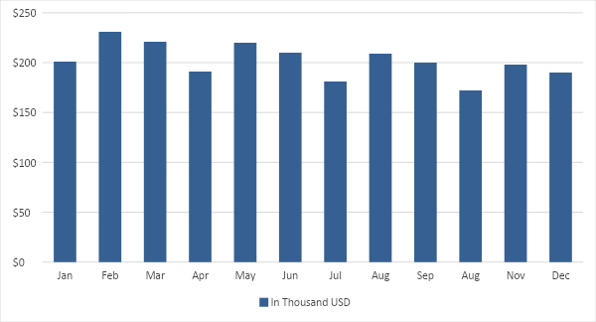

Monthly Revenue

The chart depicts the projected monthly revenues for [2019].

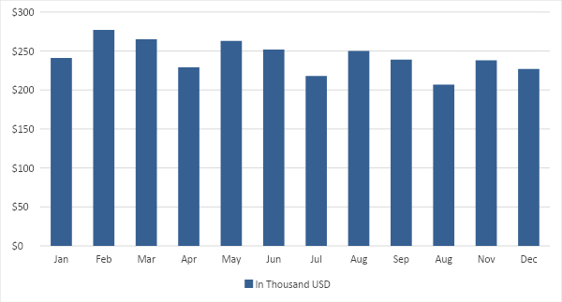

Business Financing

The business’ capital comes from [Mr. Billy Gilchrist’s] business loan.

Statements

Profit and Loss Projection
 | FY2019 | FY2020 | FY2021
Sales | $350,000.00 | $400,000.00 | $650,000.00
Direct Cost of Sale | $150,000.00 | $126,000.00 | $90,500.00
Other Cost of Sale | $5,000.00 | $8,000.00 | $270,000.00
Total Cost of Goods Sold or COGS (Sales - Direct Cost of Sale - Other Cost of Sale) | $195,000.00 | $266,000.00 | $289,500.00
Gross Profit (Sales-Total Cost of Goods Sold) | $155,000.00 | $134,000.00 | $360,500.00
Gross Margin % (Gross Profit/Sales) | 44.29% | 33.50% | 55.46%
Operating Expenses
Rent | $10,000.00 | $10,000.00 | $10,000.00
Insurance | $20,000.00 | $10,000.00 | $15,000.00
Utilities | $20,000.00 | $25,000.00 | $20,000.00
Salary (Including Tax) | $70,000.00 | $20,000.00 | $20,000.00
Maintenance & Supplies | $20,000.00 | $20,000.00 | $4,500.00
Total Operating Expenses | $140,000.00 | $85,000.00 | $69,500.00
EBITDA (Total Cost of Sale-Total Operating Expenses) | $55,000.00 | $181,000.00 | $220,000.00
Depreciation | $4,000.00 | $4,000.00 | $4,000.00
Interest Expense | $0.00 | $0.00 | $0.00
Taxes Paid | $4,000.00 | $5,000.00 | $6,000.00
Net Profit (Gross Profit - Operating Expenses - Taxes - Interest) | $11,000.00 | $44,000.00 | $285,000.00

Balance Sheet Projection
 | FY2019 | FY2020 | FY2021
Cash | $300,000.00 | $400,000.00 | $500,000.00
Accounts Receivable | $6,000.00 | $11,000.00 | $11,000.00
Inventory | $11,000.00 | $5,000.00 | $11,000.00
Other Current Assets | $6,000.00 | $6,000.00 | $8,000.00
Total Current Assets | $323,000.00 | $422,000.00 | $530,000.00
Long-Term Assets | $6,000.00 | $6,000.00 | $2,500.00
Accumulated Depreciation | $2,500.00 | $2,500.00 | $6,000.00
Total Long-Term Assets (Long-Term Assets-Accumulated Depreciation) | $3,500.00 | $3,500.00 | -$3,500.00
Total Assets (Total Current Assets + Total Long-Term Assets) | $326,500.00 | $425,500.00 | $526,500.00
Accounts Payable | $2,500.00 | $30,000.00 | $2,500.00
Notes Payable | $5,000.00 | $2,500.00 | $8,000.00
Other | $3,500.00 | $2,500.00 | $2,500.00
Total Liabilities | $11,000.00 | $35,000.00 | $13,000.00
Paid-in Capital | $120,000.00 | $5,000.00 | $120,000.00
Retained Earnings | $5,000.00 | $120,000.00 | $5,000.00
Total Owner's Equity (Total Assets - Total Liabilities) | $315,500.00 | $390,500.00 | $513,500.00
Total Liabilities & Equity (Total Liabilities/Total Owner's Equity) | 3.49% | 8.96% | 2.53%

Cash Flow Projection
 | FY2019 | FY2020 | FY2021
Operating Cash Beginning | $160,000.00 | $160,000.00 | $160,000.00
Sources of Cash | $15,000.00 | $3,000.00 | $15,000.00
Receivables | $160,000.00 | $12,000.00 | $3,000.00
Sales | $30,000.00 | $3,000.00 | $35,000.00
Others | $3,000.00 | $7,000.00 | $8,000.00
Total Cash | $368,000.00 | $185,000.00 | $221,000.00
Expenditures
Rent | $3,000.00 | $55,000.00 | $3,000.00
Insurance | $10,000.00 | $3,000.00 | $15,000.00
Utilities | $20,000.00 | $25,000.00 | $3,000.00
Salary (Including Tax) | $70,000.00 | $3,000.00 | $90,000.00
Maintenance & Supplies | $3,000.00 | $4,000.00 | $4,500.00
Total Expenditures | $106,000.00 | $90,000.00 | $115,500.00
Net Income/Loss (Total Cash - Total Expenditures) | $262,000.00 | $95,000.00 | $105,500.00

