[Gameran, Ltd.]

Sales Plan
[2018 – 2019]

Game
Studio Sales Plan

Index

Executive Summary [PAGE NUMBER]
Company Overview [PAGE NUMBER]
Products and Services [PAGE NUMBER]
Marketing Analysis [PAGE NUMBER]
Strategy and Implementation [PAGE NUMBER]
Management and Personnel [PAGE NUMBER]

Sales Action Plan [PAGE NUMBER]

EXECUTIVE SUMMARY

[GameRan, Ltd.] is a game developer company. It was founded by three friends who have vast experience in the digital gaming industry. Heading the studio is Janice Rozier who served as an art director for a giant gaming studio for the past five years. Her partners are Oda Takahashi, an award-winning game designer, and Peter Ingles, who served as assistant to Janice in their previous venture.

The game studio is the maker of the Best New Mobile Game of the Year, ["Shadows Uprising: Genesis."] Studying the market, the company decided to introduce the game further in the Asia Pacific and North American regions. The two regions are where more than half of mobile game purchases are made, specifically from countries such as China, Japan, and the US.

[GameRan, Ltd.] will promote its maiden game to said markets through target online ads and other promotions. The company is also scheduling meetings with venture capitalists to get funding for its next projects.

COMPANY OVERVIEW

Mission Statement:

[GameRan] aims to deliver a safe, rich, and innovative gaming experience that will reflect the studio's sense of adventure, diversity, and creativity.

Philosophy:

As a gaming studio that wants to be at the forefront of immersive gaming, [GameRan] strives to follow the values of innovation, adventure, diversity, creativity, responsibility, teamwork, and commitment.

Vision:

To be at the forefront of the gaming industry by providing the best games that manifest its designers’ extraordinary talent in storytelling and game development.

Outlook:

The global gaming industry projects a multi-billion dollar growth in [2019]. With the advent of more powerful gadgets such as smartphones, tablets, and gaming consoles, studios are developing more games to cater to the demands of an increasingly diverse and knowledgeable gaming market.

Type of Industry: Gaming Industry

Business Structure: Limited Partnership

Ownership: Partners, Oda Takahashi, Peter Ingles, and Janice Rozier

Start-Up Summary: The owners raised [200K USD] as a start-up cost. The fund is to be used mainly for the rent, insurance, supplies, and payroll.

Start-Up Funding
Start-Up Expenses | $100,000
Start-Up Assets | $100,000
Total Funding Required | $200,000
Assets
Non-Cash Assets from Start-Up | $80,000
Cash Requirements from Start-up | $10,000
Additional Cash Raised | $0
Cash Balance on Starting Date | $10,000
Total Assets | $100,000
Capital
Planned Investment
Owner | $200,000
Other | $0
Additional Investment Requirement | $0
Total Planned Investment | $200,000
Loss at Start-Up (Start-Up Expenses) | -$100,000
Total Capital | $100,000
Liabilities | $0
Total Capital and Liabilities | $100,000
Start-Up
Requirements
Start-Up Expenses
Rent - 5 Months | $5,000
Advertising | $5,000
Legal Fees | $2,000
Staff Training | $3,000
Insurance | $5,000
Other | $80,000
Total Start-Up Expenses | $100,000
Start-Up Assets
Cash Required | $10,000
Start-Up Inventory | $50,000
Other Current Assets | $10,000
Long-Term Assets | $30,000
Total Assets | $100,000
Total Requirements (Total Start-Up Expenses + Total Assets) | $200,000

PRODUCTS AND SERVICES

Product/Service Description:

The gaming studio provides immersive digital adventures through its well-written and designed online game.

Value Proposition:

[GameRan's] ["Shadow Uprising: Genesis"] won the Best New Mobile Game of the Year. The first game from the studio is now available for both Android and iOS mobile devices.

Pricing Strategy:

The gaming studio uses a dynamic pricing strategy. [GameRan's] offers "Shadow Uprising: Genesis" as a "freemium" where users can download the game for free but need to do in-app transactions to unlock features and experience the full game.

MARKETING ANALYSIS

The gaming industry continues to grow. The emergence of mobile gaming only made the games more accessible to a wider market. Unlike in the past where the main targets of gaming studios were mostly teenage and early-twenties males, the market today is more diversified. Also, studios need to decide on which platforms will the games be made available. Whether they cater to PC gamers, to console players, or to mobile gamers, the market for digital games is getting bigger.

Market Segmentation

According to studies, more than half of the gaming revenue in the past two years come from mobile gamers. In this light, [GameRan's] pioneer game is developed as a mobile game. This means that the studio will concentrate its marketing and sales strategies in targeting mobile users or gamers.

The graph below shows the target distribution for the gaming industry.

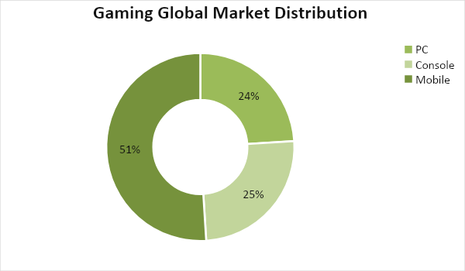

The next graph shows where the most in-game purchases come from:

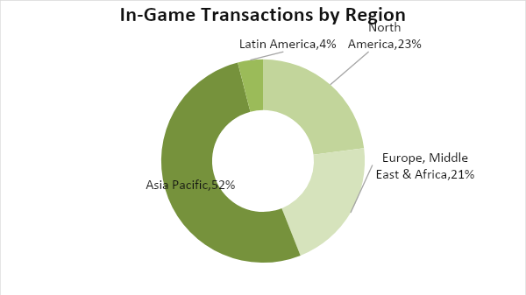

Target Market Segmentation Strategy

- [GameRan] is investing in advertising ["Shadow Uprising: Genesis"] on social media platforms including YouTube and Facebook. The studio will also tie up with game reviewers to promote the game in their channels.

- It will also penetrate Asia Pacific mobile game market where China and Japan lead in in-game purchases.

STRATEGY AND IMPLEMENTATION

Target Market Strategy

[GameRan] targets at least [2 million] app downloads for its maiden mobile game. In addition, the developer aims to achieve revenue between [100K to 200K] USD from in-game purchases for its first year.

Competitive Edge

As the Best New Mobile Game of the Year, [GameRan's] mobile game stands out against its competitor with a superior story, smoother gameplay and controls, and immersive experience. Aside from that, its dynamic pricing strategy allows the management to adjust prices to please its target market.

SWOT Analysis | Strengths | Weaknesses | Opportunities | Threats
GameRan, Ltd. | - Its product won the mobile game of the year award  - Competitive in-game prices | - Its new game can hardly penetrate the already crowded mobile game market  - Only targets mobile gamers | - Mobile gaming makes up more than half of the global gaming market revenue | - Intense competition in a profitable industry
iCraft, Ltd. | - Has produced more than five games  - Caters to both PC and console market  - Great customer service | - Games are expensive and buggy | - Rise in purchasing power of the global market | - Varied regulations and laws in its market can lead to copyright lawsuits and other litigations
USoft | - Considered as one of the best game developers today  - Has solid and loyal fan base | - Customer service needs improvement | - Market trusts known brand names even more | - Market demand for new games can be seasonal

Sales Strategy and Forecast

[GameRan] is focusing on making its game played in the regions of the Asia Pacific and North America. It will advertise the game using cinematic trailers, game walkthroughs, and reviews. In-game events and contests are also scheduled to keep users engaged and interested. Aside from these, the developers also made in and off-game forums to create a strong ["Shadow's Community."]

With these marketing initiatives, the studio projects the following monthly sales:

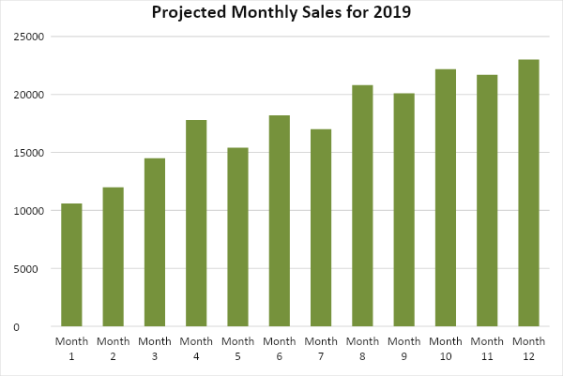

Through the different marketing drives, [GameRan] projects the following game download per region:

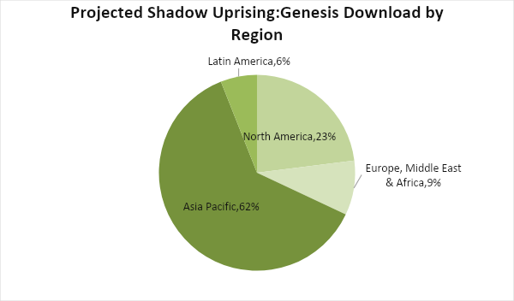

The game developer’s focus is to make the target market notice the game and convince them to download it. By hooking users through the game’s story and gameplay, different sales promotions will be done to encourage in-game purchases.

Sales Strategy | Activities | Timeline | Success Criteria
Monthly In-Game Events and Giveaways | - Monthly game events will be scheduled where rare game items and collectibles are given away to paying users | - Scheduled monthly event calendar by July 2, 2019 | - Proposed events approved by July 20, 2019
Exclusive discounts for game forum members | - By building a strong community, the game will have a loyal fan base that is willing to pay to enjoy the game in full | - July 5, 2019 | - Discount banners and ads on the forum should get at least 1000 clicks per day

Marketing Strategy

To grab a substantial share in the mobile gaming market in the Asia Pacific and North American regions, [GameRan] will make the game more visible through different online ads. Utilizing the award garnered for the game, the studio will tie up with the leading mobile game personalities to provide game walkthroughs and reviews to generate positive publicity for the game and the brand.

[GameRan] will also join in GamesCon and other regional and global gaming events not just to promote "Shadow's Uprising: Genesis" to gamers but also to attract venture capitalists and angel investors to invest in the studio's projects.

The team has kicked-off various activities to move the marketing strategies forward. Here are some of the updates:

Milestones

Marketing Strategy | Activities | Timeline | Success Criteria
Online ads | - Marketing will design and upload banners and video ads to different social media platforms | June 20, 2019 | The online ads are running before the game launch on July 10, 2019.
Reviews and walkthroughs | - Identify gaming personalities to review the game | Done | Game reviewers were given advance access to the game to make their reviews and walkthrough tutorials.
Games Conventions | - Identify which conventions are vital to attracting investors | June 20, 2019 | Proposal and schedule are approved before July.

MANAGEMENT AND PERSONNEL

[GameRan, Ltd.] is headed by its CEO, [Janice Rozier]. Under her are marketing manager Peter Ingles and operations manager Oda Takahashi. Below are the different teams that make up the entire organization:

- Art and Story Development - This team is in charge of the conceptualization and designing of the studio's games.

- Marketing and Promotion - This team is responsible for selling the company's product to its target market.

- Customer Relations - This team takes care of inquiries and suggestions from the company's users. They are also in charge of maintaining the studio's game forums.

- Human Resource - This team takes care of recruiting and training new members. This team is also responsible for the payroll and applying for different permits.

Below is the organizational structure of [GameRan]:

CEO
Marketing Manager
Marketing Director
Promotions
Investment Acquisition
Operations Manager
Art Director
Art and Story Development
Human Resource

SALES ACTION PLAN

The success of the studio hinges on the implementation of the sales plan. In the table below, the activities are listed down together with their target dates, key performance indicators (KPIs), and person-in-charge.

Sales Goals | Action Items | Start Date | End Date | KPIs | Owner
1. Game promotions | - The marketing team develops a plan to promote the studio’s game to its target audience | June 1, 2019 | June 20, 2019 | - All promotions are running before the game launch | Marketing Manager, CEO, Operations Manager
2. Obtain at least 2 million game downloads by the end of the year | - Generate online advertisement  - Give free rare in-game items to first 100 players | July 10, 2019 | Whole fiscal year | - Confirmed 2 million game downloads in both iOS and Android  - Successful game launch | Marketing Manager, CEO, Operations Manager
3. Investment generation | - Marketing team to schedule meetings with potential investors | ASAP | Whole fiscal year | - Book at least five meetings for the whole year  - Market the game during game conventions | Marketing Manager, CEO

