FLORIST BUSINESS PLAN

[INSERT NAME OF THE BUSINESS/COMPANY]
[INSERT THE COMPLETE BUSINESS/COMPANY ADDRESS]
[INSERT THE BUSINESS/COMPANY CONTACT NUMBERS]
[INSERT THE BUSINESS/COMPANY EMAIL ADDRESS]
[INSERT THE BUSINESS/COMPANY WEBSITE ADDRESS]

PREPARED BY:

[INSERT FULL NAME/S OF THE
PEOPLE WHO PREPARED THIS PLAN]

[INSERT DATE]

Index

Executive Summary [PAGE NUMBER]
Company Overview [PAGE NUMBER]
Products and Services [PAGE NUMBER]
Execution [PAGE NUMBER]
Operational Plan [PAGE NUMBER]
Financial Plan [PAGE NUMBER]

Executive Summary:

[The English Garden] is a registered flower shop located in [Camden, New Jersey]. The company has been able to lease a facility that is large enough to not only grow a garden but also to create a gorgeous display of flowers ready for sale.

[The English garden] will be engaged in the production and cultivation of its flowers, with services that include flower care and handling, floral design, flower arrangements, display, and delivery. The company will ensure that all of its customers will be given first-class treatment whenever they visit the flower shop.

Company Overview:

Mission Statement: [The English Garden] shall provide its customers with quality flowers and floral arrangements at a fair price.

Philosophy: [The English Garden] focuses on the consistency and quality of its products and services to match and surpass customer expectations.

Vision: [The English Garden] aims to be the go-to flower shop to suit any style, occasion, or budget.

Outlook: [The floral industry] is positive in its economic outlook, with consumers, retailers, and flower growers alike feeling optimistic regarding sales in the coming year. While Valentine’s Day remains to be the biggest day for sales, it is reported that floral favors such as roses, lavenders, and edible flowers are trending, making it a good opportunity for florists to [cross-merchandise products].

Type of Industry: [Floral Industry]

Business Structure: Sole Proprietorship

Ownership: Sole Proprietorship, [Susan McNeil]

Start-Up Summary: The start-up costs to launch [The English Garden] is [USD 120,000]. The amount is provided by the owner and will be mainly used for rent, cultivation, packaging, and payroll.

Start-Up Funding
Start-Up Expenses | $80,000
Start-Up Assets | $40,000
Total Funding Required | $120,000
Assets
Non-Cash Assets from Start-Up | $15,000
Cash Requirements from Start-up | $8,000
Additional Cash Raised | $7,000
Cash Balance on Starting Date | $10,000
Total Assets | $40,000
Capital
Planned Investment
Owner | $40,000
Other | $0
Additional Investment Requirement | $0
Total Planned Investment | $40,000
Loss at Start-Up (Start-Up Expenses) | $80,000
Total Capital | $120,000
Liabilities | $0
Total Capital and Liabilities | $120,000
Start-Up
Requirements
Start-Up Expenses
Rent - 6 Months | $18,000
Advertising | $10,000
Legal Fees | $6,000
Staff Training | $40,000
Insurance | $6,000
Other | $0
Total Start-Up Expenses | $80,000
Start-Up Assets
Cash Required | $25,000
Start-Up Inventory | $5,000
Other Current Assets | $5,000
Long-Term Assets | $5,000
Total Assets | $40,000
Total Requirements (Total Start-Up Expenses + Total Assets) | $120,000

Management Team:

Management Team | Role/Function | Skills
Chris Phillips | Store Manager | Communications, people skills, organizational, time management
Alina Barr | HR Manager | Employee relations, performance management

Short- and Long-Term Goals and Milestones:

Short-Term Goals | Milestones
- Sell 500 bouquets within the first month of opening | - 250 bouquets in 10 days
- Book a big event arrangement within the first month of opening | - Booked for a wedding flower arrangement for March.
Long-Term Goals | Milestones
- Create an online ordering system | - In the process of creating a website to include online payment options
- Open a new shop within the next two years

Products and Services

Product/Service Description: As part of the [floral industry], [The English Garden] has to ensure the consistency of the quality of a wide range of flowers. Its products and services include:

- Flowers in different bouquets and designs
- Floral arrangements
- Potted plants
- Complimentary gift items

Value Proposition: [The English Garden] emphasizes quality at a fair price, thus, its product pricing is determined by a combination of product costs and customer demand. The florists are at the top of their game, all of whom have studied different styles, techniques, and trends in the floral industry.

Pricing Strategy: [The English Garden] utilizes costs plus markup pricing strategies to remain competitive in the market.

Execution

Marketing Plan: The key to the [company’s marketing strategy] is to focus on specific occasions and in providing more product services and discounts for its customers. The company is in the process of getting enough traction to expand the shop in other areas of the city and generate interests from investors by promoting the flower shop through commercials and social media.

Market Research: [The floral industry] is driven by holiday purchases. [Holidays, birthdays, anniversaries, and other special events] are ideal scenarios for the [floral industry]. [Valentine’s Day] remains to be the most popular day, followed by [Mother’s Day, Christmas, and Hanukkah].

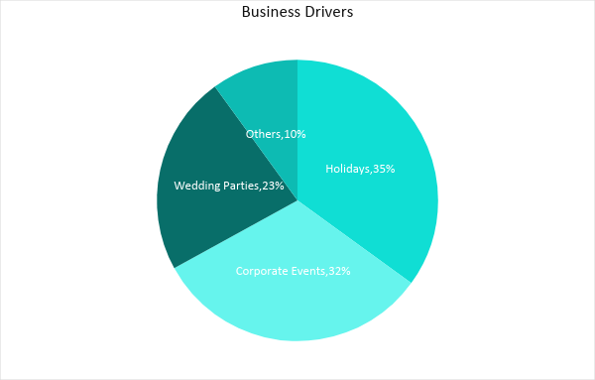

SWOT Analysis | Strengths | Weaknesses | Opportunities | Threats
The English Garden | Operating as a physical flower shop and online store | New in the industry and needs more marketing | The excellent location provides opportunities for a wider audience reach | Established competition can be threats to the business
Bloom | Range of flowers and related products in the area | Inconsistent quality of flowers during busy occasions | Opportunities for improvement by studying current industry trends | The arrival of competition in the growing industry
Belle’s Blooms | Excellent customer service and reviews | Does not have the financial capacity to compete with larger companies | Opportunities for expansion is apparent in the growing industry | An economic downturn can severely affect the company.

Marketing Strategy: For the business to continue growing, [The English Garden] should be able to sell flowers and related products, which is why it will pull all the stops to empower its sales and marketing team. The company intends to leverage promotions by using social media platforms and partnering with corporate organizations and other businesses. Branding shall also be visible via store signage and branding of its delivery vans with the company official logo to maximize visibility.

Marketing Strategy | Activities | Timeline | Success Criteria
Public Relations | Issue a press release about the store to local newspapers | January 15, 2019 | Increased inquiries about the company via phone or email
Print Advertising Campaign | Develop full-page layouts for local newspapers and magazines | February 10, 2019 | Sell at least 700 bouquets during Valentine’s Day rush
Website and social media marketing | Curate posts for its website and social media pages | ASAP | Views, likes, and post engagements should increase by at least [75%] upon launching

Organizational Structure:

Operational Plan:

Location and Facilities

CEO
In-store Staff
Maintenance
Security
Store Manager
OperationsManager
HR Manager
Financial Officer
HR Staff
Designers
Drivers
Sales, Marketing
Accountant

Tools and Equipment Checklist

Software | Quantity
None
Hardware | Quantity
Cash Register | 2
Security Cameras | 4
Flower Refrigeration System | 2

Financial Plan

Assumptions

Flower prices go up due to high demand during special occasions. However, despite the higher prices, revenue is also high especially during [Valentine’s, Mother’s Day, and other special holidays].

Monthly Expense

The chart shows the projected monthly expense for [2019].

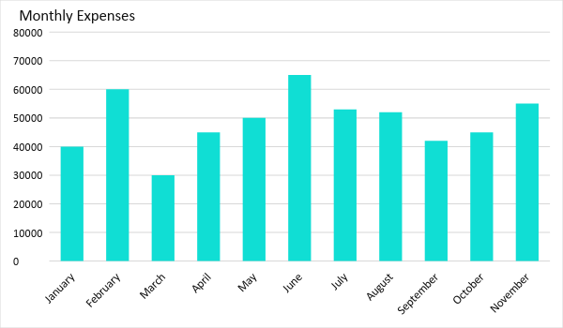
Monthly Revenue

The chart depicts the projected monthly revenue for [2019].

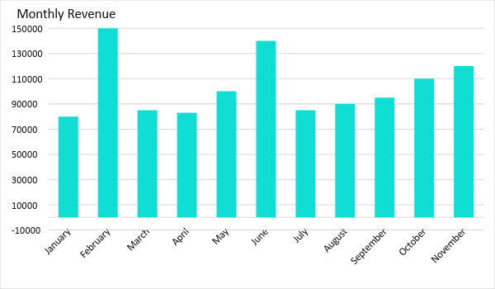

Business Financing

The funding for the business mainly comes from the personal finances of the owner. Major expenses will cover [cultivation, rent, salaries, supplies, and maintenance].

Statements

Profit and Loss Projection
 | FY2019 | FY2020 | FY2021
Sales | $1,300,000.00 | $1,700,000.00 | $2,000,000.00
Direct Cost of Sale | $500,000.00 | $650,000.00 | $800,000.00
Other Cost of Sale | $100,000.00 | $120,000.00 | $150,000.00
Total Cost of Goods Sold or COGS (Sales - Direct Cost of Sale - Other Cost of Sale) | $700,000.00 | $930,000.00 | $1,050,000.00
Gross Profit (Sales-Total Cost of Goods Sold) | $600,000.00 | $770,000.00 | $950,000.00
Gross Margin % (Gross Profit/Sales) | 46.15% | 45.29% | 47.50%
Operating Expenses
Rent | $10,000 | $10,000 | $10,000
Insurance | $3,000 | $3,000 | $3,000
Utilities | $6,000 | $6,000 | $6,000
Salary (Including Tax) | $75,000 | $75,000 | $80,000
Maintenance & Supplies | $4,000 | $4,000 | $4,000
Total Operating Expenses | $98,000.00 | $98,000.00 | $103,000.00
EBITDA (Total Cost of Sale-Total Operating Expenses) | $602,000.00 | $832,000.00 | $947,000.00
Depreciation | $3,000.00 | $4,000.00 | $4,000.00
Interest Expense | $0.00 | $0.00 | $0.00
Taxes Paid | $4,000.00 | $5,000.00 | $6,000.00
Net Profit (Gross Profit - Operating Expenses - Taxes - Interest) | $498,000.00 | $667,000.00 | $841,000.00

Balance Sheet Projection
 | FY2019 | FY2020 | FY2021
Cash | $1,300,000.00 | $1,700,000.00 | $2,200,000.00
Accounts Receivable | $10,000.00 | $15,000.00 | $11,000.00
Inventory | $10,000.00 | $12,000.00 | $15,000.00
Other Current Assets | $5,000.00 | $6,000.00 | $8,000.00
Total Current Assets | $1,325,000.00 | $1,733,000.00 | $2,234,000.00
Long-Term Assets | $80,000.00 | $70,000.00 | $60,000.00
Accumulated Depreciation | $3,000.00 | $2,500.00 | $2,000.00
Total Long-Term Assets (Long-Term Assets-Accumulated Depreciation) | $77,000.00 | $67,500.00 | $58,000.00
Total Assets (Total Current Assets + Total Long-Term Assets) | $1,402,000.00 | $1,800,500.00 | $2,292,000.00
Accounts Payable | $15,000.00 | $17,000.00 | $20,000.00
Notes Payable | $5,000.00 | $6,000.00 | $8,000.00
Other | $3,500.00 | $7,000.00 | $5,000.00
Total Liabilities | $23,500.00 | $30,000.00 | $33,000.00
Paid-in Capital | $5,000.00 | $5,000.00 | $5,000.00
Retained Earnings | $253,000.00 | $554,000.00 | $700,500.00
Total Owner's Equity (Total Assets - Total Liabilities) | $1,378,500.00 | $1,770,500.00 | $2,259,000.00
Total Liabilities & Equity (Total Liabilities/Total Owner's Equity) | 1.70% | 1.69% | 1.46%

Cash Flow Projection
 | FY2019 | FY2020 | FY2021
Operating Cash Beginning | $120,000.00 | $1,520,000.00 | $3,154,000.00
Sources of Cash | $150,000.00 | $180,000.00 | $350,000.00
Receivables | $15,000.00 | $17,000.00 | $20,000.00
Sales | $1,500,000.00 | $1,700,000.00 | $1,900,000.00
Others | $5,000.00 | $7,000.00 | $8,000.00
Total Cash | $1,790,000.00 | $3,424,000.00 | $5,432,000.00
Expenditures
Rent | $36,000 | $36,000 | $36,000
Insurance | $5,000 | $5,000 | $5,000
Utilities | $5,000 | $5,000 | $5,000
Salary (Including Tax) | $200,000 | $200,000 | $250,000
Maintenance & Supplies | $24,000 | $24,000 | $24,000
Total Expenditures | $270,000.00 | $270,000.00 | $320,000.00
Net Income/Loss (Total Cash - Total Expenditures) | $1,520,000.00 | $3,154,000.00 | $5,112,000.00

