Event Planning Budget Worksheet
Summary of Expenses and Income |  |  |  |  |  |  | Budget Summary
Venue | $11,000.00 |  |  |  |  |  | Total Expenses
Refreshments | $22,000.00 |  |  |  |  |  | $57,200.00
Program | $13,500.00 |  |  |  |  |  | Total Actual Income
Promotion | $8,000.00 |  |  |  |  |  | $66,000.00
Miscellaneous | $2,700.00 |  |  |  |  |  | Balance
Total Expenses | $57,200.00 |  |  |  |  |  | $8,800.00
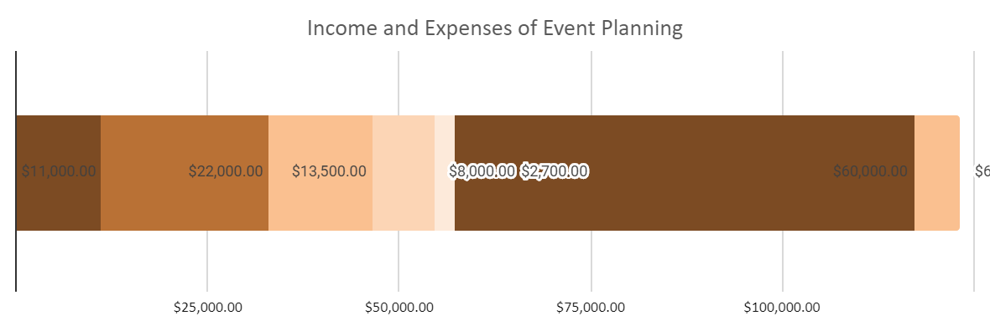

Expenses
Category |  |  |  |  |  |  |  | Amount
Venue
Room/Hall Rent |  |  |  |  |  |  |  | $2,000.00
Furniture |  |  |  |  |  |  |  | $5,000.00
Equipment’s (Speakers, Microphones, etc.) |  |  |  |  |  |  |  | $3,000.00
Decorations |  |  |  |  |  |  |  | $1,000.00
Refreshments
Food |  |  |  |  |  |  |  | $10,000.00
Drinks |  |  |  |  |  |  |  | $12,000.00
Program
Presenters |  |  |  |  |  |  |  | $5,000.00
Performers |  |  |  |  |  |  |  | $5,000.00
Presenter/Performer Travel Expenses |  |  |  |  |  |  |  | $1,500.00
Presenter/Performer Accommodation |  |  |  |  |  |  |  | $2,000.00
Promotion
Paid Advertising |  |  |  |  |  |  |  | $5,000.00
Web Development |  |  |  |  |  |  |  | $2,000.00
Special offers/giveaways |  |  |  |  |  |  |  | $1,000.00
Miscellaneous
Name Tags/Budgets |  |  |  |  |  |  |  | $1,100.00
Printed agendas/programs |  |  |  |  |  |  |  | $900.00
Swag (Stickers, Posters, Keychains, etc.) |  |  |  |  |  |  |  | $500.00
Stationary/Pen/Pencils |  |  |  |  |  |  |  | $200.00
Income
Description |  |  | Qty | Unit Price |  |  |  | Actual Income
Registrations |  |  | 200 | $300.00 |  |  |  | $60,000.00
Sales (Audio and Video CDs) |  |  | 50 | $120.00 |  |  |  | $6,000.00

