Birth Center Business Plan

[INSERT NAME OF THE BUSINESS/COMPANY]
[INSERT THE COMPLETE BUSINESS/COMPANY ADDRESS]
[INSERT THE BUSINESS/COMPANY CONTACT NUMBERS]
[INSERT THE BUSINESS/COMPANY EMAIL ADDRESS]
[INSERT THE BUSINESS/COMPANY WEBSITE ADDRESS]

PREPARED BY:

[INSERT FULL NAME/S OF THE
PEOPLE WHO PREPARED THIS PLAN]

[INSERT DATE]

Index

Executive Summary [PAGE NUMBER]

Company Overview [PAGE NUMBER]

Products and Services [PAGE NUMBER]

Execution [PAGE NUMBER]

Operational Plan [PAGE NUMBER]

Financial Plan [PAGE NUMBER]

Executive Summary:

[Newborn Birth Center] is an independent birth center in [New Castle County], [Delaware] that will provide personalized prenatal, natural childbirth, and post-natal services to its clients. The birth center targets women who are interested in experiencing different ways of natural childbirth.

[Newborn Birth Center] plans to obtain many clients during its first year of operations. The birth center aims to spread information about natural childbirth and natural childbirth services through the creation of an informative website and social media advertising.

Company Overview:

Mission Statement: [Newborn Birth Center] provides an affordable, safe, and healthy environment for mothers to acquire prenatal services, to deliver the baby and to obtain post-natal care.

Philosophy: [Newborn Birth Center] allows mothers to gain a natural childbirth experience at a trusted facility. The midwives are committed to providing sufficient education, care, and respect to the needs of all women.

Vision: [Newborn Birth Center] will become one of the leading and trusted birth centers in [Delaware].

Outlook: The demand for [birth centers] in the [US] is rising rapidly with the growing interest of women to experience natural childbirth. This positive progress within the industry projects an increase in the clientele of birth centers in the next three years or more.

Type of Industry: Health Care

Business Structure: Partnership

Ownership: Partnership, [Melissa Barrow] and [Eunice Watson]

Start-Up Summary: The start-up costs for [Newborn Birth Center] amounts to [245K] USD. The partners will divide the payment of the start-up funds equally. The initial funds cover the rent, insurance, legal fees, and initial operating expenses of the business.

Start-Up Funding
Start-Up Expenses | $146,460
Start-Up Assets | $98,540
Total Funding Required | $245,000
Assets
Non-Cash Assets from Start-Up | $52,540
Cash Requirements from Start-up | $10,000
Additional Cash Raised | $31,000
Cash Balance on Starting Date | $5,000
Total Assets | $98,540
Capital
Planned Investment
Owners | $245,000
Other | $0
Additional Investment Requirement | $0
Total Planned Investment | $245,000
Loss at Start-Up (Start-Up Expenses) | -$146,460
Total Capital | $98,540
Liabilities | $0
Total Capital and Liabilities | $98,540
Start-Up
Requirements
Start-Up Expenses
Rent - 6 Months | $38,160
Advertising | $4,000
Legal Fees | $1,800
Staff Training | $10,000
Insurance | $2,500
Other | $90,000
Total Start-Up Expenses | $146,460
Start-Up Assets
Cash Required | $46,000
Start-Up Inventory | $12,000
Other Current Assets | $15,000
Long-Term Assets | $25,540
Total Assets | $98,540
Total Requirements (Total Start-Up Expenses + Total Assets) | $245,000

Management Team:

Management Team | Role/Function | Skills
Melissa Barrow | Operations Manager | Communication, Conflict Management, Decision-making, Leadership
Eunice Watson | Head Midwife | Leadership, Organization, Communication, Caring Attitude

Short- and Long-Term Goals and Milestones:

Short-Term Goals | Milestones
Comply with the state laws and regulations to form the business | Secured the necessary operating permits and licenses last January 15, 2020
Hire qualified and certified midwives to handle the birth center’s services | Recruited 5 certified midwives last January 20, 2020, to begin on the first day
Long-Term Goals | Milestones
Adapt effectively to the market changes | Prepared personalized childbirth services for its target market
Spread awareness on the different ways of natural birth | Planned the creation of a website for clients to browse through

Products and Services

Product/Service Description: [Newborn Birth Center] offers personalized prenatal, delivery, and post-natal services to its clients. The birth center also provides counseling sessions to aid mothers in taking care of their newborn child.

Value Proposition: [Newborn Birth Center] adjusts to the needs of its clients. The birth center provides its services depending on the condition of its client.

Pricing Strategy: The [Newborn Birth Center] prices its services based on the competitor’s prices. The birth center will also apply the price-bundling scheme.

Execution

Marketing Plan: The [Newborn Birth Center] plans to spread awareness and information about its services to its target market. The birth center also aims to increase the number of clients through word of mouth and social media exposure.

Market Research: Certain laws and regulations in the US have contributed greatly to the rise in demand for birth centers. A recent survey shows that most women in Delaware opt to go to birth centers instead of maternity wards for childbirth.

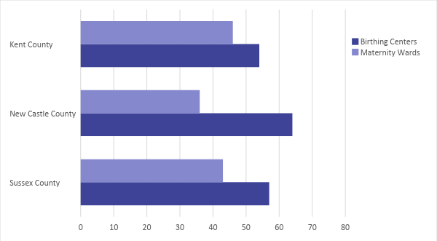

SWOT Analysis | Strengths | Weaknesses | Opportunities | Threats
Newborn  Birth Center | Personalized assistance and services to pregnant women | Lack of support from hospitals and medical practitioners since the birth center is relatively new | There are women who prefer a personalized approach to their childbirth. | The problems caused by insurers of birth centers lead to business closures of start-up birth centers.
New Castle Birth Center | A well-known and trusted birth center | Highly expensive fees for consultation and childbirth services | The increasing demand for natural childbirth | There are pending bills in the government that may hinder certain services offered by birth centers.
Baby Care Birthing Center | Reliable facility for natural childbirth | Poor customer service | The growing interest of women in natural childbirth may result in an increase in clientele. | The increasing demand for birth centers enables hospitals to support and fund independent birth centers.

Marketing Strategy: The Newborn Birth Center aims to spread awareness on natural childbirth by opening an informative website. The birth center strives to advertise its services by word of mouth and social media. The following table shows the center’s activities to implement its marketing strategies.

Marketing Strategy | Activities | Timeline | Success Criteria
Website Creation | Hire a website developer. | March 1, 2020 | Discuss the layout of the website with the developer by March 5, 2020.
Social Media Advertisements | Prepare video advertisements to be posted on various social media channels. | March 5, 2020 | Review the final draft of the video advertisements by February 28, 2020.
Word of Mouth | Post promotional information on community bulletin boards. | ASAP | Print posters by February 25, 2020.

Organizational Structure:

[Melissa Barrow] and [Eunice Watson], the owners of [Newborn Birth Center], will oversee the operations of the birth center as operations manager and head midwife respectively. They will closely supervise the delivery of services to its clients with the assistance of the hired midwives

Operational Plan:

Location and Facilities

Newborn Birth Center occupies a 4770 sq. ft. office and medical space in 1800 Naamans Rd. New Castle County, DE 19810, USA. The facility will have three birth rooms, a nursing station, a family area, and a storage room.

Tools and Equipment Checklist

Software | Quantity
Customer Database System | 1
Inventory Management | 1
Hardware | Quantity
Medical Equipment | 7
Computer | 2

IT Infrastructure

The table below describes the Newborn Birthing Center’s IT infrastructure.

Infrastructure | Existing (Y/N) | Description
Website | N | The birth center is currently in the process of creating a website.
Latency Proof | N | Interruptions and delays in network connections were encountered.
Zero Downtime | Y | There were no disruptions caused by the network.

Financial Plan

Assumptions

The [Newborn Birth Center] has the following financial assumptions in making its projected financial statements:
- The birth center expects to gain a [35%] increase in sales beginning in the second year of its operations.
- The prevailing market interest is [5.4%]. The tax rate is equal to 20% of the total compensation amount.
- Expenses are expected to increase during the second half of the year due to inflation.

Monthly Expense

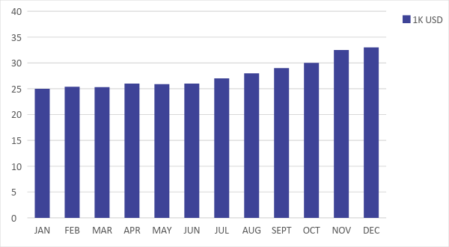

Monthly Revenue

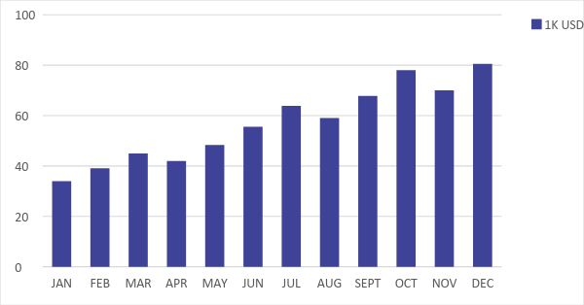

Business Financing

The partners obtained a business loan each amounting to [$122,500] to generate the initial funds of [$245,000]. The initial funds cover the starting operating expenses of the birth center.

Statements

Profit and Loss Projection
 | FY2020 | FY2021 | FY2022
Sales | $467,500.00 | $631,125.00 | $852,018.75
Direct Cost of Sale | $196,350.00 | $265,072.50 | $357,847.88
Other Cost of Sale | $4,500.00 | $4,590.00 | $4,681.80
Total Cost of Goods Sold or COGS (Sales - Direct Cost of Sale - Other Cost of Sale) | $266,650.00 | $361,462.50 | $489,489.08
Gross Profit (Sales-Total Cost of Goods Sold) | $200,850.00 | $269,662.50 | $362,529.68
Gross Margin % (Gross Profit/Sales) | 42.96% | 42.73% | 42.55%
Operating Expenses
Rent | $76,320.00 | $76,320.00 | $76,320.00
Insurance | $5,000.00 | $5,000.00 | $5,000.00
Utilities | $10,000.00 | $10,350.00 | $10,712.25
Salary (Including Tax) | $70,000.00 | $70,000.00 | $70,000.00
Maintenance & Supplies | $10,000.00 | $10,350.00 | $10,712.25
Total Operating Expenses | $171,320.00 | $172,020.00 | $172,744.50
EBITDA (Total Cost of Sale-Total Operating Expenses) | $95,330.00 | $189,442.50 | $316,744.58
Depreciation | $1,150.00 | $1,150.00 | $1,150.00
Interest Expense | $13,230.00 | $13,230.00 | $13,230.00
Taxes Paid | $14,000.00 | $14,000.00 | $14,000.00
Net Profit (Gross Profit - Operating Expenses - Taxes - Interest) | $2,300.00 | $70,412.50 | $162,555.18

Balance Sheet Projection
 | FY2020 | FY2021 | FY2022
Cash | $14,380.00 | $78,325.00 | $222,619.75
Accounts Receivable | $87,300.00 | $117,855.00 | $159,104.25
Inventory | $45,540.00 | $56,469.60 | $70,022.30
Other Current Assets | $36,230.00 | $36,230.00 | $36,230.00
Total Current Assets | $183,450.00 | $288,879.60 | $487,976.30
Long-Term Assets | $65,000.00 | $65,000.00 | $65,000.00
Accumulated Depreciation | $1,150.00 | $2,300.00 | $3,450.00
Total Long-Term Assets (Long-Term Assets-Accumulated Depreciation) | $63,850.00 | $62,700.00 | $61,550.00
Total Assets (Total Current Assets + Total Long-Term Assets) | $247,300.00 | $351,579.60 | $549,526.30
Accounts Payable | $60,000.00 | $55,000.00 | $50,000.00
Notes Payable | $5,000.00 | $6,000.00 | $7,200.00
Other | $1,500.00 | $2,000.00 | $2,500.00
Total Liabilities | $66,500.00 | $63,000.00 | $59,700.00
Paid-in Capital | $245,000.00 | $245,000.00 | $245,000.00
Retained Earnings | $2,300.00 | $72,712.50 | $235,267.68
Total Owner's Equity (Total Assets - Total Liabilities) | $180,800.00 | $288,579.60 | $489,826.30
Total Liabilities & Equity (Total Liabilities/Total Owner's Equity) | 36.78% | 21.83% | 12.19%

Cash Flow Projection
 | FY2020 | FY2021 | FY2022
Operating Cash Beginning | $10,000.00 | $14,380.00 | $78,325.00
Sources of Cash | $7,500.00 | $9,375.00 | $11,718.75
Receivables | $50,000.00 | $67,500.00 | $91,125.00
Sales | $115,000.00 | $155,250.00 | $209,587.50
Others | $3,200.00 | $3,840.00 | $4,608.00
Total Cash | $185,700.00 | $250,345.00 | $395,364.25
Expenditures
Rent | $76,320.00 | $76,320.00 | $76,320.00
Insurance | $5,000.00 | $5,000.00 | $5,000.00
Utilities | $10,000.00 | $10,350.00 | $10,712.25
Salary (Including Tax) | $70,000.00 | $70,000.00 | $70,000.00
Maintenance & Supplies | $10,000.00 | $10,350.00 | $10,712.25
Total Expenditures | $171,320.00 | $172,020.00 | $172,744.50
Net Income/Loss (Total Cash - Total Expenditures) | $14,380.00 | $78,325.00 | $222,619.75

