YOUTUBE BUSINESS PLAN

Business Plan For Fiscal Year 2019

[January 16, 2019]
[Melvin Wesselink] [melvinwesselink@gmail.com]
[310-627-3931]
[www.melvin-wesselink.com]
[4394 Sumner Street Los Angeles, CA 90017, USA]

INDEX
Executive Summary
Company Overview
Products and Services
Execution
Operational Plan
Financial Plan
[Page Number]
[Page Number]
[Page Number]
[Page Number]
[Page Number]
[Page Number]

Executive Summary:

[Melvin Wesselink] is a YouTube channel of Dutch-American magician and filmmaker Melvin Augustus [Wesselink]. The channel mainly contains videos narrating his journey as a magician. He also shares tutorial videos on magic tricks and filmmaking. Currently, the channel has [101,473] subscribers who are mostly young. Melvin is currently looking at creating more valuable content to reach a wider audience.

Company Overview:

Mission Statement: [Melvin Wesselink] aims to connect with people through magic and films. He wants to help his audience understand the world of magic through his vlogs.

Philosophy: [Melvin Wesselink] always strives to provide high-quality content that gives value to the audience.

Vision: [Melvin Wesselink’s] vision is to be one of the most influential YouTuber in the world.

Outlook: In the business of personal branding, the playing field has become very competitive. Many content creators have emerged in the past couple of years and the competition for consumer attention is increasing. In the YouTube platform, thousands of users have already reached one million or more subscribers. Contents have become saturated and strategies can change drastically in any minute. Nevertheless, the audience base of the platform is increasing by the day due to the general shift of consumer behavior. To succeed in the YouTube business, one must keep up with the latest trends and continue to create more valuable content that speaks directly to a greater audience.

Type of Industry: Digital Content Creation Industry

Business Structure: Sole Proprietorship

Ownership: Sole Proprietorship, [Melvin Wesselink]

Start-Up Summary: The cost of this start-up is [$5,000]. It will be used for advertisements, supplies, payroll, and maintenance.

Start-Up Funding
Start-Up Expenses | $1,500
Start-Up Assets | $3,500
Total Funding Required | $5,000
Assets
Non-Cash Assets from Start-Up | $1,000
Cash Requirements from Start-up | $700
Additional Cash Raised | $1,100
Cash Balance on Starting Date | $700
Total Assets | $3,500
Capital
Planned Investment
Owner | $5,000
Other | $0
Additional Investment Requirement | $0
Total Planned Investment | $5,000
Loss at Start-Up (Start-Up Expenses) | -$1,500
Total Capital | $3,500
Liabilities | $0
Total Capital and Liabilities | $3,500
Start-Up
Requirements
Start-Up Expenses
Advertising | $250
Fare | $200
Editing Software | $300
Freelance Employee | $250
Equipment | $500
Other | $0
Total Start-Up Expenses | $1,500
Start-Up Assets
Cash Required | $700
Start-Up Inventory | $1,000
Other Current Assets | $1,100
Long-Term Assets | $700
Total Assets | $3,500
Total Requirements (Total Start-Up Expenses + Total Assets) | $5,000

Management Team:

Management Team | Role/Function | Skills
Ryan [Kerstetter] | Personal Manager | Planning, Organization, Decision-Making, Communication
[Melvin Wesselink] | Managing Director | Negotiation, Problem-Solving, Interpersonal, Branding

Short- and Long-Term Goals and Milestones:

Short-Term Goals | Milestones
Hire a part-time editor | Screening for candidates is ongoing
Raise a budget for channel boosting | The fund is already in place
Long-Term Goals | Milestones
Increase the number of subscribers by 200% within 18 months | The budget for advertising the channel is already in place
Increase content production by 50% at the end of the year | Is already hiring a part-time videographer and editor to help with the production

Products and Services

Product/Service Description: [Melvin Wesselink] provides his audience with valuable content that engages, educates, and inspires. His content features magic performances, magic and filmmaking tutorials.

Value Proposition: [Melvin Wesselink] prioritizes the quality of his contents as he creates them. He makes sure that his audiences get the best out of his contents through his entertaining and inspiring materials.

Pricing Strategy: [Melvin Wesselink] gets most of his revenue from sponsorships, merchandise, and ads.

Formula:
Profit Margin = 1- (Expenses/Net Sales)

[Melvin Wesselink]
Profit Margin = 1 - ($18,000/$30,000)
= 1-0.6
= 0.4 or 40%

Execution

Marketing Plan: [Melvin Wesselink] will promote his channel on other social media platforms such as Facebook, Instagram, and Twitter. He will also run ads on Google and YouTube to increase his visibility. Search engine optimization will also be used on his YouTube channel to further increase his presence on the internet.
Market Research: The YouTube business is part of a growing digital content creation industry that is projected to grow at a rate of [16.8%] per year and will reach a valuation of [$43] million by [2026]. Based on the latest survey, [54%] of respondents prefer to consume digital content that is visual, like the videos on YouTube, because of its accessibility and convenience.

SWOT Analysis | Strengths | Weaknesses | Opportunities | Threats
[Melvin Wesselink] | - High-quality content  - High engagement rating | Limited resources to produce more content | Increasing consumption of visual content | Increasing YouTube personalities who are competing for consumer’s attention
Devon Dorsey | - Professional magician  - Engaging content | Content has weak cinematography | The cost to advertise the channel on social media platforms is cheap | Other media platforms that may attract viewership from YouTube
Mr. Magic | - Has more than 200,000 subscribers  - Content is entertaining | The channel is mainly focused on magic | Increasing YouTube viewership | Viewers may get tired of consuming one type of content from a channel

Marketing Strategy: The marketing strategy for [Melvin Wesselink’s] channel will solely focus on increasing his presence and visibility online. His team will utilize targeted ads to reach his ideal audience. It will then choose a few of Melvin’s video that will be used for the ad, ones that easily catch his target viewer’s attention. The ad will be aired on the following social media platforms: YouTube, Facebook, and Instagram, and will be adjusted based on what platform it will be aired on.

Melvin will also collaborate with other YouTubers to increase his viewership. He will reach out his fellow magician and filmmaker influencers on YouTube to create videos together.

The team has started several activities to drive its strategies forward. Below are some of the updates:

Marketing Strategy | Activities | Timeline | Success Criteria
Collaboration | The team has already messaged eight influential Youtubers for collaboration. | March 3, 2019 | Melvin will start shooting the video with co-influencers.
Targeted advertising | The team has already paid the platforms for the ad. | February 27, 2019 | The platforms will start airing the ads in the first week of March.

Organizational Structure:

CEO
PERSONAL MANAGER
MANAGING DIRECTOR
VIDEOGRAPHER/EDITOR

Operational Plan:
Location and Facilities

Provide a sketch or blueprint of the facility.

Provide photos or images of the location/facility.

Tools and Equipment Checklist

Software | Quantity
Adobe Premiere Pro | 2
Adobe Photoshop | 2
Hardware | Quantity
Camera | 2
Microphone | 1
Desktop Computer | 1
Lighting | 1
Tripod | 2

IT Infrastructure

The following table reflects [Melvin Wesselink’s] IT infrastructure.

Infrastructure | Existing (Y/N) | Description
Editing Software | Y | Essential software in creating quality videos
Camera | Y | Melvin uses a high-quality camera to produce high-quality content.

Financial Plan

Assumptions

The current marketing condition for content creation has served as a basis for [Melvin Wesselink’s] financial forecast. The company will take advantage of the current trends in advertising but will adapt to future changes in content marketing. The majority of Melvin’s expenses will be on supplies, payroll, and marketing initiatives.

Monthly Expense
The chart shows [Melvin Wesselink’s] projected monthly expenses for 2019.
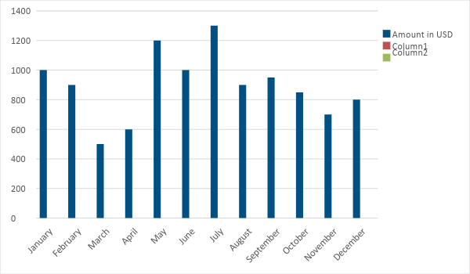

Monthly Revenue
The chart depicts [Melvin Wesselink’s] projected monthly revenues for [2019].
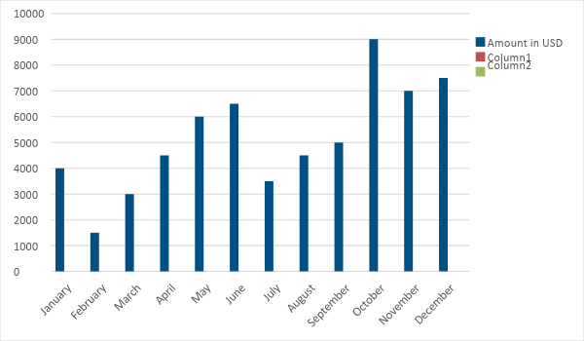

Business Financing

The personal brand’s funding mainly comes from the owner worth [$5,000]. The majority of the funds will go to advertising, initial supplies, maintenance, and payroll.

Statements

Profit and Loss Projection
 | FY2019 | FY2020 | FY2021
Sales | $50,000.00 | $65,000.00 | $80,000.00
Direct Cost of Sale | $10,000.00 | $15,000.00 | $30,000.00
Other Cost of Sale | $10,000.00 | $12,000.00 | $15,000.00
Total Cost of Goods Sold or COGS (Sales - Direct Cost of Sale - Other Cost of Sale) | $30,000.00 | $38,000.00 | $35,000.00
Gross Profit (Sales-Total Cost of Goods Sold) | $20,000.00 | $27,000.00 | $45,000.00
Gross Margin % (Gross Profit/Sales) | 40.00% | 41.54% | 56.25%
Operating Expenses
Advertising | $5,000.00 | $6,000.00 | $8,000.00
Fare | $1,000.00 | $1,500.00 | $1,600.00
Editing Software | $500.00 | $550.00 | $600.00
Freelance Employee | $10,000.00 | $12,000.00 | $20,000.00
Maintenance & Supplies | $1,500.00 | $2,000.00 | $3,000.00
Total Operating Expenses | $18,000.00 | $22,050.00 | $33,200.00
EBITDA (Total Cost of Sale-Total Operating Expenses) | $12,000.00 | $15,950.00 | $1,800.00
Depreciation | $2,000.00 | $2,500.00 | $3,000.00
Interest Expense | $1,000.00 | $1,200.00 | $1,400.00
Taxes Paid | $200.00 | $500.00 | $600.00
Net Profit (Gross Profit - Operating Expenses - Taxes - Interest) | $800.00 | $3,250.00 | $9,800.00

Balance Sheet Projection
 | FY2019 | FY2020 | FY2021
Cash | $30,000.00 | $50,000.00 | $70,000.00
Accounts Receivable | $15,000.00 | $20,000.00 | $25,000.00
Inventory | $10,000.00 | $10,000.00 | $12,000.00
Other Current Assets | $4,000.00 | $5,000.00 | $6,000.00
Total Current Assets | $59,000.00 | $85,000.00 | $113,000.00
Long-Term Assets | $5,000.00 | $5,000.00 | $5,500.00
Accumulated Depreciation | $2,000.00 | $2,500.00 | $3,000.00
Total Long-Term Assets (Long-Term Assets-Accumulated Depreciation) | $3,000.00 | $2,500.00 | $2,500.00
Total Assets (Total Current Assets + Total Long-Term Assets) | $62,000.00 | $87,500.00 | $115,500.00
Accounts Payable | $12,000.00 | $16,000.00 | $20,000.00
Notes Payable | $2,000.00 | $2,500.00 | $3,000.00
Other | $2,000.00 | $5,500.00 | $10,000.00
Total Liabilities | $16,000.00 | $24,000.00 | $33,000.00
Paid-in Capital | $10,000.00 | $15,000.00 | $18,000.00
Retained Earnings | $50,000.00 | $60,000.00 | $80,000.00
Total Owner's Equity (Total Assets - Total Liabilities) | $46,000.00 | $63,500.00 | $82,500.00
Total Liabilities & Equity (Total Liabilities/Total Owner's Equity) | 34.78% | 37.80% | 40.00%

Cash Flow Projection
 | FY2019 | FY2020 | FY2021
Operating Cash Beginning | $5,000.00 | $1,000.00 | $15,000.00
Sources of Cash | $10,000.00 | $11,000.00 | $12,000.00
Receivables | $12,000.00 | $15,000.00 | $16,000.00
Sales | $30,000.00 | $50,000.00 | $80,000.00
Others | $1,200.00 | $2,000.00 | $3,000.00
Total Cash | $58,200.00 | $79,000.00 | $126,000.00
Expenditures
Advertising | $5,000.00 | $6,000.00 | $8,000.00
Fare | $1,000.00 | $1,500.00 | $1,600.00
Editing Software | $500.00 | $550.00 | $600.00
Freelance Employee | $10,000.00 | $12,000.00 | $20,000.00
Maintenance & Supplies | $1,500.00 | $2,000.00 | $3,000.00
Total Expenditures | $18,000.00 | $22,050.00 | $33,200.00
Net Income/Loss (Total Cash - Total Expenditures) | $40,200.00 | $56,950.00 | $92,800.00

