WEB DESIGN & DEVELOPMENT BUSINESS PLAN
[INSERT COMPANY NAME]
Business Plan for Fiscal Year [INSERT YEAR]
[INSERT DATE]

[Ricky Rogers]
[rickyrogers@gmail.com]
[301-319-0309]
[www.swiftwebsolutionsllc.com]
[7910 Wood Mont Ave 7,
Bethesda, MD 20814, USA]
INDEX

EXECUTIVE SUMMARY  COMPANY OVERVIEW  PRODUCTS AND SERVICES  EXECUTION  OPERATIONAL PLAN  FINANCIAL PLAN | [INSERT PAGE NO.]  [INSERT PAGE NO.]  [INSERT PAGE NO.]  [INSERT PAGE NO.]  [INSERT PAGE NO.]  [INSERT PAGE NO.]

EXECUTIVE SUMMARY

[Swift Web Solutions LLC] is a mid-sized web design and development company based in [Bethesda, Maryland]. The company particularly designs and develops e-commerce sites. The company considers small to medium-sized businesses as its target market.

[Swift Web Solutions LLC] plans to make itself more known to its target market through email marketing and flyer distribution. The company anticipates increments in the number of clients in the coming years with the growing demand for web design and development services.

COMPANY OVERVIEW

Mission Statement: [Swift Web Solutions LLC] helps companies set their brand and reputation in the market through premium quality web design and development services.

Philosophy: [Swift Web Solutions LLC] maintains respect, professionalism, and integrity in every single project handled.

Vision: [Swift Web Solutions LLC] envisions itself as one of the leading mid-sized web designers and developers in [Maryland].

Outlook: The priority of most small to medium-sized businesses is to retain customers, and this can be done by ensuring customer satisfaction every time they avail of their products or services. Following this context, the company anticipates clients from small to mid-sized companies that aim to leverage consumers’ intensive use of the internet now-a-days.

Type of Industry: Web Design and Development Industry

Business Structure: Limited Liability Company

Ownership: Limited Liability Company; [Ricky Rogers], [Nikita Morgan], [Laurence Thomas]

Start-Up Summary: [Swift Web Solutions LLC] has a total start-up cost of 200K USD. The company’s members generated the funds through contribution and business loan. The initial funds cover payments for rent, insurance, legal fees, and payroll.

Start-Up Funding
Start-Up Expenses | $101,200
Start-Up Assets | $98,800
Total Funding Required | $200,000
Assets
Non-Cash Assets from Start-Up | $59,500
Cash Requirements from Start-up | $8,000
Additional Cash Raised | $29,300
Cash Balance on Starting Date | $2,000
Total Assets | $98,800
Capital
Planned Investment
Owners | $200,000
Other | $0
Additional Investment Requirement | $0
Total Planned Investment | $200,000
Loss at Start-Up (Start-Up Expenses) | -$101,200
Total Capital | $98,800
Liabilities | $0
Total Capital and Liabilities | $98,800
Start-Up
Requirements
Start-Up Expenses
Rent - 6 Months | $21,200
Advertising | $2,500
Legal Fees | $1,500
Staff Training | $4,000
Insurance | $2,000
Other | $70,000
Total Start-Up Expenses | $101,200
Start-Up Assets
Cash Required | $10,000
Start-Up Inventory | $9,500
Other Current Assets | $29,300
Long-Term Assets | $50,000
Total Assets | $98,800
Total Requirements (Total Start-Up Expenses + Total Assets) | $200,000

Management Team:

Management Team | Role/Function | Skills
Nikita Morgan | Web Design  Operations Manager | Leadership, Communication, Decision-Making, Team Management
Laurence Thomas | Web Development Operations Manager | Leadership, Problem-Solving, Communication, Planning

Short- and Long-Term Goals and Milestones:

Short-Term Goals | Milestones
Hire talented web designers and developers | Evaluated 5 applicants last October 29, 2018.
-- | --
Long-Term Goals | Milestones
Obtain projects from large businesses | Sent email to a few large retail establishments
-- | --

PRODUCTS AND SERVICES

Product/Service Description: [Swift Web Solutions LLC] uses responsive web design as an approach to designing web pages. The company also develops e-commerce websites for small and mid-sized commercial establishments who want to venture online.

Value Proposition: [Swift Web Solutions LLC] collaborates with clients to gain positive returns of investment through a user-friendly and well-designed website.

Pricing Strategy: [Swift Web Solutions LLC] uses competitive pricing to set a fee per hour for its services. The company charges its clients at $150 per hour for new types of web projects.

EXECUTION

Marketing Plan: [Swift Web Solutions LLC] targets small and mid-sized offices and businesses. The company plans to utilize traditional and online marketing strategies to promote its services to the identified target market.

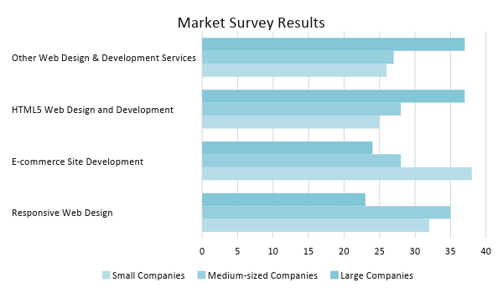
Market Research: The web design and development industry is the fastest growing industry in the modern era. The demand for services from the industry continues to grow with the consumers’ consistent use of the internet and the businesses’ aim to satisfy them. A market survey reveals that web design and e-commerce site development are two of the most popular web services availed by small and mid-sized companies.

SWOT Analysis | Strengths | Weaknesses | Opportunities | Threats
Swift Web Solutions LLC | Uses responsive web design in designing and developing web pages and sites | Weak market presence | Growing demand for user-responsive web pages and sites | Established large companies have a greater market share
MD Web Design Inc. | Known for its cost-efficient customer service | Outsourced technical team | Increasing demand for web design opens the chances of the company to expand | Marketing tactics that negatively affect the company’s reputation
Bethesda Web Development Corp. | One of the leading web development companies | Highly expensive charges | Outsourcing other department tasks to reliable partners may enhance cost-efficiency | Governmental regulations may hinder the plans of the company to outsource

Marketing Strategy: [Swift Web Solutions LLC] will use email marketing aggressively. The company will generate a list of potential clients and send a quote for its web design and website development service. The company will also distribute flyers to neighboring offices and establishments. The table below shows the actions being taken by the company to accomplish the aforementioned strategies.

Marketing Strategy | Activities | Timeline | Success Criteria
Email Marketing | List down small to mid-sized companies with a history of availing web design and development services | January 25, 2019 | The company receives replies from interested small and mid-sized companies.
Flyer Distribution | Layout a promotional flyer to be distributed to neighboring businesses | ASAP | The company gains customers from businesses near the office location.
-- | -- | -- | --

Organizational Structure:

[Swift Web Solutions LLC] follows a divisional organizational structure with web design and web development separated into two teams. Two members assume managerial positions and oversee the day-to-day operations of each division. The employed web designers and developers take orders from their respective operations managers.

OPERATIONAL PLAN

Location and Facilities

[Swift Web Solutions LLC] operates in a [1,060 square foot] office space in [7910 wood Mont Ave 7, Bethesda, MD 20814, USA]. The company adopts an open office layout for web designers and developers. There are separate offices for the managers and a soundproof conference room for executive meetings.

Tools and Equipment Checklist

Software | Quantity
Adobe Dreamweaver | 3
Accounting Software | 1
Hardware | Quantity
Computers | 10
Business Phones | 5

IT Infrastructure

The table below presents the IT infrastructure of [Swift Web Solutions LLC].

Infrastructure | Existing (Y/N) | Description
Secured Network | Y | The company uses VLAN for traffic.
Irregular Data Backup | N | The company has continuous and consistent data backup and storage.
Network Security | Y | A firewall protects and secures the network.
-- | -- | --

FINANCIAL PLAN

Assumptions

[Swift Web Solutions LLC] refers to market trends and past performance of the company when preparing its projected financial statements. The financial assumptions are as follows:

- The company projects an increase of [42%] in sales in the next three years.
- The business loan follows an interest rate of [2.5%]. Compensation tax equals to [10%] of the gross compensation amount.
- There is an expected [5%] inflation by [2021].

Monthly Expense

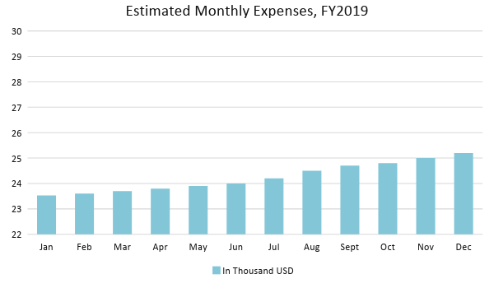
Monthly Revenue

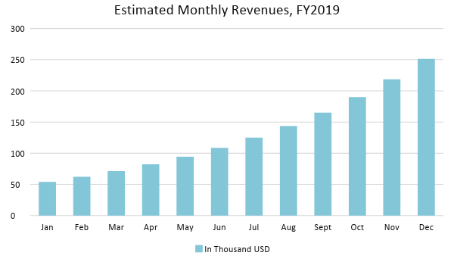

Business Financing

The members of [Swift Web Solutions LLC] contributed equally to generate about [45%] of the [200K USD] initial operating funds. The remaining [55%] came from a business loan jointly acquired by the members amounting to [110K USD] payable within three years.

Statements

Profit and Loss Projection
 | FY2019 | FY2020 | FY2021
Sales | $385,000.00 | $546,700.00 | $776,314.00
Direct Cost of Sale | $134,750.00 | $191,345.00 | $271,709.90
Other Cost of Sale | $1,500.00 | $1,500.00 | $1,575.00
Total Cost of Goods Sold or COGS (Sales - Direct Cost of Sale - Other Cost of Sale) | $248,750.00 | $353,855.00 | $503,029.10
Gross Profit (Sales-Total Cost of Goods Sold) | $136,250.00 | $192,845.00 | $273,284.90
Gross Margin % (Gross Profit/Sales) | 35.39% | 35.27% | 35.20%
Operating Expenses
Rent | $42,400.00 | $42,400.00 | $42,400.00
Insurance | $8,000.00 | $8,000.00 | $8,000.00
Utilities | $6,500.00 | $6,500.00 | $6,825.00
Salary (Including Tax) | $60,000.00 | $60,000.00 | $60,000.00
Maintenance & Supplies | $3,500.00 | $3,500.00 | $3,675.00
Total Operating Expenses | $120,400.00 | $120,400.00 | $120,900.00
EBITDA (Total Cost of Sale-Total Operating Expenses) | $128,350.00 | $233,455.00 | $382,129.10
Depreciation | $500.00 | $500.00 | $500.00
Interest Expense | $2,750.00 | $2,750.00 | $2,750.00
Taxes Paid | $6,000.00 | $6,000.00 | $6,000.00
Net Profit (Gross Profit - Operating Expenses - Taxes - Interest) | $7,100.00 | $63,695.00 | $143,634.90

Balance Sheet Projection
 | FY2019 | FY2020 | FY2021
Cash | $7,600.00 | $52,800.00 | $164,754.00
Accounts Receivable | $45,000.00 | $63,900.00 | $90,738.00
Inventory | $25,000.00 | $26,250.00 | $27,562.50
Other Current Assets | $42,500.00 | $42,000.00 | $42,000.00
Total Current Assets | $120,100.00 | $184,950.00 | $325,054.50
Long-Term Assets | $95,000.00 | $95,000.00 | $95,000.00
Accumulated Depreciation | $500.00 | $1,000.00 | $1,500.00
Total Long-Term Assets (Long-Term Assets-Accumulated Depreciation) | $94,500.00 | $94,000.00 | $93,500.00
Total Assets (Total Current Assets + Total Long-Term Assets) | $214,600.00 | $278,950.00 | $418,554.50
Accounts Payable | $90,000.00 | $70,000.00 | $50,000.00
Notes Payable | $6,500.00 | $7,150.00 | $7,865.00
Other | $1,000.00 | $1,000.00 | $1,000.00
Total Liabilities | $97,500.00 | $78,150.00 | $58,865.00
Paid-in Capital | $110,000.00 | $130,000.00 | $150,000.00
Retained Earnings | $7,100.00 | $70,795.00 | $214,429.90
Total Owner's Equity (Total Assets - Total Liabilities) | $117,100.00 | $200,800.00 | $359,689.50
Total Liabilities & Equity (Total Liabilities/Total Owner's Equity) | 83.26% | 38.92% | 16.37%

Cash Flow Projection
 | FY2019 | FY2020 | FY2021
Operating Cash Beginning | $10,000.00 | $7,600.00 | $52,800.00
Sources of Cash | $4,000.00 | $4,800.00 | $5,760.00
Receivables | $45,000.00 | $63,900.00 | $90,738.00
Sales | $65,000.00 | $92,300.00 | $131,066.00
Others | $4,000.00 | $4,600.00 | $5,290.00
Total Cash | $128,000.00 | $173,200.00 | $285,654.00
Expenditures
Rent | $42,400.00 | $42,400.00 | $42,400.00
Insurance | $8,000.00 | $8,000.00 | $8,000.00
Utilities | $6,500.00 | $6,500.00 | $6,825.00
Salary (Including Tax) | $60,000.00 | $60,000.00 | $60,000.00
Maintenance & Supplies | $3,500.00 | $3,500.00 | $3,675.00
Total Expenditures | $120,400.00 | $120,400.00 | $120,900.00
Net Income/Loss (Total Cash - Total Expenditures) | $7,600.00 | $52,800.00 | $164,754.00

