STARTUP SALES PLAN
[FRESH OF THE DAY, LTD.]

[2018 – 2019]

Index

Executive Summary [PAGE NUMBER]
Company Overview [PAGE NUMBER]
Products and Services [PAGE NUMBER]
Marketing Analysis [PAGE NUMBER]
Strategy and Implementation [PAGE NUMBER]
Management and Personnel [PAGE NUMBER]
Sales Action Plan [PAGE NUMBER]

EXECUTIVE SUMMARY

[Fresh of the Day (FD)] is a food delivery company operating in the city of [Oakland]. The company specializes in delivering fresh and healthy food. As a new player in the growing industry, FD first challenge is to build up its brand name. The food delivery industry is a customer-centered business. How [Fresh of the Day] position itself to the customers and the community have a great effect on its success.

As such, Fresh of the Day is targeting Oaklanders who prefer to eat fresh food but couldn’t prepare them due to busy work schedule. To reach out to this market, FD is focusing on digital advertising as well as offering affordable service charges. The company will constantly work with restaurant partners to offer excellent choices to customers.

COMPANY OVERVIEW

Mission Statement:

[Fresh of the Day] is always ready to deliver fresh and healthy meals from the customer’s choice of restaurant. It ensures customer satisfaction by making payment transaction and delivery fast and easy.

Philosophy:

[Fresh of the Day] lives by the principles of Honesty, Punctuality, Professionalism, and Hard Work.

Vision:

To deliver fresh and healthy meals by building meaningful partnerships with restaurants from all over [Oakland].

Outlook:

[Food delivery service] is considered as one of the fastest growing sectors of the food and beverage industry. As people live a busy and on-the-go lifestyle, preparing meals have become an afterthought. Thus, the need arises for a service that will bring them the food that they want, where and when they want it. The advent of food delivery apps makes delivery transactions, including the payment method, fast and easy.

Type of Industry: Food Delivery Industry

Business Structure: Partnership (Ltd.)

Ownership: Partners, Jason Merryman, Yushin Okada, Jameel Shay, and Alisha Moore

Start-Up Summary:

The partners collected [40K] USD as a start-up fund. The fund is allocated mainly for insurance, supplies, billings, and payroll.

Start-Up Funding
Start-Up Expenses | $25,000
Start-Up Assets | $15,000
Total Funding Required | $40,000
Assets
Non-Cash Assets from Start-Up | $10,000
Cash Requirements from Start-up | $1,000
Additional Cash Raised | $3,000
Cash Balance on Starting Date | $1,000
Total Assets | $15,000
Capital
Planned Investment
Owner | $40,000
Other | $0
Additional Investment Requirement | $0
Total Planned Investment | $40,000
Loss at Start-Up (Start-Up Expenses) | -$25,000
Total Capital | $15,000
Liabilities | $0
Total Capital and Liabilities | $15,000
Start-Up
Requirements
Start-Up Expenses
Software & Website Development | $5,500
Utilities | $3,500
Advertising | $1,500
Legal Fees | $2,000
Staff Training | $2,000
Marketing Materials | $5,000
Insurance | $3,000
Other | $2,500
Total Start-Up Expenses | $25,000
Start-Up Assets
Cash Required | $5,000
Start-Up Inventory | $5,000
Other Current Assets | $3,000
Long-Term Assets | $2,000

PRODUCTS AND SERVICES

Product/Service Description:

[Fresh of the Day] is a food delivery service provider in the city of Oakland. It specializes in delivering healthy and fresh meals to subscribers anywhere in the city.

Value Proposition:

[24/7] [fresh food delivery]. Fresh of the Day is a fast, reliable, and affordable delivery partner.

Pricing Strategy:

As a new player in the business, FD uses a penetration pricing strategy to stay competitive in the market.

MARKETING ANALYSIS

The food delivery service industry is enjoying robust growth in the last five years. Economists and experts maintain that the industry will continue to grow in the coming years. More people are relying on this type of service because, aside from the convenience it brings, they are so busy with their work.
Market Segmentation

[Fresh of the Day’s] target market is divided into four categories from the working sector of Oakland’s populace: Married Couples, Single Male Workers, Single Female Workers, and Boarders (friends/relatives living together in someone’s house). The company will focus on these sectors as they are the most likely to avail of the food delivery service.

The table below shows the population of Oakland by household type:

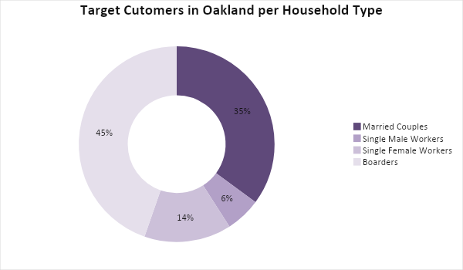

Target Market Segmentation Strategy

Boarders (friends, colleagues or relatives living together in someone’s house)

- This market is the main target for food delivery services as the majority of them live a busy lifestyle and prefers ordering food than preparing.
- The company will place targeted online ads on Facebook, Twitter, Instagram, and other social media platforms.

Married Couples

- The second largest sector in the market.
- The company will partner with restaurants who can offer meals that are good for a family of at least five members.

Single Female Workers

- Single working females in Oakland are known to live a healthier lifestyle.
- Ads focusing on delivering healthy, fresh, and organic meals will be used to convince this sector to avail of the company’s service.

Single Male Workers

- Ads focusing on delivering fresh and delicious meals from their favorite food joints will be used to convince this sector to avail of the company’s service.

STRATEGY AND IMPLEMENTATION

Target Market Strategy

Surveys show that the majority of the company’s target customers rely on food delivery services for their meals. Fresh of the Day (FD) is using targeted online advertisements to reach the said market. Through promotions, excellent service, and fast delivery, FD aims to deliver at least [10,000] meals per month in its first year.

Competitive Edge

By adopting a penetration pricing strategy, FD is aiming to attract users with its affordable fees. At the same time, the company will focus on partnering with restaurants and other food joints that specialize in healthy dishes.

SWOT Analysis | Strengths | Weaknesses | Opportunities | Threats
Fresh of the Day, Ltd. | - Offers very affordable delivery fees  - Specializes in the delivery of healthy meals  - Fast delivery time | - Still new in the business  - Only has a few restaurant partners | - Demand for food delivery service is rising, presenting opportunities to expand beyond Oakland | - Restaurants that are slow to accept partnership deals with new companies
Eats, Inc. | - Biggest food delivery service provider in the country today  - Has several restaurant partners, including fastfood restaurants | - The app is full of ads, making ordering onerous | - The growing number of partners will allow the company to make delivery free of charge | - More competitors are entering the industry
OFoods, Inc. | - Oldest food delivery service provider in Oakland | - Slower delivery time  - Has yet to develop an online app; relies on phone call ordering system | - Opportunity to develop an online delivery system to cater to a wider market | - Other companies are faster to adapt to market shifts

Sales Strategy and Forecast

Fresh of the Day is adding more partners to give its subscribers more meal choices to order. At the same time, the company will focus on making the brand more visible and trusted in the first quarter of the year.

By improving the company’s brand recognition and through very low service charges, Fresh of the Day targets the following monthly sales in its first year:

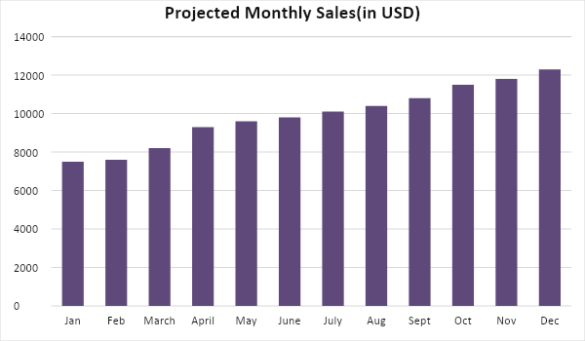

Through targeted advertisement, Fresh of the Day projects the following distribution of its subscribers based on household type:

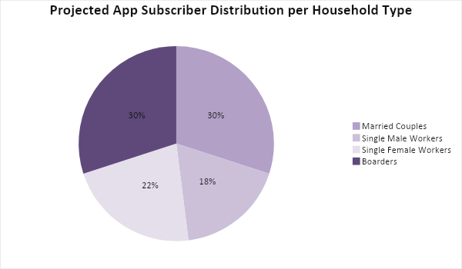

To meet the projected monthly sales, [Fresh of the Day] will focus on giving app users wonderful and smooth experience when placing their orders. At the same time, on-time delivery will be given emphasis to increase the company’s reputation. Also, FD will work with its partners to offer meal discounts for first-time users as well as frequent app users. These are the following sales strategies that the company is implementing:

Sales Strategy | Activities | Timeline | Success Criteria
New user and frequent user discounts | - The sales team will work with partner restaurants to identify which products can be included in the promotion. | - Monthly meeting schedule with partners | - Increase in the number of new users per month  - The frequency of app use increases each month
On-time delivery and excellent customer service | - Encourage the delivery team to consistently deliver the meals on time by giving them incentives  - Make sure app carries less bug for excellent user experience | ASAP | - 90% of orders are delivered on time  - App reviews are 90% positive

Marketing Strategy

[Fresh of the Day] will rely on targeted digital advertising as its service starts with ordering online. The focus of the company’s marketing strategy for its first year is to increase visibility and recognition of its brand and app. To do this, FD will upload contents on its website promoting healthy and fresh meals. The company will also work with its partners in featuring “Meals of the Day” and other food-related contents to increase traffic.

At the same time, the food delivery service company will require its delivery team to wear uniforms and the delivery vehicles to carry company stickers to increase brand visibility. FD will also regularly do application audit to ensure users will have a great experience while placing their orders.

Here are the updates of the company’s marketing programs:

Milestones

Marketing Strategy | Activities | Timeline | Success Criteria
Digital advertising | - Marketing team will launch targeted ads on different social media platforms to reach its market | January 11, 2019 | Ads launched by the third week of January 2019
On-time delivery incentive program | - The sales team will coordinate with HR to propose viable programs | ASAP | The incentive program is finalized by February 2019
Marketing materials | - Company stickers and uniforms | ASAP | Uniforms and vehicle stickers are available by the end of January 2019
App audit | - Schedule monthly app diagnosis | ASAP | Positive app user reviews

MANAGEMENT AND PERSONNEL

The company is headed by a Board of Directors. The board is composed of the partners who will elect among them who will serve as the General Manager. The General Manager is the one in charge of the company’s operation.

Under the General Manager are the following departments:

- Marketing Department:

Responsible for the promotion and marketing of the company to its target market as well as restaurant partners.

- Sales Department:

Duties include coordinating with partners on customer orders.

- Delivery Department:

Composed of delivery teams.

Below is [Fresh of the Day’s] organizational structure:

Board of Directors
General Manager
HR MANAGER
Marketing Manager
Sales Manager
Delivery Manager
Content
Partner Relation
Finance Manager
Delivery Team
Training
Budget
SALES ACTION PLAN

[Fresh of the Day’s] sales action plan for its first year of operation is summarized in the table below. The plan includes the sales goals and their corresponding activities with details on the target dates, resources, person-in-charge, and key performance indicators (KPIs) to measure their success.

Sales Goals | Action Items | Start Date | End Date | KPIs | Owner
1. Overall goal alignment | - Coordinate with marketing team about the sales and marketing goals for the year | - January 5, 2019 | - Weekly meetings to be scheduled | - Develop sales and promotional programs to achieve goals by the end of the year | General Manager, Sales Manager, and Marketing Manager
2. Obtain 3000 new subscribers in the first quarter | - Targeted online ads to get the core market to sign up with the company’s app | - January 15, 2019 | - March 31, 2019 | - A confirmed number of subscribers | Marketing Manager
3. Partner acquisition | - Sales and Marketing team to meet with restaurant and other food shop owners for partnership proposal | - January 25, 2019 | - December 2019 | - Confirmed 50 partners by the end of the year | Sales Manager, Marketing Manager

