SOFTWARE SALES PLAN

2019 - 2020

Index

Executive Summary
Company Overview

Products and Services

Marketing Analysis
Strategy and Implementation

Management and Personnel
Sales Action Plan

EXECUTIVE SUMMARY

[Phoenix Software Inc.] is a startup software development business that is based in [California, USA]. The industry has had dynamic growth between [2011] and [2016], especially as there has been an increasing demand from businesses and consumers, with more people spending their income on products such as video games, which greatly involves software development. The software development industry has room for growth as there is considerable demand in this industry with more companies and businesses adopting software programs that will allow for improved efficiency and lower operating costs.

[Phoenix] is in the business of developing software for general purposes to various clients. The company also has software development training services in place and offers technical support in line with the business. The company will be networking with other software companies and will leverage the use of letters, directories, and blogs to reach other companies and consumers.

COMPANY OVERVIEW

Mission Statement

[Phoenix] will ensure that it attains its goal of being the preferred software company and in meeting all the software needs of the customers here in [California, USA].

Philosophy

[Phoenix] will always put its focus on the needs of the customers. The company’s act of focusing the customers’ needs will allow them to develop new ideas.

Vision

The company’s vision is to be distinct from other software companies by creating and developing a software that suits the different needs of the end users and to be the preferred software firm in [California, USA].

Outlook

The software industry has experienced significant growth because of the need to establish new and innovative programs and games with the use of diverse software. One of the top five industries in California is the software industry as the state is the home to many computer products, which have helped boost the state’s economy. As such, software providers make up the largest elements of this industry and have generated [8]% of the gross state product.

Type of Industry: Software Industry

Business Structure: Corporation
Ownership: Corporation, Stockholders: [Patricia Yale], [William Primmer], [Erika Larsen], and [Ashley Colee]

Start-Up Summary

The start-up cost is [88K] USD to be provided by the stockholders and to be used mainly to pay the rent, insurance, supplies, and payroll. The stockholders shall equally share in the startup capital and shall each contribute [22K] USD.

Start-Up Funding
Start-Up Expenses to Fund | $43,000
Start-Up Assets to Fund | $45,000
Total Funding Required | $88,000
Assets
Non-Cash Assets from Start-Up | $20,000
Cash Requirements from Start-Up | $10,000
Additional Cash Raised | $5,000
Cash Balance on Starting Date | $10,000
Total Assets | $45,000
Capital
Planned Investment
Stockholders | $88,000
Other | $0
Additional Investment Requirement | $0
Total Planned Investment | $88,000
Loss at Start-Up (Start-Up Expenses) | -$43,000
Total Capital | $45,000
Total Capital and Liabilities | $45,000
Start-Up
Requirements
Start-Up Expenses | $10,000
Rent - 5 Months | $10,000
Advertising | $500
Legal Fees | $1,000
Staff Training | $1,000
Insurance | $500
Software Programs | $20,000
Total Start-Up Expenses | $43,000
Start-Up Assets
Cash Required | $25,000
Start-Up Inventory | $5,000
Other Current Assets | $5,000
Long-Term Assets | $10,000
Total Assets | $45,000
Total Requirements | $88,000

PRODUCTS AND SERVICES

Product/Service Description

[Phoenix] intends to offer the following products and services: software, subscriptions of developed software, developing software according to the client’s specifications, license fees for the developed software, training services, and technical support.

Value Proposition

[Phoenix] serves customers in the State of [California] with software for programs, games and other needs. Its fast, unique and high-quality software developments are known to be the best in the business.

Pricing Strategy

Determining the price of various software products will depend on how much the market will willingly pay for such software, competitor software prices, and the uniqueness of the software. Other factors that will determine the prices are the licensing as well as the subscription fees.

MARKETING ANALYSIS

Technology has been really useful in making business operations faster and easier. There has been an increasing demand for the development of different software for a faster business operation. Software for various uses such as in accounting, finance, recording, and writing would greatly benefit from software developed based on their requirements.

Market Segmentation

[Phoenix] will focus its market and sales strategy on the small start-up companies in the state of [California], [USA], specifically in the following types of businesses: service, retail, manufacturing, and hybrid businesses. In connection with this, the company focuses on offering software licensing and charging software subscription fees. As such, it will also provide training services and technical support to its end users. Phoenix will always put its clients first and it believes that by doing so, it will benefit marketing and sales.

The table below shows which type of business has high software development demands and in which part of the business operation.

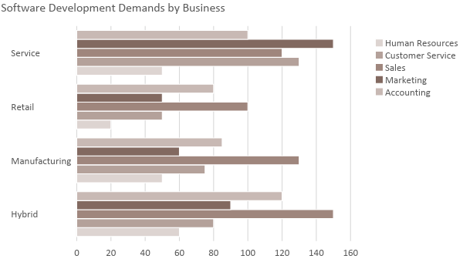

Target Market Segmentation Strategy

Service

- The company will be developing new software that is applicable to various service operations.

Retail

- Phoenix will be offering subscription agreements to clients with this type of business, specifically applicable to the buying and selling operations of the business.

Manufacturing

- The company will offer to license existing and new software programs that can be used mostly in inventories and accounting.

Hybrid

- Hybrid businesses combine an Internet front-end with a physical office back-end. Phoenix will be increasing its online presence through online advertisements.

STRATEGY AND IMPLEMENTATION

Target Market Strategy

[Phoenix Software, Inc.] aims to increase its sales in the first year by at least [3]%. This will be accomplished by developing new software programs that can generally be applied to businesses, offering license and subscription agreements for the developed software, and making online advertisements.

Competitive Edge

The company is also adopting price bundling and competitive pricing on top of its efficient global delivery system.

SWOT Analysis | Strengths | Weaknesses | Opportunities | Threats
[Phoenix Software, Inc.] | - The software developers are the best in the field  - Offers licensing and subscription for the software | - Has a limited connection with companies located in California  - Has limited choices for the licensing and subscription of its software | - New market segments in the state | - Changing government policies
[Globe works Corporation] | - Its software has passed through a quality process  - Vast choices for software subscription | - Limited software licensing offerings | - Has the opportunity to move into the international market | - The arrival of a new competitor in the location
[Electra Technologies, Inc.] | - The biggest software developer in California  - Has more than [30 years] experience in the software industry  - Offers vast choices for software licensing and subscription | - Does not offer licensing and subscription of their software outside of California | - Has many strategic alliances with other businesses | - A price war with competitors

Sales Strategy and Forecast

[Phoenix Software, Inc.] will be developing more software for general use and will be offering licenses and subscriptions.

The company targets the following monthly sales:

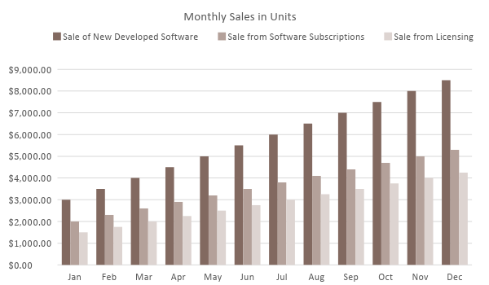

With an increased number of developed software, the offering of software licenses and subscriptions, and increased online advertisements, the table below depicts the projected percentage growth of software users for different businesses in 3 years.
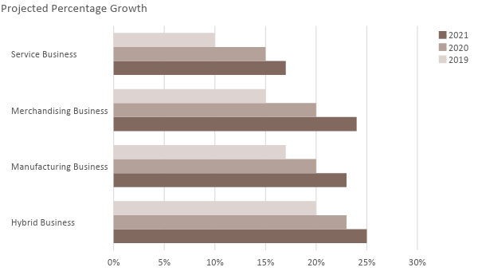
Emphasis is placed on software development to meet sales goals. The following shall be the sales strategies of the company:

Sales Strategy | Activities | Timeline | Success Criteria
Direct Sales | - Prepare an event for the launching of the newly developed software  - Obtain a list of companies with their contact numbers | Event: February 14, 2019  December 15, 2018 | Launching of the new set of software on [February 14, 2019]  Contact at least [50]% of the companies in the list
Licensing and Subscription Programs | - Prepare the licensing and subscription agreements  - Offer the license and subscription agreements to businesses that are not willing to buy newly developed software | January 2-15, 2019 | Hire a lawyer to prepare the license and subscription agreements by [December 26, 2018]
Online Advertisements | - Produce content-focused advertisements and post them on the company website and social media accounts | January 10-31, 2019 | Hire a marketing specialist by [December 26, 2018]

Marketing Strategy

[Phoenix Software, Inc.] plans to offer more software, offer licensing and subscription, and improve its online presence. The company has a website which meets the search engine optimization guidelines and is always updated on product offerings.

The company will be hiring a new software developer, a lawyer, and a marketing specialist in order to manage the marketing strategy of the company. The marketing executive manages the implementation of the marketing strategy which is done to support the company’s sales goals.

The team has kicked-off various activities to move the marketing strategy forward. Here are some of the updates:

Milestones

Marketing Strategy | Activities | Timeline | Success Criteria
Introduction of software development services | HR has posted a job listing for the hiring of a software developer | December 20, 2018 | The new software developer will start on [December 26, 2018]
Advertisement of software development services in local newspapers | The final draft for the advertisement is for review by the marketing executive | January 2, 2019 | Hire a marketing specialist by [December 26, 2018]
Direct marketing and sales | The marketing team is currently in contact with different companies in the state to offer software development services | End of December 2018 | Contact at least [50]% of the listed companies in the state

MANAGEMENT AND PERSONNEL

The Board of Directors appoint the chief executive officer and the CEO heads the company. The software development manager, business development manager, and the administration manager will report directly to the CEO.

The software development manager will manage all tasks in software development and lead a team composed of 5 software developers. They will be in charge of the development of new software.

The business development manager manages the sales executive, marketing executive, and the lawyer. They will be in charge of marketing and sales strategy, as well as the preparation of the licensing and subscription agreements.

Under the administration manager are the company accountant, HR manager, and customer service executives.

Below is the organizational structure of the company:

Board of Directors
Chief Executive Officer
Business Development Manager
Software Development Manager
Administration Manager
Software Developers
Lawyer
Marketing Executive
Sales Executive
Accountant
HR Manager
Customer Service Executive

SALES ACTION PLAN

The table provided below summarizes the sales goals of the company and their corresponding activities with details on the target dates, resources, person-in-charge, and key performance indicators (KPIs) to measure their success.

Sales Goals | Action Items | Start Date | End Date | KPIs | Owner
Increase the number of direct sales by [3]% by the end of [2019] | - Hire a software developer  - Develop new software | December 20, 2018  January 2, 2019 | December 26, 2019  January 31, 2019 | - The hiring of a software developer  - Development of new software | Software Development Manager
Obtain [N] of software subscriptions | - Obtain a list of companies with contact numbers  - Obtain at least [20]% software subscription | December 15, 2018  December 20, 2018 | December 20, 2018  December 31, 2018 | - Obtained a full list of companies with contact numbers  - Confirmed [20]% subscription | Business Development Manager  Marketing Executive  Lawyer
Obtain [N] of software licenses | - Obtain at least [15]% confirmation of the licensing  - Obtain at least [5]% confirmed meeting with prospective licensees | December 15, 2018  December 20, 2018 | December 31, 2018  January 10, 2019 | - Confirmed 20% software licensing and signing of the license agreement  - Confirmed business appointment | Business Development Manager  Marketing Executive  Lawyer

