Business Income and Expenses Spreadsheet
[Company Name]
[Redmond, Washington, 98502]
[USA]
Income: | Total | January |  | February |  | March |  | 1st Quarter |  | April |  |  | May
Income 1 | $27,650.00 | $5,000.00 |  | $5,500.00 |  | $6,650.00 |  | $17,150.00 |  | $4,500.00 |  |  | $6,000.00
Income 2 | $22,000.00 | $5,000.00 |  | $2,550.00 |  | $4,450.00 |  | $12,000.00 |  | $5,500.00 |  |  | $4,500.00
Income 3 | $25,350.00 | $7,000.00 |  | $8,000.00 |  | $4,000.00 |  | $19,000.00 |  | $3,000.00 |  |  | $3,350.00
Income 4 | $29,300.00 | $5,000.00 |  | $5,500.00 |  | $6,650.00 |  | $17,150.00 |  | $5,500.00 |  |  | $6,650.00
Income 5 | $20,000.00 | $4,000.00 |  | $4,550.00 |  | $4,450.00 |  | $13,000.00 |  | $2,550.00 |  |  | $4,450.00
Expenses: | Total | January |  | February |  | March |  | 1st Quarter |  | April |  |  | May
Advertising | $14,300.00 | $1,000.00 |  | $1,800.00 |  | $4,500.00 |  | $7,300.00 |  | $5,500.00 |  |  | $1,500.00
Bad Debts | $3,400.00 | $550.00 |  | $1,000.00 |  | $650.00 |  | $2,200.00 |  | $550.00 |  |  | $650.00
Fees | $16,500.00 | $5,000.00 |  | $2,500.00 |  | $3,000.00 |  | $10,500.00 |  | $1,000.00 |  |  | $5,000.00
Depletion | $9,400.00 | $450.00 |  | $4,500.00 |  | $2,000.00 |  | $6,950.00 |  | $450.00 |  |  | $2,000.00
Rent / Lease | $2,880.00 | $650.00 |  | $680.00 |  | $450.00 |  | $1,780.00 |  | $650.00 |  |  | $450.00
Insurance | $10,100.00 | $2,000.00 |  | $5,000.00 |  | $550.00 |  | $7,550.00 |  | $2,000.00 |  |  | $550.00
Services | $8,980.00 | $440.00 |  | $4,500.00 |  | $1,800.00 |  | $6,740.00 |  | $440.00 |  |  | $1,800.00
Office Expenses | $5,800.00 | $650.00 |  | $1,500.00 |  | $1,500.00 |  | $3,650.00 |  | $650.00 |  |  | $1,500.00
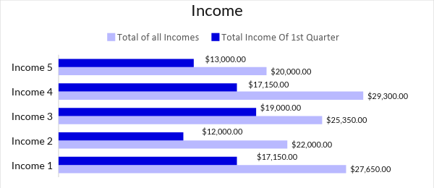

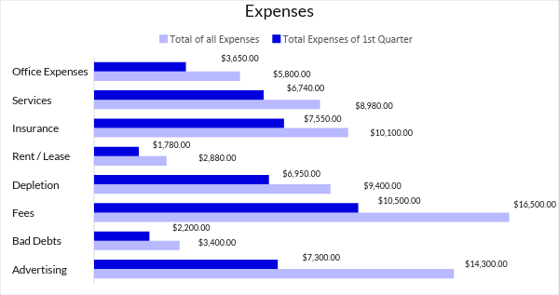

To Use This Document
The text inside the brackets which is highlighted is meant to be edited with your text. This is the way you can edit the document as given below:

To Edit Text:
- Point the mouse where you want to edit and delete the sample text and then you can add your text.
- You can change the size, font & color of the text in the Main Tab: Home

To Edit Table:
- Point the mouse in the table where you want to edit and delete the sample text and then you can add your text.
- You can adjust the row & column size of the table in the Main Tab: Layout

To Edit Chart:
- Select the chart which is going to edit and then
- In Main tab: Design -> Edit Data
- It will open the excel sheet where you can edit the values of the chart

