BALANCE SHEET
[Carolina Construction Company]
[Street # 5, phase-2, North Carolina, 058157]
ASSETS
Current Assets | Amount
Cash in Bank | $57,000.00
Accounts Payable | $30,000.00
Accounts Payable - Retention | $7,999.00
Allowance for Bad Debts | $599.00
Inventory | $5.00
Prepaid Expenses | $2,001.00
Total Current Assets | $97,604.00
Non-Current Assets | Amount
Construction Equipment’s | $40,000.00
Trucks and Automobiles | $32,000.00
Office Equipment | $8,599.00
Total Non-Current Assets | $80,599.00
Total Assets | $178,203.00

LIABILITIES AND NET WORTH
Current Liabilities | Amount
Accounts Payable - Trade | $45,500.00
Accounts Payable - Retention | $32,500.00
Billing in Expenses of Costs and Profits | $74,500.00
Notes Payable | $1,000.00
Accrued Taxes | $400.00
Others | $6,000.00
Total Current Liabilities | $159,900.00
Long Term Liabilities | Amount
Mortgage Payable | $40,599.00
Short term Portion | $32,035.00
Note Payable Auto | $8,799.00
Total Long Term Liabilities | $81,433.00
Owners’ Equity(Net worth) | Amount
Capital Stock | $16,500.00
Retained Earnings | $50,000.00
Current Period Net income | $40,599.00
Total Owners Equity | $107,099.00
Total Liabilities and Equity | $348,432.00

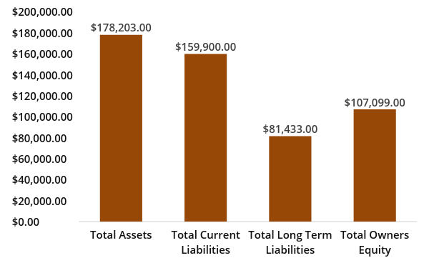
BALANCE SHEET

