Security
Guard Business Plan

Business Plan For Fiscal Year 2019

[February 1, 2019]

[Alex Webber]
[awebber@blackwater.com]
[626-274-3691]
[www.blackwater.com]
[308 Rainbow Road
Alhambra, CA 91801]

Index

Executive Summary [PAGE NUMBER]
Company Overview [PAGE NUMBER]
Products and Services [PAGE NUMBER]
Execution [PAGE NUMBER]

Operational Plan [PAGE NUMBER]
Financial Plan [PAGE NUMBER]

EXECUTIVE SUMMARY

[Blackwater Security] is a startup security guard agency founded by [Alex Webber], a former [Lieutenant] General for the US Army. Located in [Alhambra, California], the agency will provide security guards and recommend security equipment providers for commercial buildings and retail businesses in the vicinity.

[Blackwater Security] will grow its base of security guards carefully based on client contracts and employ both full-time and part-time security guards. The business expects modest sales in the first year of operation, but increasing and nearly doubling its numbers by the end of the third year. After its initial launch, the agency aims to establish its office and training grounds in its second year and focus on expansion in its third year.

COMPANY OVERVIEW

Mission Statement

[Blackwater Security] strives to be the best in security and investigation services for corporate businesses, serving not only corporate offices and buildings but also special events.

Philosophy

[Blackwater Security] understands that a company grows with its employees. This is why the agency is looking into working with staff to create an environment that gives job satisfaction. This could include tailoring schedules and offering flexible hours to accommodate the personal situations of each of its employees.

Vision

[Blackwater Security] is committed to improving the services that it provides to its clients. By investing and developing the agency’s most important assets, it aims to achieve its goals and exceed client expectations.

Outlook

Increasing fears of criminal and terrorist activity, as well as the current economic climate, promises an upswing in general and in outsourced services. Thus, the agency’s launch is arriving at the right time as more and more businesses feel more comfortable with 24-hour security.

Type of Industry: Security Services

Business Structure: Sole Proprietorship

Ownership: Sole Proprietorship, [Alex Webber]

Start-Up Summary

[Blackwater Security] aims to launch its services in [California], where it will provide security guard training and employment. Start-up costs include costs of operations and permits, including concealed weapon permits, business licenses, police clearances, and other legal fees, and initial website development and marketing.

Start-Up Funding
Start-Up Expenses to Fund | $55,000
Start-Up Assets to Fund | $445,000
Total Funding Required | $500,000
Assets
Non-Cash Assets from Start-Up | $300,000
Cash Requirements from Start-up | $95,000
Additional Cash Raised | $45,000
Cash Balance on Starting Date | $5,000
Total Assets | $445,000
Capital
Planned Investment
Owners | $450,000
Other | $0
Additional Investment Requirement | $0
Total Planned Investment | $500,000
Loss at Start-Up (Start-Up Expenses) | $55,000
Total Capital (Total Planned Investment - Loss at Start-Up) | $445,000
Total Capital and Liabilities | $445,000
Start-Up
Requirements
Start-Up Expenses
Rent - 6 Months | $12,000
Advertising | $2,000
Legal Fees | $6,000
Staff Training | $3,000
Insurance | $2,000
Other | $30,000
Total Start-Up Expenses | $55,000
Start-Up Assets
Cash Required | $145,000
Start-Up Inventory | $100,000
Other Current Assets | $30,000
Long-Term Assets | $170,000
Total Assets | $445,000
Total Requirements (Total Start-Up Expenses + Total Assets) | $500,000

Management Team:

Management Team | Role/Function | Skills
[Owen Yang] | Store Manager | Communication, People Management, Teamwork, and Resilience
[Christina Hunt] | HR Manager | Communication, Onboarding, People Skills, and Performance Management

Short- and Long-Term Goals and Milestones:

Short-Term Goals | Milestones
Recruit an efficient, qualified workforce | Recruitment process finished. Training is in progress.
Create a solid marketing campaign for the agency | The marketing division is finalizing the marketing materials, which are to be submitted by [March 30, 2019].
Long-Term Goals | Milestones
Receive accreditation and be recognized in industry quality standards | Application for accreditation filed
Deliver consistently high levels of service to clients | End the year with a [90]% satisfactory rating

PRODUCTS AND SERVICES

Product/Service Description

[Blackwater Security] shall be a licensed and insured business that offers the services of both armed and unarmed security guards based on client needs and budget. Each of the guards working for the security force shall be certified for security work and to carry firearms.

[Blackwater Security] will provide the following services for its clients:

- Armed and unarmed security guards who can guard and screen guests and employees entering guarded premises, deter crime and organize a response in case of fire, evacuation, or other emergencies as applicable.

- Audit and recommend security and refer clients to providers of security technology such as camera systems and alarms.

Value Proposition

[Blackwater Security] delivers a meaningful security program that fits the needs of its customers, emphasizing on the importance of locally-experienced security agency with responsive management. The agency delivers flexible, responsive, and personalized services with extensive industry knowledge to serve the clients the best that it could.

Pricing Strategy

Due to the uniqueness of every business, [Blackwater Security] offers personalized pricing strategies based on the needs and monetary abilities of its clients.

EXECUTION

Marketing Plan

Security services are sold on a business-to-business basis, and thus, marketing and advertising are targeted mainly on the markets and industries that they seek to serve. These businesses generally search for providers online or through referrals from other companies that they trust. Thus, [Blackwater Security] will focus its marketing plan on creating and maintaining a search engine-optimized website.

Market Research

Research has shown that there are over [50,000] security service firms in the US, all of which are running approximately [80,000] establishments. The average size of a firm has a $[700,000] revenue per year, meaning that the industry serves both small and larger companies. The industry depends on a supply of labor and for as long as establishments continue to grow in the city, the industry shall thrive.

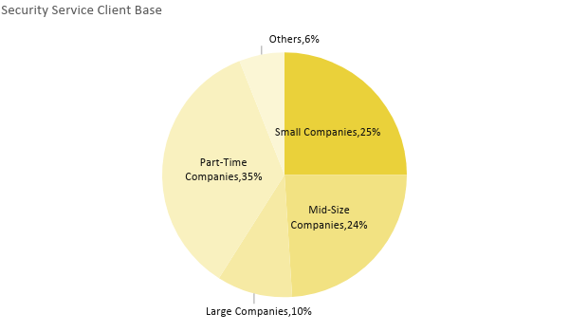

SWOT Analysis | Strengths | Weaknesses | Opportunities | Threats
[Blackwater Services] | Trained in disaster mitigation | New in the industry | Potential expansion of the agency | Other more established security guard agencies
[Advanced Security Services] | Has access control on the majority of businesses in the area | Focuses on VIP clients | Keeping up-to-date with technology | The increasing number of security services in the area
[Protection One Security Service] | Known to be the best in law enforcement | Limited variety of options | Provide more advanced apps and services | The rise in popularity of do-it-yourself security practices

Marketing Strategy

[Blackwater Security] will use different tactics to reach its target markets. Among these tactics include developing basic brochure websites with services and contact information. Direct selling based on purchasing or developing target lists, and direct mailing brochures and letters to the aforementioned list of potential clients in the area.

Marketing Strategy | Activities | Timeline | Success Criteria
Develop an agency website | Front-end developer hired | March 10, 2019 | Agency website up and running efficiently
Design a downloadable brochure | Graphic designer hired | March 15, 2019 | Downloadable brochure created and compatible with different systems
Create a mailing list and mail advertising materials | Marketing officers creating a mailing list, 45% done | April 1, 2019 | Sending out advertising mail, achieving a minimum of [65]% response rate from potential clients

Organizational Structure

CEO
Operations Manager
HR Manager
Marketing Manager
Marketing Staff
Training Supervisor
Training Staff
Security Employees
Financial Officer

OPERATIONAL PLAN

Location and Facilities

The agency office is located in [downtown Alhambra] and is a large office space divided into several areas that include the reception hall for clients, two conference rooms that serve as lecture rooms for training purposes, lockers, and a pantry.

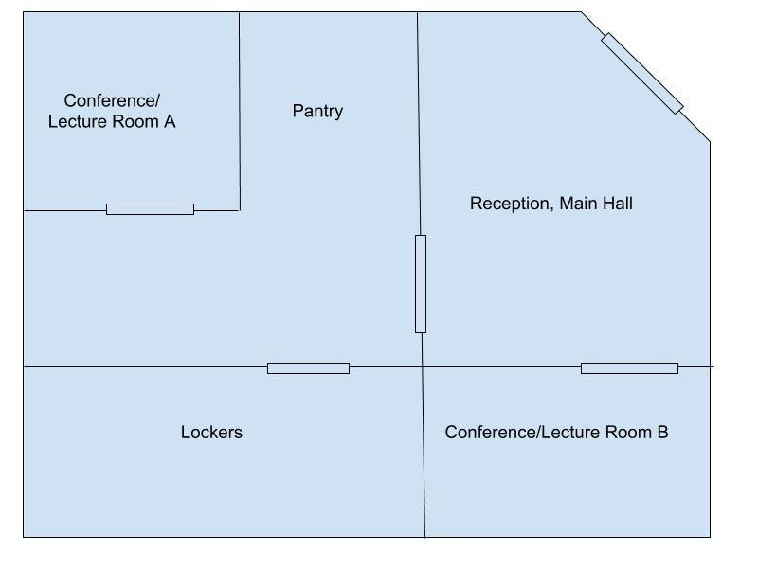

FINANCIAL PLAN

Assumptions

Based on the current economic climate, security guard service sales shall be recurring. Assuming a client retention rate of [85]% annually, sales are expected to escalate quickly with a possibility of agency expansion within the next [three to five] years.

Sales will be a combination of clients requiring 24/7 security service and daytime only or nighttime only coverage as well. Sales are expected to meet the agency’s objective of $[700,000] by its third year of operations.

Monthly Expense

The chart shows the agency’s projected monthly expense for [2019], including training and fixed expenses.

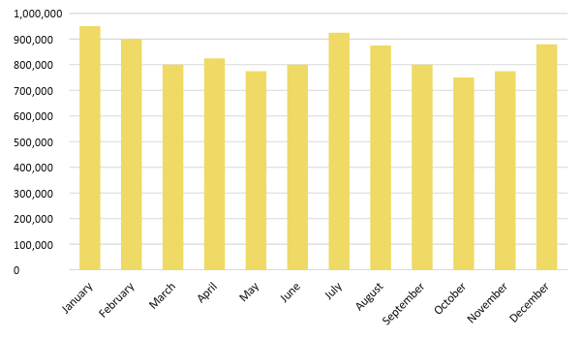

Monthly Revenue

The following chart depicts the monthly net revenue of the security agency for [2018]. This already excludes fixed expenses and employee salaries.

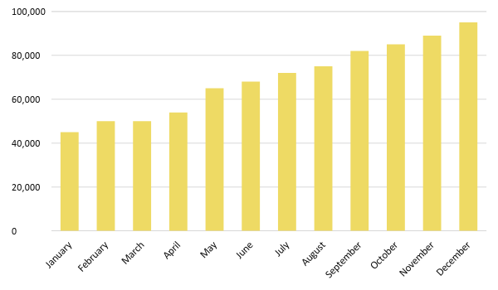

Business Financing

The funding for the business mainly comes from a business loan worth $[500,000.00]. The major expenses will go to business insurance, rent, salaries, supplies, and maintenance.

Statements

The following projected financial statements show the agency’s possible standing in the next three years.

Profit and Loss Projection
 | FY2018 | FY2019 | FY2020
Sales | $3,200,000.00 | $3,500,000.00 | $3,700,000.00
Direct Cost of Sale | $500,000.00 | $570,000.00 | $600,500.00
Other Cost of Sale | $100,000.00 | $141,000.00 | $157,000.00
Total Cost of Goods Sold or COGS (Sales - Direct Cost of Sale - Other Cost of Sale) | $2,600,000.00 | $2,789,000.00 | $2,942,500.00
Gross Profit (Sales-Total Cost of Goods Sold) | $600,000.00 | $711,000.00 | $757,500.00
Gross Margin % (Gross Profit/Sales) | 18.75% | 20.31% | 20.47%
Operating Expenses
Rent | $72,000.00 | $72,000.00 | $72,000.00
Insurance | $12,000.00 | $12,000.00 | $12,000.00
Utilities | $20,000.00 | $20,000.00 | $20,000.00
Salary (Including Tax) | $350,000.00 | $350,000.00 | $350,000.00
Maintenance & Supplies | $5,000.00 | $5,000.00 | $5,000.00
Total Operating Expenses | $459,000.00 | $459,000.00 | $459,000.00
EBITDA (Total Cost of Sale-Total Operating Expenses) | $2,141,000.00 | $2,330,000.00 | $2,483,500.00
Depreciation (Asset Cost - Residual Value)/Useful Life of the Asset) | $10,000.00 | $10,000.00 | $10,000.00
Interest Expense | $0.00 | $0.00 | $0.00
Taxes Paid | $15,000.00 | $18,000.00 | $20,000.00
Net Profit (Gross Profit - Operating Expenses - Taxes - Interest) | $126,000.00 | $234,000.00 | $278,500.00

Balance Sheet Projection
 | FY2019 | FY2020 | FY2021
Cash | $1,000,000.00 | $1,250,000.00 | $1,450,000.00
Accounts Receivable | $100,000.00 | $150,000.00 | $110,000.00
Inventory | $7,000.00 | $8,000.00 | $10,000.00
Other Current Assets | $20,000.00 | $25,000.00 | $35,000.00
Total Current Assets | $1,127,000.00 | $1,433,000.00 | $1,605,000.00
Long-Term Assets | $45,000.00 | $43,000.00 | $47,000.00
Accumulated Depreciation | $3,000.00 | $2,500.00 | $2,000.00
Total Long-Term Assets (Long-Term Assets-Accumulated Depreciation) | $42,000.00 | $40,500.00 | $45,000.00
Total Assets (Total Current Assets + Total Long-Term Assets) | $1,169,000.00 | $1,473,500.00 | $1,650,000.00
Accounts Payable | $150,000.00 | $170,000.00 | $155,000.00
Notes Payable | $7,000.00 | $7,500.00 | $5,000.00
Other | $3,500.00 | $7,000.00 | $5,000.00
Total Liabilities | $160,500.00 | $184,500.00 | $165,000.00
Paid-in Capital | $10,000.00 | $5,000.00 | $5,000.00
Retained Earnings | $90,000.00 | $120,000.00 | $130,000.00
Total Owner's Equity (Total Assets - Total Liabilities) | $1,008,500.00 | $1,289,000.00 | $1,485,000.00
Total Liabilities & Equity (Total Liabilities/Total Owner's Equity) | 15.91% | 14.31% | 11.11%

Cash Flow Projection
 | FY2019 | FY2020 | FY2021
Operating Cash Beginning | $1,000,000.00 | $1,500,000.00 | $1,600,000.00
Sources of Cash | $15,000.00 | $18,000.00 | $15,000.00
Receivables | $10,000.00 | $12,000.00 | $30,000.00
Sales | $70,000.00 | $25,000.00 | $35,000.00
Others | $50,000.00 | $7,000.00 | $8,000.00
Total Cash | $1,145,000.00 | $1,562,000.00 | $1,688,000.00
Expenditures
Rent | $72,000.00 | $72,000.00 | $72,000.00
Insurance | $12,000.00 | $12,000.00 | $12,000.00
Utilities | $15,000.00 | $15,000.00 | $15,000.00
Salary (Including Tax) | $350,000.00 | $40,000.00 | $450,000.00
Maintenance & Supplies | $4,500.00 | $4,500.00 | $4,500.00
Total Expenditures | $453,500.00 | $143,500.00 | $553,500.00
Net Income/Loss (Total Cash - Total Expenditures) | $691,500.00 | $1,418,500.00 | $1,134,500.00

