RESTAURANT MARKETING REPORT

For:

[SPECIFY THE NAME OF THE RESTAURANT]
[SPECIFY THE STREET ADDRESS OF THE RESTAURANT]
[SPECIFY THE CITY/STATE ADDRESS OF THE RESTAURANT]
[SPECIFY THE ZIP CODE]

Date:

[SPECIFY WHEN THE REPORT WAS CREATED]

EXECUTIVE SUMMARY

The marketing challenge for [SPECIFY YOUR RESTAURANT NAME] is to [SPECIFY THE CHALLENGE] within a span of [SPECIFY THE PERIOD GIVEN TO MEET THE CHALLENGE]. Although it is a rather ambitious improvement from the current sales level, the [SPECIFY YOUR RESTAURANT NAME]’s sales goal is certainly achievable after [SPECIFY THE STEPS MADE BY THE RESTAURANT IN ORDER TO ACHIEVE THE CHALLENGE].

[SPECIFY YOUR RESTAURANT NAME] has limited [SPECIFY THE LIMITS OF THE RESTAURANT IF THERE IS ANY] due to [SPECIFY THE REASON OF THE WEAKNESS OF THE RESTAURANT IF THERE IS ANY]. Despite the [SPECIFY YOUR RESTAURANT NAME]’s unfavourable [SPECIFY], it was able to [SPECIFY THE ACHIEVEMENT MADE BY THE RESTAURANT]. The competitive advantage of [SPECIFY YOUR RESTAURANT NAME] is that it is [SPECIFY THE ADVANTAGES OF THE RESTAURANT].

INTRODUCTION

[SPECIFY YOUR RESTAURANT NAME] is a [SPECIFY A BRIEF DESCRIPTION OF THE RESTAURANT] with a wide range of products and services that include [SPECIFY THE MAJOR PRODUCTS AND SERVICES OFFERED IN THE PUBLIC]. [SPECIFY YOUR RESTAURANT NAME] is a [SPECIFY HOW ITS OWNERSHIP WAS ESTABLISHED INCLUDING ITS OWNER/S NAME/S]. It website addresses in [SPECIFY] countries. It is also the [SPECIFY OTHER MAJOR ACHIEVEMENT OF THE RESTAURANT].

[SPECIFY DESCRIPTION AND MEANING OF THE RESTAURANT’S LOGO IF THERE IS ANY].

This report will help [SPECIFY THE PURPOSE FOR CREATING THE MARKETING REPORT].

OBJECTIVES OF THE RESTAURANT

In establishing the restaurant, the aim is to:

[SPECIFY THE OBJECTIVE]
[SPECIFY ADDITIONAL OBJECTIVES]

VISION OF THE RESTAURANT

As a restaurant, its aim is to:

[SPECIFY THE VISION]
[SPECIFY ADDITIONAL VISIONS]

KEY PRINCIPLES OF THE RESTAURANT

The guiding principles of the restaurant are:

[SPECIFY THE PRINCIPLE]
[SPECIFY ADDITIONAL PRINCIPLES]

SCENARIO

New Campaign vis-a-vis Past Campaign

Considering the months that the restaurant had gone through, various marketing strategies were used. Some of them are:

[SPECIFY PREVIOUS MARKETING STRATEGY, ITS OUTCOME AND ITS CONTRIBUTION]
[SPECIFY OTHER PREVIOUS MARKETING STRATEGIES, ITS OUTCOMES AND CONTRIBUTION]

[PROVIDE A TABLE SHOWING COMPARISONS BETWEEN THE STRATEGIES USED]

Progress and Results:

Progress is the name of the game, use the same to the market report to ensure continual optimization of the marketing strategy.

[PROVIDE A GRAPH OR TABLE SHOWING THE PROGRESS AND RESULTS OF THE STRATEGIES USED INDIVIDUALLY]

FACTORS

The first [SPECIFY] of [SPECIFY YOUR RESTAURANT NAME] move was to look into the macro environmental factors. Upon completion of the analysis of these factors, the opportunities begin to arise and thus the restaurant keep up with the growing and competitive world of business. The macro environmental factors of [SPECIFY] were evaluated through a [SPECIFY THE METHOD OF ANALYSIS USED BY THE RESTAURANT], which looks at the [SPECIFY THE ASPECT], [SPECIFY THE ASPECT], [SPECIFY OTHER ASPECT], [SPECIFY ADDITIONAL ASPECT]. Each of these factors will be discussed individually as follows:

[SPECIFY THE ASPECT/FACTOR]
[SPECIFY THE MEANING OF THIS FACTOR]
[SPECIFY HOW THIS FACTOR WILL BE HELPFUL IN MARKETING]

[SPECIFY THE ASPECT/FACTOR]

[SPECIFY THE MEANING OF THIS FACTOR]
[SPECIFY HOW THIS FACTOR WILL BE HELPFUL IN MARKETING]

[SPECIFY THE ASPECT/FACTOR]

[SPECIFY THE MEANING OF THIS FACTOR]
[SPECIFY HOW THIS FACTOR WILL BE HELPFUL IN MARKETING]

Because of the above mentioned factors chosen by the restaurant, it is determinable that there will be a high possibility of success in the business.

MARKET

The following market are chosen simple because [SPECIFY WHY AND HOW THE TARGET MARKET WAS CHOSEN].

[PROVIDE SPECIFICATION AS TO THE MARKET]
[PROVIDE SPECIFICATION AS TO THE MARKET]
[PROVIDE SPECIFICATION AS TO THE MARKET]
[PROVIDE SPECIFICATION AS TO THE MARKET]

RESULTS AND CONCLUSION

HIGHLIGHTS

[SPECIFY THE PERCENTAGE AS TO THE TOTAL MARKETING REACH GREW]

[SPECIFY THE PERCENTAGE AS TO THE WEBPAGE VISITS]

[SPECIFY AS TO THE LEADS THAT WERE GENERATED]

[SPECIFY AS TO THE GROWTH OF CUSTOMERS DUE TO MARKETING]

DATA

Blog Posts Published:

Account for the content that has been created [SPECIFY PERIOD WHEN CREATED]. Keep track of the blog posts published by the restaurant and their metrics in order to determine where the content marketing should be heading.

[PROVIDE FOR A SUMMARY OF THE CONTENTS IN THE BLOG OF THE RESTAURANT]

Email Sends and Statistics:

Just like the blogs, measuring and reporting email sends and statistics will help the restaurant to further optimize the email marketing strategy. Should the restaurant be emailing more or less often? What changes have we made this [SPECIFY] and how our email marketing been affected? Be sure to include statistics like [SPECIFY], [SPECIFY], [SPECIFY] and [SPECIFY].

[SPECIFY AND GIVE A GRAPH OR TABLE SHOWING THE THREAD AND ITS STATISTICS]

Website Visitors:

Much of the restaurant’s marketing may be focused on driving traffic to the restaurant’s website. Be sure to detail just how much traffic was generated and where it came from. You should include how many of those visitors became leads.

[PROVIDE A GRAPH OR TABLE FOR THE ABOVE INFORMATION]

Customer Loyalty:

Customers are the major factor in achieving a successful market strategy. Thus, always include the information on the long-term value of the restaurant’s marketing efforts. Reporting customer loyalty is a great way to display that feedback. Be sure to include the following:

[SPECIFY WHAT TO INCLUDE]
[SPECIFY OTHER THINGS TO INCLUDE]

MARKETING RESULTS AND STATISTICS

Marketing Reach:

Why might management care about your reach and whether the same is increasing or not? This number is a good indicator of how well the content you’re publishing is engaging your network, and how effectively you’re growing your entire marketing database. If this number isn’t growing, it will be challenging to grow your leads number.
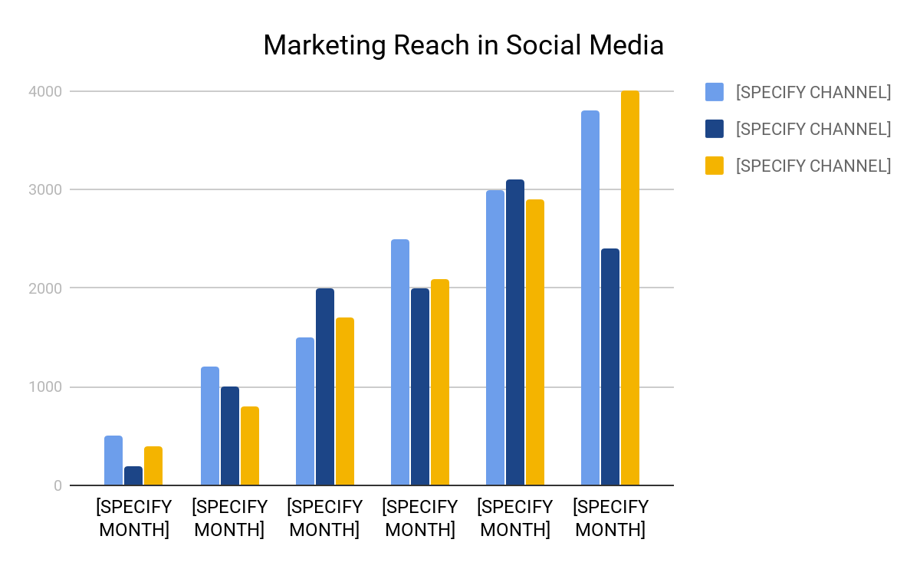
Total Reach:

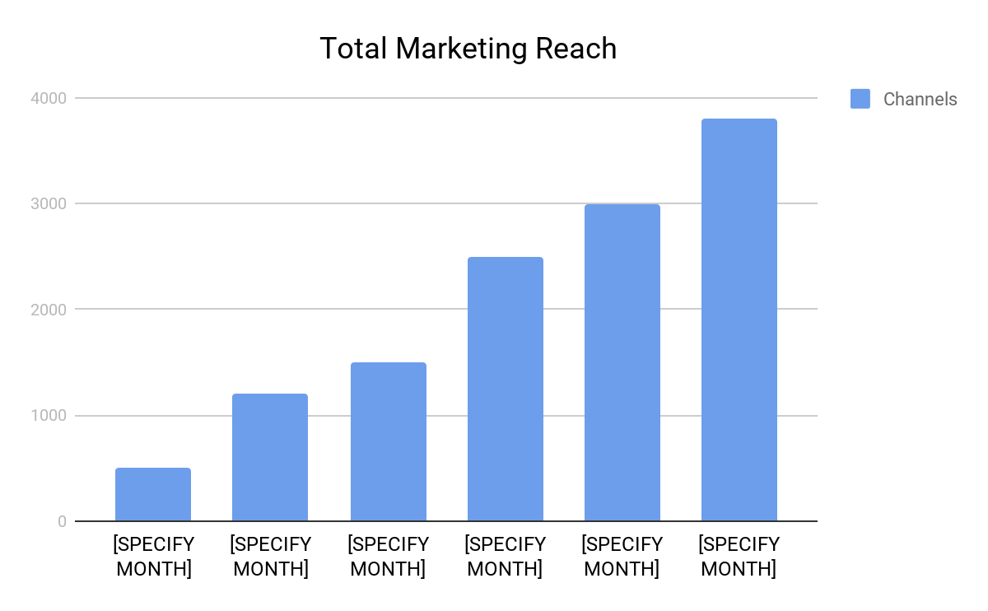
What is the total number of people your company can reach across your different networks? Consider this your total potential prospects count.

Reach by Channel:

This metric tells you how many people are following or subscribed to you per channel. Do you notice any particular growth in one channel? Perhaps invest more time in that channel to improve your marketing.

Customers by Source:

Communicating your direct impact on customer generation will be the best way to get to your CEO or boss’ heart. Track which marketing campaigns are yielding the most customer acquisition - the metrics below can help.

Total Customers Driven by Marketing: Sales closes leads, but the number of customers teed up by marketing is just as important. How many customers were closed that were driven by your marketing programs?

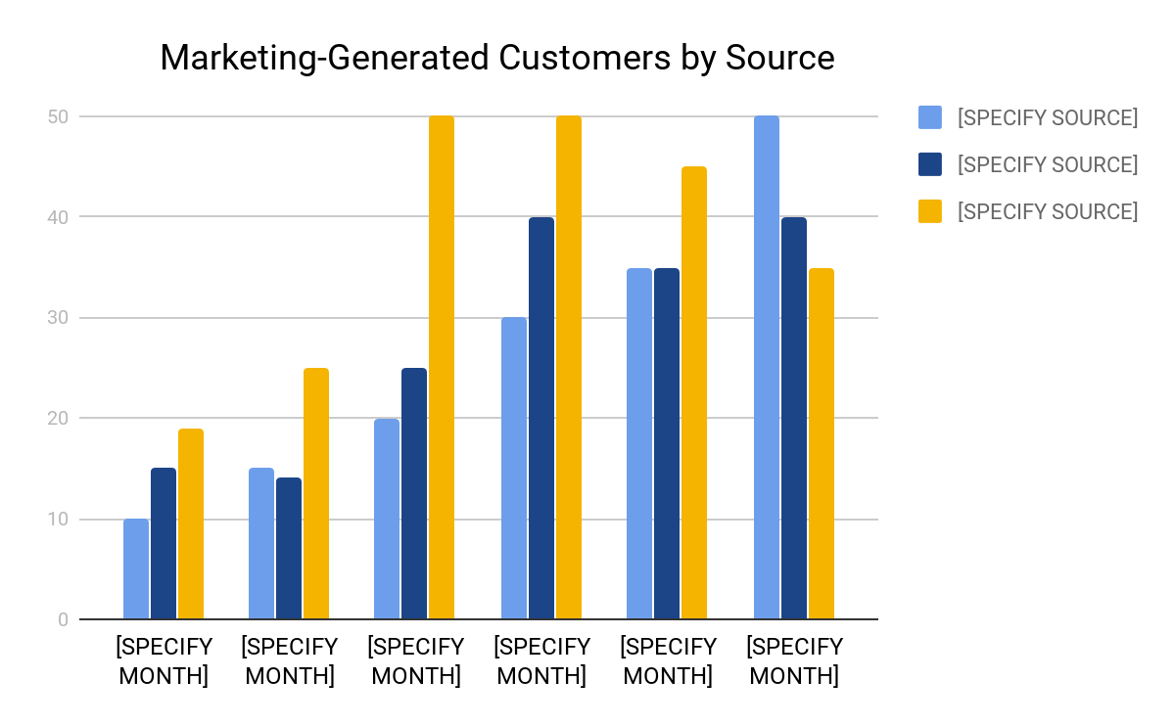
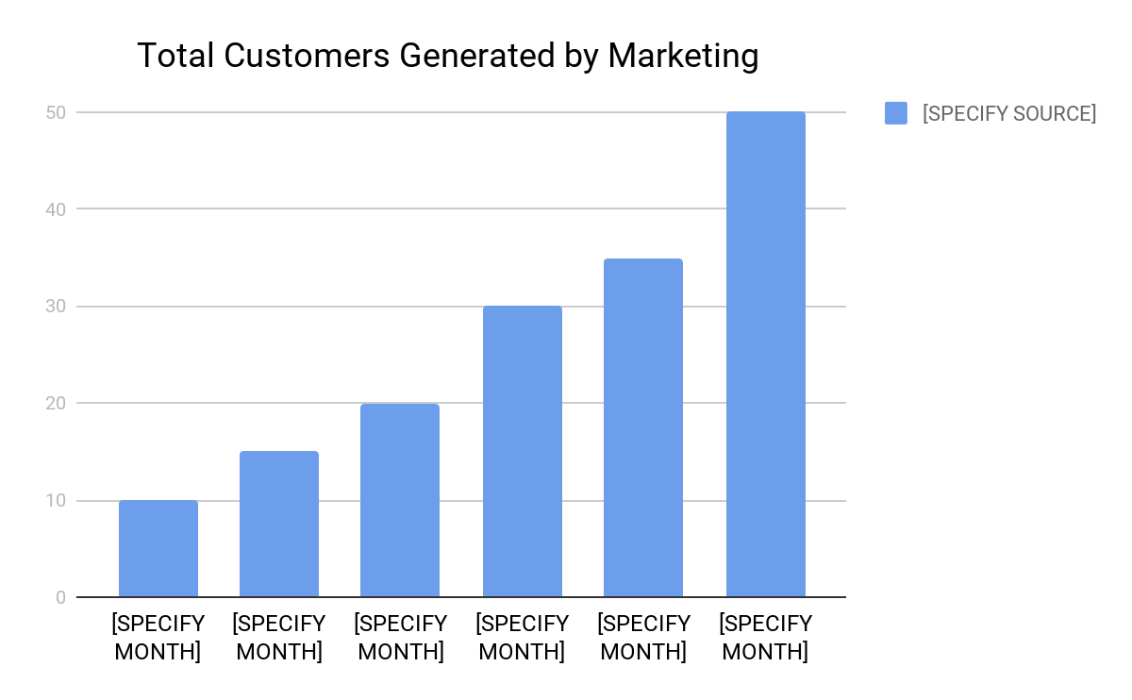
Marketing-Generated Customers by Source: Similar to the prior metrics, this data will help you see where the majority of your customers are coming from
Customer Growth through Marketing:

[PROVIDE A GRAPH SHOWING HOW THE CUSTOMERS GROWTH HAS CHANGED BECAUSE OF THE MARKETING STRATEGIES]

Top Marketing Campaigns:

Out of the several campaigns used, the ones that topped and helped in the success of the marketing plans of the restaurant are as follows:

[SPECIFY THE TOP MARKETING CAMPAIGN]
[SPECIFY ADDITIONAL MARKETING CAMPAIGN THAT TOPPED]

RECOMMENDATIONS AND CONCLUSION

Future campaign plans:

The following steps are highly recommended in order to ensure a [SPECIFY THE FUTURE PLANS TO BE ATTAINED]:

[SPECIFY FUTURE PLANS OF THE RESTAURANT]
[SPECIFY ADDITIONAL FUTURE PLANS]

Conclusion:

[SPECIFY YOUR RESTAURANT NAME] will not always be successful in its every endeavour. Improvements in every area of the restaurant are necessary if the restaurant is, to [SPECIFY] and [SPECIFY]. The key areas to reform are [SPECIFY THE GENERAL RECOMMENDATIONS THAT CAN BE GIVEN]

It must be remembered that the Marketing Report is limited: a greater depth of understanding and evaluation can only occur with the utilization of resources other than the above such as [SPECIFY OTHER RESOURCES THAT CAN BE UTILIZED]. Only after this process can [SPECIFY WHAT CAN BE ACHIEVED UPON COMPLETION OF THE PROCESS].

At this point, the restaurant does not have a strong future prospects due to [SPECIFY THE REASON AS TO WHY THERE IS STILL NO STRONG PROSPECT] especially in the areas of [SPECIFY AREA], [SPECIFY ARE], and [SPECIFY OTHER AREA]. [SPECIFY] should be concerned with the current rates of return and management and [SPECIFY] on the other hand must be concerned with the liquidity of the restaurant as indicated in the [SPECIFY].

