PROJECT WEEKLY STATUS REPORT

Subject: | [SPECIFY THE PROJECT NAME] Weekly Status Report
Project Manager: | [SPECIFY PROJECT MANAGER NAME]
Project Status: | [SPECIFY THE PERCENTAGE] (00%) Completion
Status Date: | [SPECIFY COVERAGE DATES] (Weekly)

PROJECT MILESTONES

DATE | DELIVERABLES | MILESTONES | ACTION ITEMS
[SPECIFIC DATE] | [INSERT PROJECT ITEM] | [SPECIFY THE TASKS ACCOMPLISHED WITH DATE OF ACCOMPLISHMENT] | [SPECIFY THE TASK WITH TARGET DATE OF ACCOMPLISHMENT]
10/15/25 | Design review | Peer review was successful and came up with improvements for the design (10/16/25) | Make sure that changes are implemented correctly (10/18/25)

Overall Project Status

[INSERT CHART SHOWING PERCENTAGE OF PROGRESS]
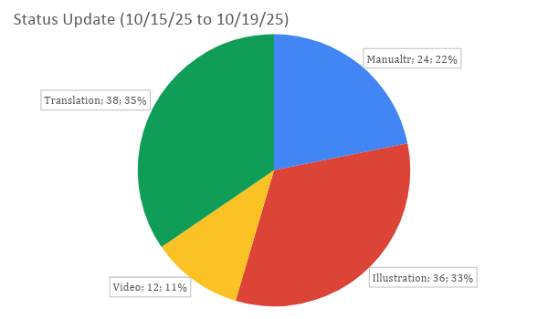

MITIGATION ACTIVITIES

DATE | ACTIVITIES | Owners | Target Date
[SPECIFY DATE] | [SPECIFY MITIGATION ACTIVITIES] | [SPECIFY NAMES] | [SPECIFY TARGET DATE OF COMPLETION]

Prepared by:

[SPECIFY THE NAME AND SIGNATURE]
[SPECIFY DATE]

