Photography Studio Business Plan

Business Plan For Fiscal Year 2019

[February 5, 2019]

[Nancy Sinclair]
[sinclair.nancy@gmail.com]
[732-994-7924]
[www.sinclairnancy.com]
[1844 Center Street
Eugene, Oregon 97401, USA]

Index

Executive Summary [PAGE NUMBER]

Company Overview [PAGE NUMBER]

Products and Services [PAGE NUMBER]

Execution [PAGE NUMBER]

Operational Plan [PAGE NUMBER]

Financial Plan [PAGE NUMBER]

EXECUTIVE SUMMARY

[Maze Lighting Photo Studio] will offer both indoor and outdoor photoshoots in the state of [Oregon]. Photography has been in demand due to its exposure in social media.

The company will offer photos in high-resolution digital and printed formats. It will also have a website where prospective clients can easily access the photographer’s portfolio.

The business targets schools, women between the ages of [18-35], and families located in the State of [Oregon].

COMPANY OVERVIEW

Mission Statement

[Maze Lighting Photo Studio] helps its clients preserve memories. The company thrives in developing relationships with its clients. Maze Lighting makes professional quality photographs that are easily available in digital format.

Philosophy

[Maze Lighting Photo Studio] focuses on simplicity and enjoyment. Being simple lets the company focus on its clients’ needs. Bringing joy through the art of photography allows the company to effectively bring about new ideas and concepts.

Vision

[Maze Lighting Photo Studio] vision is to be the go-to photography company in the state of [Oregon].

Outlook

Social media has been used by photographers to showcase their skills. Through social media, the demand for professional photographers and professional photo editors have increased. There is a growing number for the demand for photography services in the US alone. As such, the company aims to reach at least $[100,000] in services for the first year and have a payback period of only 1 year.

Type of Industry: Photography Industry

Business Structure: Sole Proprietorship

Ownership: Sole Proprietorship, [Nancy Sinclair], who has been a professional photographer for [20] years will solely operate the business.

Start-Up Summary

The start-up cost is [91K] USD to be provided by the owner and to be used mainly for the rent, insurance, payroll, and photography equipment.

Start-Up
Requirements
Start-Up Expenses | $10,000
Rent - 1 year | $12,000
Advertising | $1,000
Legal Fees | $1,300
Insurance | $600
Accounting | $300
Staff Training | $200
Photography Equipment | $10,000
Photoshop Subscription | $100
Total Start-Up Expenses | $35,500
Start-Up Assets
Cash Required | $25,500
Start-Up Inventory | $20,000
Other Current Assets | $5,000
Long-Term Assets | $5,000
Total Assets | $55,500
Total Requirements (Total Start-Up Expenses + Total Assets) | $91,000

Management Team

Management Team | Role/Function | Skills
[Orval Simon] | Studio Manager | Indoor Photography, Photo Editing, Multi-Tasking, Communication, and Teamwork
[William Eagan] | Outdoor Photography Manager | Location scouting, Photo Editing, Collaboration and teamwork, and Multi-Tasking
[Jorge Stamm] | HR Manager | Communication, Organization, Leadership, and Time Management

Short- and Long-Term Goals and Milestones

Short-Term Goals | Milestones
Rent a photo studio | Signed the rental agreement last [December 20, 2018]
Hire an HR Manager | Done hiring last [December 23, 2018]
Hire a Studio and Outdoor Photography Manager | HR Manager has posted for the job listings on [December 27, 2018]
Purchase photography equipment | The owner has started purchasing cameras on [December 28, 2018], and reserved other studio essentials.
Long-Term Goals | Milestones
Create a marketing plan for the first year of operations | Hired marketing consultants, discussed the plans and outline for the marketing plan, and managed the changes in the company to drive the execution of the new market strategy
Generate [20]% of the current income from indoor shoots | Visited schools to enter an agreement for graduation photo shoots
Focus on social media and branding | Prepared the portfolio which will be featured on the company website

PRODUCTS AND SERVICES

Product/Service Description

[Maze Lighting Photo Studio] offers the following products and services:

- Indoor/Studio Shooting

  - Baby pictures
  - Family portraits
  - Individual portraits
  - Wedding portraits
  - High school senior yearbook portraits

- Outdoor Studio Shooting

  - Model’s portfolio and glamour shots
  - Wedding album

The company will be hiring both studio and outdoor photography managers to manage indoor and outdoor shooting. The owner will also be outsourcing makeup artists and hairstylists for prospective clients who prefer to hire professional makeup artists and hairstylists.

Value Proposition

Professional-quality photographs. [Maze Lighting Photo Studio] serves customers from [9:00 AM] to [6:00 PM] for indoor and outdoor shoots and offers high-quality photos delivered through the digital and printed format.

Pricing Strategy

[Maze Lighting Photo Studio] utilizes competitive pricing and price bundling. The company’s pricing is affordable to promote the notion that creativity does not always have to be expensive. The packages for both indoor and outdoor shoots are as follows:

 | Price
Inclusions | Indoor Shoot | Outdoor Shoot
1 session  1 large photo print  3 wallet-size photo print  Raw digital copy of the photos | $50.00 | $100.00
1 session  2 large photo prints  6 wallet-size photo print  Raw and edited digital copy of the photos | $75.00 | $150.00
1 session  1 large photo print and frame  3 large photo prints  12 wallet-size photo print | $100.00 | $200.00

EXECUTION

Marketing Plan

[Maze Lighting Photo Studio] aims to expand its market to organizations and events for event photography’s. The company wants to focus on social media and branding since social media is very accessible to everyone. It has already established accounts on Facebook, Instagram, Youtube, LinkedIn, and Pinterest, and has already prepared its photography portfolio. The company will also be developing its website which shall also feature the portfolio, products and services, and contact information.

Market Research

Photography services will experience an increase in demand projected at [12]% from [2016] to [2026]. While demand from traditional print publications is declining, the increasingly image-centric Internet has become the focus of professional photographers, enabling sole proprietors to market their services and photographs directly to a growing audience.

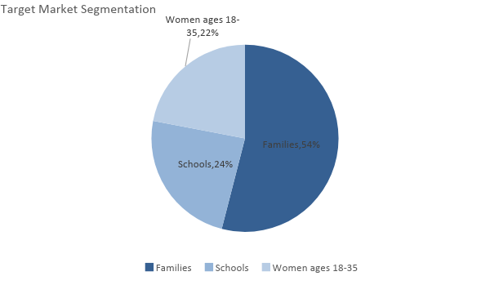

SWOT Analysis | Strengths | Weaknesses | Opportunities | Threats
[Maze Lighting Photo Studio] | - Affordable prices  - Flexible to changes | - Still new in the business  - Less customer base | - Trends in the industry allow flexibility  - Opportunities to expand the photography services of the company | - More freelance photographers are getting into the business
[Imagine Photo Arts] | - Larger customer base  - Low prices with a larger range of package inclusions | - Photos are not of high quality | - Greater exposure of the photography industry means faster demand for products and services | - Convincing people to hire professional photographers instead of using their own cameras requires rigorous marketing
[Visionetworks Inc.] | - Offers its services to at least 10 states in the US  - Offers higher quality of photos and at a lower price | - Has yet to expand | - Demand is increasing for photography services | - Slow execution could impair the business goals

Marketing Strategy

[Maze Lighting Photo Studio] plans to focus its marketing strategy on its social media exposure and branding. The company has already prepared its photography portfolio to be featured on its company website and social media accounts. The company has already established its accounts on the following social media platforms: Facebook, Instagram, YouTube, LinkedIn, and Pinterest.

The team has kicked-off various activities to move the marketing strategy forward. Here are some of the updates:

Marketing Strategy | Activities | Timeline | Success Criteria
Social Media Exposure | Establish social media accounts  Upload and post portfolios | December 25, 2018  ASAP | Social media accounts are fully established and operational by the end of [December 2018]  The portfolio is uploaded by [December 31, 2018].
Website Development | HR will meet with IT companies for the outsourcing of IT services | December 31, 2018 | The company will start website development by [January 2, 2019], and the website will be fully functional by [February 1, 2019].

Organizational Structure

[Nancy Sinclair], as owner, shall be the general manager and will be assisted by the HR manager, studio manager, and outdoor photography manager. The company will be outsourcing the services for IT, accounting, and marketing consultancy to minimize the costs.

The HR manager will have the responsibility of hiring employees as well as meeting with other outsourced service companies.

The studio manager will be assisted by one (1) studio photographer. They shall be assigned to all studio photoshoots and the editing of the photos.

The outdoor photography manager will be assisted by two (2) outdoor photographers. They shall be assigned to all the outdoor photoshoots and editing of the photos. If necessary, the outdoor photography manager will also have the responsibility of scouting locations.

The organizational structure of the company is as follows:

Nancy Sinclair
Owner, General Manager
Studio Manager
Studio Photographer
Outdoor Photographer
Outdoor Photography Manager
HR Manager

OPERATIONAL PLAN

Location and Facilities

The photo studio will be located at a small rented space in [1844 Center Street, Eugene, Oregon]. [1844 Center Street] is within commercial spaces, so it is expected that the foot traffic entering or passing by will bring attention to the company’s photo studio. The photo studio’s size is 50 square meters, ¼ of which shall be the front desk, ¼ of which is the makeup room, and ½ portion of the rented space will be the studio.

Tools and Equipment Checklist

Photography Equipment | Quantity
Prime Lenses | 4
Reflector | 4
Camera | 4
Software | Quantity
Adobe Photoshop | 1
Adobe Lightroom | 1
Hardware | Quantity
External Hardware | 2

IT Infrastructure

[Maze Lighting Photo Studio] will be utilizing basic IT systems which will be managed by the outsourced IT company. Social media management will be done by [Nancy Sinclair] and will be assisted by the HR manager. If the business is able to profit within 1 year of operations, the company will be employing a marketing manager for social media management.

FINANCIAL PLAN

Assumptions

The financial forecast is based on the current trends in the photography industry. The company will focus its efforts on indoor photography for school graduation photos and family portraits. Most of its expenses will be on photography equipment, insurance, rent, and payroll.

Monthly Expense

The chart shows the projected monthly expense for [2019].

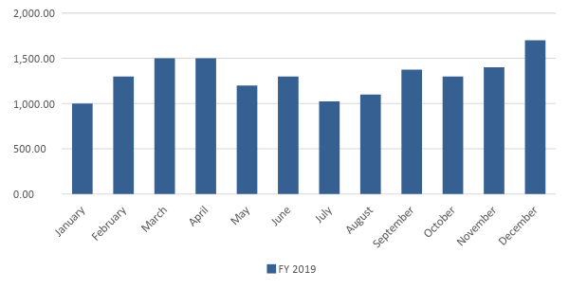

Monthly Revenue

The chart depicts the projected monthly revenue for [2019].

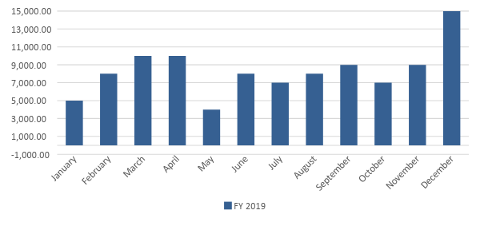
Business Financing

The funding for the business will solely be coming from the owner, which is $[91,000.00]. The company assumes that it will reach $[100,000.00] in sales for the first year of operations, with at least [250] working days, and an average daily income of $[400.00]. The company also assumes that it will experience a [3]% increase in sales for the year [2020] and a [3.5]% increase in sales for the year [2021].

Other financial assumptions are projected in the financial statements provided below.
Statements

Profit and Loss Projection
 | FY 2019 | FY 2020 | FY 2021
Sales | $100,000.00 | $103,000.00 | $106,605.00
Direct Cost of Sale | $60,000.00 | $61,800.00 | $63,654.00
Other Cost of Sale | $5,000.00 | $5,100.00 | $5,202.00
Total Cost of Goods Sold or COGS (Sales - Direct Cost of Sale - Other Cost of Sale) | $35,000.00 | $36,100.00 | $37,749.00
Gross Profit (Sales-Total Cost of Goods Sold) | $65,000.00 | $66,900.00 | $68,856.00
Gross Margin % (Gross Profit/Sales) | 65.00% | 64.95% | 64.59%
Operating Expenses
Rent - 1 year | $12,000.00 | $12,000.00 | $12,000.00
Advertising | $1,000.00 | $1,000.00 | $1,000.00
Legal Fees | $1,300.00 | $1,300.00 | $1,300.00
Insurance | $600.00 | $600.00 | $600.00
Accounting | $300.00 | $300.00 | $300.00
Other Operating Expenses | $500.00 | $500.00 | $500.00
Total Operating Expenses | $15,700.00 | $15,700.00 | $15,700.00
EBITDA (Gross Profit-Total Operating Expenses) | $49,300.00 | $51,200.00 | $53,156.00
Depreciation | $500.00 | $500.00 | $500.00
Interest Expense | $0.00 | $0.00 | $0.00
Taxes Paid | $7,395.00 | $7,680.00 | $7,973.40
Net Profit (Gross Profit - Operating Expenses - Taxes - Interest) | $41,905.00 | $43,520.00 | $45,182.60

Balance Sheet Projection
 | FY 2019 | FY 2020 | FY 2021
Cash | $139,800.00 | $142,800.00 | $146,405.00
Accounts Receivable | $10,000.00 | $10,300.00 | $10,660.50
Inventory | $5,300.00 | $2,400.00 | $1,000.00
Other Current Assets | $5,000.00 | $2,400.00 | $900.00
Total Current Assets | $160,100.00 | $157,900.00 | $158,965.50
Long-Term Assets | $8,000.00 | $8,000.00 | $8,000.00
Accumulated Depreciation | $1,000.00 | $2,000.00 | $3,000.00
Total Long-Term Assets (Long-Term Assets-Accumulated Depreciation) | $7,000.00 | $6,000.00 | $5,000.00
Total Assets (Total Current Assets + Total Long-Term Assets) | $167,100.00 | $163,900.00 | $163,965.50
Accounts Payable | $76,100.00 | $44,900.00 | $30,000.00
Notes Payable | $0.00 | $0.00 | $0.00
Other | $10,000.00 | $5,000.00 | $12,365.50
Total Liabilities | $10,000.00 | $5,000.00 | $12,365.50
Paid-in Capital | $91,000.00 | $81,000.00 | $120,000.00
Retained Earnings | $10,000.00 | $10,300.00 | $10,660.50
Total Owner's Equity (Total Assets - Total Liabilities) | $157,100.00 | $158,900.00 | $151,600.00
Total Liabilities & Equity (Total Liabilities/Total Owner's Equity) | 6.37% | 3.15% | 8.16%

Cash Flow Projection
 | FY 2019 | FY 2020 | FY 2021
Operating Cash Beginning | $55,500.00 | $55,500.00 | $55,500.00
Sources of Cash
Receivables | $10,000.00 | $10,300.00 | $10,660.50
Sales | $100,000.00 | $103,000.00 | $106,605.00
Total Cash | $165,500.00 | $168,800.00 | $172,765.50
Expenditures
Rent - 1 year | $12,000.00 | $12,000.00 | $12,000.00
Advertising | $1,000.00 | $1,000.00 | $1,000.00
Legal Fees | $1,300.00 | $1,300.00 | $1,300.00
Insurance | $600.00 | $600.00 | $600.00
Accounting | $300.00 | $300.00 | $300.00
Other Operating Expenses | $500.00 | $500.00 | $500.00
Total Expenditures | $15,700.00 | $15,700.00 | $15,700.00
Net Income/Loss (Total Cash - Total Expenditures) | $149,800.00 | $153,100.00 | $157,065.50

