PARTNERSHIP BUSINESS PLAN
[INSERT COMPANY NAME]
BUSINESS PLAN FOR FISCAL YEAR [INSERT YEAR]
[INSERT DATE]

[LORI R. FLEMING]
[FLEMING.LR@GMAIL.COM]
[609-391-7601 | 201-417-1186]
[4042 LAKE ROAD, BOARDWALK]
[OCEAN CITY, NJ 08226 USA]

INDEX

EXECUTIVE SUMMARY  COMPANY OVERVIEW  PRODUCTS AND SERVICES  EXECUTION  OPERATIONAL PLAN  FINANCIAL PLAN | [INSERT PAGE NO.]  [INSERT PAGE NO.]  [INSERT PAGE NO.]  [INSERT PAGE NO.]  [INSERT PAGE NO.]  [INSERT PAGE NO.]

EXECUTIVE SUMMARY

[Boardwalk Sweet Shop] sells a wide variety of desserts and confections such as [ice cream, cakes, cookies, chocolates, and candies]. Formerly a sole proprietorship named [Lori’s Seaside Spot], the business needed to sell cold treats such as [ice cream] in order to cater to the demands of its target customers. [Boardwalk Sweet Shop] will capitalize on its proximity to high foot traffic areas like the [Boardwalk] in order to gain more revenue.

COMPANY OVERVIEW

Mission Statement: [Boardwalk Sweet Shop] aims to give customers an enjoyable and fulfilling experience with a large selection of sweets and excellent customer service.

Philosophy: Integrity, quality, and passion for enjoyable consumption are key aspects of the business. [Boardwalk Sweet Shop] believes that the ultimate business success is knowing that its customers are satisfied both with the products and the services it provides.

Vision: [Boardwalk Sweet Shop] envisions to be the most sought-after dessert place at the Boardwalk.

Outlook: The [Ocean City Boardwalk] expects high foot traffic all year long as it is one of the busiest places in [New Jersey]. The summer season sees a surge of locals and tourists visiting to engage in different recreational activities. Dining places provide the easiest form of leisure for these visitors, and most Americans find desserts and other sweets the best type of food to consume when de-stressing.

Type of Industry: [Restaurant Industry]

Business Structure: General Partnership

Ownership: Formerly a sole proprietorship under [Lori Fleming], [Boardwalk Sweet Shop] will become a general partnership with the addition of two new partners, [Steve Hicks] and [Sandy Newman]. [Fleming] owns [40%] of the company shares, while [Hicks] and [Newman] both own [30%] of shares. All costs and profits will be shared accordingly.

Start-Up Summary: The [$38,000.00] start-up cost will be used for rent, utilities, equipment, and other operational expenses. The owners will split the costs on a [40-30-30] basis.

Start-Up Funding
Start-Up Expenses | $18,000.00
Start-Up Assets | $20,000.00
Total Funding Required | $38,000.00
Assets
Non-Cash Assets from Start-Up | $5,000.00
Cash Requirements from Start-up | $5,000.00
Additional Cash Raised | $5,000.00
Cash Balance on Starting Date | $5,000.00
Total Assets | $20,000.00
Capital
Planned Investment
Owners | $38,000.00
Additional Investment Requirement | $0.00
Total Planned Investment | $38,000.00
Loss at Start-Up (Start-Up Expenses) | -$18,000.00
Total Capital | $20,000.00
Total Capital and Liabilities | $20,000.00
Start-Up
Requirements
Start-Up Expenses
Rent | $5,000.00
Utilities | $3,000.00
Equipment | $3,000.00
Operations | $5,000.00
Marketing and Promotion | $2,000.00
Total Start-Up Expenses | $18,000.00
Start-Up Assets
Cash Required | $15,000.00
Other Current Assets | $2,000.00
Long-Term Assets | $3,000.00
Total Assets | $20,000.00
Total Requirements (Total Start-Up Expenses + Total Assets) | $38,000.00

Management Team:

Management Team | Role/Function | Skills
Lori Fleming | Operations Manager | resource management, conflict management
Steve Hicks | Finance Manager | numeracy and technical, budget management
Sandy Newman | Sales and Marketing Manager | business negotiation, customer relations

Short- and Long-Term Goals and Milestones:

Short-Term Goals | Milestones
Change legal status of the business | - Completed requirements and submitted the registration form to the state revenue division (October 17, 2018)  - Obtained Employer Identification Number under the new business name (November 10, 2018)
Enter into a partnership agreement with new partners | - Consulted with a lawyer on drafting the agreement terms (September 30, 2018)  - Signed the partnership agreement (October 20, 2018)
Long-Term Goals | Milestones
Improve products and services | - Met and discussed with partners on removing old products and adding new ones (November 3, 2018)  - Proposed additional services (November 10, 2018)
Revamp internal management systems | - Hired an admin officer (December 1, 2018)  - Hired assistant staff (December 2, 2018)

PRODUCTS AND SERVICES

Product/Service Description: [Boardwalk Sweet Shop] sells a wide variety of desserts and confections, including [ice cream, cakes, chocolates, cookies, and candies]. A DIY (do-it-yourself) Dessert Station will be made available at the beginning of [2019]. Delivery and party concession services are also being considered.

Value Proposition: [Boardwalk Sweet Shop] is conveniently located in an area surrounded by several restaurants and bars. Potential customers going in and out of the [Ocean City Music Pier] will easily find the shop as it is just a three-minute walk from the esteemed venue. The DIY Dessert Station will be a big hit among experimental dessert lovers and children.

Pricing Strategy: The business adopts psychology pricing in order to instantly attract customers by creating added value on each dessert or confection sold at the shop. This is most effective during peak season especially summertime and when there are big events at the [Ocean City Music Pier]. Bundle pricing will be used on promotional offers combining two or more complementary products.

EXECUTION

Marketing Plan: The marketing plan for [Boardwalk Sweet Shop] involves traditional approaches designed to specifically attract each target demographic. Discount promos and partnerships with nearby establishments will help increase interest and awareness of the brand. Social media will be used mostly as a communication tool for [Boardwalk Sweet Shop]'s existing customer base.

Market Research: [Boardwalk Sweet Shop]'s market consists of New Jersey locals and visiting tourists, and is further segmented into four: (1) families with children, (2) young adolescents, (3) millennial locals and tourists, and (4) senior citizens. Summertime is peak season for dining places at the Boardwalk, and these demographics are observed to flock around dessert places looking for ice cream and other refreshing sweets after eating lunch or dinner or during afternoon snack time.

SWOT Analysis | Strengths | Weaknesses | Opportunities | Threats
Boardwalk Sweet Shop | - Strategic location  - Many product choices | Some products don't sell as much as the others | High foot traffic in the area | Healthy dessert alternatives such as yogurt, allergen-free cakes and pastries
Jake's Ice Creamery | Excellent product quality | Poor customer service | Demand for related products such as ice cream cakes and sandwiches | Customer complaints
Don Gelato | - Homemade and organic ingredients  - Eco-friendly | Inconvenient location | Increased demand for healthy desserts

Marketing Strategy: Since [Boardwalk Sweet Shop]'s target customers are in close proximity, most of its marketing strategies will be traditional and customer-centric.

Marketing Strategy | Activities | Timeline | Success Criteria
Social media | -Post promotional material on social media accounts | Ongoing | Online engagement increases by 15%.
Partnership | Concession partnership with the Ocean City Music Pier | January 2019 | Boardwalk Sweet Shop's sales will increase as Music Pier entrants will get a 10% discount on purchases.
Customer engagement | Hold special eating contests at the store | January 2019 | At least 5 participants every week.

Organizational Structure:

OPERATIONS MANAGER
FINANCE MANAGER
SALES AND MARKETING
ADMIN OFFICER
STORE STAFF

OPERATIONAL PLAN

Location and Facilities: The shop is located at the [Boardwalk], accessible through Lake Road. The [1,200 sq. ft.] floor space includes the [kitchen, register, interior dining area, comfort rooms, and an administrative office] at the back. The interior dining space can accommodate up to [10] people at a time. The exterior has [4] umbrella booths that can accommodate up to [4] people per booth.

Tools and Equipment Checklist:

Software | Quantity
Square POS | 1
Xerox accounting software | 1
Hardware | Quantity
Ice cream machine | 2
Freezer | 2

IT Infrastructure

Infrastructure | Existing (Y/N) | Description
POS system | Y | Square register, credit card processing, and basic inventory management
Social media | Y | Facebook, Instagram, Twitter

FINANCIAL PLAN

Assumptions: The financial plan for Boardwalk Sweet Shop is based on the following assumptions:

1. By Q2 of 2019, monthly total expenses will not exceed $1,500.00.

2. By Q2 of 2019, revenue will increase by 2.9% monthly.

Monthly Expense

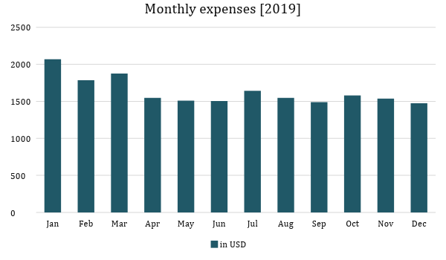
Monthly Revenue

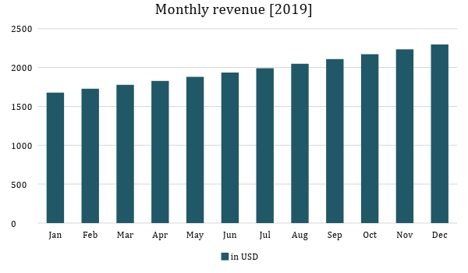

Business Financing: The business will be fully funded by the three partners. Fleming will be solely responsible for all liabilities incurred in the sole proprietorship.

Statements

Profit and Loss Projection
 | FY2019 | FY2020
Sales | $23,675.89 | $31,915.10
Direct Cost of Sale | $7,102.77 | $9,574.53
Other Cost of Sale | $436.00 | $576.00
Total Cost of Goods Sold or COGS (Sales - Direct Cost of Sale - Other Cost of Sale) | $7,538.77 | $10,150.53
Gross Profit (Sales-Total Cost of Goods Sold) | $16,137.12 | $21,764.57
Gross Margin % (Gross Profit/Sales) | 68.16% | 68.20%
Operating Expenses
Rent | $5,000.00 | $5,000.00
Utilities | $3,000.00 | $3,000.00
Equipment | $3,000.00 | $1,000.00
Operations | $5,000.00 | $5,000.00
Marketing and Promotion | $2,000.00 | $2,000.00
Total Operating Expenses | $18,000.00 | $16,000.00
EBITDA (Total Cost of Sale-Total Operating Expenses) | -$10,461.23 | -$5,849.47
Depreciation | $0.00 | $0.00
Interest Expense | $0.00 | $0.00
Taxes Paid | $0.00 | $0.00
Net Profit (Gross Profit - Operating Expenses - Taxes - Interest) | -$1,862.88 | $5,764.57

Balance Sheet Projection
 | FY2019 | FY2020
Cash | $15,000.00 | $15,000.00
Accounts Receivable | $0.00 | $0.00
Inventory | $0.00 | $2,000.00
Other Current Assets | $2,000.00 | $3,000.00
Total Current Assets | $17,000.00 | $20,000.00
Long-Term Assets | $3,000.00 | $3,000.00
Accumulated Depreciation | $0.00 | $500.00
Total Long-Term Assets (Long-Term Assets-Accumulated Depreciation) | $3,000.00 | $2,500.00
Total Assets (Total Current Assets + Total Long-Term Assets) | $20,000.00 | $22,500.00
Accounts Payable | $0.00 | $0.00
Notes Payable | $0.00 | $0.00
Other | $1,862.88 | $0.00
Total Liabilities | $1,862.88 | $0.00
Paid-in Capital | $38,000.00 | $40,000.00
Retained Earnings | $13,576.00 | $21,645.80
Total Owner's Equity (Total Assets - Total Liabilities) | $18,137.12 | $22,500.00
Total Liabilities & Equity (Total Liabilities/Total Owner's Equity) | 10.27% | 0.00%

Cash Flow Projection
 | FY2019 | FY2020
Operating Cash Beginning | $15,000.00 | $15,000.00
Sources of Cash
Receivables | $0.00 | $0.00
Sales | $23,675.89 | $31,915.10
Others | $2,000.00 | $3,000.00
Total Cash | $40,675.89 | $49,915.10
Expenditures
Rent | $5,000.00 | $5,000.00
Utilities | $3,000.00 | $3,000.00
Equipment | $3,000.00 | $1,000.00
Operations | $5,000.00 | $5,000.00
Marketing and Promotion | $2,000.00 | $2,000.00
Total Expenditures | $18,000.00 | $16,000.00
Net Income/Loss (Total Cash - Total Expenditures) | $22,675.89 | $33,915.10

