PAINTING DECORATOR BUSINESS PLAN
[INSERT COMPANY NAME]
BUSINESS PLAN FOR FISCAL YEAR [INSERT YEAR]
[INSERT DATE]

[FRANK GORMAN]
[FRANKGORMAN@GMAIL.COM]
[334-617-2724]
[WWW.GORMANRESIDENTIALDECORATORS.COM]
[44 MARKET PLAZA DOWNTOWN MONTGOMERY]
[MONTGOMERY, AL 36104, USA]
INDEX

EXECUTIVE SUMMARY  COMPANY OVERVIEW  PRODUCTS AND SERVICES  EXECUTION  OPERATIONAL PLAN  FINANCIAL PLAN | [INSERT PAGE NO.]  [INSERT PAGE NO.]  [INSERT PAGE NO.]  [INSERT PAGE NO.]  [INSERT PAGE NO.]  [INSERT PAGE NO.]

EXECUTIVE SUMMARY

[Gorman Residential Decorators] is a startup painting and decorating company based in [Montgomery], [Alabama]. The company provides full residential painting and decorating services at inexpensive prices. The company takes full advantage of the internet in promoting its services. With the continuously growing market, the company expects an increase in the number of customers monthly in the coming years.

COMPANY OVERVIEW

Mission Statement: [Gorman Residential Decorators] provides professional quality painting and decorating services to its target customers.

Philosophy: [Gorman Residential Decorators] delivers its services focusing on the values of excellence, reliability, and honesty.

Vision: [Gorman Residential Decorators] envisions itself as the first choice of residences in Montgomery, Alabama for painting and decorating services.

Outlook: The painting and decorating industry steadily grows following the boom in the housing market. In [Montgomery], [Alabama], about [60%] of the residential establishments require regular painting maintenance. The company foresees sufficient monthly customers as these residences will prefer not to do the paint job on their own.

Type of Industry: Painting and Decorating Industry

Business Structure: Sole Proprietorship

Ownership: Sole Proprietorship, [Frank Gorman]

Start-Up Summary: [Gorman Residential Decorators] has a total start-up cost of [185K USD]. The sole proprietor will provide the funds to pay for initial operating expenses such as rent, insurance, payroll, legal fees, and advertising costs.

Start-Up Funding
Start-Up Expenses | $98,300
Start-Up Assets | $86,700
Total Funding Required | $185,000
Assets
Non-Cash Assets from Start-Up | $54,700
Cash Requirements from Start-up | $8,500
Additional Cash Raised | $22,000
Cash Balance on Starting Date | $1,500
Total Assets | $86,700
Capital
Planned Investment
Owners | $185,000
Other | $0
Additional Investment Requirement | $0
Total Planned Investment | $185,000
Loss at Start-Up (Start-Up Expenses) | -$98,300
Total Capital | $86,700
Liabilities | $0
Total Capital and Liabilities | $86,700
Start-Up
Requirements
Start-Up Expenses
Rent - 6 Months | $10,800
Advertising | $2,000
Legal Fees | $3,000
Staff Training | $5,000
Insurance | $2,500
Other | $75,000
Total Start-Up Expenses | $98,300
Start-Up Assets
Cash Required | $10,000
Start-Up Inventory | $20,000
Other Current Assets | $22,000
Long-Term Assets | $34,700
Total Assets | $86,700
Total Requirements (Total Start-Up Expenses + Total Assets) | $185,000

Management Team:

Management Team | Role/Function | Skills
Frank Gorman | General Manager | Leadership, Communication, Decision-Making, Delegation, Time Management
Lori Higgins | Marketing Manager | Planning and Organization, Attention to Detail, Market Awareness

Short- and Long-Term Goals and Milestones:

Short-Term Goals | Milestones
Recruit qualified residential painters and decorators | Hired a total of 8 painters and decorators on November 28, 2018
Acquire the necessary permits and licenses to operate | Submitted the required documents to receive the license to provide painting and decorating services
Long-Term Goals | Milestones
Gain a client base in popular neighborhoods in Montgomery, Alabama | Chosen an office near large neighborhoods in Montgomery, Alabama
Secure a solid online market presence | Hired a website developer to create the company’s website

PRODUCTS AND SERVICES

Product/Service Description: [Gorman Residential Decorators] provides full residential painting and decorating services to small and medium houses at affordable rates. The company offers a quote to the client after a survey of the residence location.

Value Proposition: [Gorman Residential Decorators] uses only premium quality paints when rendering its painting and decorating services. In addition, the company completes the paint job with quality and in the quickest way possible.

Pricing Strategy: [Gorman Residential Decorators] chooses the cost-plus pricing approach when providing a quote to the client.
EXECUTION

Marketing Plan: [Gorman Residential Decorators] plans to promote its services with the full use of the internet through its website and various social media platforms.

Market Research: The residential painting and decorating industry has grown so much as more and more people are investing in the housing market. Most of the residences [Montgomery], [Alabama], show interest in availing painting and decorating services for their homes instead of doing them on their own.
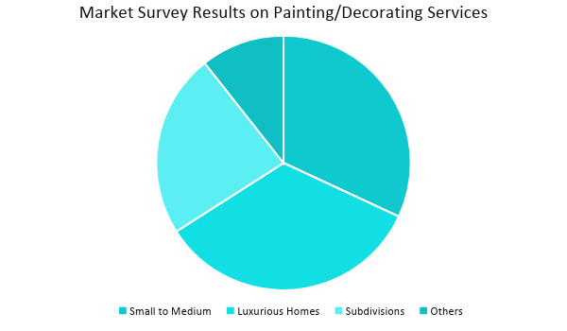

SWOT Analysis | Strengths | Weaknesses | Opportunities | Threats
Gorman Residential Decorators | Offers cost-efficient and professional quality painting/  decorating services | Has a weak market presence | Developers are looking for low-cost yet quality painters/  decorators making it advantageous for the company | Impending increase in the price of paint threatens the cost-efficiency of the company’s services
Alabama Painting Contractors | Uses advanced technology when rendering its painting and  decorating  services | Has poor customer service | Consumers tend to rely on companies having reliable technology maintaining the demand for such painting services | Consumer behavior depends on the quality of service they can get
Monte Residential Painters | Recognized as one of the top provider of painting and  decorating services | Has limited service offerings | Steady increase in the demand for painting/  decorating services | Governmental laws that restrict the companies to offer certain painting/  decorating services

Marketing Strategy: [Gorman Residential Decorators] will utilize the internet to advertise its painting and decorating services. The company will equip its website with rich content and will use social media to promote its services.

The following activities have been started by the marketing manager to accomplish the marketing strategies.

Marketing Strategy | Activities | Timeline | Success Criteria
Website Creation | Develop a website with rich content | ASAP | The informative and user-friendly website of the company is available by January 2019.
Social Media | Post articles, videos, and images highlighting the company’s services and every post must have a link that goes straight to the company website. | January 10, 2019 | The company’s posts receive 1,000 likes from social media users.

Organizational Structure:

Frank Gorman, the owner of Gorman Residential Decorators, will personally oversee the business’ daily operations. All the employees of the company will directly report to the owner. The owner will solve any conflict or problem at work.

OPERATIONAL PLAN

Location and Facilities

[Gorman Residential Decorators] will operate in a 1,600 square foot leased space located at [44 Market Plaza Downtown Montgomery], [Montgomery], [Alabama] 36104, USA. The company will use this space as an office where all planning and organization with clients take place. The office will have an open-space layout for easy communication among employees.
Tools and Equipment Checklist

Software | Quantity
Inventory Management System | 1
Customer Database System | 1
Hardware | Quantity
Computers | 5
Printers | 2

IT Infrastructure

The following table reflects the IT infrastructure of Gorman Residential Decorators.

Infrastructure | Existing (Y/N) | Description
Social Media | N | The company has no social media accounts yet.
Website | N | The company does not own a website yet.
Latency Proof | Y | The company does not suffer delays in network connections.
Zero Downtime | Y | The company does not experience any downtime.

FINANCIAL PLAN

Assumptions

[Gorman Residential Decorators] referred to market trends as basis for its financial assumptions during the creation of projected financial statements. These assumptions are as follows:

- The company projects a [35%] increase in its sales in the next three years.
- The prevailing market interest is [4.5%]. The tax rate on compensation is [10%].
- The company expects a [5%] increase in the cost of paint, utilities, and maintenance by the end of the year.

Monthly Expense

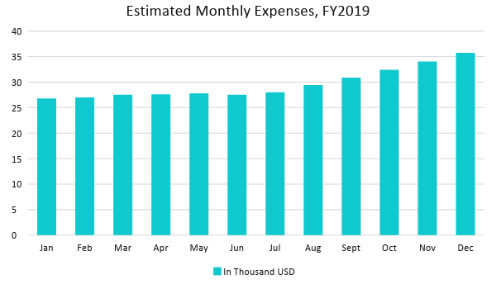

Monthly Revenue

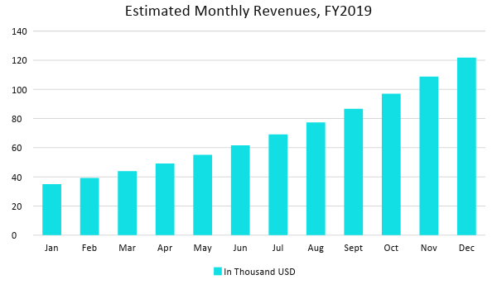

Business Financing

The sole proprietor generated the fund to initially operate Gorman Residential Decorators through a short-term business loan payable within [2 years]. The interest imposed on the business loan follows the prevailing market interest rate.

Statements

Profit and Loss Projection
 | FY2019 | FY2020 | FY2021
Sales | $255,000.00 | $344,250.00 | $464,737.50
Direct Cost of Sale | $102,000.00 | $137,700.00 | $185,895.00
Other Cost of Sale | $2,500.00 | $2,625.00 | $2,756.25
Total Cost of Goods Sold or COGS (Sales - Direct Cost of Sale - Other Cost of Sale) | $150,500.00 | $203,925.00 | $276,086.25
Gross Profit (Sales-Total Cost of Goods Sold) | $104,500.00 | $140,325.00 | $188,651.25
Gross Margin % (Gross Profit/Sales) | 40.98% | 40.76% | 40.59%
Operating Expenses
Rent | $21,600.00 | $21,600.00 | $21,600.00
Insurance | $10,000.00 | $10,000.00 | $10,000.00
Utilities | $5,000.00 | $5,100.00 | $5,202.00
Salary (Including Tax) | $50,000.00 | $50,000.00 | $50,000.00
Maintenance & Supplies | $5,000.00 | $5,125.00 | $5,253.13
Total Operating Expenses | $91,600.00 | $91,825.00 | $92,055.13
EBITDA (Total Cost of Sale-Total Operating Expenses) | $58,900.00 | $112,100.00 | $184,031.13
Depreciation | $850.00 | $850.00 | $850.00
Interest Expense | $8,325.00 | $8,325.00 | $8,325.00
Taxes Paid | $5,000.00 | $5,000.00 | $5,000.00
Net Profit (Gross Profit - Operating Expenses - Taxes - Interest) | -$425.00 | $35,175.00 | $83,271.13

Balance Sheet Projection
 | FY2019 | FY2020 | FY2021
Cash | $18,400.00 | $60,400.00 | $147,566.13
Accounts Receivable | $30,000.00 | $40,500.00 | $54,675.00
Inventory | $50,000.00 | $52,500.00 | $55,125.00
Other Current Assets | $35,000.00 | $42,000.00 | $42,000.00
Total Current Assets | $133,400.00 | $195,400.00 | $299,366.13
Long-Term Assets | $65,000.00 | $65,000.00 | $65,000.00
Accumulated Depreciation | $850.00 | $1,700.00 | $2,550.00
Total Long-Term Assets (Long-Term Assets-Accumulated Depreciation) | $64,150.00 | $63,300.00 | $62,450.00
Total Assets (Total Current Assets + Total Long-Term Assets) | $197,550.00 | $258,700.00 | $361,816.13
Accounts Payable | $70,000.00 | $65,000.00 | $60,000.00
Notes Payable | $22,000.00 | $25,300.00 | $29,095.00
Other | $6,000.00 | $6,000.00 | $6,000.00
Total Liabilities | $98,000.00 | $96,300.00 | $95,095.00
Paid-in Capital | $100,000.00 | $100,000.00 | $100,000.00
Retained Earnings | -$425.00 | $34,750.00 | $118,021.13
Total Owner's Equity (Total Assets - Total Liabilities) | $99,550.00 | $162,400.00 | $266,721.13
Total Liabilities & Equity (Total Liabilities/Total Owner's Equity) | 98.44% | 59.30% | 35.65%

Cash Flow Projection
 | FY2019 | FY2020 | FY2021
Operating Cash Beginning | $10,000.00 | $18,400.00 | $60,400.00
Sources of Cash | $6,500.00 | $8,125.00 | $10,156.25
Receivables | $30,000.00 | $40,500.00 | $54,675.00
Sales | $60,000.00 | $81,000.00 | $109,350.00
Others | $3,500.00 | $4,200.00 | $5,040.00
Total Cash | $110,000.00 | $152,225.00 | $239,621.25
Expenditures
Rent | $21,600.00 | $21,600.00 | $21,600.00
Insurance | $10,000.00 | $10,000.00 | $10,000.00
Utilities | $5,000.00 | $5,100.00 | $5,202.00
Salary (Including Tax) | $50,000.00 | $50,000.00 | $50,000.00
Maintenance & Supplies | $5,000.00 | $5,125.00 | $5,253.13
Total Expenditures | $91,600.00 | $91,825.00 | $92,055.13
Net Income/Loss (Total Cash - Total Expenditures) | $18,400.00 | $60,400.00 | $147,566.13

