Business Plan For Fiscal Year 2019

[December 21, 2018]

[Jerry F. Quillen]
[jfquillen@gmail.com]
[915-490-1508]
[www.facebook.com/Veggie-Go]
[El Coco Strip, 1956 Ward Road]
[El Paso, TX 79936 USA]

ORGANIC
RESTAURANT
BUSINESS PLAN

Contents

Executive Summary

Company Overview
Products and Services
Execution

Operational Plan
Financial Plan

EXECUTIVE SUMMARY

[Veggie-Go] will be the pioneering organic fast food restaurant in [El Paso, Texas]. Serving alternative versions of everybody's favorite burgers, hot dogs, fries, and other fast food staples, [Veggie-Go] is the response to the growing demand for healthier food in one of America's most diabetic cities. The business targets individuals within the [18 to 35] years old age bracket as it centers on affordability and service speed without compromising the nutritional value or taste of the food. Marketed and managed properly, [Veggie-Go] has the potential to be a competitor of large fast food chains such as Burger King and McDonald’s.

COMPANY OVERVIEW

Mission Statement

[Veggie-Go Organic Resto] aspires to be an efficient provider of affordable and healthy fast food meals made with all organic ingredients in [El Paso, Texas].

Philosophy

[Veggie-Go] focuses on the holistic well-being. To take care of one's physical body is a necessary prerequisite to achieving a healthy mind and soul. By providing healthy and affordable fast food options to our target consumers, we are affording them a shot at leading a healthier life. Sustainable development is also a core value of the business, and we aim to build and run the restaurant utilizing methodologies that will have little to no impact on the natural resources of [El Paso].

Vision

[Veggie-Go Organic Resto] sees itself as the leading organic restaurant in [El Paso, Texas] that will start the trend of healthy fast food using ingredients that include local and homegrown produce.

Outlook

[Veggie-Go Organic Resto] aims to capitalize on the growing interest of [El Paso] citizens on low-carb and low-sugar food items. The business aims to gain at least [30,000 patrons] a year in its first and second year of business. It expects to break-even by the middle of the second year of operations. By the third year, it sees the opening of a second branch, increasing the projected profits by at least [35]%.

Type of Industry: Hospitality Industry

Business Structure and Ownership

The business will be a limited partnership consisting of a general partner, [Jerry Quillen], and two limited partners, [Nancy Castro] and [Henry Mason]. [Jerry Quillen] is the owner and operator of the business and has total control over how the business runs. The two limited partners, [Castro] and [Mason], will provide a significant amount of the start-up capital. This serves as their investment to the company, and both have agreed to start claiming their returns at the end of the second year of operations.

Start-Up Summary: The restaurant's startup costs total to $[300,000.00].

START-UP FUNDING
Start-Up Expenses | $150,000.00
Start-Up Assets | $150,000.00
Total Funding Required | $300,000.00
ASSETS
Non-Cash Assets from Start-Up | $60,000.00
Cash Requirements from Start-up | $50,000.00
Additional Cash Raised | $5,000.00
Cash Balance on Starting Date | $35,000.00
Total Assets | $150,000.00
LIABILITIES AND CAPITAL
Liabilities
Current Borrowing | $0.00
Long-term Liabilities | $20,000.00
Outstanding Bills | $10,000.00
Other Liabilities | $0.00
Total Liabilities | $30,000.00
Capital
Planned Investment
Owner | $100,000.00
Partner 1 | $100,000.00
Partner 2 | $70,000.00
Additional Investment Requirement | $0.00
Total Planned Investment | $270,000.00
Loss at Start-Up (Start-Up Expenses) | -$150,000.00
Total Capital | $120,000.00
Total Capital and Liabilities | $120,000.00
START-UP
Requirements
Start-Up Expenses
Lease Payments | $30,000.00
Equipment, Tools, Software | $80,000.00
Site Redesign | $10,000.00
Staff Training | $10,000.00
Other | $20,000.00
Total Start-Up Expenses | $150,000.00
START-UP ASSETS
Cash Required | $50,000.00
Start-Up Inventory | $30,000.00
Other Current Assets | $10,000.00
Long-Term Assets | $60,000.00
Total Assets | $150,000.00
Total Requirements (Total Start-Up Expenses + Total Assets) | $300,000.00

Management Team:

Management Team | Role/Function | Skills
[Jerry Quillen] | General Manager | Communication, organization, team building, leadership, business management
[Tony Castro] | Finance Manager | Organization, financial management, time management, communication

Short- and Long-Term Goals and Milestones:

Short-Term Goals | Milestones
Secure a leasehold on the commercial property for the restaurant facility | Closed lease contract with El Coco Strip property management [December 12, 2018]
Finalize the menu for the soft opening | Rough drafts of the menu were made, final menu approved [December 15, 2018]
Long-Term Goals | Milestones
Create a marketing plan for the first year of operations | Consulted with marketing professionals and discussed the elaborate plans for the online marketing of the [Veggie-Go] brand [December 10, 2018]
Achieve customer traffic of at least [400] customers per day by the end of the first year | Created specific opening promos; patron discounts to be given during the soft opening [December 10, 2018]

PRODUCTS AND SERVICES

Product Offerings

[Veggie-Go] will be serving basic fast food products (burgers, hot dogs, fries) with a twist, that is, instead of using meat and other fattening ingredients, each recipe will be made with all organic and vegetarian products. The owner has contracted with two suppliers of organic and vegetarian products, and one of them will exclusively supply the restaurant with delicious meat alternatives that will be used as replacements for burger patties and hot dogs. Drinks on the menu will consist of fresh juices, shakes, and smoothies. A healthy version of the Slurpee, an all-time fast food favorite, is currently being developed by the owner. More fast food menu items will be introduced beginning in the second half of the first year of operations.

Value Proposition

"Tastes like the real thing." The developers of the [Veggie-Go] taste are making sure that people will still be attracted to the food simply because each menu item closely resembles the taste of fast food.

Pricing Strategy

A mix of customary and bundle pricing will be employed by the business. Aiming to compete with famous fast food dining places, [Veggie-Go] will sell its products at affordable prices. This is to promote the notion that eating healthy doesn't have to be expensive. Bundle pricing will be an effective means to sell the menu items faster by having customers purchase more than one item together. A la carte items will be sold for a dollar a piece, while value meals will not exceed the maximum of 3 dollars per meal.

EXECUTION

Marketing Plan:

[Veggie-Go] aims to establish itself as the number one alternative to both fast food restaurants and expensive organic eateries in the [El Paso] area. Selling the [Veggie-Go] brand will require both traditional and modern forms of marketing to maintain the "organic" feel and philosophy of the brand. Online marketing will be aimed primarily at the college students who live near or around the restaurant. Word-of-mouth marketing will work for the working class who often go to the farmer's market during the weekends.

Market Research

In a [March 2018] survey, [El Paso] was identified as one of the top diabetic cities in America. This has led to a growing interest in healthy food and the emergence of a few organic grocery shops all over the city. [Veggie-Go's] target market consists of the following: a) college students within [18 to 25] years of age; b) The working class between [20 to 30] years, and; c) Fast food consumers of any age who are required to eat healthier food due to certain medical conditions.

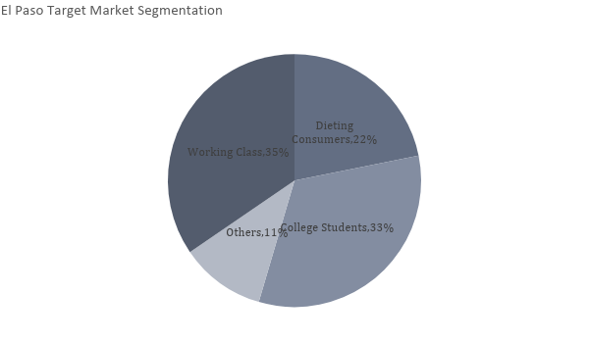
SWOT Analysis:

Company | Strengths | Weaknesses | Opportunities | Threats
[Veggie-Go] | - Affordable prices  - Healthy food offerings | - Newly established, less customer base  - Fewer product offerings | - Health consciousness among [El Paso] citizens will increase the demand for healthier food alternatives  - Fresh approaches to marketing will pique the interest of [Veggie-Go's] top target market segments (college students and working class) | - Convincing people to make the switch from actual fast food to healthy fast food requires rigorous marketing  - Fast food chains are coming up with marketing promos such as discounts and price drops that may attract [Veggie-Go's] main target market segments
[Burger King] | - Large customer base/patronage  - Affordable prices | - Poor customer service  - Little to no fresh ingredients | - Continued high demand for cheap fast food among students and the working class  - Can make prices go lower than usual through marketing promos to entice customers | - Closure of a branch in uptown [El Paso] due to labor strikes  - [El Paso] continues to be on high alert on its diabetes statistics and the call for healthier food may affect sales in the future as diabetes awareness is implemented in the city
[Jardin del Eden] | - Healthy food offerings  - Offers self-prepared menu | - High prices  - Recipes are not relatable to the common folk | - The increase of high-paying jobs in the area where [Jardin] is located may increase its customer base  - Continued patronage of its relatively wide customer base | - Competitive prices among [El Paso] restaurants take away a huge portion of [Jardin's] target market  - The increased demand for affordable and accessible healthy food by the middle to lower class

Marketing Strategy

Selling [Veggie-Go] to consumers will require a mix of both word-of-mouth and online marketing activities. We aim to refrain from using print media to save resources.

Marketing Strategy | Activities and Timeline | Success Criteria
Online | Put up Facebook, Instagram and Twitter accounts [1st week of December] and Invite followers [1st week of December] right after setting up social media accounts | All social media accounts are active as early as [December 3, 2018], and an update [text or image post] must be posted on the weekend following the activation, around [December 7 to 8\. Gain at least [100] followers within the first two weeks of activation.
Word-of-mouth | Course news of restaurant opening through our suppliers who are both well-known sellers at the [El Paso] farmer's market. The suppliers are [Mr. Johnny] Fresh and Delia Organics. [Johnny] and [Delia] will casually talk about the opening of the restaurant and make informal invitations to the Farmer's Bazaar, where [Veggie-Go] will go public for the first time for a sampling activity. | Public interest on [Veggie-Go] will be measured subjectively in this manner, i.e. it depends on how Johnny and Delia deliver their word-of-mouth marketing techniques.
Sampling | During the annual Farmer's Bazaar on [January 5, 2019], [Veggie-Go] will have a stall space where people can taste samples of the menu items for free. The attending persons on the stall will encourage the tasters to provide feedback on the food and drinks. | At least [100] people will drop by the stall. At least [60]% of the prepared food samples must be consumed.

Organizational Structure

[Jerry Quillen] will be in charge of the restaurant's overall management. The assistants and staff will be supervised by a manager. Plans on hiring a bookkeeper and a human resource manager are also underway.

Name | Position | Roles/Responsibilities | Reports to
[Jerry Quillen] | Owner/Operator/General Manager | Overall management and supervision of the restaurant during the first year of operations | NA
[Tony Castro] | Finance Manager | Overall management of all financial aspects of the business | [Jerry Quillen]
[Maria Olvio] | Kitchen Manager | Makes decisions on the product and service specifications and all backdoor procedures | [Jerry Quillen]
[Henrietta Slacks] | Front Office Manager | Full administration of restaurant processes (service, order taking, payments, etc.) | [Jerry Quillen]

OPERATIONAL PLAN

Location and Facilities

The restaurant will be located at a small rent space in the [El Coco] Strip at Ward Road. Ward Road is within [El Paso's] residential and commercial areas, so it is expected that the foot traffic entering or passing by El Coco Strip will bring potential customers to [Veggie-Go]. The rented space will be revamped to make the restaurant appear like a hole-in-the-wall dining place. The place can house up to [30] people. The kitchen space at the back can accommodate all the basic equipment such as the fryer, beverage dispenser, and refrigerator/freezer.

Tools and Equipment

Kitchen |  | Operations
Item | Qty | Item | Qty
Fryer | 2 | PC unit | 2
Refrigerator/freezer | 1 | Point of sale software | 1

IT Infrastructure

[Veggie-Go] will be utilizing basic IT systems. The restaurant will only require a point of sale and inventory software. Social media management will also be done by [Jerry Quillen] with the help of his family. If the business is able to profit significantly within its first six months or first year of operations, employing advanced IT systems personnel may be considered depending on the budget and the availability of IT professionals that the business can afford.

FINANCIAL PLAN

Assumptions

The financial forecast is based on the emerging trends of consuming healthier food products in [El Paso]. As the city is more aware of the benefits of organic food, [Veggie-Go] is making a bold assumption that its food products will be on high demand as early as the second to third quarter of its first year of operations, thus producing considerable income for the restaurant. Expenses are also seen to be high due to certain factors such as the cost of fresh produce, leasehold payments, and marketing costs among others.

Monthly Expenses:

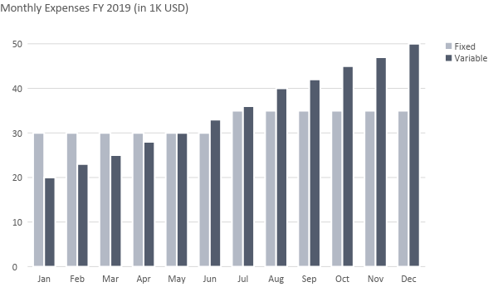

Monthly Revenue:

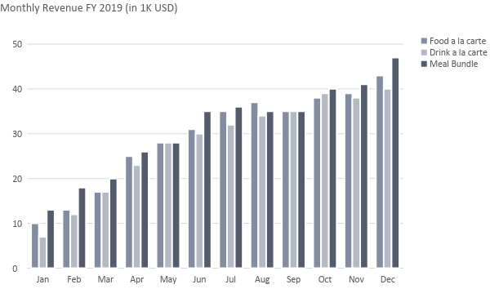

Business Financing

[Veggie-Go] will be fully funded by the owner and the two limited partners. The owner plans to invite more partners if the business grows substantially well within the 3rd to 4th quarter of its second year of operations. On the other hand, if the business does not meet the financial projection for its first two years of operations, the owner may consider a business loan to cover up costs supposedly payable by restaurant income.

Financial Statements

Profit and Loss Projection
 | FY2019 | FY2020 | FY2021
Sales | $300,000.00 | $350,000.00 | $375,000.00
Direct Cost of Sale | $125,000.00 | $135,000.00 | $165,000.00
Other Cost of Sale | $1,000.00 | $1,500.00 | $2,000.00
Total Cost of Goods Sold or COGS (Sales - Direct Cost of Sale - Other Cost of Sale) | $174,000.00 | $213,500.00 | $208,000.00
Gross Profit (Sales-Total Cost of Goods Sold) | $126,000.00 | $136,500.00 | $167,000.00
Gross Margin % (Gross Profit/Sales) | 42.00% | 39.00% | 44.53%
Operating Expenses
Lease Payments | $15,000.00 | $15,000.00 | $15,000.00
Insurance | $5,000.00 | $5,000.00 | $5,000.00
Utilities | $20,000.00 | $25,000.00 | $30,000.00
Salary (Including Tax) | $50,000.00 | $50,000.00 | $53,000.00
Maintenance & Supplies | $10,000.00 | $13,000.00 | $15,000.00
Total Operating Expenses | $100,000.00 | $108,000.00 | $118,000.00
EBITDA (Total Cost of Sale-Total Operating Expenses) | $74,000.00 | $105,500.00 | $90,000.00
Depreciation | $4,000.00 | $4,000.00 | $4,000.00
Interest Expense | $0.00 | $0.00 | $0.00
Taxes Paid | $4,000.00 | $5,000.00 | $6,000.00
Net Profit (Gross Profit - Operating Expenses - Taxes - Interest) | $22,000.00 | $23,500.00 | $43,000.00

Balance Sheet Projection
 | FY2019 | FY2020 | FY2021
Cash | $200,000.00 | $230,000.00 | $250,000.00
Accounts Receivable | $10,000.00 | $15,000.00 | $11,000.00
Inventory | $10,000.00 | $12,500.00 | $15,000.00
Other Current Assets | $7,500.00 | $8,000.00 | $8,500.00
Total Current Assets | $227,500.00 | $265,500.00 | $284,500.00
Long-Term Assets | $10,000.00 | $10,000.00 | $10,000.00
Accumulated Depreciation | $2,500.00 | $3,000.00 | $3,500.00
Total Long-Term Assets (Long-Term Assets-Accumulated Depreciation) | $7,500.00 | $7,000.00 | $6,500.00
Total Assets (Total Current Assets + Total Long-Term Assets) | $235,000.00 | $272,500.00 | $291,000.00
Accounts Payable | $50,000.00 | $35,000.00 | $15,000.00
Notes Payable | $5,000.00 | $3,000.00 | $2,000.00
Other | $1,000.00 | $0.00 | $0.00
Total Liabilities | $56,000.00 | $38,000.00 | $17,000.00
Paid-in Capital | $100,000.00 | $100,000.00 | $100,000.00
Retained Earnings | $80,000.00 | $90,000.00 | $100,000.00
Total Owner's Equity (Total Assets - Total Liabilities) | $179,000.00 | $234,500.00 | $274,000.00
Total Liabilities & Equity (Total Liabilities/Total Owner's Equity) | 31.28% | 16.20% | 6.20%

Cash Flow Projection
 | FY2019 | FY2020 | FY2022
Operating Cash Beginning | $150,000.00 | $175,000.00 | $200,000.00
Sources of Cash
Receivables | $20,000.00 | $23,000.00 | $27,000.00
Sales | $22,000.00 | $23,500.00 | $43,000.00
Others | $5,000.00 | $7,000.00 | $8,000.00
Total Cash | $197,000.00 | $228,500.00 | $278,000.00
Expenditures
Lease Payments | $15,000.00 | $15,000.00 | $15,000.00
Insurance | $5,000.00 | $5,000.00 | $5,000.00
Utilities | $20,000.00 | $25,000.00 | $30,000.00
Salary (Including Tax) | $50,000.00 | $50,000.00 | $53,000.00
Maintenance & Supplies | $10,000.00 | $13,000.00 | $15,000.00
Total Expenditures | $100,000.00 | $108,000.00 | $118,000.00
Net Income/Loss (Total Cash - Total Expenditures) | $97,000.00 | $120,500.00 | $160,000.00

