NAIL SALON BUSINESS PLAN
Business Plan For Fiscal Year 2020
November 30, 2018
[Judy Deville]
[judydeville@gmail.com]
[206-719-6657] [www.trendstylenailparlor.com]
[425 Fairview Ave N South Lake Union, Seattle, WA 98109, USA]

INDEX
Executive Summary
Company Overview
Products and Services
Execution
Operational Plan
Financial Plan
[Page Number]
[Page Number]
[Page Number]
[Page Number]
[Page Number]
[Page Number]

Executive Summary:

[Trendstyle Nail Parlor] is a nail care salon based in Seattle, Washington. The company provides affordable and high-quality nail care and treatment services to its customers by appointment basis. The company wants to increase the number of customers, targeting women ages [24-34].

[Trendstyle Nail Parlor]wants to establish a solid market presence online. The company will optimize its website and will utilize social media platforms to promote its services.

Company Overview:

Mission Statement: [Trendstyle Nail Parlor] enhances the innate beauty of a woman by providing them with trendy and fashionable nail care services.

Philosophy: [Trendstyle Nail Parlor] focuses on providing excellent service quality while being innovative and customer-focused all the time.

Vision[Trendstyle Nail Parlor] will be one of the leading nail salons in Seattle, Washington.

Outlook: The demand for nail care services is still thriving and growing. Different nail art designs have emerged and the company plans to introduce them to its new and loyal customers. The company expects increases in revenue in the coming years.

Type of Industry: Nail Salon Industry

Business Structure: Sole Proprietorship

Ownership: Sole Proprietorship, Judy Deville

Start-Up Summary: [Trendstyle Nail Parlor] needs initial operating costs amounting to 180K USD. The sole proprietor will shoulder the payment of the company’s startup costs that will cover expenses such as rent, insurance, payroll, legal fees, and advertising.

Start-Up Funding
Start-Up Expenses | $101,025
Start-Up Assets | $78,975
Total Funding Required | $180,000
Assets
Non-Cash Assets from Start-Up | $50,000
Cash Requirements from Start-up | $8,000
Additional Cash Raised | $18,975
Cash Balance on Starting Date | $2,000
Total Assets | $78,975
Capital
Planned Investment
Owners | $180,000
Other | $0
Additional Investment Requirement | $0
Total Planned Investment | $180,000
Loss at Start-Up (Start-Up Expenses) | -$101,025
Total Capital | $78,975
Liabilities | $0
Total Capital and Liabilities | $78,975
Start-Up
Requirements
Start-Up Expenses
Rent - 6 Months | $24,525
Advertising | $1,800
Legal Fees | $2,200
Staff Training | $5,500
Insurance | $2,000
Other | $65,000
Total Start-Up Expenses | $101,025
Start-Up Assets
Cash Required | $10,000
Start-Up Inventory | $13,000
Other Current Assets | $18,975
Long-Term Assets | $37,000
Total Assets | $78,975
Total Requirements (Total Start-Up Expenses + Total Assets) | $180,000

Management Team:

Management Team | Role/Function | Skills
Judy Deville | General Manager | Leadership, Conflict Management, Decision-Making, Delegation, Communication
Catherine Cruz | Marketing Executive | Communication, Attention to Detail, Analytical, Planning and Organization

Short- and Long-Term Goals and Milestones:

Short-Term Goals | Milestones
Hire nail salon personnel to execute the salon’s services with excellence | Recruited 2 more qualified and experienced applicants last November 20, 2018
Train personnel relative to the process of nail art | Completed the first training session last November 28, 2018.
Long-Term Goals | Milestones
Increase monthly sales | Set a monthly target of 2,000 customers
Secure a solid market presence online | Opened social media pages aside from its recently created website

Products and Services

Product/Service Description: [Trendstyle Nail Parlor] offers manicure, pedicure, and other nail treatment services to women of Seattle, Washington. The company also offers nail art to customers who prefer such service during their respective appointments.

Value Proposition: [Trendstyle Nail Parlor] follows the customer’s preference in delivering its services. The company only uses safe and premium quality nail care materials.

Pricing Strategy: [Trendstyle Nail Parlor] uses competitive pricing and price bundling approaches when pricing its services.

Execution

Marketing Plan: [Trendstyle Nail Parlor]plans to establish an online media presence through website optimization and social media advertising. The company will also use conventional marketing strategies such as print advertisements to be posted outside the commercial establishment.

Market Research: The nail salon industry remains stable over the years. Women still avail of commercial nail care services instead of doing them on their own. The most recent survey of the company shows that women ages [24-34] are more likely to avail of nail care offerings.

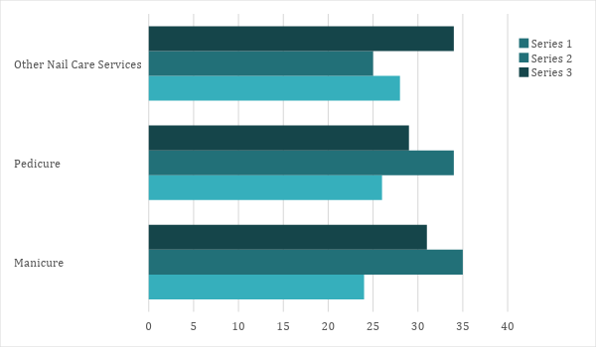

SWOT Analysis | Strengths | Weaknesses | Opportunities | Threats
Trendstyle Nail Parlor | Offers affordable yet premium quality nail care services | Customers must set an appointment to avail of service | Women want to be given special treatments making it favorable for appointment-driven businesses | Established nail salons occupy a greater percentage in the market
Seattle Nail Salon and Spa | Provides its customers with a remarkable nail treatment experience | Company has extra charges for additional nail care services | There is a demand for nail care services partnered with other services regardless of the price | There are nail salons that offer high-quality nail care services at affordable rates
Artsy Nail Parlor | Offers unique and artistic nail art designs | Company uses substandard acrylic materials for its nail art services | Increasing demand for nail art services enables the company to venture and add more services | Tight market competition among small to medium nail salon businesses

Marketing Strategy: [Trendstyle Nail Parlor] will utilize both conventional and online marketing strategies in advertising its services to its target market. The company plans to optimize its website and use social media as its advertising channel/tool. The company will also produce a standing tarpaulin outside the commercial establishment. The table below shows the set of activities for each strategy.

Marketing Strategy | Activities | Timeline | Success Criteria
Website Optimization | Hire the services of an SEO company to optimize website | January 10, 2019 | The website will become one of the top search results by the end of January 2019
Social Media Advertising | Post videos and articles that advertise the company | January 5, 2019 | The company’s followers on its Facebook page reaches 10,000 by January 20, 2019
Tarpaulin | Display a standing tarpaulin promoting the company’s nail art services | January 2, 2019 | The number of customers who avail nail art services begins to increase by January and February 2019

Organizational Structure:

[Trendstyle Nail Parlor] follows a simple organizational structure with Judy Deville as the general manager. All employees directly report to the general manager during the daily operations. The general manager closely supervises the efficiency of the nail care personnel in delivering the services to the customers. The marketing executive is responsible for the company’s promotional activities.
Operational Plan:

Location and Facilities

[Trendstyle Nail Parlor] is located at a [1,090] square foot commercial space in [425] Fairview Ave N
South Lake Union, Seattle, WA [98109], USA. The company has a spacious nail parlor that can accommodate [5-8] customers all at once. The company has a sufficient storage space dedicated for its supplies.

Tools and Equipment Checklist

Software | Quantity
Inventory Management | 1
Point of Sale System | 1
Hardware | Quantity
Computer | 2
Nail Care Equipment | 1

IT Infrastructure

[Trendstyle Nail Parlor] follows the IT infrastructure provided on the table below.

Infrastructure | Existing (Y/N) | Description
Social Media | Y | The company owns a Facebook page.
Website | Y | The company recently created its website.
Zero Downtime | N | The company encounters a few network disruptions.

Financial Plan

Assumptions

[Trendstyle Nail Parlor] refers to these financial assumptions during the preparation of its projected financial statements:
- The company expects increases in sales equal to [40%] in the next three years.
- The prevailing market interest is [5%]. The tax rate on compensation is [10%].
- The company expects no sudden increments in its operating expenses.

Monthly Expense

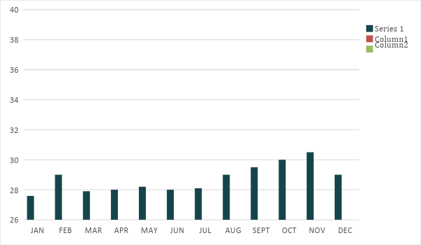
Monthly Revenue

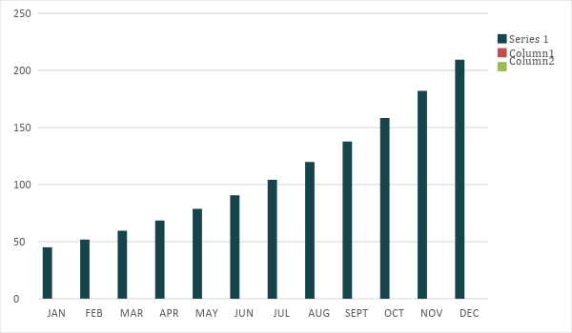

Business Financing

The sole proprietor acquired a business loan amounting to [180K] USD to fund the initial operating cost of [Trendstyle Nail Parlor] The business loan is payable within [5 years].

Statements

Profit and Loss Projection
 | FY2019 | FY2020 | FY2021
Sales | $295,000.00 | $413,000.00 | $578,200.00
Direct Cost of Sale | $132,750.00 | $185,850.00 | $260,190.00
Other Cost of Sale | $1,500.00 | $1,575.00 | $1,653.75
Total Cost of Goods Sold or COGS (Sales - Direct Cost of Sale - Other Cost of Sale) | $160,750.00 | $225,575.00 | $316,356.25
Gross Profit (Sales-Total Cost of Goods Sold) | $134,250.00 | $187,425.00 | $261,843.75
Gross Margin % (Gross Profit/Sales) | 45.51% | 45.38% | 45.29%
Operating Expenses
Rent | $49,050.00 | $49,050.00 | $49,050.00
Insurance | $6,000.00 | $6,000.00 | $6,000.00
Utilities | $5,000.00 | $5,100.00 | $5,202.00
Salary (Including Tax) | $55,000.00 | $55,000.00 | $55,000.00
Maintenance & Supplies | $5,000.00 | $5,125.00 | $5,253.13
Total Operating Expenses | $120,050.00 | $120,275.00 | $120,505.13
EBITDA (Total Cost of Sale-Total Operating Expenses) | $40,700.00 | $105,300.00 | $195,851.13
Depreciation | $700.00 | $700.00 | $700.00
Interest Expense | $9,000.00 | $9,000.00 | $9,000.00
Taxes Paid | $5,500.00 | $5,500.00 | $5,500.00
Net Profit (Gross Profit - Operating Expenses - Taxes - Interest) | -$300.00 | $52,650.00 | $126,838.63

Balance Sheet Projection
 | FY2019 | FY2020 | FY2021
Cash | $20,450.00 | $81,150.00 | $211,883.63
Accounts Receivable | $45,000.00 | $63,000.00 | $88,200.00
Inventory | $13,000.00 | $16,250.00 | $20,312.50
Other Current Assets | $18,975.00 | $21,821.25 | $25,094.44
Total Current Assets | $97,425.00 | $182,221.25 | $345,490.56
Long-Term Assets | $37,000.00 | $42,550.00 | $48,932.50
Accumulated Depreciation | $700.00 | $1,400.00 | $2,100.00
Total Long-Term Assets (Long-Term Assets-Accumulated Depreciation) | $36,300.00 | $41,150.00 | $46,832.50
Total Assets (Total Current Assets + Total Long-Term Assets) | $133,725.00 | $223,371.25 | $392,323.06
Accounts Payable | $45,000.00 | $40,000.00 | $35,000.00
Notes Payable | $15,000.00 | $17,250.00 | $19,837.50
Other | $2,000.00 | $5,000.00 | $5,000.00
Total Liabilities | $62,000.00 | $62,250.00 | $59,837.50
Paid-in Capital | $80,000.00 | $80,000.00 | $80,000.00
Retained Earnings | -$300.00 | $52,350.00 | $214,403.80
Total Owner's Equity (Total Assets - Total Liabilities) | $71,725.00 | $161,121.25 | $332,485.56
Total Liabilities & Equity (Total Liabilities/Total Owner's Equity) | 86.44% | 38.64% | 18.00%

Cash Flow Projection
 | FY2019 | FY2020 | FY2021
Operating Cash Beginning | $10,000.00 | $20,450.00 | $81,150.00
Sources of Cash | $7,500.00 | $9,375.00 | $11,718.75
Receivables | $45,000.00 | $63,000.00 | $88,200.00
Sales | $75,000.00 | $105,000.00 | $147,000.00
Others | $3,000.00 | $3,600.00 | $4,320.00
Total Cash | $140,500.00 | $201,425.00 | $332,388.75
Expenditures
Rent | $49,050.00 | $49,050.00 | $49,050.00
Insurance | $6,000.00 | $6,000.00 | $6,000.00
Utilities | $5,000.00 | $5,100.00 | $5,202.00
Salary (Including Tax) | $55,000.00 | $55,000.00 | $55,000.00
Maintenance & Supplies | $5,000.00 | $5,125.00 | $5,253.13
Total Expenditures | $120,050.00 | $120,275.00 | $120,505.13
Net Income/Loss (Total Cash - Total Expenditures) | $20,450.00 | $81,150.00 | $211,883.63

