MONTHLY BUSINESS REPORT

[INSERT COMPANY LOGO]
[INSERT COMPLETE ADDRESS OF COMPANY]
[INSERT CONTACT DETAILS]
[INSERT EMAIL ADDRESS]
[INSERT WEBSITE]

[INSERT COMPANY NAME]

PREPARED BY

[INSERT NAME/S]

[INSERT MONTH]

SUMMARY

The company, [INSERT COMPANY NAME], requires a monthly report containing details of the following aspects in the business. This is to evaluate how they impact company sales and revenue growth.

- Product Appreciation in the Market - This aspect shows how well the product is doing in the market. This aspect will mainly determine whether the product is feasible and if there is a chance that it will have long-term effect in the market. Most likely, product appreciation is based on the number of sales for each product that is introduced into the market.
- Customer Response - The customers are our lifeline. Without them, [INSERT COMPANY NAME] will not be able to continue existing.
- Product Deliveries - Evaluating product deliveries for each month will determine the impact of these deliveries on product sales.
- Social Media Response - Nowadays, marketing and advertising of company products are made easy through social media. Social media response is one way of evaluating if a certain product is feasible in the market and that if the certain product can attract more potential customers. The social media response will also determine if the product has the potential of staying in the market long-term.
- Planning and Strategy - Planning and strategy are the backbone of product delivery. Careful planning and strategy must be observed for every product development cycle.

PRODUCT APPRECIATION IN THE MARKET

For this year, [INSERT COMPANY NAME] has launched a series of products namely [INSERT THE NAME OF THE PRODUCTS]. These products were introduced in the market on [INSERT DATE]. For the first month, it was observed that these products were [INSERT STATUS OF THE PRODUCT]. The table below shows the status of each product in the market for the month of [INSERT MONTH].

[INSERT NAME OF PRODUCT/S]
Income Statement
For the period [INSERT PERIOD]

REVENUE GENERATED (GROSS) | $0.00
LESS: EXPENSES | $0.00
TAXES | $0.00
ADD: OTHER INCOME | $0.00
NET INCOME | $0.00

CUSTOMER RESPONSE

The graph below shows how the customers responded to the products. For the first month, it is noted that customers for a certain product are increasing in number. The whole month of [INSERT MONTH] proves the customers’ acknowledgment of the products.

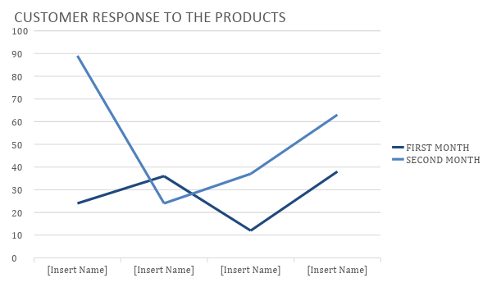

PRODUCT DELIVERIES

Product deliveries to the different retail stores also impact product performance. The graph below shows the frequency of deliveries to the different retail stores for the month of [INSERT MONTH].
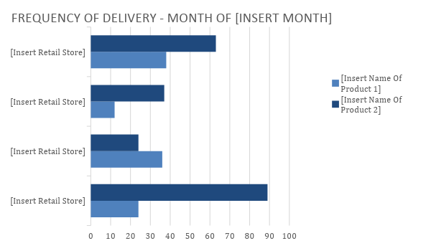

SOCIAL MEDIA RESPONSE

Using social media for marketing and advertising is one way of introducing products to the general public. The social media created for the products that were recently launched will help determine how many social media users know about the products. The graph below details consumer responses in social media:

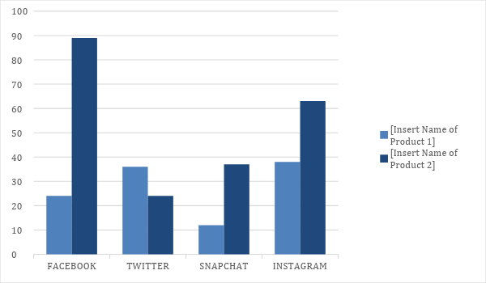
PLANNING AND STRATEGY

The chart lists down the activities under planning and strategy.

COURSES OF ACTION | DATE IMPLEMENTED | REMARKS/STATUS
[INSERT COURSES OF ACTION] | [INSERT DATE IMPLEMENTED] | [INSERT REMARKS/STATUS]

