MICROFINANCE BUSINESS
PLAN
[INSERT COMPANY NAME]
Business Plan for Fiscal Year [INSERT YEAR]
[INSERT DATE]

[Clara Mann]
[claramann@gmail.com]
[413-442-8174]
[www.mann&comicrofinancellc.com]
[54 North St, Pittsfield, MA 01201, USA]

INDEX

EXECUTIVE SUMMARY  COMPANY OVERVIEW  PRODUCTS AND SERVICES  EXECUTION  OPERATIONAL PLAN  FINANCIAL PLAN | [INSERT PAGE NO.]  [INSERT PAGE NO.]  [INSERT PAGE NO.]  [INSERT PAGE NO.]  [INSERT PAGE NO.]  [INSERT PAGE NO.]

EXECUTIVE SUMMARY

[MANN AND CO. MICROFINANCE LLC] is a microfinance bank based in [PITTSFIELD, MASSACHUSETTS]. The company offers premium quality financial services to small and mid-sized businesses. Although considered as an alternative for conventional banks, the company aims to support economic development through its services.

[MANN AND CO. MICROFINANCE LLC] will use email and social media marketing as well as search engine optimization [SEO] to reach a wider scope of its target market. The company anticipates increments in the number of clients with the current growing interest in microfinance services.

COMPANY OVERVIEW

Mission Statement: [MANN AND CO. MICROFINANCE LLC] contributes to the city’s economic development by providing financial solutions and support to micro and medium-scale enterprise growth.

Philosophy: [MANN AND CO. MICROFINANCE LLC] prioritizes the needs of its clients and serves them with honesty, integrity, and professionalism.

Vision: [MANN AND CO. MICROFINANCE LLC] wants to become the leading microfinance institution that provides business opportunities to entrepreneurs.

Outlook: The microfinance industry may still be young in the [US] but is steadily growing with the ongoing interest in alternative financial solutions. The company expects small to mid-sized businesses to consider microcredit financial services compared to other enterprises.

Type of Industry: Banking and Finance Industry

Business Structure: Limited Liability Company

Ownership: Limited Liability Company, [Clara Mann], [Joanne Mack], and [Michael Aiken]

Start-Up Summary: The board members of [MANN AND CO. MICROFINANCE LLC] contributed equally to generate a total start-up cost of [150K USD]. The funds are used to pay for rent, insurance, legal fees, and advertising costs.

Start-Up Funding
Start-Up Expenses | $64,550
Start-Up Assets | $85,450
Total Funding Required | $150,000
Assets
Non-Cash Assets from Start-Up | $56,450
Cash Requirements from Start-up | $9,000
Additional Cash Raised | $19,000
Cash Balance on Starting Date | $1,000
Total Assets | $85,450
Capital
Planned Investment
Owners | $150,000
Other | $0
Additional Investment Requirement | $0
Total Planned Investment | $150,000
Loss at Start-Up (Start-Up Expenses) | -$64,550
Total Capital | $85,450
Liabilities | $0
Total Capital and Liabilities | $85,450
Start-Up
Requirements
Start-Up Expenses
Rent - 6 Months | $2,550
Advertising | $2,000
Legal Fees | $3,000
Staff Training | $5,500
Insurance | $1,500
Other | $50,000
Total Start-Up Expenses | $64,550
Start-Up Assets
Cash Required | $10,000
Start-Up Inventory | $11,450
Other Current Assets | $19,000
Long-Term Assets | $45,000
Total Assets | $85,450
Total Requirements (Total Start-Up Expenses + Total Assets) | $150,000

Management Team:

Management Team | Role/Function | Skills
Michael Aiken | General Manager | Leadership, Team Management, Communication, Problem-Solving
Joanne Mack | Finance Manager | Attention to Detail, Analytical, Data Interpretation

Short- and Long-Term Goals and Milestones:

Short-Term Goals | Milestones
Hire competent employees for the company | Hired 2 new employees last November 1, 2018 to handle microcredit transactions
Tighten online market presence | Opened social media accounts to be closer to the target market
Long-Term Goals | Milestones
Open a branch in a different developing city | Scouted a strategic location in Boston
Retain valuable clients | Offered customer-centric financial solutions

PRODUCTS AND SERVICES

Product/Service Description: [MANN AND CO. MICROFINANCE LLC] offers savings and microcredit financial services to its clients who lack requirements to acquire approval for conventional business loans.

Value Proposition: [MANN AND CO. MICROFINANCE LLC] is a customer-centric company. The company supports an individual’s dream to start a business through the financial services it offers.

Pricing Strategy: [MANN AND CO. MICROFINANCE LLC] uses the penetration pricing method. The company offers microcredit at lower but still competitive interest rates. Finance charges are also lower than most existing microfinance companies in [Pittsfield, Massachusetts].

EXECUTION

Marketing Plan: [MANN AND CO. MICROFINANCE LLC] targets existing small to medium-scale enterprises having the potential for business growth. The company takes advantage of the Internet and plans to use online marketing strategies.

Market Research: The [US] has been rather late in adapting microfinance. Microfinance has been used by various states to boost the economic vitality of small to medium-scale enterprises. In this regard, the [US] microfinance movement also caters to the aforementioned businesses as they are also vital to the state’s economic development. Microfinance companies mostly target small to mid-sized businesses in steadily growing cities like [Pittsfield, Massachusetts].

SWOT Analysis | Strengths | Weaknesses | Opportunities | Threats
Mann and Co. Microfinance LLC | Offers customer-focused microcredit financial services | Limited market coverage | The growing interest of small businesses on microcredit financial solutions | Influence of established microfinance banks in Pittsfield
MA Microfinance Company | Recognized as one of the trusted microfinance banks in Massachusetts | High interest rates and finance charges |  | Increase in the number of microfinance banks that offer lower interest rates and finance charges
Pittsfield Microfinance Inc. | Ranks as the top microfinance bank in terms of customer service | Weak market presence | The advantages of adopting advanced technology in the form of mobile banking | Tight competition due to the increasing number of microfinance banks

Marketing Strategy: [MANN AND CO. MICROFINANCE LLC] will utilize email and social media marketing to promote its services. The company will also optimize its website through the help of an external [SEO] service provider. The following table sums up the activities needed to be accomplished and the success criteria for each.

Marketing Strategy | Activities | Timeline | Success Criteria
Email Marketing | Complete a final list of potential clients before sending the emails | January 10, 2019 | The company receives feedback from potential clients.
Social Media Marketing | Post about the company’s microcredit services on social media | ASAP | The company gains website visits and inquiries about its services.
SEO | Hire an SEO company to handle website optimization | January 25, 2019 | The company’s website tops the search list on various search engines.

Organizational Structure:

[MANN AND CO. MICROFINANCE LLC’S] corporate structure is headed by the board members with business owner Clara Mann. The board members decide the implementation of strategies and policies to boost the company’s growth and development. Among the board members, [Michael Aiken] and [Joanne Mack] assume managerial positions in the company.
OPERATIONAL PLAN

Location and Facilities:

[MANN AND CO. MICROFINANCE LLC] operates in an office space located in [54 North St, Pittsfield, MA 01201, USA]. The office has a typical ambiance of a financial institution.

Tools and Equipment Checklist:

Software | Quantity
Finance software | 3
Customer database system | 2
Hardware | Quantity
Computers | 5
Printers | 3

IT Infrastructure:

The following table reflects the IT infrastructure of Mann and Co. Microfinance LLC.

Infrastructure | Existing (Y/N) | Description
Social Media | Y | The company owns a Facebook and Twitter account.
Website | N | The company has no website yet.
Latency Proof | Y | The company has no recorded delays in network response and processing time.

FINANCIAL PLAN

Assumptions:

[MANN AND CO. MICROFINANCE LLC] considers the market trends and the past financial performance of similar companies in the preparation of its estimated financial statements. The financial assumptions are as follows:

- Tax compensation equals to 11.5% of the total compensation amount.
- The company expects an increase in sales from 15% to 20% in the next five years.

Monthly Expense:

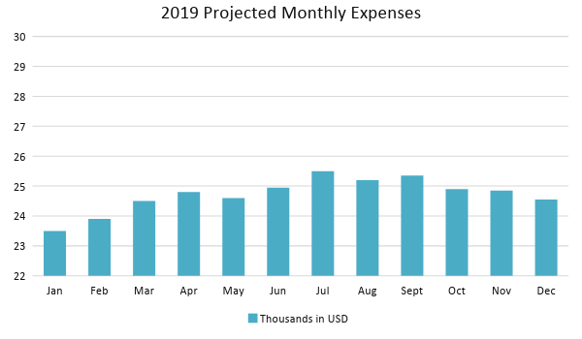
Monthly Revenue:

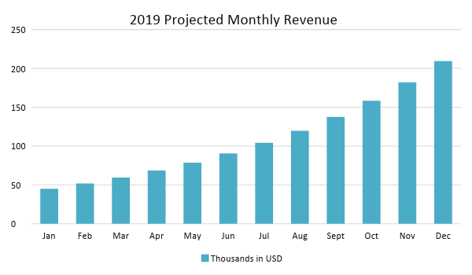

Business Financing:

[MANN AND CO. MICROFINANCE LLC] used equity financing to finance the business. The board members contributed a total of [150K USD] to purchase stocks for the company and fund its initial operating expenses.

Statements:

Profit and Loss Projection
 | FY2019 | FY2020 | FY2021
Sales | $250,000.00 | $300,000.00 | $360,000.00
Direct Cost of Sale | $75,000.00 | $90,000.00 | $108,000.00
Other Cost of Sale | $5,000.00 | $5,000.00 | $5,000.00
Total Cost of Goods Sold or COGS (Sales - Direct Cost of Sale - Other Cost of Sale) | $170,000.00 | $205,000.00 | $247,000.00
Gross Profit (Sales-Total Cost of Goods Sold) | $80,000.00 | $95,000.00 | $113,000.00
Gross Margin % (Gross Profit/Sales) | 32.00% | 31.67% | 31.39%
Operating Expenses
Rent | $5,100.00 | $5,100.00 | $5,100.00
Insurance | $5,000.00 | $5,000.00 | $5,000.00
Utilities | $7,000.00 | $7,000.00 | $7,000.00
Salary (Including Tax) | $40,000.00 | $40,000.00 | $40,000.00
Maintenance & Supplies | $3,000.00 | $3,000.00 | $3,000.00
Total Operating Expenses | $60,100.00 | $60,100.00 | $60,100.00
EBITDA (Total Cost of Sale-Total Operating Expenses) | $109,900.00 | $144,900.00 | $186,900.00
Depreciation | $150.00 | $150.00 | $150.00
Interest Expense | $0.00 | $0.00 | $0.00
Taxes Paid | $4,600.00 | $4,600.00 | $4,600.00
Net Profit (Gross Profit - Operating Expenses - Taxes - Interest) | $15,300.00 | $30,300.00 | $48,300.00

Balance Sheet Projection
 | FY2019 | FY2020 | FY2021
Cash | $20,900.00 | $45,875.00 | $87,721.25
Accounts Receivable | $20,000.00 | $24,000.00 | $28,800.00
Inventory | $25,000.00 | $25,375.00 | $25,755.63
Other Current Assets | $35,000.00 | $42,000.00 | $42,000.00
Total Current Assets | $100,900.00 | $137,250.00 | $184,276.88
Long-Term Assets | $70,000.00 | $70,000.00 | $70,000.00
Accumulated Depreciation | $150.00 | $300.00 | $450.00
Total Long-Term Assets (Long-Term Assets-Accumulated Depreciation) | $69,850.00 | $69,700.00 | $69,550.00
Total Assets (Total Current Assets + Total Long-Term Assets) | $170,750.00 | $206,950.00 | $253,826.88
Accounts Payable | $10,000.00 | $9,500.00 | $8,500.00
Notes Payable | $1,500.00 | $1,575.00 | $1,653.75
Other | $1,000.00 | $1,000.00 | $1,000.00
Total Liabilities | $12,500.00 | $12,075.00 | $11,153.75
Paid-in Capital | $150,000.00 | $150,000.00 | $150,000.00
Retained Earnings | $15,300.00 | $45,600.00 | $93,900.00
Total Owner's Equity (Total Assets - Total Liabilities) | $158,250.00 | $194,875.00 | $242,673.13
Total Liabilities & Equity (Total Liabilities/Total Owner's Equity) | 7.90% | 6.20% | 4.60%

Cash Flow Projection
 | FY2019 | FY2020 | FY2021
Operating Cash Beginning | $10,000.00 | $20,900.00 | $45,875.00
Sources of Cash | $3,500.00 | $4,200.00 | $5,040.00
Receivables | $20,000.00 | $24,000.00 | $28,800.00
Sales | $45,000.00 | $54,000.00 | $64,800.00
Others | $2,500.00 | $2,875.00 | $3,306.25
Total Cash | $81,000.00 | $105,975.00 | $147,821.25
Expenditures
Rent | $5,100.00 | $5,100.00 | $5,100.00
Insurance | $5,000.00 | $5,000.00 | $5,000.00
Utilities | $7,000.00 | $7,000.00 | $7,000.00
Salary (Including Tax) | $40,000.00 | $40,000.00 | $40,000.00
Maintenance & Supplies | $3,000.00 | $3,000.00 | $3,000.00
Total Expenditures | $60,100.00 | $60,100.00 | $60,100.00
Net Income/Loss (Total Cash - Total Expenditures) | $20,900.00 | $45,875.00 | $87,721.25

