[Casey’s Candies]
[2019 – 2020]

MASS
MARKETING PLAN

Index

Executive Summary | [PAGE NUMBER]
Company Overview | [PAGE NUMBER]
Products and Services | [PAGE NUMBER]
Marketing Analysis | [PAGE NUMBER]
Strategy and Implementation | [PAGE NUMBER]
Management and Personnel | [PAGE NUMBER]
Financial Plan | [PAGE NUMBER]

EXECUTIVE SUMMARY

[Casey’s Candies] is a neighborhood candy store based in [Tacoma, Washington], which recently secured an ideal location for its candy retailing business. Set to sell a wide range of sweet treats to kids and kids-at-heart, the company wants to announce its opening to everyone in [Tacoma].

The company will secure different mass marketing strategies to reach as much of the Tacoma population as possible. These strategies will include print advertisements, banners, and stand-up posters, as well as free-taste testing in malls and public areas with heavy foot traffic. In doing so, the company hopes to see a consistent increase in sales on a per-month basis.

COMPANY OVERVIEW

Mission Statement

[Casey’s Candies] aims to develop a profitable candy retail store with quality products for children and children-at-heart.

Philosophy

By showcasing excellent candies with unique flavors, [Casey’s Candies] is guaranteed to bring a smile to the customers’ faces.

Vision: [Casey’s Candies] wants its brand to be synonymous with excellent quality for all occasions.

Outlook

As part of the confectionery industry, candy retailers see a huge demand, especially during the holiday season. The global candy market industry has been valued at nearly $[80 billion] in [2018], with an expected compound annual growth rate of [3]% percent annually until [2023].

Type of Industry: Confectionery

Business Structure: Sole Proprietorship

Ownership: Sole Proprietorship, [Casey James]

Start-Up Summary

The owner will provide the necessary [$70,000] for start-up expenses. This will be used for the rent, equipment, supplies, and payroll for the first six months of operation.

Start-Up Funding
Expenses | $35,000
Assets | $35,000
Total Funding Required | $70,000
Assets
Non-Cash Assets | $20,000
Cash Requirements | $5,000
Additional Cash Raised | $7,000
Cash Balance on Starting Date | $3,000
Total Assets | $35,000
Capital
Planned Investment
Owner | $70,000
Other | $0
Additional Investment Requirement | $0
Total Planned Investment | $70,000
Loss | -$35,000
Total Capital | $35,000
Total Capital and Liabilities | $35,000
Start-Up
Requirements
Start-Up Expenses
Rent - 6 Months | $9,000
Advertising | $3,500
Legal Fees | $1,500
Staff Training | $20,000
Insurance | $1,000
Other | $0
Total Start-Up Expenses | $35,000
Start-Up Assets
Cash Required | $5,000
Inventory | $7,000
Other Current Assets | $3,000
Long-Term Assets | $20,000
Total Assets | $35,000
Total Requirements (Total Start-Up Expenses + Total Assets) | $70,000

PRODUCTS AND SERVICES

Product/Service Description

[Casey’s Candies] offers a variety of candy products with unique flavors that children and children-at-heart will love, including different types of the following:

- Hard candy
- Gum
- Chocolates
- Gummy Candies
- Mints
- Lollipops

Value Proposition

[Casey’s Candies] also offers candy products with unusual flavors, which make these products effective as a marketing strategy on their own. Flavors such as chili chocolate, lavender, and dragon fruit among others, set the candy store apart from its competitors.
Pricing Strategy

[Casey’s Candies] utilizes competitive pricing strategies to better penetrate the market in the first few months of operation.

MARKETING ANALYSIS

Candy retailing businesses are growing due to the increase in disposable income and the rise of urbanization in the United States. With the rising demand for candies and chocolates from children and adults alike, manufacturers have come up with different innovative solutions to take advantage of the highly competitive market. With the non-chocolate candy market recording a higher growth rate, a positive, steady increase in revenue is expected.

Market Segmentation

The United States is the biggest contributor to the candy market revenue. As a catch-all business, [Casey’s Candies] will take advantage of mass marketing strategies to reach a wide audience. In the application of its marketing strategies, the company will take into account age, gender, and socioeconomic status.

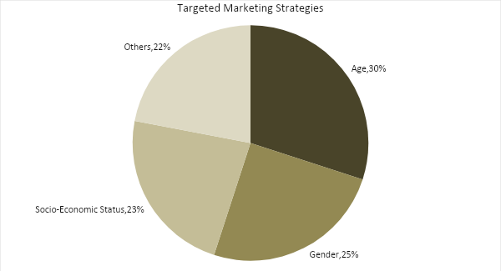

Target Market Segmentation Strategy

The company will differentiate its marketing strategies based on its target segmentation of age, gender, and socioeconomic status. The company will address its marketing needs through the following strategies:

Age - The Company will focus on children, as they are ones most likely to want to try different candy flavors. The company will attract children by providing them with free samples in malls.

Gender - Females are more likely to buy chocolates and sweets. Chocolates are targeted toward female consumers and/or their partners who like to buy sweets for them. The company can better attract these customers through product packaging with elegant, well-thought-out designs.

Socioeconomic Status - Premium candies and chocolates that are more expensive than their mass-produced counterparts are sold to those who have higher disposable income. These consumers love luxury, which is why products geared toward them will emphasize quality and premium status.

STRATEGY AND IMPLEMENTATION

Target Market Strategy

[Casey’s Candies] aims to increase its sales by [25]% in the second year. This can be accomplished by creating mass marketing campaigns that appeal to the majority of the population through a combination of print and online advertising, product sampling strategies, and product launching through mall events.

Competitive Edge

The company offers unique candies and flavors while adopting price bundling and competitive pricing to attract consumers.

SWOT Analysis | Strengths | Weaknesses | Opportunities | Threats
[Casey’s Candies] | Offers unusual candy flavors | New candy shop with limited finances for marketing | Distributors want to carry unique brands | Volatile cost of raw materials could limit sales
[Tacoma Candy Shop] | Established confectionery with good quality | Uses outdated technology, limiting production | New technologies improve production | Low-profit margins as ingredient prices increase
[Candyland] | Has a loyal customer base | Product quality needs improvement | E-Commerce opens the business to a broader customer base | Changing customer taste could be a problem for revenue

Sales Strategy and Forecast

With an aggressive mass marketing campaign, [Casey’s Candies] is targeting consistent increase in monthly sales, with the expected spikes in February (Valentines), April (Easter), October (Halloween), and December (Hanukkah and Christmas):

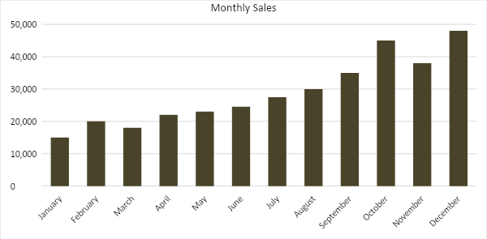

The chart below depicts the projected percentage growth in sales per candy type:

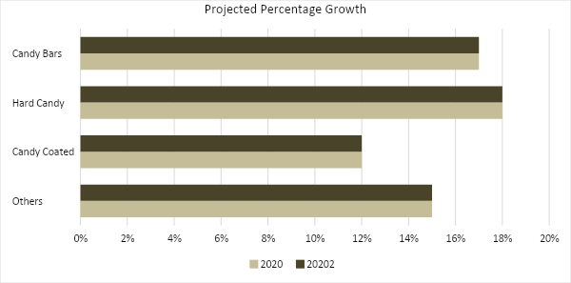
MARKETING STRATEGY

[Casey’s Candies] will utilize mass marketing strategies that will allow the company to reach as many people as possible, regardless of age, race, gender, or socioeconomic status. Product sampling shall also be made available in strategic areas. The company shall use the following marketing strategies:

Milestones

Marketing Strategy | Activities | Timeline | Success Criteria
Direct sales | Speak with convenience stores and supermarkets about selling Casey’s Candies | March 30, 2019 | At least three retail outlets will sell [Casey’s Candies] in their stores, restocking at least every month
Mass marketing through product sampling | Hire product endorsers to share products for taste testing in large areas such as malls, parks, bowling alleys, or during community events | April 5, 2019 | Increased sales by at least [45]% on weekends when product sampling is hosted
Online marketing | Create and update company website to showcase the products | ASAP | At least [10,000] website views in three months, and increased online sales by at least [15]% every month

Management and Personnel

A small mom-and-pop shop with specialized products, the store will be managed by its owner.

Owner
Food production
In-Store Staff
Security

FINANCIAL PLAN

The financial plan includes the projected break-even analysis, profit and loss, balance sheet, and cash flow.

Break-Even Analysis

Fixed Costs | Average Price |  | Variable Costs |  | Contribution Margin | Break-Even Units
$10,000.00 | $7.00 |  | $2.00 |  | $5.00 | 2,000.00
Fixed Costs |  | Amount |  | Variable Costs |  | Per Unit Amount
Rent |  | 9,000 |  | Advertising |  | 0.57
Insurance |  | 1,000 |  | Legal Fees |  | 1.33
 |  |  |  | Staff Training |  | 0.1
Total |  | 10,000 |  | Total |  | 2

Fixed Costs |  | Variable Costs
Business Lease - Rent |  | $9,000
Insurance |  | $1,000
Total Fixed Costs |  | $10,000
Total Units Sold in 1 Month |  | 2,000
Variable Costs (Unit Sold/Cost per Unit) | Average Price | Variable Costs
Advertising | $3,500 | $0.57
Legal Fees | $1,500 | $1.33
Staff Training | $20,000 | $0.10
Total Variable Cost (Per Unit) |  | $2.00
Break-Even
Selling Price Per Unit |  | $7.00
Break-Even Point Per Unit [Fixed Costs/(Sales Price Per Unit - Variable Cost Per Unit)] |  | 10,000
 |  | 5.00
Break-Even Point in Units |  | 2,000
Contribution Margin (Selling Price - Total Variable Cost) |  | $5.00

Profit and Loss Projection
 | FY2019 | FY2020 | FY2021
Sales | $350,000.00 | $400,000.00 | $500,000.00
Direct Cost of Sale | $320,000.00 | $370,000.00 | $470,000.00
Other Cost of Sale | $10,000.00 | $13,000.00 | $15,500.00
Total Cost of Goods Sold or COGS (Sales - Direct Cost of Sale - Other Cost of Sale) | $20,000.00 | $17,000.00 | $14,500.00
Gross Profit (Sales-Total Cost of Goods Sold) | $330,000.00 | $383,000.00 | $485,500.00
Gross Margin % (Gross Profit/Sales) | 94.29% | 95.75% | 97.10%
Operating Expenses
Rent | $18,000.00 | $18,000.00 | $18,000.00
Advertising | $7,000.00 | $7,000.00 | $7,000.00
Legal Fees | $1,500.00 | $1,500.00 | $1,500.00
Salary (With Tax) | $40,000.00 | $45,000.00 | $50,000.00
Other | $3,000.00 | $3,250.00 | $4,000.00
Total Operating Expenses | $69,500.00 | $74,750.00 | $80,500.00
EBITDA (Total Cost of Sale-Total Operating Expenses) | -$49,500.00 | -$57,750.00 | -$66,000.00
Depreciation | $4,000.00 | $4,000.00 | $4,000.00
Interest Expense | $0.00 | $0.00 | $0.00
Taxes Paid | $4,000.00 | $5,000.00 | $6,000.00
Net Profit (Gross Profit - Operating Expenses - Taxes - Interest) | $256,500.00 | $303,250.00 | $399,000.00

Balance Sheet Projection
 | FY2019 | FY2020 | FY2021
Cash | $10,000.00 | $15,000.00 | $18,000.00
Accounts Receivable | $5,000.00 | $15,000.00 | $17,000.00
Inventory | $3,000.00 | $5,000.00 | $6,000.00
Other Current Assets | $5,000.00 | $5,500.00 | $6,300.00
Total Current Assets | $23,000.00 | $40,500.00 | $47,300.00
Long-Term Assets | $12,000.00 | $7,000.00 | $6,000.00
Accumulated Depreciation | $1,200.00 | $800.00 | $500.00
Total Long-Term Assets (Long-Term Assets-Accumulated Depreciation) | $10,800.00 | $6,200.00 | $5,500.00
Total Assets (Total Current Assets + Total Long-Term Assets) | $33,800.00 | $46,700.00 | $52,800.00
Accounts Payable | $10,000.00 | $12,000.00 | $15,000.00
Notes Payable | $5,000.00 | $6,000.00 | $8,000.00
Other | $3,500.00 | $7,000.00 | $5,000.00
Total Liabilities | $18,500.00 | $25,000.00 | $28,000.00
Paid-in Capital | $5,000.00 | $5,000.00 | $5,000.00
Retained Earnings | $256,500.00 | $303,250.00 | $399,000.00
Total Owner's Equity (Total Assets - Total Liabilities) | $15,300.00 | $21,700.00 | $24,800.00
Total Liabilities & Equity (Total Liabilities/Total Owner's Equity) | 120.92% | 115.21% | 112.90%

Cash Flow Projection
 | FY2019 | FY2020 | FY2021
Operating Cash Beginning | $20,000.00 | $482,000.00 | $975,250.00
Sources of Cash | $5,000.00 | $7,000.00 | $10,000.00
Receivables | $7,000.00 | $5,000.00 | $7,500.00
Sales | $350,000.00 | $400,000.00 | $500,000.00
Others | $5,000.00 | $7,000.00 | $8,000.00
Total Cash | $387,000.00 | $901,000.00 | $1,500,750.00
Expenditures
Rent | $18,000.00 | $18,000.00 | $18,000.00
Advertising | $7,000.00 | $7,000.00 | $7,000.00
Legal Fees | $1,500.00 | $1,500.00 | $1,500.00
Salary (With Tax) | $40,000.00 | $45,000.00 | $50,000.00
Other | $3,000.00 | $3,250.00 | $4,000.00
Total Expenditures | $69,500.00 | $74,750.00 | $80,500.00
Net Income/Loss (Total Cash - Total Expenditures) | $317,500.00 | $826,250.00 | $1,420,250.00

