MARKETING

AGENCY MARKETING PLAN

[Publicis Marketing Group]
[2019 – 2020]

Index

Executive Summary | [PAGE NUMBER]
Company Overview | [PAGE NUMBER]
Products and Services | [PAGE NUMBER]
Marketing Analysis | [PAGE NUMBER]
Strategy and Implementation | [PAGE NUMBER]
Management and Personnel | [PAGE NUMBER]
Financial Plan | [PAGE NUMBER]

EXECUTIVE SUMMARY

[Publicis Marketing Group] is an established marketing agency that offers services for companies looking to increase their own marketing programs. [Publicis Marketing Group] offers different strategies that include print and broadcast marketing, email, event, networking, and social media.

The increasing number of businesses in [Seattle, Washington] offers a lot of room for [Publicis Marketing Group] to hone their marketing services to better serve a growing list of old and new companies alike that are in need of better marketing strategies to maximize their client reach.

COMPANY OVERVIEW

Mission Statement

[Publicis Marketing Group] focuses on branding, marketing, and public relations solutions for growing business ventures in Seattle.

Philosophy

[Publicis Marketing Group] promises effective marketing strategies for the success of its clients’ business.

Vision

[Publicis Marketing Group] will be the leading marketing agency in [Seattle] in the next [10] years.

Outlook

Marketing and advertising agencies have seen a massive increase in revenue since [2016], and this trend is expected to continue in the next [three] years as social media networks have developed their own advertising strategies, which have significantly helped increase profit margins in [2018].

Type of Industry: Marketing Industry

Business Structure: Partnership

Ownership: Partnership, [Spencer Marin] and [Hannah Fields]

Marketing Summary

[Publicis Marketing Group] put up $[50,000] USD. This amount shall be provided by the owners and will be used for maintenance and renovation, equipment, supplies, and payroll.

Start-Up Funding
Expenses | $25,000
Assets | $25,000
Total Funding Required | $50,000
Assets
Non-Cash Assets | $10,000
Cash Requirements | $5,000
Additional Cash Raised | $7,000
Cash Balance on Starting Date | $3,000
Total Assets | $25,000
Capital
Planned Investment
Owner | $50,000
Other | $0
Additional Investment Requirement | $0
Total Planned Investment | $50,000
Loss | -$25,000
Total Capital | $25,000
Total Capital and Liabilities | $25,000
Start-Up
Requirements
Marketing Expenses
Deliverables | $12,000
Advertising | $3,000
Legal Fees | $1,000
Hardware | $6,000
Insurance | $1,000
Other | $2,000
Total Start-Up Expenses | $25,000
Start-Up Assets
Cash Required | $5,000
Inventory | $3,000
Other Current Assets | $5,000
Long-Term Assets | $12,000
Total Assets | $25,000
Total Requirements (Total Start-Up Expenses + Total Assets) | $50,000

PRODUCTS AND SERVICES

Product/Service Description

[Publicis Marketing Group] handles the marketing efforts of its clients, offering the following services:

- Print Advertising
- Broadcast Advertising
- Online Advertising
- Marketing Campaigns
- Public Relations

Value Proposition

With the help of [Publicis Marketing Group], entrepreneurs can better define their business ventures with the help of professional and innovative marketing services.

Pricing Strategy

[Publicis Marketing Group] uses a blended rate and time estimate pricing strategy, which covers specialist fees at every level. Clients may contact the company to ask for price quotes, which depend on the amount of work and deliverables they want to be produced.

MARKETING ANALYSIS

The marketing industry continues to grow as more and more businesses open in [Seattle]. These businesses are especially interested in the rates and quality of service and deliverables offered by [Publicis Marketing Group], thus, the company is looking to expand its clientele.

Market Segmentation

The continued growth of the US economy reflects positively on the marketing sector as new business ventures find the need to reach their target markets in a highly competitive corporate environment. [Publicis Marketing Group] sees steady positive growth in its revenue by serving different business segments.

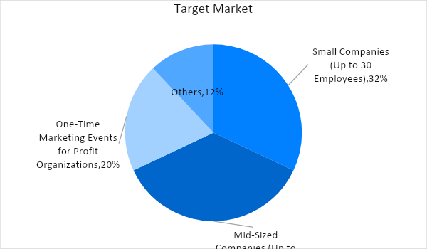

Target Market Segmentation Strategy

Small companies (Up to 30 employees)

- Focus on social media strategies (Facebook and Instagram) for minimum cost with maximum reach
- Connect small companies with business expos related to client industry, if applicable

Mid-sized companies (Up to 100 employees)

- Announce new products or services through a press release or as a newspaper or magazine feature
- Produce marketing events that focus on the client’s products, for instance, product launches, fashion shows, and other related strategies.

STRATEGY AND IMPLEMENTATION

Target Market Strategy

[Publicis Marketing Group] aims to increase its sales by [20]%. To accomplish this feat, the agency needs to gain more clients by directly approaching new business ventures. It will also encourage more spending from its current roster by providing more services and focusing on customer satisfaction.

Competitive Edge

[Publicis Marketing Group] offers highly effective marketing strategies for new business ventures and established companies alike at a lower price compared to the industry standard.

SWOT Analysis | Strengths | Weaknesses | Opportunities | Threats
[Publicis Marketing Group] | Good record with consistently high customer service rating |  | Number of businesses opening every year opens market opportunities | Barriers to entry remain low, with increasing competition
[AB Marketing and Events] | An extensive list of loyal clients |  | Focus on marketing trends prove effective for revenue
[Ross-Paulson Advertising] | Experienced in the marketing industry |  |  | Economic changes could prove problematic

Sales Strategy and Forecast

The company is aiming to reach the following monthly sales:

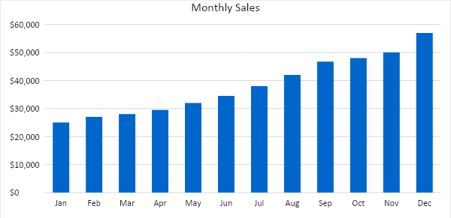

With a more aggressive marketing campaign and client acquisition strategy, [Publicis Marketing Group] expects the following percentage growth in two years:

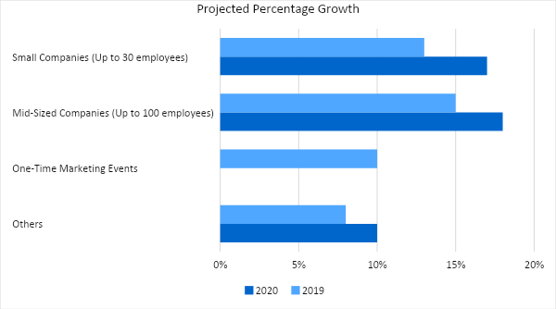

Marketing Strategy

By focusing on small and mid-sized businesses, [Publicis Marketing Group] opens itself to a large client base. To gain higher profits this year, the company will focus on targeted customer acquisition strategies and directly speak with decision-makers to expand its client base.
Milestones

Marketing Strategy | Activities | Timeline | Success Criteria
Website upgrade | Update and upgrade the website for better customer navigation | March 1, 2019 | - More online inquiries  - Increased blog hits  - Better visitor ratio
Customer acquisitions | Meet with business contacts to discuss marketing offers and strategies | ASAP | - Positive responses from company decision-makers  - Gain at least 10 new clients on a retainer basis
Networking | Keep in contact with government and private agencies | ASAP | - Increased client referrals, with at least 30% positive responses

MANAGEMENT AND PERSONNEL

[Publicis Marketing Group] has a basic organizational structure where the HR Manager and Marketing Executive report to the Operations Manager. In turn, the Operations Manager and the Financial Officer report directly to the Managing Partner of the agency. The organizational structure is shown below:

CEO
Operations Manager
Financial Officer
HR Manager
Marketing Executive
HR Assistant
Video
Graphics
Events Team

FINANCIAL PLAN

Below is the financial plan of the [Publicis Marketing Group]. The statements include the projected break-even analysis, profit and loss, balance sheet, and cash flow.

Break-Even Analysis

Fixed Costs | Average Price |  | Variable Costs |  | Contribution Margin | Break-Even Units
$22,000.00 | $1,000.00 |  | $4.00 |  | $996.00 | 22
Fixed Costs |  | Amount |  | Variable Costs |  | Per Unit Amount
Deliverables |  | 12,000 |  | Production Costs |  | 2
Insurance |  | 1,000 |  | Utilities |  | 2
Legal Fees |  | 1,000
Others |  | 8,000
Total |  | 22,000 |  | Total |  | 4

Fixed Costs |  | Variable Costs
Deliverables |  | 12,000
Insurance |  | 1,000
Legal Fees |  | 1,000
Others |  | 8,000
Total Fixed Costs |  | $22,000
Total Sold in 1 Month |  | 6,000
Variable Costs (Unit Sold/Cost per Unit) | Average Price | Variable Costs
Production Costs | $3,000 | $2.00
Utility Costs | $3,000 | $2.00
Total Variable Cost (Per Unit) |  | $4.00
Break-Even
Selling Price Per Unit |  | $1,000.00
Break-Even Point Per Unit [Fixed Costs/(Sales Price Per Unit - Variable Cost Per Unit)] |  | 20,000
 |  | 996.00
Break-Even Point in Units |  | 20
Contribution Margin (Selling Price - Total Variable Cost) |  | $996.00

Profit and Loss Projection
 | FY2019 | FY2020 | FY2021
Sales | $460,000.00 | $500,000.00 | $600,000.00
Direct Cost of Sale | $430,000.00 | $470,000.00 | $540,000.00
Other Cost of Sale | $10,000.00 | $13,000.00 | $15,500.00
Total Cost of Goods Sold or COGS (Sales - Direct Cost of Sale - Other Cost of Sale) | $20,000.00 | $17,000.00 | $44,500.00
Gross Profit (Sales-Total Cost of Goods Sold) | $440,000.00 | $483,000.00 | $555,500.00
Gross Margin % (Gross Profit/Sales) | 95.65% | 96.60% | 92.58%
Operating Expenses
Deliverables | $12,000.00 | $15,000.00 | $16,500.00
Advertising | $3,000.00 | $3,500.00 | $4,000.00
Legal Fees | $1,000.00 | $1,250.00 | $1,300.00
Hardware | $6,000.00 | $4,000.00 | $5,000.00
Other | $3,000.00 | $2,000.00 | $4,500.00
Total Operating Expenses | $25,000.00 | $25,750.00 | $31,300.00
EBITDA (Total Cost of Sale-Total Operating Expenses) | -$5,000.00 | -$8,750.00 | $13,200.00
Depreciation | $4,000.00 | $4,000.00 | $4,000.00
Interest Expense | $0.00 | $0.00 | $0.00
Taxes Paid | $4,000.00 | $5,000.00 | $6,000.00
Net Profit (Gross Profit - Operating Expenses - Taxes - Interest) | $411,000.00 | $452,250.00 | $518,200.00

Balance Sheet Projection
 | FY2019 | FY2020 | FY2021
Cash | $5,000.00 | $6,500.00 | $70,000.00
Accounts Receivable | $5,000.00 | $15,000.00 | $17,000.00
Inventory | $3,000.00 | $5,000.00 | $6,000.00
Other Current Assets | $5,000.00 | $5,500.00 | $6,300.00
Total Current Assets | $18,000.00 | $32,000.00 | $99,300.00
Long-Term Assets | $12,000.00 | $7,000.00 | $6,000.00
Accumulated Depreciation | $1,200.00 | $800.00 | $500.00
Total Long-Term Assets (Long-Term Assets-Accumulated Depreciation) | $10,800.00 | $6,200.00 | $5,500.00
Total Assets (Total Current Assets + Total Long-Term Assets) | $28,800.00 | $38,200.00 | $104,800.00
Accounts Payable | $10,000.00 | $12,000.00 | $15,000.00
Notes Payable | $5,000.00 | $6,000.00 | $8,000.00
Other | $3,500.00 | $7,000.00 | $5,000.00
Total Liabilities | $18,500.00 | $25,000.00 | $28,000.00
Paid-in Capital | $5,000.00 | $5,000.00 | $5,000.00
Retained Earnings | $126,000.00 | $142,000.00 | $148,000.00
Total Owner's Equity (Total Assets - Total Liabilities) | $10,300.00 | $13,200.00 | $76,800.00
Total Liabilities & Equity (Total Liabilities/Total Owner's Equity) | 179.61% | 189.39% | 36.46%

Cash Flow Projection
 | FY2019 | FY2020 | FY2021
Operating Cash Beginning | $30,000.00 | $482,000.00 | $975,250.00
Sources of Cash | $5,000.00 | $7,000.00 | $10,000.00
Receivables | $7,000.00 | $5,000.00 | $7,500.00
Sales | $460,000.00 | $500,000.00 | $600,000.00
Others | $5,000.00 | $7,000.00 | $8,000.00
Total Cash | $507,000.00 | $1,001,000.00 | $1,600,750.00
Expenditures
Deliverables | $12,000.00 | $15,000.00 | $16,500.00
Advertising | $3,000.00 | $3,500.00 | $4,000.00
Legal Fees | $1,000.00 | $1,250.00 | $1,300.00
Hardware | $6,000.00 | $4,000.00 | $5,000.00
Other | $3,000.00 | $2,000.00 | $4,500.00
Total Expenditures | $25,000.00 | $25,750.00 | $31,300.00
Net Income/Loss (Total Cash - Total Expenditures) | $482,000.00 | $975,250.00 | $1,569,450.00

