INTERIOR DESIGN BUSINESS PLAN

[INSERT DATE]
[INSERT COMPANY NAME]
[INSERT COMPLETE ADDRESS]
[INSERT CONTACT DETAIL]

TABLE OF CONTENTS

- EXECUTIVE SUMMARY

- OBJECTIVES

- PRIMARY KEYS TO SUCCESS

- BUSINESS OWNERSHIP

  - LOCATIONS & FACILITIES

  - PRODUCTS & SERVICES

- MARKET ANALYSIS

- MARKET SEGMENTATION

  - GEOGRAPHICS

  - DEMOGRAPHICS

  - PSYCHOGRAPHICS

- MARKET STRATEGY

- MARKET GROWTH

- BUSINESS BUDGET ANALYSIS

- BUSINESS COMPETITORS

    - EXECUTIVE SUMMARY

[ADD COMPANY NAME] will be one of the leading interior design companies in [ADD CITY/STATE]. The company is a proposed undertaking made by [ADD NAME] and [ADD NAME] under [ADD DETAILS]. [ADD COMPANY NAME] will provide comprehensive and topnotch interior design services for residential homes, commercial buildings, and offices in [ADD CITY/STATE] area. Moreover, [ADD COMPANY NAME] will provide clients a wide access to different interior products that will complement the design services. The services include furniture build-up (both antique and new), decorator fabric, and various amazing selections of home and office embellishments. This is in addition to the fact that [ADD COMPANY NAME] offers customized services that the target market wants that is highly economical. It offers services that are indeed one-of-a-kind from concept to application.

As per market research, [ADD YEAR] shows the increased demand and need for interior design consulting services as well as products, hence [ADD COMPANY NAME] provides all these needs under one roof. The marketing strategy will focus on a cost effective approach when it comes to defining the target market. In promoting and advertising [ADD COMPANY NAME] effectively, the [ADD TEAM NAME] team will handle the promotion by means of establishing great relationship with the target people in [ADD CITY/STATE], [ADD MORE DETAIL], [ADD MORE DETAIL], and [ADD MORE DETAIL]. [ADD COMPANY NAME] will focus more on developing loyal client relationship especially when it comes to providing design solutions. [ADD COMPANY NAME] ensures great product accessibility, services for design, and reasonable service and product costs. This what makes [ADD COMPANY NAME] a noteworthy interior design company in the market.

An expected amount, more or less, of [ADD AMOUNT] will be projected in the first year of operation. As per [ADD NAME], [ADD JOB TITLE] of [ADD COMPANY NAME], the business revenue will increase in [ADD YEAR] and [ADD YEAR]. Additionally, the profit tends to increase to almost [ADD AMOUNT] for the year [ADD YEAR]. This business plan for [ADD COMPANY NAME], shows the implementation of the company’s development and success in the first [ADD HOW MANY YEARS] of undertaking.

    - OBJECTIVES

[ADD COMPANY NAME] will reach an estimated amount of [ADD VALUE] of sales during the first year, [ADD VALUE] on the second, and [ADD VALUE] on the third.
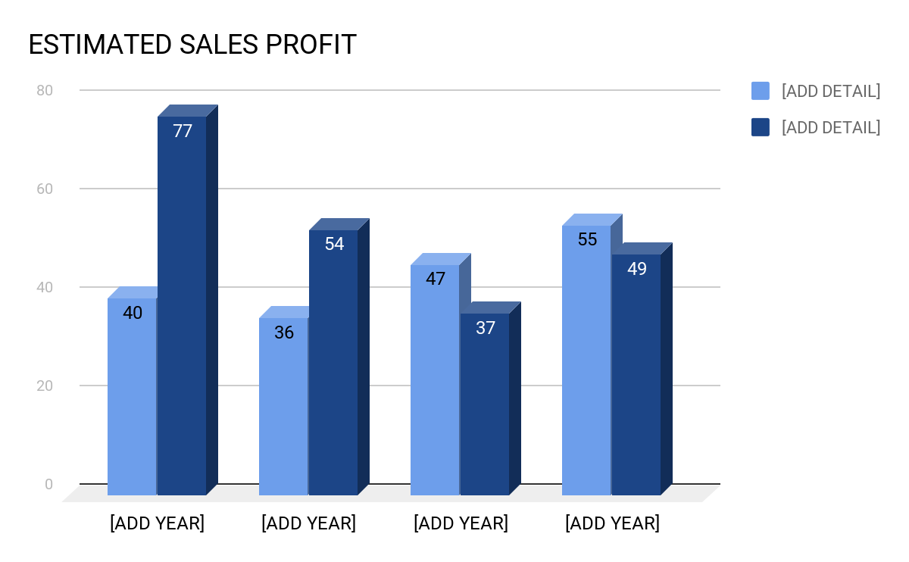

Estimated Sales Profit
 | [ADD YEAR] | [ADD YEAR] | [ADD YEAR]
[INSERT DESCRIPTION] | [ADD DETAIL] | [ADD DETAIL] | [ADD DETAIL]
[INSERT DESCRIPTION] | [ADD DETAIL] | [ADD DETAIL] | [ADD DETAIL]
[INSERT DESCRIPTION] | [ADD DETAIL] | [ADD DETAIL] | [ADD DETAIL]

[ADD COMPANY NAME] will generate an average [ADD PERCENTAGE VALUE] of business revenues from different products and services rendered. [ADD DEPARTMENT] will keep track regarding details for commercial revenue that has a total of [ADD PERCENTAGE VALUE] overall revenues.

Mission

[ADD COMPANY NAME] is an interior design consulting service intended for clients who are keen on quality and details of their design selections, especially when it comes to designs for residences, vacation homes, and commercial establishments. This one-of-a-kind experience provides clients their attention through the entire design process. Also, it provides resources and materials for design to clients by means of special purchases that include [ADD DETAIL], [ADD DETAIL], [ADD DETAIL], and [ADD DETAIL]. [ADD COMPANY NAME] wants their clients to experience premium home and business layout transformation for a more unique and customized experience like no other.
    - PRIMARY KEYS TO SUCCESS

[ADD COMPANY NAME]’s primary keys to success are the following:

- [ADD COMPANY NAME] ensures to provide excellent service quality in order to retain clients. This will then generate repeat purchase process that will be beneficial to the business.

- [ADD COMPANY NAME] makes sure to sell topnotch selected items to clients. This is one of the great ways to further meet the client’s interior design desires.

- Provide proper communication towards clients based through the website [ADD WEBSITE] and other forms of proper and convenient communication styles.

- [ADD COMPANY NAME] will always provide nothing but the highest premium quality for interior design consulting services in the market.

[ADD COMPANY NAME] Summary

[ADD COMPANY NAME] is a [ADD COMPLETE COMPANY DETAILS] that will provide complete and excellent interior design services for both residential and commercial structures. [ADD COMPANY NAME] specializes in facilitating and developing basic to complex design concept of their project to their clients who don’t have any background in terms of interior design. Moreover, [ADD COMPANY NAME] provides their clients new and antique furniture, embellishment, artwork, and accessories. Clients can further check their products and services through their website [ADD WEBSITE]. This can also be used in communicating services that are readily available. The website also contains [ADD COMPANY NAME]’s complete portfolio of their works. [ADD COMPANY NAME] will first start as a [ADD DETAILS] and is expected to remain the way it is for at least [ADD SPECIFIC YEARS].

    - BUSINESS OWNERSHIP

In terms of location, [ADD COMPANY NAME] is located in [ADD COMPLETE ADDRESS] and is registered as [INSERT TYPE OF BUSINESS]. The company is owned and managed by [ADD COMPLETE NAME].

- Locations and Facilities

[ADD COMPANY NAME] is managed by [ADD NAME] in [ADD COMPLETE ADDRESS]. The structure is designed to provide assistance to a work area, business establishments, and will also showcase some of their design concepts, materials, and accomplished work.

- Products and Services

[ADD COMPANY NAME] focuses in providing premium interior design products and services. This will be integrated by [ADD DETAIL], [ADD DETAIL], [ADD DETAIL], [ADD DETAIL], [ADD DETAIL], and [ADD DETAIL]. When it comes to the sales and marketing process, [ADD COMPANY NAME] will start with interior design consulting services, then later on advance to offering compelling elements that will suffice the design layout. Below are some products that [ADD COMPANY NAME] offers and are readily available to clients.

  - Premium furniture quality available for purchase through special arrangements with [ADD SHOP NAME], [ADD SHOP NAME], [ADD SHOP NAME], and [ADD SHOP NAME].

  - An exquisite collection of drapery hardware referred to as “[ADD TERM]” that can be purchased through [ADD SHOP NAME] at [ADD LOCATION], with their website [ADD WEBSITE NAME].

  - An amazing and stunning selection of embellishments from [ADD DESIGNER NAME], [ADD DESIGNER NAME], [ADD DESIGNER NAME], and [ADD DESIGNER NAME].

  - Different window coverings that are also available at [ADD SHOP NAME] located in [ADD LOCATION].

  - Wide variety of “polywood” for interior shutters. This item is also available at [ADD SHOP NAME] at [ADD LOCATION].

  - Special antiques that are only available through direct purchase and arrangement. Check out [ADD WEBSITE] for images and samples.

Below are details regarding our main key points of quality differentiation:

- [ADD COMPANY NAME] set of interior designers are all trained and professional in their areas of expertise. These people are capable of meeting the needs of our insightful clients with high standard of expectations. This will serve as a unique experience towards our clients.

- [ADD COMPANY NAME] provides unlimited access to our unique and wide variety collection of [ADD DETAIL], [ADD DETAIL], [ADD DETAIL], and [ADD DETAIL].

- [ADD COMPANY NAME] provides 1:1 ratio client assistance in terms of product or service offering that includes [ADD DETAIL], [ADD DETAIL], [ADD DETAIL], [ADD DETAIL], and [ADD DETAIL].

Competitive Market Comparison

[ADD COMPANY BUSINESS NAME]’s major competition is primarily other interior design shops in [ADD CITY/STATE] and other neighboring cities. Additionally, for DIY (Do It Yourself) design aspects, [ADD COMPANY NAME] provides a wide variety of selection for materials and other equipment that comes with complete guide and tutorial.

The following are some of our major competitors in [ADD CITY/STATE] wherein we at [ADD COMPANY NAME] will do our utmost best to transcend these companies for interior design.

- [ADD COMPETITOR’S NAME] moved into the interior design company in the year [ADD YEAR] at [ADD LOCATION]. This company provides superb services and offers outstanding interior designs.

- [ADD COMPETITOR’S NAME] continues to be a strong and competitive force together with [ADD NAME OF COMPANY], [ADD NAME OF COMPANY], [ADD NAME OF COMPANY], and [ADD NAME OF COMPANY].

- [ADD COMPETITOR’S NAME] continues to make topnotch designs since [ADD YEAR]. Located in the heart of [ADD CITY/STATE] and home of various antique furniture’s and accessories.

    - MARKET ANALYSIS

The basis for [ADD COMPANY NAME] business construction is its construed target market. The target market consists of both residential and commercial clients in [ADD CITY/STATE]. It also includes [ADD DETAIL], [ADD DETAIL], and [ADD DETAIL]. The market should be identical and this is based on various roles for each market element.

When talking about compelling market strategy, there should be an optimal offering and promoting of products and services. This is one critical move that [ADD COMPANY NAME] should focus and prioritize since this is an identification of the company’s success and future expediency. [ADD COMPANY NAME] must possess concrete information regarding the market’s background and should know what are the common elements of soon-to-be loyal clients. [ADD COMPANY NAME] should understand these details for them to know the people they will soon serve, meeting their certain needs, and ways on how to properly interact and communicate with them.

    - MARKET SEGMENTATION

Regarding [ADD COMPANY NAME]’s client profile, it consists of the following details:

- Geographic

The geographic market of [ADD COMPANY NAME] will be the well-to-do group of clients residing within [ADD CITY/STATE]. It has an estimated population of [ADD VALUE], this is based on the census data of [ADD ORGANIZATION]. A [ADD MILE VALUE] geographic area will be in need of products and services offered by [ADD COMPANY NAME] for their interior design needs.

- Demographics

Sample population demographics of [ADD CITY/STATE] in the year [INSERT SPECIFIC YEAR]. This data will determine [ADD COMPANY NAME]’s effective marketing strategy for great business revenue.
Sample Table I:

Sample Demographics (I)
Gender | With/without children | Married/Single | Age | With/without residential home
[ADD DETAIL] | [ADD DETAIL] | [ADD DETAIL] | [ADD DETAIL] | [ADD DETAIL]
[ADD DETAIL] | [ADD DETAIL] | [ADD DETAIL] | [ADD DETAIL] | [ADD DETAIL]
[ADD DETAIL] | [ADD DETAIL] | [ADD DETAIL] | [ADD DETAIL] | [ADD DETAIL]
[ADD DETAIL] | [ADD DETAIL] | [ADD DETAIL] | [ADD DETAIL] | [ADD DETAIL]

Sample Table II:

Sample Demographics (II)
Married | Working Professionals | Completed College | Ages [ADD VALUE] to [ADD VALUE] | Have lived in the area for [ADD YEAR]
[ADD PERCENTAGE VALUE] | [ADD PERCENTAGE VALUE] | [ADD PERCENTAGE VALUE] | [ADD PERCENTAGE VALUE] | [ADD PERCENTAGE VALUE]
[ADD PERCENTAGE VALUE] | [ADD PERCENTAGE VALUE] | [ADD PERCENTAGE VALUE] | [ADD PERCENTAGE VALUE] | [ADD PERCENTAGE VALUE]
[ADD PERCENTAGE VALUE] | [ADD PERCENTAGE VALUE] | [ADD PERCENTAGE VALUE] | [ADD PERCENTAGE VALUE] | [ADD PERCENTAGE VALUE]
[ADD PERCENTAGE VALUE] | [ADD PERCENTAGE VALUE] | [ADD PERCENTAGE VALUE] | [ADD PERCENTAGE VALUE] | [ADD PERCENTAGE VALUE]

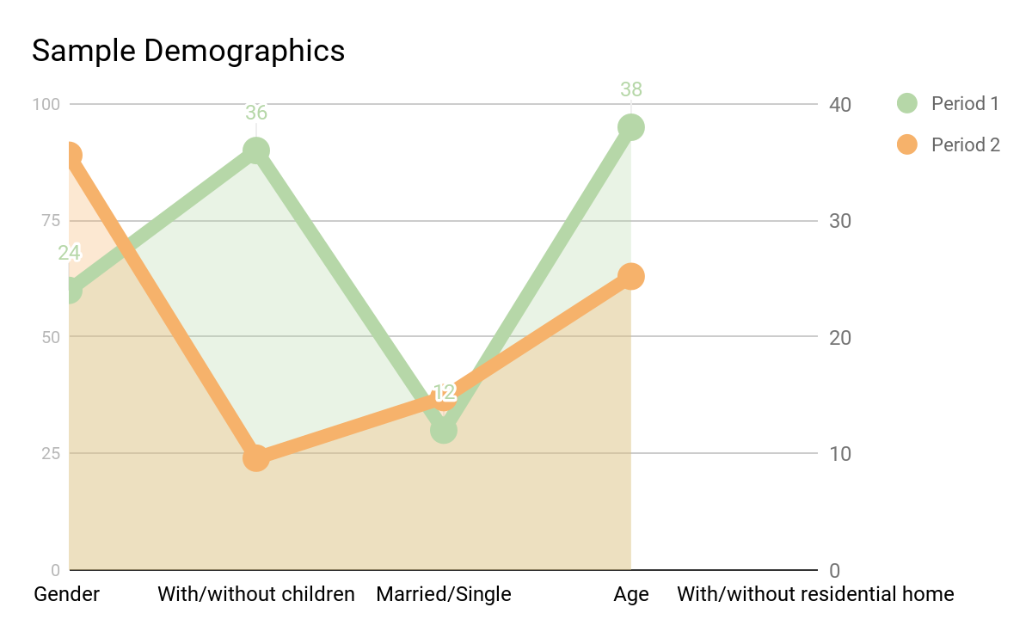

- Psychographics

One thing that makes [ADD COMPANY NAME] outstanding is the ability to provide its clients the opportunity to craft a structure environment that will help them convey who they are by means of stunning interior art design. These clients look for design assistance and resources that will help them in achieving their desired interior design for their respective spaces (residential or commercial). These people want their place to be more unique and creative as it displays a meaningful message about them. [ADD COMPANY NAME] will make certain to provide these benefits to clients and help them in fulfilling their design goal.

    - MARKET STRATEGY

[ADD COMPANY NAME]’s marketing strategy will surely create effective public recognition and interest from their target market. There will be [ADD HOW MANY SECTIONS] sections of target market that [ADD COMPANY NAME] caters, these are [ADD DETAIL], [ADD DETAIL], [ADD DETAIL], and [ADD DETAIL]. [ADD COMPANY NAME] will offer readily available and well defined services that is beneficial to these sections.

Target Market Sections and Percentage
[ADD SECTION DETAIL] | [ADD PERCENTAGE VALUE]
[ADD SECTION DETAIL] | [ADD PERCENTAGE VALUE]
[ADD SECTION DETAIL] | [ADD PERCENTAGE VALUE]
[ADD SECTION DETAIL] | [ADD PERCENTAGE VALUE]

    - MARKET GROWTH

As per [ADD CITY/STATE]’s statistical record, [ADD CITY/STATE] has a number of households that grows around [ADD PERCENTAGE VALUE] by the year [ADD YEAR]. These households consists of people ages [ADD AGE] to [ADD AGE]. These people are either married or single and are over the age of [ADD AGE]. The result of this statistical growth determines the growing population that soon needs new homes or will move to different locations. Hence, the need for home design will also increase. With roughly [ADD PERCENTAGE VALUE] of [ADD CITY STATE]’s [ADD ESTIMATE POPULATION VALUE] dwellings built before [INSERT YEAR], therefore these people are also expected to rebuilt their houses, another need for interior design services.

    - BUSINESS BUDGET ANALYSIS

[ADD COMPANY NAME]’s business implementation will bring more success to the interior design industry. As the interior design industry continues to be more competitive, [ADD COMPANY NAME] and its talented and skilled designers are ready with their world-class skill and background level in serving their target market. When it comes to [ADD COMPANY NAME]’s suppliers, there are tons of available suppliers that are ready to provide additional design services and products. There are available wholesale purchases of [ADD ITEM], [ADD ITEM], [ADD ITEM], [ADD ITEM], and [ADD ITEM] that are needed for every design process.

[ADD COMPANY NAME] will have a consistent growth for more than [ADD NUMBER OF YEARS] since the industry is in high demand for interior design products and services. In terms of growth and expansion for the interior design industry, it has been properly and carefully considered. [ADD COMPANY NAME] knows this aspect since it will help them determine their target market value and their estimated profit rate. Competition in the interior design industry is obviously adamant. Nowadays, growth of aspiring designers tend to increase, ranging from different areas such as [ADD DETAIL], [ADD DETAIL], [ADD DETAIL], [ADD DETAIL], and [ADD DETAIL].

A sample table that shows the percentage of clients decision when choosing an interior design provider.

 | ASID certification | Past work | Personality | Referrals
[ADD DETAIL] | [PERCENTAGE VALUE] | [PERCENTAGE VALUE] | [PERCENTAGE VALUE] | [PERCENTAGE VALUE]
[ADD DETAIL] | [PERCENTAGE VALUE] | [PERCENTAGE VALUE] | [PERCENTAGE VALUE] | [PERCENTAGE VALUE]
[ADD DETAIL] | [PERCENTAGE VALUE] | [PERCENTAGE VALUE] | [PERCENTAGE VALUE] | [PERCENTAGE VALUE]
[ADD DETAIL] | [PERCENTAGE VALUE] | [PERCENTAGE VALUE] | [PERCENTAGE VALUE] | [PERCENTAGE VALUE]
[ADD DETAIL] | [PERCENTAGE VALUE] | [PERCENTAGE VALUE] | [PERCENTAGE VALUE] | [PERCENTAGE VALUE]

    - BUSINESS COMPETITORS

[ADD COMPANY NAME] has a wide variety of competitors in the industry, all are within [ADD CITY/STATE] area. As for the current record, there are [ADD NUMBERS OF DESIGNERS] of interior designers in [ADD CITY/STATE]’s yellow pages. When it comes to costs for interior design service and product, [ADD COMPANY NAME] offers reasonable price, great for clients who are on a tight budget. [ADD NAME] wants [ADD COMPANY NAME] to have [ADD DETAIL] with great product availability since designers of [ADD COMPANY NAME] have extensive design experience. Regardless of the existing competitors, [ADD COMPANY NAME] still has an edge.

This ends the comprehensive interior design business plan of [ADD COMPANY NAME].

[ADD NAME OF PRESENTER]
[ADD JOB TITLE]
[INSERT COMPLETE DATE]

