Hospital
Sales Plan

Lifecare Medical Center
[2020 – 2022]

Index

Executive Summary [PAGE NUMBER]
Company Overview [PAGE NUMBER]
Products and Services [PAGE NUMBER]
Marketing Analysis [PAGE NUMBER]
Strategy and Implementation [PAGE NUMBER]
Management and Personnel [PAGE NUMBER]
Sales Action Plan [PAGE NUMBER]

EXECUTIVE SUMMARY

[Lifecare Medical Center hospital] offers affordable, comprehensive, and holistic care to its patients. Healthcare has always been and will continue to be a dire global need, and more importantly, due to present economic and growing global health concerns, quality but accessible healthcare is on high demand.

[Lifecare Medical Center] seeks to deliver on that demand by providing general and specialty medical services. [Lifecare Medical Center] also aims to stay ahead of the latest medical advancements and give its patients access to ground-breaking treatments. [Lifecare Medical Center] serves its community and its patients through a balanced and conscientious type of healthcare.

COMPANY OVERVIEW

Mission Statement:

To provide excellent and affordable healthcare to as many people in need.

Philosophy:

[Lifecare Medical Center] values the comfort and welfare of patients first and foremost.

Vision:

To become a leading provider of quality and advanced healthcare.

Outlook:

The [healthcare industry] continues to grow and show no signs of slowing down. The demand for healthcare is still greatly felt in the industry due to the world’s increasing aging population, the pervasiveness of chronic diseases, and advances in medical technology and treatments. The increase of the numbers of these factors, in turn, require for healthcare to shift to a more value-centered and accessible perspective.

Type of Industry: Healthcare Industry

Business Structure: Corporation

Ownership: Corporation, Rivers Group

Start-Up Summary:

The start-up cost is estimated to be [1.95M] USD to be provided by the owner and to be used for expenses such as the rent, insurance, medical equipment and supplies, and salary.

Start-Up Funding
Start-Up Expenses | $1,100,000
Start-Up Assets | $850,000
Total Funding Required | $1,950,000
Assets
Non-Cash Assets from Start-Up | $730,000
Cash Requirements from Start-up | $60,000
Additional Cash Raised | $20,000
Cash Balance on Starting Date | $40,000
Total Assets | $850,000
Capital
Planned Investment
Owner | $1,950,000
Other | $0
Additional Investment Requirement | $0
Total Planned Investment | $1,950,000
Loss at Start-Up (Start-Up Expenses) | -$1,100,000
Total Capital | $850,000
Liabilities | $0
Total Capital and Liabilities | $850,000
Start-Up
Requirements
Start-Up Expenses
Rent - 5 Months | $500,000
Advertising | $10,000
Legal Fees | $50,000
Staff Training | $70,000
Insurance | $70,000
Other | $400,000
Total Start-Up Expenses | $1,100,000
Start-Up Assets
Cash Required | $100,000
Start-Up Inventory | $700,000
Other Current Assets | $25,000
Long-Term Assets | $25,000
Total Assets | $850,000
Total Requirements (Total Start-Up Expenses + Total Assets) | $1,950,000

PRODUCTS AND SERVICES

Product/Service Description:

[Lifecare Medical Center] offers short- and long-term hospitalization services, such as general and specialized surgery, emergency and laboratory services, and radiology. Lifecare Medical Center also provides specialty services such as pediatrics, physical therapy and rehabilitation, and mental health care.

Value Proposition:

Quality and accessible healthcare. [Lifecare Medical Center] focuses on the wellness of patients by providing quality medical care.

Pricing Strategy:

[Lifecare Medical Center] adopts a competitive pricing strategy. This allows for low service pricing while maintaining quality health care services and staying competitive in the industry.

Marketing Analysis

The state of the [healthcare industry] continues to be promising and profitable. Currently, there is an increasing demand for low-cost quality health care procedures and services. Various advancements in medicine and growing consumer awareness have also added to these increasing demands. Accountable care organizations such as hospitals should now look into balancing price and quality in order to stay profitable and competitive in the industry.

Market Segmentation

[Lifecare Medical Center] identifies three major categories in its market according to procedure or treatment. It will focus on general and specialized procedures and chronic disease treatments, emergency and laboratory services.

The chart below shows the segmentation of the population according to the identified categories.

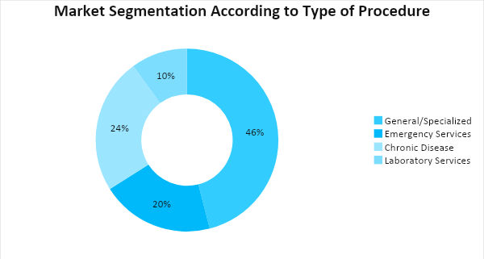

Target Market Segmentation Strategy

General and specialized procedures and chronic disease treatment

- A marketing team will be hired to carry out the planned marketing strategies.
- Creation of a website and social media accounts for the hospital
- Community centers will be visited for research and to gauge the health concerns of the people in the community.
- An advertising company will be hired to make traditional advertisements to promote the hospital.

STRATEGY AND IMPLEMENTATION

Target Market Strategy

[Lifecare Medical Center] aims to increase its revenue by [10%] in the first year.

Competitive Edge

[Lifecare Medical Center’s] balanced price for quality services will put it ahead of its competition.

SWOT Analysis | Strengths | Weaknesses | Opportunities | Threats
Lifecare Medical Center | - Affordable, quality health care services  - Employees are highly-trained professionals and specialists | - New hospital  - Moderately- sized | - Has no direct competition in the area | - Older and bigger hospitals with an established name
Morris General Med | - Has a wide variety of services and procedures  - Large hospital | - Not enough manpower | - The urban population prefers hospitals with many medical services | - Increasing labor costs in the healthcare industry
St. Anne’s Community Hospital | - Has a specialized treatment facility for chronic diseases | - Small hospital in an urban area | - Chronic diseases are more prevalent recently | - Changing reimbursement process in the healthcare system

Sales Strategy and Forecast

With its improved online and community outreach and visibility, [Lifecare Medical Center] targets the following monthly sales:

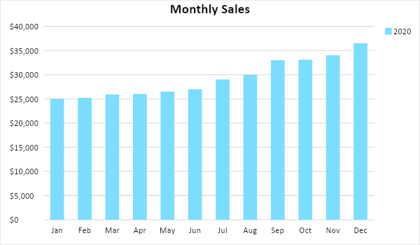

The following sales strategies will apply to the two identified target markets:

Sales Strategy | Activities | Timeline | Success Criteria
Community Outreach | Lifecare Medical Center will reach out to the local community and build the hospital’s image by volunteering in community events, providing first aid services or lessons, and etc. | April 2020 | The community will be encouraged to visit the hospital’s website and social media accounts
Medical Information Website | In addition to the company landing page containing information about the hospital and its services, a “WebMD”-like medical information website will be created to provide answers to frequently asked medical questions. The web developer will collect information provided by medical professionals for the website and start making the website. | March 2020 | The website will be 50% complete by the end of the month

Marketing Strategy

[Lifecare Medical Center] plans to hire a marketing team and an advertising agency. The two teams will come up with strategies to boost the hospital’s image and promote its services to the local community.

The hired web developer will create the hospital website and the marketing team will employ SEO strategies. The advertising campaign will include TV commercials and a billboard to be placed in a populated area in the community.

The hospital will visit community centers to reach out to the local community and engage with them, perform free check-ups and consultation. This is to build relationships and establish patient loyalty.

The web developer will develop the medical information site and collaborate with the hired content writers and hospital medical staff.

To keep track of the marketing plan progress, the team has set the following milestones:

Milestones

Marketing Strategy | Activities | Timeline | Success Criteria
Advertising campaign | - The company will canvas for advertising agencies | February 2020 | The company will find the right agency and start planning the advertising campaign.
Website launch | - The web developer will start making the website | February-March 2020 | The web developer will have the website ready.
Community outreach | - The hospital will contact community centers to start planning the outreach programs | March 2020 | Plans for community events will be ironed out with community heads.

MANAGEMENT AND PERSONNEL

The board of directors manage the hospital in its entirety and makes the various executive decisions, with the president of the board as their representative.

Under the president are the following directors who manage their own departments in the hospital:

- The director of medicine provides leadership and guidance to the medical staff and is also in charge of the training and assessment of new staff members. Reporting under the director of medicine are the chief of surgery, chief of therapy and diagnostics, and other chief staff members.
- The financial director manages the financial state of the company and creates and implements financial strategies for profitable growth.
- The administration and support services director is responsible for the daily operation, the hospital facilities, and the rest of the hospital staff members.

SALES ACTION PLAN

The table below summarizes [Lifecare Medical Center’s] sales goals and their corresponding activities. It also includes target dates, resources, person-in-charge, and key performance indicators (KPIs).

Sales Goals | Action Items | Start Date | End Date | KPIs | Owner
1. Coordinate marketing and advertising campaigns | - Schedule weekly progress meetings for both teams | - February 2020 | - April 2020 | - Timelines for both teams will be aligned | Marketing and Advertising Team Heads
2. Gain 10% revenue growth | - Initiate community outreach events  - Launch the hospital website | - April 2020 | - September 2020 | - Achieve 25% patient capacity | Marketing and Advertising Team Heads

